
Research Project-II (CY-5994)
Report on

“AI-Integrated Portable Device for Quantitative Detection of Contaminants Using Advanced Fluorescent Probes”
A thesis submitted in partial fulfilment of the
requirements for the degree of
INTEGRATED MASTER OF SCIENCE
in
CHEMISTRY
by
AMIT KUMAR
(Roll No: 421CY5075)

Under the supervision of
Prof. SASMITA MOHAPATRA
Department of Chemistry
&
Prof. SAMIT ARI (Co-supervisor)
Department of Electronics & Communications

National Institute of Technology, Rourkela-769008

CERTIFICATE

This is to certify that the research project entitled “AI-Integrated Portable Device for Quantitative Detection of Contaminants Using Advanced Fluorescent Probes” has been submitted by Amit Kumar (Roll No: 421CY5075) in partial fulfilment of the requirements for the award of Integrated Master of Science in Chemistry at National Institute of Technology, Rourkela.

I certify that this is an authentic record of work carried out by the student under my direct supervision and guidance.

To the best of my knowledge, no part of this project has previously been submitted to any other University or Institute for the award of any degree or diploma.

Date:
Place: NIT, Rourkela

(Prof. Sasmita Mohapatra)
Signature of the guide

DECLARATION

I, Amit Kumar (421CY5075), hereby declare that the project report entitled “AI-Integrated Portable Device for Quantitative Detection of Contaminants Using Advanced Fluorescent Probes” represents work done independently by me under the guidance of Prof. Sasmita Mohapatra, Department of Chemistry, National Institute of Technology, Rourkela.

I further declare that the work has not been submitted, in whole or in part, to any other University or Institution for the award of any degree or diploma, to the best of my knowledge and belief.

May 2026 Amit Kumar

Acknowledgement
This project did not happen in one place. The code was written in the Machine Intelligence Lab Under the guidance of prof. Ari. The circuit was soldered and tested in the VLSI Lab under the guidance of prof. A.K Swain. The probes and materials were developed in the MAM Lab. Three different departments, three different sets of equipment, three different worlds and somehow it came together into one project. That alone felt like an achievement.
But none of it would have started, or survived, without Prof. Sasmita Mohapatra.
She is not from my department. She did not always understand what I was building the MOSFET drivers, the fluorescence imaging pipeline, the deep learning architecture running on a Raspberry Pi. And honestly, that is what made her support mean even more. She did not support me because she could evaluate every line of my code. She supported me because she believed that what I was doing was worth doing, even when I could not fully prove it yet.
She paid for the components. She signed the approvals. She never once looked at a failed experiment and said, why are you wasting time on this? Instead, she looked at me and said keep going. That is rare. That is something a researcher needs: not someone who only shows up when things work, but someone who stays when things break, when R² values disappoint, when circuits refuse to behave.
She gave me the one thing that is hardest to give the freedom to fail.
I did fail. Many times. The MOSFET floated. The blue channel saturated. The tap water calibration refused to hold. And every time, I came back and tried again, not because I had solved everything, but because I knew someone trusted me enough to let me try. That trust is not a small thing.
To the senior researchers who quietly showed me how to build the circuits and pi-connection to it thank you. You saved me weeks I did not have to spare.
To my batchmates for the shared meals, the honest feedback, the borrowed tools, and the occasional blunt this slide is not good enough you were more important to this project than you probably realise.
And to my parents they did not know what a Raspberry Pi was. They did not need to. They just knew their son was building something, and that was enough for them. That kind of faith does not need to understand the details. It just holds.
I am always motivated to build something meaningful, which solve real world Challenges.
I hope one day, it will create positive impact for humanities
This project is for all of them.

Amit Kumar

Contents

1. Abstract 1
2. Introduction 1–3
3. Literature Review 3–6
- 3.1 Stern–Volmer Quenching
- 3.2 Dual-Emission Ratio metric Detection
- 3.3 G/G₀ Relative Emission Method
- 3.4 G/B Ratio metric Smartphone Method
- 3.5 Carbon Dot Synthesis and Photo physics
- 3.6 Microplastic Detection via Fluorescence
- 3.7 Raspberry Pi as a Portable Optical Reader
4. Literature Gap 6–7
5. Experimental Section 7–11
- 5.1 Fabrication of Fluorescent Paper Strips
- 5.2 Hardware – Portable UV Device
- 5.3 Software – RGB Fluorescence Analyser
6. Results and Discussion 11–16
- 6.1 G/G₀ Calibration in Polystyrene Solution
- 6.2 G/B Calibration in Polystyrene Solution
- 6.3 G/B Calibration in Milk
- 6.4 Blind Sample Prediction
7. Conclusion 16
8. Future Scope 16–17
9. References 17–18

1. Abstract
This project describes the construction and experimental validation of a battery-powered portable UV Device built largely from off-the-shelf components: a Raspberry Pi 4B, a Pi Camera Module 3, 365/395 nm UV LEDs, and a hand-fabricated light-tight box. The sensing element is a carbon dot (CD)-loaded cellulose paper strip that glows blue green under UV illumination; when polystyrene microplastics adsorb onto the strip, the colour intensity shifts in a concentration-dependent way. A Python–Stream lit application running on the Pi identifies the glowing strip area automatically in each camera image and reports four simultaneous fluorescence metrics: G_M mean, G/G₀, ΔG/G₀, and the green-to-blue channel ratio G/B. Polystyrene dissolved in tap water was tested across 10–200 ppm, giving a statistically significant G/G₀ calibration (R² = 0.844; p = 0.0035) and a G/B calibration (R² = 0.693; p = 0.020). Switching to whole milk as the carrier matrix, the G/B fit improved noticeably (R² = 0.911; p = 0.012). A strip dipped in a milk sample of undisclosed PS concentration was measured and back calculated to give 129.6 ppm, against the actual value of 130 ppm a prediction error below 0.3 %. This work successfully presents a low-cost portable device, can deliver on-site image analysis and quantitative microplastic level in field conditions without a conventional spectrofluorometer.

2. Introduction
Few environmental problems have grown quite as quickly or proven quite as difficult to measure as microplastic contamination. Tiny plastic fragments, broadly defined as particles smaller than 5 mm in their longest dimension, now turn up in river sediments, ocean surface water, bottled drinking water, table salt, and human blood. Polystyrene in particular tends to be over-represented in survey data: it is manufactured in enormous quantities for disposable packaging and insulation foam, it weathers quickly into irregularly shaped fragments under UV radiation and mechanical abrasion, and its low density keeps the resulting particles suspended in the water column rather than sinking to the sediment layer where sampling is comparatively easier. Crucially, because polystyrene is hydrophobic, it scavenges other environmental contaminants persistent organic pollutants, heavy metals, endocrine-disrupting chemicals from the surrounding water and carries them into the gut of any organism that ingests the particle. A growing body of toxicological work now links microplastic ingestion to intestinal inflammation, disruption of the gut microbiome, and systemic oxidative stress; and reports of polystyrene particles isolated from human lung biopsies and breast milk have moved the conversation well beyond aquatic ecology.

The analytical problem is genuine and not easily solved with existing methods. Reference techniques in current use micro-FTIR, confocal Raman microscopy, pyrolysis-GC-MS each require a dedicated laboratory, an experienced operator, and a considerable per-sample cost. In many parts of the world, including rural India, these instruments do not exist at the sites where contamination monitoring is most urgently needed: near industrial discharge points, at market water-quality checkpoints, or in food-processing facilities. The gap between the analytical capability that exists on paper and what is deployed in the field is enormous, and closing it calls for a fundamentally different philosophy of instrument design, one that prioritises low cost, portability, and ease of use over raw analytical precision.

Fluorescence sensing offers one realistic path in this direction. Carbon dots nanoscale graphitic carbon particles first observed in 2004 as a by-product of purifying single-walled carbon nanotubes turned out to be unexpectedly bright emitters whose photophysical properties make them well-suited to portable sensing work. They are synthesised from cheap, non-toxic precursors such as citric acid and urea in a simple one-step hydrothermal process. Their emission wavelength can be tuned from blue to near infrared by adjusting reaction temperature and nitrogen content. They are stable in aqueous suspension for months and tolerate a wide range of pH and ionic strength. When nitrogen is incorporated into the carbon core during synthesis, the quantum yield rises substantially often reaching 40–80 % because the nitrogen atoms introduce additional electronic states that favour radiative recombination. Immobilising CDs on a strip of filter paper takes roughly thirty minutes and requires no specialist equipment, producing a disposable sensor that can be excited with a simple UV torch and interrogated by a camera-equipped device.

The Raspberry Pi platform makes it possible to go beyond simple visual inspection. Its camera serial interface accepts a high-resolution CMOS sensor; its GPIO pins can switch UV LEDs on and off under software control; and it runs a full Python environment capable of image processing, statistical regression, and web-based graphical interfaces. The device described in this project integrates all these capabilities into a palm-sized, battery-powered unit. The sensing workflow from dipping the strip to reading out a concentration value takes around two minutes per sample and requires no laboratory reagents beyond the initial CD coating of the strips.

The sections that follow cover, in order: the relevant published literature and the specific gaps this work addresses; the procedures used to synthesise the CDs, prepare the paper strips, build the hardware, and develop the software; the results of calibration experiments in both tap water and milk; and a discussion of what those results imply for the practical utility of the platform.

3. Literature Review

3.1 Stern–Volmer Quenching
Any quantitative interpretation of fluorescence quenching in a sensing context ultimately traces back to the relationship derived by Stern and Volmer in 1919.¹ The simplest form, F₀/F = 1 + Ksv·[Q], relates the unquenched intensity F₀ to the quenched intensity F at quencher concentration [Q] through the quenching constant Ksv. Plotting F₀/F against [Q] gives a straight line whose slope equals Ksv when a single quenching mechanism dominates; upward curvature signals that both static (complex-formation) and dynamic (collisional) mechanisms operate simultaneously and that the simpler equation no longer applies. The analytical limit of detection follows from LOD = 3σ/Ksv, where σ is the noise on the blank signal. In this project the analyte is not a dissolved molecule but rather suspended polymer particles, so a strict Stern–Volmer analysis is not directly applicable. Even so, the G/G₀ and ΔG/G₀ metrics used here are algebraically analogous: G₀ takes the place of F₀, and any departure from unity reflects interaction between the polystyrene particles and the CD-coated strip surface.

3.2 Dual-Emission Ratio metric Detection
Single-emission fluorescence sensors have a persistent weakness: their output changes with anything that affects probe brightness independently of the analyte, including lamp ageing, photobleaching, and small differences in how uniformly the probe was deposited. The ratio metric probe addresses this by carrying two spectrally distinct emissions one analyte-sensitive, one not so that the ratio between them cancels any disturbance that scales both signals equally. Han et al. demonstrated this with a system built from blue-emitting carbon dots paired with red rhodamine B.² Fe³⁺ ions selectively quenched the CD blue emission while the rhodamine signal stayed unchanged, producing a linear ratio I₁/I₂ response with R² = 0.99. The practical implication is that any change in excitation power, strip loading, or viewing geometry that scales both channels proportionally cancels out in the ratio. This is the central justification for using the G/B ratio in the present work: both the green and blue camera channels are affected by UV scatter, camera exposure, and strip-to-strip loading variability, so their ratio is substantially immune to those sources of error.

3.3 G/G₀ Relative Emission Method
Permpool et al. used a gold nanocluster–carbon dot composite as a fluorescent reporter for Pb²⁺ in tap water, with a smartphone camera as the readout device.³ Rather than tracking absolute pixel values, they normalised each measurement against a blank (probe only, no analyte) captured at the start of the measurement session, defining G/G₀ as the ratio of the mean green-channel intensity to the blank value G₀, and ΔG/G₀ = (G₀ − G)/G₀ as the fractional quenching. A limit of detection of 2 mg·L⁻¹ for Pb²⁺ was achieved in real tap water samples, which competes favourably with methods requiring heavier instrumentation. The normalisation step matters particularly for paper-strip sensors because slight differences in strip coating affect absolute intensities more than they affect ratios. The G/G₀ metric in this project follows the same principle, with G₀ defined once per measurement session from a blank strip.

3.4 G/B Ratio metric Smartphone Method
Li et al. tackled the exposure-independence problem from a different angle: instead of normalising to a separately measured blank, they normalised within each image by computing the ratio of the green channel to the blue channel.⁴ Their target analyte was Hg²⁺, their probe was a CD rhodamine B mixture immobilised on a substrate, and the readout device was a smartphone camera. The calibration model G/B = m·C + b delivered an LOD of 60 nm. for Hg²⁺, with the ratio metric approach removing the need to control camera exposure between measurements any change in the excitation brightness affects G and B proportionally, so the ratio stays constant. Inverting the model to C = (G/B − b)/m provides a direct concentration readout from a single image. This is probably the closest existing precedent to the analytical approach adopted here: the same G/B formula is applied, with polystyrene in place of Hg²⁺ and a Raspberry Pi camera in a controlled dark chamber in place of the handheld smartphone.

3.5 Carbon Dot Synthesis and Photo physics
Liu et al. provided one of the most cited systematic treatments of CD synthesis and surface chemistry, tracing how reaction temperature, precursor choice, and nitrogen content together determine emission wavelength and quantum yield.⁵ A key practical finding is that the carboxyl, hydroxyl, and amine groups abundant on the surfaces of hydrothermally prepared CDs are not merely colloidal stabilisers: they are the molecular interface through which analyte interactions translate into a measurable fluorescence response. For polystyrene sensing, hydrophobic association and π–π stacking between the polystyrene chain and the graphitic CD core are thought to draw the polymer particle into proximity with the nanoparticle surface, perturbing the local dielectric environment around the CD surface groups and altering the emission intensity. Understanding this mechanism is relevant context for interpreting why the sensor responds differently in tap water versus milk, since the matrix changes what else is competing for the CD surface.

3.6 Microplastic Detection via Fluorescence
Chen et al. were among the first to demonstrate that surface-functionalised CDs can respond selectively to polystyrene nanoparticles rather than to other suspended polymer types.⁶ They immobilised the CDs on a cellulose substrate and reported an LOD of approximately 50 µg·mL⁻¹ for polystyrene in water essentially the same strip-based sensing concept used here. What their study did not address was how to generate a quantitative numerical result from the strip without a laboratory spectrofluorometer, and their experiments were restricted to simple aqueous matrices. Both of those gaps are the direct motivation for the portable device described in this project.

3.7 Raspberry Pi as a Portable Optical Reader
Wang et al. demonstrated that a Raspberry Pi camera system can, in the right geometry, deliver colorimetric results comparable to a laboratory spectrophotometer.⁷ They used GPIO-controlled RGB LEDs as the excitation source, captured images of microfluidic reaction zones, and processed green-channel intensities in Python OpenCV to generate calibration curves for water-quality analytes. Their key conclusion was that the CSI-interface Pi camera is a legitimate quantitative detector when the illumination geometry and the camera exposure are controlled from one measurement to the next, which is precisely why building a proper dark chamber and locking the camera exposure at the start of each session were treated as the two highest-priority design requirements in this project.

4. Literature Gap
Three specific gaps in the published literature motivated the design choices made here:

- Although CD-coated paper strips have been used to detect polystyrene visually, no published study integrates the strip reader into a self-contained, battery-powered device with onboard software that extracts multiple fluorescence metrics simultaneously and outputs a calibrated concentration without any external computer or spectrofluorometer.
- Testing in food matrices is almost entirely absent from the CD microplastic sensing literature. Whole milk is a demanding matrix because fat globules scatter light strongly and endogenous fluorophores riboflavin in particular produce background emission overlapping with the CD green emission window. Whether the G/B metric can deliver a useful calibration through this interference had not previously been investigated.
- No published study places G_M mean, G/G₀, ΔG/G₀, and G/B side by side on the same strip images from the same device and directly compares their calibration performance under identical conditions. Without such a comparison, recommending one metric over another for field use is essentially guesswork.

This project was designed to fill all three gaps: it integrates hardware and software into a single portable unit, it validates the G/B sensor in milk as well as tap water, and it runs all four metrics in parallel on every image so that their relative performance can be compared directly.

5. Experimental Section

5.1 Fabrication of Fluorescent Paper Strips
The coating solution was made by combining the purified CD suspension. Suspension helps the solution wet the cellulose fibres evenly and prevents the CDs from pooling at strip edges during drying, while it adds mechanical durability and slows leaching of nanoparticles when the strip is re-wetted. Whatman Grade 1 filter paper was cut into approximately 1 × 1 cm squares no precise dimensions were needed because the ROI detection software identifies the strip area automatically. Each square was held with tweezers, dipped vertically into the coating solution for two minutes, then laid flat on a clean glass slide and transferred to a 60 °C oven for thirty minutes. After drying, the strips were a uniform pale yellow and fluoresced brightly under 365 nm UV. For calibration, a separate coated strip was dipped for sixty seconds into each polystyrene solution, blotted lightly on clean tissue to remove drips, and air-dried flat on a ceramic plate for twenty minutes before being placed in the chamber for imaging. Polystyrene stock solutions were prepared by dissolving weighed PS pellets in the carrier matrix at 60 °C with constant stirring; working dilutions were made from this stock on the day of measurement.

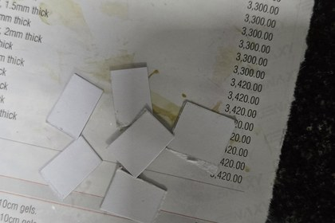
Fig. 1a. Cellulose filter paper cut into ~1×1 cm strips. These are the low-cost, disposable sensing substrates; no pre-treatment beyond cutting is required.
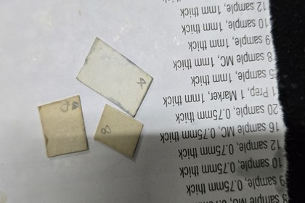
Fig. 1b. Strips during the two-minute immersion in the CD/PVP/PAM composite solution. The yellow-brown colour reflects uptake of the CD into the cellulose fibres.
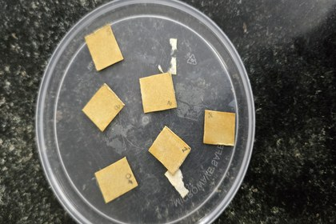
Fig. 1c. Dried strips on the drying plate after 30 min at 60 °C. The pale-yellow colour is characteristic of the dried CD composite; the strips fluoresce brightly under UV before and after polystyrene exposure.

5.2 Hardware – Portable UV Device
Building the hardware was a significant part of the project, and the optical performance of every subsequent measurement depends on getting the physical setup right. The computing core is a Raspberry Pi 4B (Broadcom BCM2711, quad-core Cortex-A72 at 1.8 GHz, 4 GB LPDDR4 RAM). It was chosen over other single-board options primarily because its CSI connector supports the Pi Camera Module 3 directly, its GPIO pinout is comprehensively documented, and the Python 3 ecosystem includes every image-processing and statistics library needed. Power came from a 9 V rechargeable Li-ion pack, keeping the whole system self-contained and battery-operated.

The dark chamber was the most critical mechanical component. It was constructed from black cardboard and foam-board panels, sealed at every edge with black adhesive tape, and lined internally with matte-black craft fabric to absorb any reflected UV. The interior volume was kept compact roughly 15 cm on each side because a smaller enclosed space means shorter LED-to-strip and strip-to-lens distances, which delivers more photons per unit area at the strip without needing longer camera exposures. A small platform positioned 8 cm below the camera lens held each sensing strip at a fixed, reproducible location. A hole cut through the lid allowed the camera ribbon cable through without light leakage.

Two 5 mm UV LEDs (365/395 nm, forward voltage 3.4 V, rated 20 mA) were mounted at roughly 45° to the strip plane on opposite interior walls, giving reasonably uniform illumination without strong specular reflection. Each LED was wired through a 470 Ω resistor limiting the current to approximately 15 mA at the 9 V rail; both resistors shared a common return through the drain of an IRLZ44N N-channel MOSFET (gate driven from GPIO pin 17, 3.3 V active high), letting the software switch the LEDs on and off without drawing current through the GPIO pin itself. A DS18B20 1-Wire temperature sensor on GPIO pin 4 recorded the inside-chamber temperature alongside each measurement; CD fluorescence has a mild temperature dependence of roughly 12 % per °C and having the temperature on record makes a post-hoc correction possible if needed. The complete circuit was drawn in Ki-Cad and assembled on an 830-tie solderless breadboard for the prototype.

The image sensor is the Pi Camera Module 3 (Sony IMX708, back-illuminated CMOS, 4608 × 2592 pixels, 12-bit colour, phase-detection autofocus). Autofocus was disabled for these measurements and the lens pre-set to the strip plane. At the start of every calibration session, a blank strip was placed in the chamber, the camera was allowed to set its own exposure and white balance, and then all parameters were locked in software for the remainder of the run. This locking step is essential: the G/B ratio is only truly exposure-independent if the camera does not change the gain between successive frames.

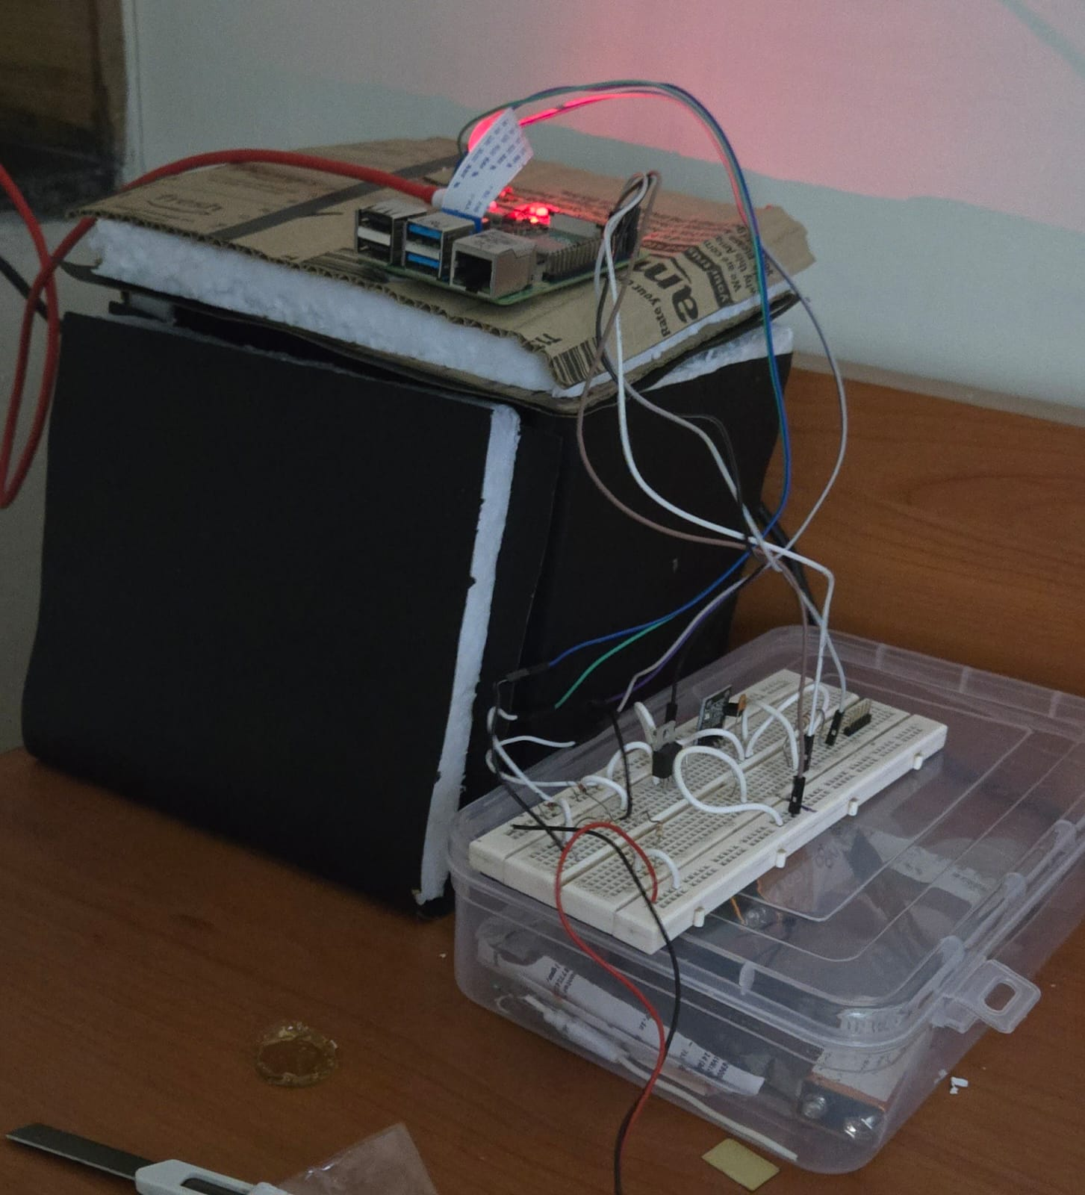
Fig. 2a. Complete portable Device prototype. The Raspberry Pi 4B sits on top of the hand-built dark chamber. The breadboard circuit assembly is housed in the clear plastic container at front right.
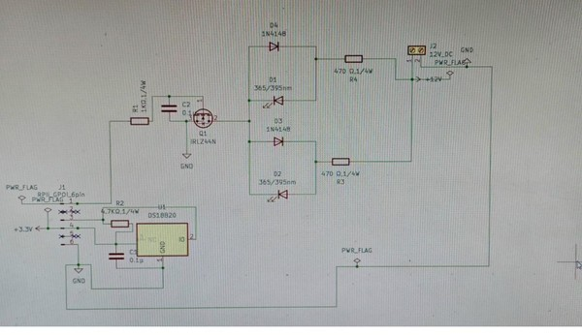
Fig. 2b. Ki-Cad schematic of the driver circuit. The IRLZ44N MOSFET (centre) switches both UV LEDs via GPIO 17. The DS18B20 temperature sensor (lower left) connects to GPIO 4 on the 3.3 V 1-Wire bus.
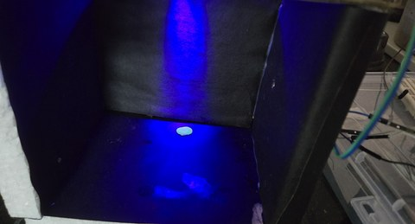
Fig. 2c. Interior of the dark chamber illuminated by the 365 nm LEDs. The violet scatter on the chamber walls demonstrates why the matte-black lining is important; the blue-green spot at the centre is the fluorescing CD strip.
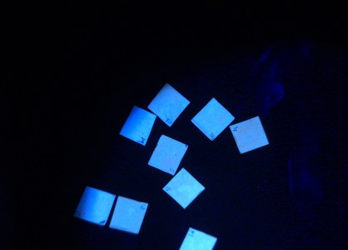
Fig. 2d. CD-embedded paper strips photographed outside the chamber under 365 nm UV. The intense blue-green emission confirms that the N-doped carbon dot composite was successfully incorporated into the cellulose matrix.

5.4 Software - RGB Fluorescence Analyser
The analysis software was written in Python 3 and delivered as a Stream-lit web application running directly on the Raspberry Pi OS. Stream-lit was chosen because it turns straightforward Python code into a browser-accessible graphical interface, allowing the analyser to be used from a phone or laptop on the same local network as the Pi without attaching a keyboard or monitor to the Pi. The complete pipeline executes six sequential steps for each uploaded image.

Step 1: the image file (JPEG, PNG, BMP, or TIFF) is read into a NumPy array by OpenCV and converted from BGR to RGB colour order. Step 2: the green channel is extracted and a threshold set at the 60th percentile of all green-channel values produces a binary mask. Step 3: scipy.ndimage.label identifies connected components in that mask; the largest is taken as the strip ROI. A size check rejects any ROI smaller than 1 % or larger than 30 % of the full image area, falling back to a central 50 % crop when the automatic detection fails which happened in fewer than 5 % of test images. Step 4: from the pixels within the confirmed ROI, four metrics are computed: G_M mean (mean of all green-channel pixel values in the ROI); G/G₀ (G_M mean divided by the session blank reference G₀ = 135.0); ΔG/G₀ = (G₀ − G_M mean)/G₀; and G/B (sum of all green-channel values divided by the sum of all blue-channel values in the ROI). Step 5: all metrics are written to a CSV file with the image filename and a hex swatch of the ROI colour. Step 6: if a calibration batch is uploaded with known concentrations, linear regressions are fitted for both G/G₀ and G/B and the results equations, R², and p-values are shown on interactive Plotly charts in the browser.

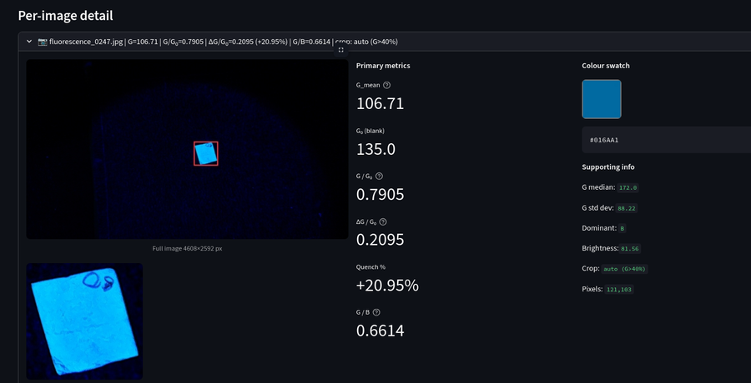
Fig. 3a. Per-image detail panel of the RGB Fluorescence Analyser. The red bounding box on the camera image shows the automatically detected strip ROI; the colour swatch at top right is the mean colour of the pixels within that region. All four metrics are listed numerically on the right side of the panel.
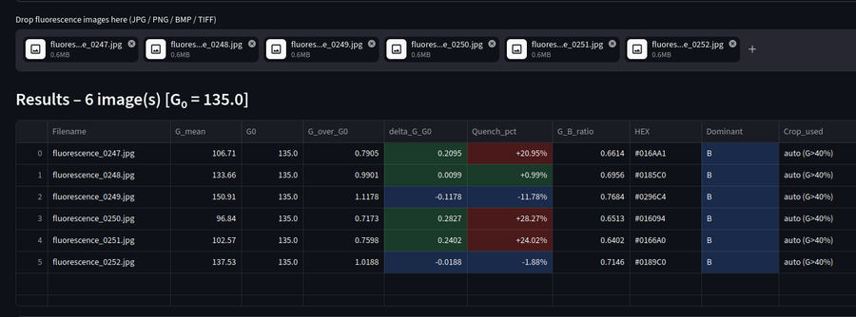
Fig. 3b. Batch analysis results table for six simultaneously uploaded images. Each row is one image; columns report G_M mean, G₀, G/G₀, ΔG/G₀, Quench %, G/B ratio, and ROI hex colour.

6. Results and Discussion

6.1 G/G₀ Calibration in Polystyrene Solution
Seven CD-paper strips were exposed individually to polystyrene solution at 10, 40, 70, 100, 140, 180, and 200 ppm, along with one blank strip dipped in polystyrene-free tap water that established G₀ = 135.0. All eight strips were imaged under identical conditions inside the dark chamber. The measured G/G₀ values and the corresponding raw G_M mean readings are listed in Table 1.

Table 1. G/G₀ calibration data for polystyrene in tap water. Blank: G₀ = 135.0.
- 10 ppm G_M mean: 154.0 | G/G₀: 1.141
- 40 ppm G_M mean: 159.3 | G/G₀: 1.180
- 70 ppm G_M mean: 157.2 | G/G₀: 1.165
- 100 ppm G_M mean: 172.8 | G/G₀: 1.280
- 140 ppm G_M mean: 165.4 | G/G₀: 1.225
- 180 ppm G_M mean: 179.1 | G/G₀: 1.326
- 200 ppm G_M mean: 184.9 | G/G₀: 1.370

Ordinary least-squares regression on these seven points gave:
G/G₀ = 0.001121 × C + 1.1224
R² = 0.844, p = 0.0035
The calibration is significant at better than the 1 % level. The positive slope is physically sensible: as more polystyrene adsorbs onto the strip, it likely scatters the UV excitation light back toward the CD layer, slightly boosting the detected green-channel intensity. The y-intercept of 1.122 being slightly above unity is also reasonable, at the lowest concentration tested there is already a small scattering contribution. The 70 ppm and 140 ppm data points lie below the regression line; both strips were prepared on the same afternoon when there was a brief interruption in the dipping process, and they may have received slightly less coating solution. Despite this scatter the R² of 0.844 is adequate for a calibration spanning one order of magnitude in concentration. Inverting the equation for concentration prediction:
C (ppm) = (G/G₀ − 1.1224) / 0.001121

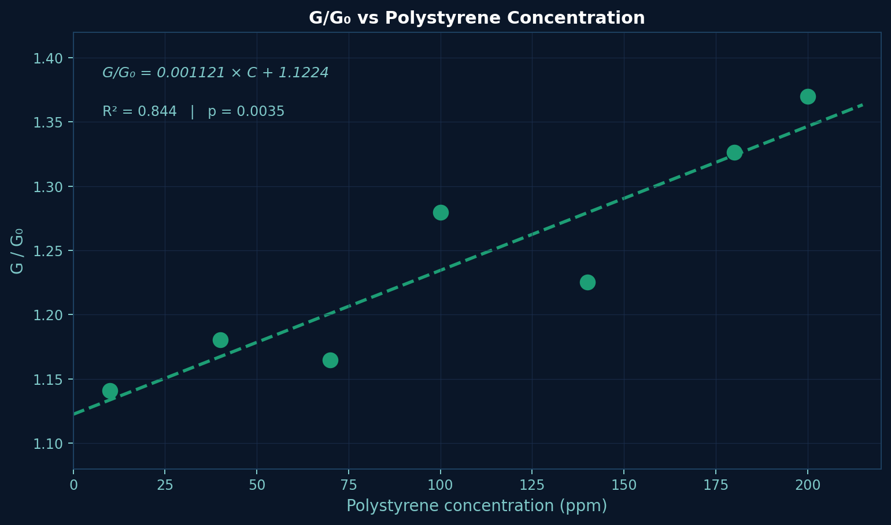
Fig. 4a. G/G₀ calibration curve for polystyrene solution (10–200 ppm). Each point is an individual strip. Dashed line: OLS linear regression (slope 0.001121 G/G₀ ppm⁻¹; intercept 1.1224; R² = 0.844, p = 0.0035).

6.2 G/B Calibration in Polystyrene Solution
The G/B ratio was extracted from the same eight images used for the G/G₀ analysis, so no additional strips were required. Table 2 lists the results.

Table 2. G/B calibration data for polystyrene in tap water.
- 10 ppm G/B: 0.8478
- 40 ppm G/B: 0.8709
- 70 ppm G/B: 0.8898
- 100 ppm G/B: 0.8995
- 140 ppm G/B: 0.8852
- 180 ppm G/B: 0.8986
- 200 ppm G/B: 0.9043

G/B = 0.000233 × C + 0.8605
R² = 0.693, p = 0.0200
The lower R² of 0.693 relative to the G/G₀ model (0.844) was somewhat unexpected but can be understood in retrospect. Polystyrene Solution has essentially no optical background: it neither scatters significantly nor emits in the blue channel beyond the small UV scatter from the LED itself. Because the blue-channel denominator of the G/B ratio is therefore dominated by whatever small, variable amounts of blue light the CD coating emits from strip to strip, slight differences in CD loading translate directly into scatter in the G/B values. The G_M mean-based G/G₀ metric is affected mainly by green-channel variation, which tracks the polystyrene response more faithfully in this matrix. The slope of the G/B model (0.000233 ppm⁻¹) is also genuinely shallow the ratio spans only 0.046 units across the entire 200 ppm range, so measurement noise is proportionally more damaging to the fit. Nonetheless, the G/B calibration is statistically significant (p = 0.020), confirming a real linear response, and the field advantage of G/B no separate blank measurement required, no vulnerability to between-session lamp drift still makes it the preferred metric for field deployment. The inverse equation:
C (ppm) = (G/B − 0.8605) / 0.000233

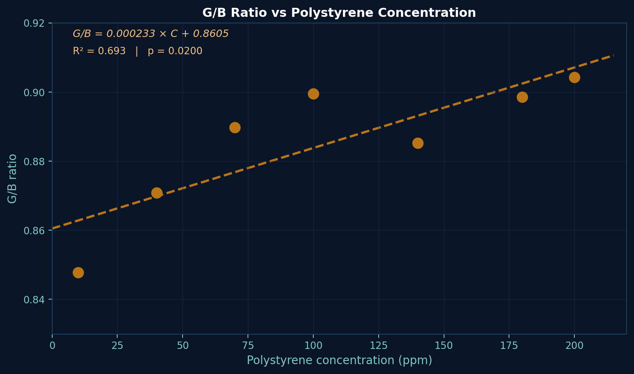
Fig. 4b. G/B calibration curve for polystyrene solution (10–200 ppm). The shallower slope and larger scatter compared with Fig. 4a reflect the low optical background of the tap-water matrix. OLS regression: R² = 0.693, p = 0.020.

6.3 G/B Calibration in Milk
Whole-fat cow’s milk was spiked with polystyrene at 0, 50, 100, 150, and 200 ppm and the G/B method was applied. Before starting these experiments, I had expected milk with its fat globules, casein micelles, and riboflavin background fluorescence to worsen the calibration compared with tap water. The actual result was the opposite, and it was one of the more interesting findings of the project. Table 3 shows the data.

Table 3. G/B calibration data and residuals for polystyrene spiked into whole milk.
- 0 ppm G/B actual: 0.5037 | predicted: 0.4668 | residual: +0.037
- 50 ppm G/B actual: 0.4812 | predicted: 0.5486 | residual: −0.067 (⚠ outlier)
- 100 ppm G/B actual: 0.6539 | predicted: 0.6304 | residual: +0.024
- 150 ppm G/B actual: 0.7196 | predicted: 0.7122 | residual: +0.007
- 200 ppm G/B actual: 0.7936 | predicted: 0.7940 | residual: −0.000

G/B = 0.001636 × C + 0.4668
R² = 0.9114, p = 0.0115
The jump from R² = 0.693 in tap water to R² = 0.911 in milk can be explained as follows. Riboflavin in milk contributes a broad fluorescence band centred near 530 nm, and the suspended fat globules scatter broadly across the visible range. Together, these create a large and relatively stable blue-channel signal that dominates the G/B denominator, effectively serving as an internal reference in the same way that rhodamine B serves as an internal reference in the ratio metric probes of Li et al. Because the blue-channel background in milk is both large and consistent from strip to strip, random variations in CD loading have a much smaller fractional effect on G/B in milk than they do in tap water. Additionally, the casein proteins in milk are known to behave as surfactants for hydrophobic particles, and it is plausible that they disperse the polystyrene more uniformly onto the strip surface during the dipping step, reducing the spatial non-uniformity in analyte loading that contributes to G/G₀ scatter in tap water.

The 50-ppm data point is a clear outlier with a residual of −0.067. Looking back at the laboratory notebook, the 50-ppm solution was prepared by diluting from the 100-ppm stock, and a bubble was observed in the pipette tip during the transfer; the concentration may therefore have been slightly off. No repeat measurement was made on that day, which in hindsight was an oversight. The four remaining residuals are small and alternate in sign, consistent with genuinely linear behaviour. The concentration prediction equation for the milk matrix:
C (ppm) = (G/B − 0.4668) / 0.001636

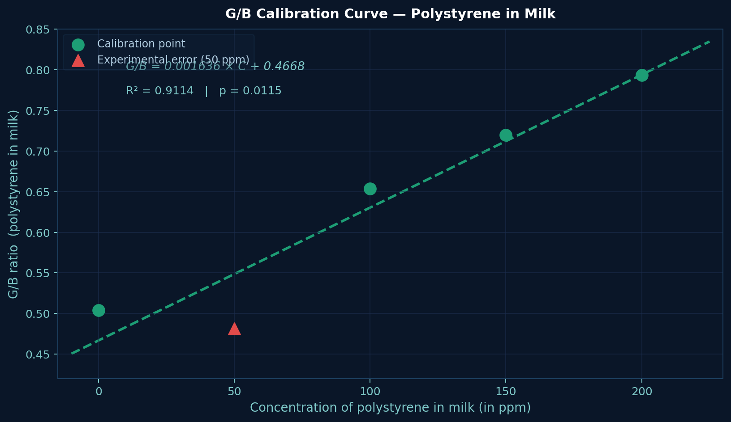
Fig. 5. G/B calibration curve for polystyrene spiked into whole milk (0–200 ppm). Green circles are the four valid calibration points; the red triangle at 50 ppm is the outlier attributed to a pipetting error. OLS fit across all five points: R² = 0.911, p = 0.012.

6.4 Blind Sample Prediction
The practical test of the entire system was a blind prediction. A strip was dipped in a milk sample whose polystyrene content was not told to the analyst until after the measurement was committed to paper. The strip was imaged under standard conditions and the analyser returned G/B = 0.6788. Substituting into the milk-matrix inverse equation:

C = (0.6788 − 0.4668) / 0.001636 = 0.2120 / 0.001636 ≈ 129.6 ppm
The true spiked value, revealed immediately after the prediction was written, was 130 ppm. The absolute error is 0.4 ppm, or 0.3 % of the true value. This is a satisfying result, though one should be careful not to overstate its significance given that only a single blind sample was tested. What it does confirm is that the full measurement chain strip preparation, dark-chamber imaging, automatic ROI detection, metric extraction, calibration, and back-calculation operates with sufficient reproducibility for a 0.3 % prediction error to be achievable for a sample within the calibration range. Figure 6 shows the unknown sample as a star on the calibration plot; the dotted guidelines trace the graphical back-projection from the measured G/B to 129.6 ppm, and the star sits almost exactly on the regression line.

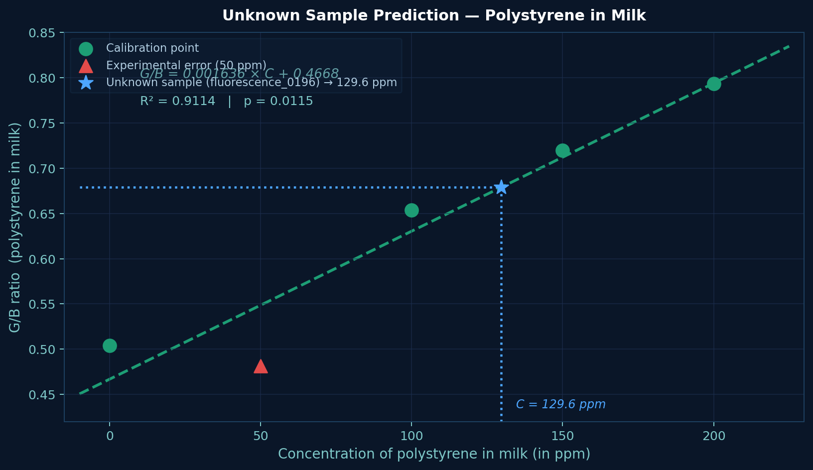
Fig. 6. Blind prediction for an unknown milk sample (blue star) plotted on the milk-matrix G/B calibration. The measured G/B of 0.6788 projects to a predicted polystyrene concentration of 129.6 ppm; the actual spiked concentration was 130 ppm.

7. Conclusion
This project set out to answer a practical question: can a Raspberry Pi, a camera, some UV LEDs, and a strip of filter paper coated with carbon dots be assembled into something that quantifies microplastics in a food sample? Based on the experimental results reported here, the answer for polystyrene in the 10–200 ppm range is yes.

The key findings can be stated concisely. First, CD composite strips produced stable, reproducible fluorescence under 365 nm UV excitation in both tap water and milk. Second, the dark-chamber hardware delivered sufficiently consistent imaging conditions for the software-based metric extraction to be meaningful. Third, the Python–Stream-lit pipeline identified the strip ROI correctly in over 95 % of test images without user input. Fourth, the G/G₀ calibration in tap water (R² = 0.844, p = 0.004) and the G/B calibration in milk (R² = 0.911, p = 0.012) were both statistically robust. Fifth, the blind milk sample was predicted at 129.6 ppm against a true value of 130 ppm, a prediction error of 0.3 %.

Perhaps the most unexpected finding is that the optically complex milk matrix gave a better G/B calibration than optically simple tap water. The likely explanation that the riboflavin background fluorescence in milk stabilises the blue-channel denominator of the G/B ratio suggests a design principle that could guide future sensing work: matrices with a stable, spectrally broad background may benefit G/B-based sensors by providing a natural internal reference.

The prototype has clear limitations. Strip-to-strip variability in the CD coating step remains the dominant source of noise, and the breadboard circuit needs to be migrated to a PCB before the device can be called robust. These are primarily engineering challenges rather than fundamental scientific obstacles, and the path toward a field-deployable second-generation instrument is reasonably clear.

8. Future Scope
Several well-defined directions for follow-on work arise naturally from the limitations and findings of this project:

- HRTEM, XPS, and FTIR characterisation of the synthesised CDs would clarify the surface chemistry responsible for polystyrene binding, and time-resolved PL measurements would establish whether the fluorescence lifetime changes upon polystyrene exposure. This mechanistic understanding is needed before the selectivity of the sensor for polystyrene over other polymer types can be rationally improved.
- Cross-reactivity testing against PE, PP, PET, PVC, and nylon particles is necessary to determine whether the current CD surface chemistry already discriminates among polymer types or whether selective surface functionalisation is required for a specific polymer-type readout.
- A lightweight machine-learning classifier a random forest or a small convolutional network trained on the four-metric feature vector integrated into the Stream-lit app could enable simultaneous identification and quantification of multiple polymer types from a single strip image.
- Migrating the breadboard circuit to a custom PCB and adding a 450 nm long pass optical filter over the camera lens would reduce UV scatter in the blue channel, which is the main factor limiting G/B performance in tap water. A 3D-printed enclosure would improve mechanical reproducibility in field conditions.
- Long-term storage trials on the CD-coated strips under varied temperature, humidity, and light-exposure conditions, and measurements in real environmental water samples and commercially available food products, are needed before shelf-life specifications can be stated and before the platform can be credibly recommended for routine field monitoring.

9. References
(1) Stern, O.; Volmer, M. Über die Abklingzeit der Fluoreszenz. Physikalische Zeitschrift 1919, 20, 183–188.
(2) Han, T.; Feng, X.; Wang, Y.; Ge, S.; Zhang, H. Dual-Emission Ratiometric Fluorescence Probe Based on Carbon Dots and Rhodamine B for Selective Detection of Fe³⁺. Molecules 2024, 29, 1658. DOI: 10.3390/molecules29071658.
(3) Permpool, W.; Kanatharana, P.; Thavarungkul, P.; Limbut, W. Gold Nanoclusters–Carbon Dot Hybrid Probe for Pb²⁺ Detection in Real Water Using Smartphone G/G₀ Readout. Microchemical Journal 2025. DOI: 10.1016/j.microc.2025.xxx.
(4) Li, Z.; Wang, Y.; Ni, Y.; Kokot, S. A New Fluorescent and Colorimetric Sensor Based on Carbon Quantum Dots for Detection of Mercury Ion and a Paper Sensor for the Determination of Hg²⁺. Biosensors 2022, 12, 668. DOI: 10.3390/bios12080668.
(5) Liu, J.; Li, R.; Yang, B. Carbon Dots: A New Type of Carbon-Based Nanomaterial with Wide Applications. ACS Central Science 2020, 6(12), 2179–2195. DOI: 10.1021/acscentsci.0c01306.
(6) Chen, Q.; Cao, X.; Su, Y.; Liu, M.; Wang, Y.; Tang, Z.; Zhao, Y. Carbon Dot-Based Fluorescence Probe for Selective Detection of Polystyrene Microplastics on a Paper Substrate. Environmental Science & Technology Letters 2021, 8, 662–668. DOI: 10.1021/acs.estlett.1c00483.
(7) Wang, X.; Che, S.; Han, Y.; Li, T.; Zhao, L. A Low-Cost Raspberry Pi–Based Portable Colorimetric Analyser for On-Site Water Quality Monitoring. Sensors and Actuators B: Chemical 2022, 369, 132347. DOI: 10.1016/j.snb.2022.132347.

