NETWORK SECURITY SPECIALIST
Task 2 – Hands-On Lab Implementation
Network Traffic Analysis Report

Internship Task | Task 2 – Hands-On Lab Implementation
Analysis Tool | Wireshark 4.4.6
Datasets | Wireshark Sample Captures: arp-storm.pcap and SkypeIRC.cap
Dataset Type | Publicly available cybersecurity lab/sample captures
Purpose | Educational network traffic analysis

1. Introduction
The purpose of this task was to examine network traffic using an authorized cybersecurity lab dataset and understand how packets reveal communication patterns. The analysis was performed in Wireshark using two publicly available sample captures from the Wireshark Sample Captures collection. The first capture, arp-storm.pcap, was used to examine repeated ARP broadcast activity. The second capture, SkypeIRC.cap, was used to examine IPv4, TCP, UDP-related conversations, DNS, IRC, HTTP and other protocols. Using actual packet captures made it possible to record specific addresses, ports, packet counts and timing information instead of relying only on theoretical descriptions.

2. Objectives
- Understand the purpose of network traffic analysis.
- Review authorized cybersecurity lab network traffic.
- Identify source and destination IP addresses.
- Analyze commonly used ports and network protocols.
- Identify unusual or potentially suspicious communication patterns.
- Document observations and explain why selected traffic may require further investigation.
- Prepare a network traffic analysis report.

3. Methodology
Wireshark was used to open and inspect the sample PCAP files. The packet list was reviewed to identify source and destination information and protocol types. Wireshark's Statistics features were then used to examine protocol hierarchy, endpoints, conversations and capture file properties. The analysis focused on observable traffic characteristics such as packet frequency, broadcast behavior, external endpoints, protocol usage and TCP/UDP ports. No live traffic from the user's network was captured for this task.

4. Capture A – arp-storm.pcap
The first dataset was arp-storm.pcap. The capture contained 622 packets over approximately 28.969 seconds. Wireshark reported an average of 21.5 packets per second and an average packet size of 60 bytes. The total captured data was 37,320 bytes.
Measurement | Observed value
Packets | 622
Time span | 28.969 seconds
Average packets/sec | 21.5
Average packet size | 60 bytes
Total bytes | 37,320 bytes
Link type | Ethernet
Format | Wireshark/pcap

4.1 ARP packet observation
The packet list showed ARP requests being sent from the same displayed source MAC address to the Ethernet broadcast destination. In the first inspected packet, the sender MAC address was 00:07:0d:af:f4:54 and the sender IP address was 24.166.172.1. The target IP address was 24.166.173.159 and the target MAC address was all zeroes, which is consistent with an ARP request for the MAC address associated with the target IP.
The packet list also showed requests for multiple target IP addresses while the source remained the same. Examples visible in the capture include 24.166.173.159, 24.166.172.141, 24.166.173.161, 65.28.78.76, 69.76.220.131 and other addresses. The repeated broadcast requests, together with the measured packet rate, form the main unusual communication pattern in this dataset.

4.2 Interpretation
The traffic is unusual because of the volume and repetition of ARP requests within a short time period. This should be treated as an observation requiring investigation rather than automatic proof of an attack. In a real environment, an analyst would compare the rate with the normal behavior of the network, determine which device generated the traffic, and check whether there was a legitimate reason for the requests.

5. Capture B – SkypeIRC.cap
The second dataset contained 2,263 packets over 322.750 seconds (approximately 5 minutes 23 seconds). The capture contained 384,637 bytes and Wireshark reported an average of 7.0 packets per second and an average packet size of 170 bytes.
Measurement | Observed value
Packets | 2,263
Time span | 322.750 seconds
Average packets/sec | 7.0
Average packet size | 170 bytes
Total bytes | 384,637 bytes
Link type | Ethernet

5.1 Protocol analysis
The Wireshark Protocol Hierarchy window showed IPv4 in 2,247 packets (99.3% of the capture). TCP accounted for 1,150 packets (50.8%). DNS appeared in 707 packets (31.2%), IRC in 158 packets (7.0%), ICMP in 23 packets (1.0%), HTTP in 4 packets (0.2%), and ARP in 10 packets (0.4%). The hierarchy also showed 362 packets classified as data and a small number of other protocol records.
Protocol / category | Packets | Percent of packets
IPv4 | 2,247 | 99.3%
TCP | 1,150 | 50.8%
DNS | 707 | 31.2%
IRC | 158 | 7.0%
ICMP | 23 | 1.0%
HTTP | 4 | 0.2%
ARP | 10 | 0.4%

5.2 Source/destination and port observations
The packet list and TCP conversation statistics showed the internal host 192.168.1.2 communicating with multiple external IPv4 addresses. One packet visible in the capture used source 192.168.1.2 and destination 212.204.214.114 and was identified as IRC traffic. The packet details showed TCP source port 2848 and destination port 6667. Port 6667 is commonly associated with IRC, which is consistent with the protocol identification in the capture.
Endpoint A | Port A | Endpoint B | Port B
212.204.214.114 | 8022 | 192.168.1.2 | 3863
65.190.6.124 | 47452 | 192.168.1.2 | 2967
68.95.198.126 | 1928 | 192.168.1.2 | 2996
69.205.247.140 | 9908 | 192.168.1.2 | 1782
69.248.108.13 | 22960 | 192.168.1.2 | 3663
71.10.179.129 | 14232 | 192.168.1.2 | 4026
The UDP conversation view contained 115 UDP conversations. The displayed conversations included multiple short exchanges involving 192.168.1.2 and external addresses. These observations show that the capture contains both persistent and short-lived communication patterns across different ports.

6. Traffic Requiring Further Investigation
Repeated ARP broadcast activity: The arp-storm capture contains 622 ARP packets in 28.969 seconds, averaging 21.5 packets/sec. The same source MAC repeatedly sends broadcast ARP requests for different target IP addresses. This is the clearest unusual pattern in the datasets and warrants investigation in a real network.
IRC communication on TCP port 6667: The SkypeIRC capture contains IRC traffic and an observed TCP conversation involving port 6667. IRC itself is not evidence of malicious activity, but an analyst may investigate whether the use of IRC is expected for the particular host and environment.
Large number of external endpoints: The endpoint and conversation views show 192.168.1.2 communicating with many external IPv4 addresses. This is not inherently malicious; the appropriate next step would be to identify the applications or services responsible and compare the destinations with expected network activity.
Malformed packets reported by Wireshark: The protocol hierarchy included a small group of packets classified as malformed. A malformed classification is an indicator for closer inspection, but it does not by itself establish malicious intent.

7. Key Findings
- Network traffic analysis can reveal communication patterns that are difficult to see from host activity alone.
- The ARP sample demonstrated repeated broadcast requests at a sustained rate, providing a concrete example of unusual local network behavior.
- The SkypeIRC sample demonstrated practical use of IPv4, TCP, DNS, IRC, ICMP and HTTP traffic in one capture.
- The traffic included both internal communication involving 192.168.1.2 and many external IPv4 endpoints.
- Port information provides useful context when combined with protocol identification; for example, TCP port 6667 was observed with IRC traffic.
- Unusual traffic should be investigated using context and additional evidence rather than being labelled malicious from a single PCAP alone.

8. Limitations
The analysis was performed on public sample captures rather than a live organizational network. Therefore, conclusions describe the traffic contained in these specific files and should not be treated as conclusions about a current production network. IP addresses, host roles and the reasons for communications cannot always be determined from packet data alone. Additional context such as asset ownership, DNS records, application logs and endpoint telemetry would be needed for a real incident investigation.

9. Conclusion
This hands-on exercise provided practical experience in examining network packets and identifying communication patterns. The arp-storm.pcap capture showed a concentrated pattern of repeated ARP broadcast requests, while SkypeIRC.cap provided a broader view of IPv4, TCP, DNS, IRC, ICMP and other traffic, including real source/destination addresses and port numbers. The exercise also demonstrated why unusual traffic should be documented with measurable evidence before further investigation. Overall, the analysis connected basic networking concepts with a practical packet analysis workflow in Wireshark.

10. Evidence Screenshots
The submission package should include selected Wireshark screenshots showing the packet list, protocol hierarchy, endpoints/conversations and capture file properties. These screenshots provide visual evidence supporting the numerical observations in this report.
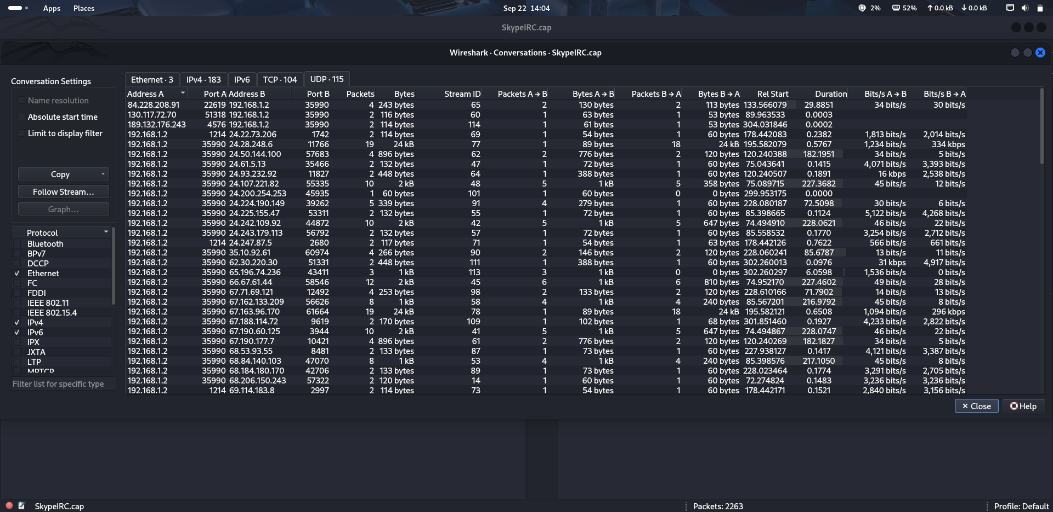
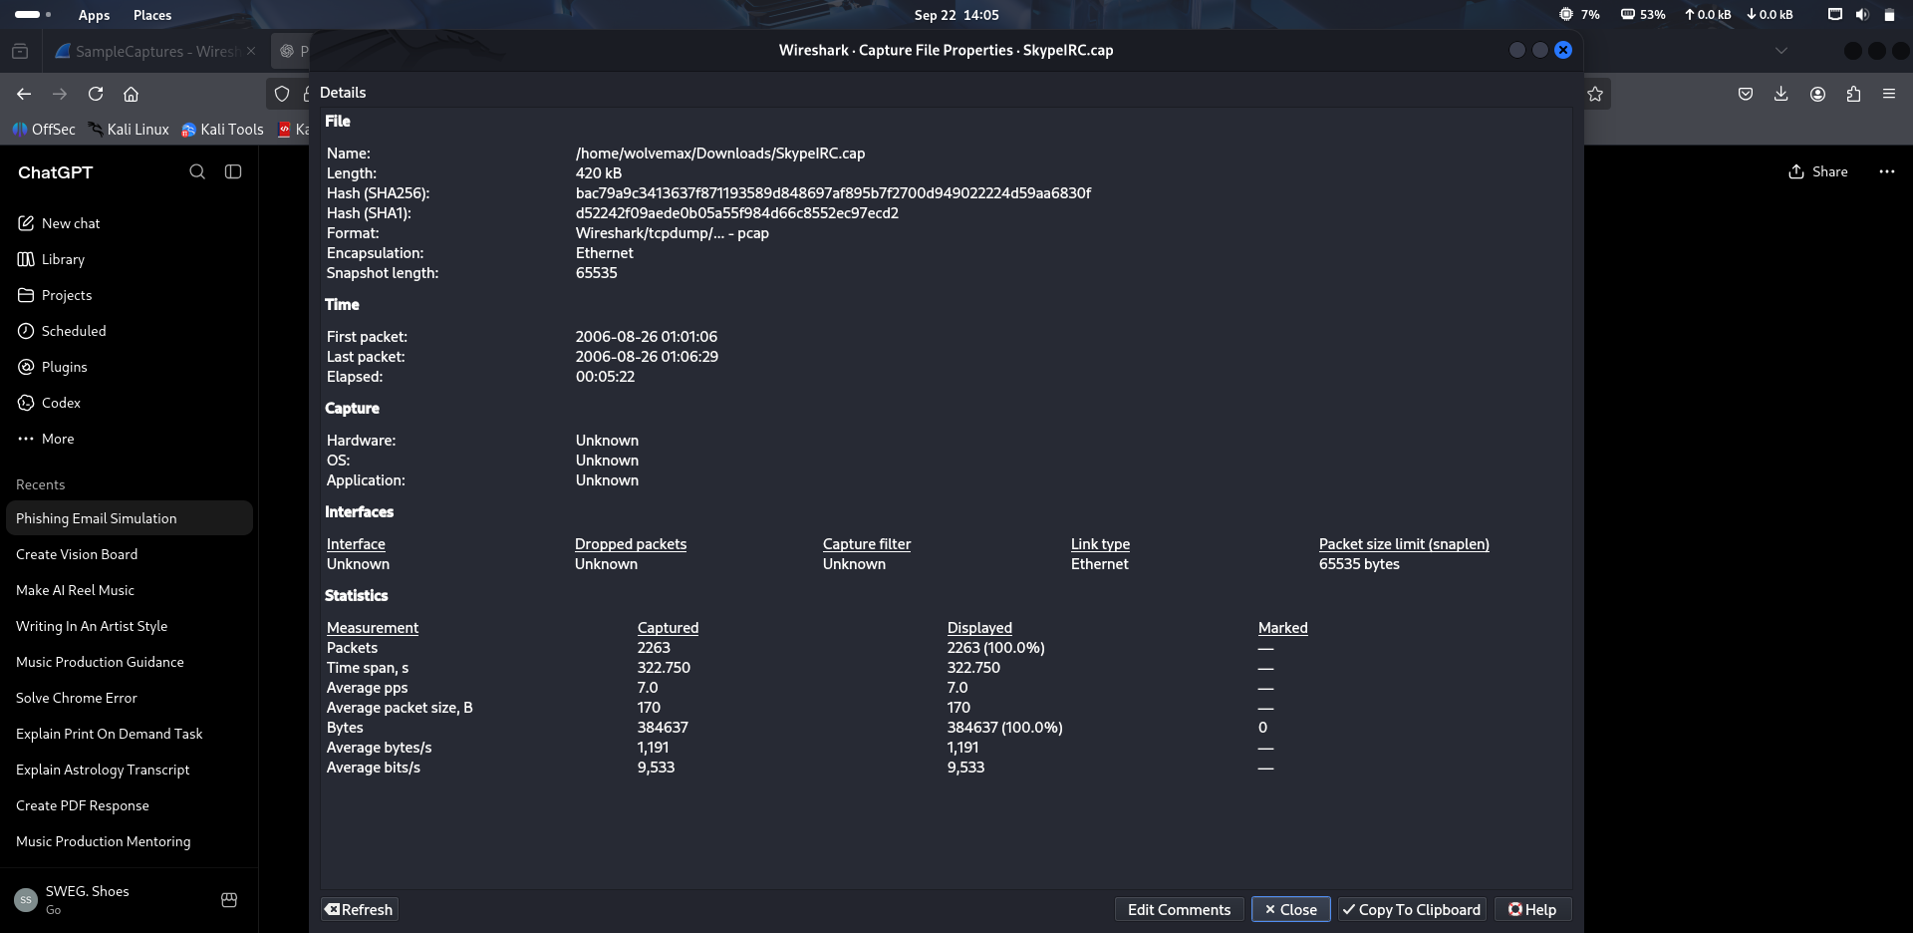

11. Dataset Source
Wireshark Sample Captures – official Wireshark Wiki collection. The datasets used in this exercise were publicly available sample captures intended for network analysis and learning.

