NETWORK SECURITY SPECIALIST
Task 3 – Real-World Case Study Analysis
Firewall Rule Review and Security Recommendations

1. Introduction
A firewall controls network traffic by applying rules that allow or deny connections between networks, hosts, services, or ports. This case study reviews a sample firewall rule set, identifies unnecessary access and overly broad permissions, and suggests practical improvements.

2. Sample Firewall Configuration
The following is a simple firewall rule set for a small network with a web server. I used a mix of normal and risky rules so they could be reviewed.
Rule | Direction | Source | Destination / Service | Action
1 | Inbound | Any | Web Server / TCP 80 (HTTP) | Allow
2 | Inbound | Any | Web Server / TCP 443 (HTTPS) | Allow
3 | Inbound | Any | Any Internal Host / TCP 23 (Telnet) | Allow
4 | Inbound | Any | Any Destination / Any IP Traffic | Allow
5 | Inbound | Any | Any Remaining Traffic | Deny

3. Evidence
Because no actual firewall configuration was supplied, the following evidence documents the constructed case-study configuration and the review performed on it. This keeps the report transparent while still providing supporting evidence for the analysis.
Evidence Screenshot A – Constructed sample firewall configuration
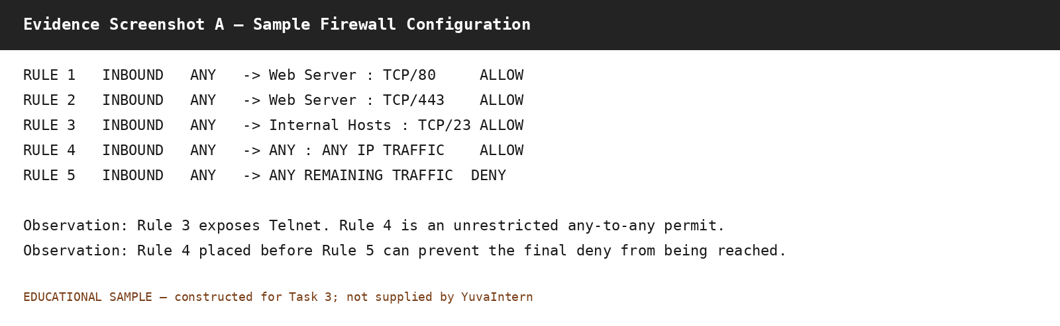
Figure 1. Constructed educational configuration used for the case study. It is not presented as a the internship-provided configuration.
Evidence Screenshot B – Findings from the rule review
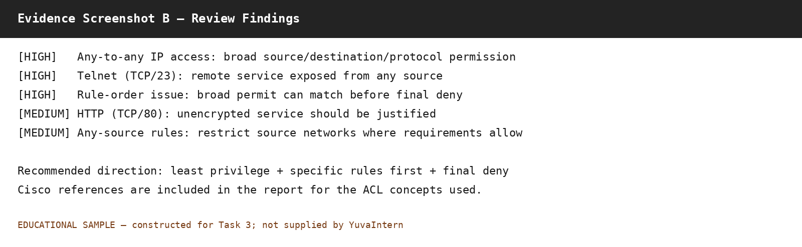
Figure 2. Findings and security priorities derived from the constructed rule set.

4. Rule-by-Rule Analysis
Rule 1 – HTTP (TCP 80): Allowing HTTP to the intended web server can be necessary when the service is intentionally exposed. However, HTTP is unencrypted, so it should remain open only when there is a documented requirement.
Rule 2 – HTTPS (TCP 443): Allowing HTTPS to the web server is a common requirement for a public web application. The rule should still be restricted to the correct destination rather than allowing TCP 443 to every internal host.
Rule 3 – Telnet (TCP 23): This rule is risky because it allows Telnet access from any source to internal hosts. Cisco's ACL examples specifically show TCP port 23 being denied when Telnet access needs to be blocked. If remote administration is required, a secure method such as SSH should be considered and access should be restricted to approved management sources.
Rule 4 – Any-to-Any IP Access: This is the broadest rule in the sample. Cisco documentation gives 'permit ip any any' as an example that allows all hosts through the interface where it is applied. Such a broad rule can create unnecessary exposure.
Rule 5 – Deny Remaining Traffic: A deny rule for traffic that has not been explicitly allowed is a useful security control. In this sample it is ineffective if Rule 4 appears before it, because ACL processing stops after the first matching entry.

5. Identified Security Issues
Issue | Observation | Priority
Overly permissive access | Rule 4 allows any source to any destination using any IP protocol. | High
Insecure remote service | Rule 3 exposes Telnet (TCP 23) from any source to internal hosts. | High
Unrestricted source access | Rules 1–3 use Any as the source; access should be limited where possible. | Medium
Rule-order problem | Rule 4 can match traffic before the final deny rule, making the deny ineffective. | High
Unencrypted web access | HTTP on TCP 80 is unencrypted and should only be exposed when required. | Medium

6. Recommended Improvements
- Remove the unrestricted any-to-any rule unless there is a clearly documented requirement for it.
- Use least privilege: allow only the required source, destination, protocol, and port.
- Remove or restrict Telnet. If remote administration is required, use a secure protocol such as SSH and restrict it to approved management systems.
- Keep specific allow/deny rules before broad rules so the intended controls are actually evaluated.
- Allow public web traffic only to the web server that needs it, rather than to all internal hosts.
- Prefer HTTPS for web services and review whether HTTP is genuinely required.
- Use a final deny approach for traffic that is not explicitly required, while ensuring rule order makes it effective.
- Review firewall rules periodically and remove old or unused entries.

7. Example of a More Restrictive Rule Set
This is only an example. The exact commands would depend on the firewall being used.
Rule | Direction | Source | Destination / Service | Action
1 | Inbound | Approved sources / Any | Web Server / TCP 443 | Allow
2 | Inbound | Approved management network | Management Server / TCP 22 | Allow
3 | Inbound | Any | Internal Hosts / TCP 23 | Deny
4 | Inbound | Any | Any other traffic | Deny

8. Key Learning from the Case Study
Cisco documentation states that ACL entries are evaluated sequentially and that the first match determines whether the packet is accepted or rejected. Therefore, a broad permit placed before a more specific deny can make the specific deny ineffective. The same documentation also demonstrates that ACLs can be made more granular using source, destination, protocol, and port criteria.

9. Conclusion
The sample configuration contained several security concerns, especially the unrestricted any-to-any rule and exposure of Telnet from any source. The review also showed why rule order matters and why firewall rules should follow least privilege. A practical configuration should expose only required services, restrict management access, remove unnecessary legacy services, and be reviewed regularly.

10. References
Cisco, Configure Commonly Used IP ACLs (updated January 28, 2025). This documentation explains sequential ACL processing, first-match behavior, implicit deny, and examples involving Telnet and broad permit rules.
Cisco, CLI Book 2: Cisco ASA Series Firewall CLI Configuration Guide – Access Control Lists. This documentation explains ACL order and provides the 'permit ip any any' example.
Official Cisco reference links:
- https://www.cisco.com/c/en/us/support/docs/ip/access-lists/26448-ACLsamples.html
- https://www.cisco.com/c/en/us/td/docs/security/asa/asa912/configuration/firewall/asa-912-firewall-config/access-acls.html

