SECURITY RISK ASSESSMENT REPORT
Task 5 – Security Report & Documentation
Network Security Specialist Internship

1. Assessment Overview
This assessment analyzes a representative sample network environment to identify, evaluate, and prioritize security risks based on their likelihood and potential impact. The assessment also recommends suitable security controls and mitigation measures.
No network architecture, firewall export, system inventory, or organization-specific configuration was supplied with the task. Therefore, a representative environment and sample configuration were constructed specifically for this assessment. The IP addresses, rules, and findings below are assessment examples and are not presented as evidence from a real organization.

2. Sample Network Architecture
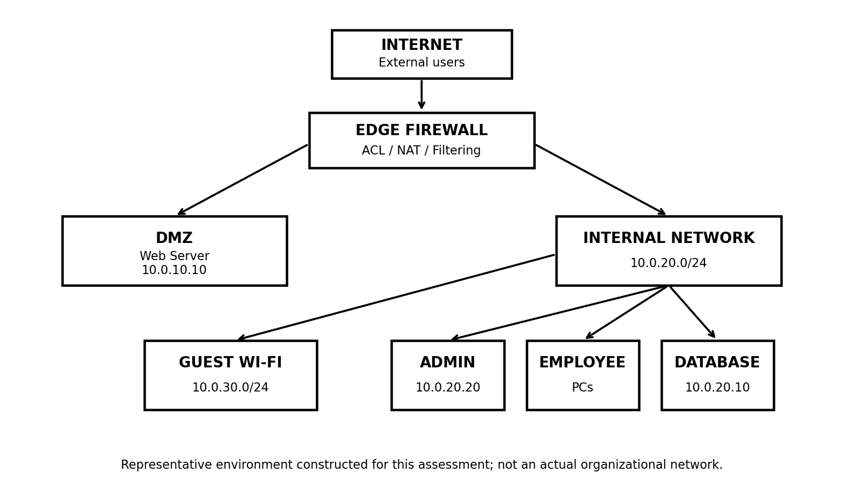
The sample environment contains an Internet-facing web server in a DMZ, an internal employee network, a database server, an administrator workstation, and a separate guest Wi-Fi network. The edge firewall controls traffic between these trust zones.

3. Sample Network and Security-Control Data
Zone | System / Purpose | Address
DMZ | Public Web Server | 10.0.10.10
Internal | Employee PCs | 10.0.20.0/24
Internal | Database Server | 10.0.20.10
Internal | Admin Workstation | 10.0.20.20
Guest | Guest Wi-Fi | 10.0.30.0/24

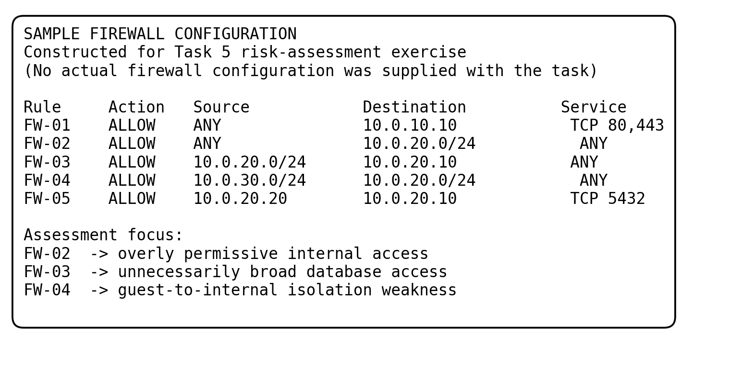
The firewall image above is a concrete sample configuration artifact created for this exercise. It is included so that each risk can be traced to a specific rule. It must not be interpreted as an exported configuration from a real firewall.

4. Risk Identification and Evaluation
ID | Risk | Specific Evidence | Likelihood | Impact | Risk Level
R-01 | Overly permissive firewall rule | FW-02: ANY → 10.0.20.0/24, ANY | High | High | High
R-02 | Guest-to-internal access | FW-04: guest → internal, ANY | Medium | High | High
R-03 | Broad database access | FW-03: employee subnet → DB, ANY | Medium | High | High
R-04 | Internet-facing web server | FW-01 exposes TCP 80/443 | Medium | High | High
R-05 | Insufficient centralized monitoring | No centralized security logging defined | Medium | Medium | Medium
R-06 | Single-layer dependence | Trust-zone separation relies heavily on edge firewall | Low | High | Medium

5. Detailed Findings
R-01 – Overly Permissive Firewall Rule
FW-02 allows any source to reach the entire internal subnet using any service. This is broader than necessary and does not follow least-privilege access. Likelihood is High because the rule is explicitly broad, while impact is High because the destination contains internal business systems.
Mitigation: remove the ANY-to-internal rule and replace it with specific source, destination, protocol, and port rules. Use default-deny for unnecessary traffic.
R-02 – Guest-to-Internal Network Access
FW-04 allows the guest Wi-Fi subnet to communicate with the internal network. Guest devices are less trusted than managed corporate devices, so a compromised guest device could potentially reach internal resources.
Mitigation: isolate guest Wi-Fi from internal networks and allow guests only the Internet services they require.
R-03 – Broad Employee-to-Database Access
FW-03 allows the entire employee subnet to reach the database on any service. A database normally requires only specific application and administrative connections.
Mitigation: restrict database access to approved application servers and administrators and allow only the required database port.
R-04 – Internet-Facing Web Server
FW-01 exposes the public web server on TCP 80 and 443. This is expected for a public website, but it creates an external attack surface and therefore requires secure configuration, patching and monitoring.
Mitigation: expose only required ports, maintain the server, use secure HTTPS configuration, monitor logs, and restrict DMZ-to-internal access.
R-05 – Insufficient Centralized Monitoring
No centralized collection and review of firewall, server, and authentication logs is defined in the sample environment. This can make detection and investigation of suspicious activity more difficult.
Mitigation: centralize relevant security logs, synchronize system time, and configure alerts for significant events.
R-06 – Single-Layer Dependence on the Firewall
The sample design relies heavily on the edge firewall to separate trust zones. A firewall configuration error could therefore affect several network segments.
Mitigation: add defense-in-depth controls such as host firewalls, endpoint protection, strong authentication, segmentation and monitoring.

6. Risk Prioritization
Priority | ID | Risk | Level | First Action
1 | R-01 | Overly permissive firewall rule | High | Correct firewall ACL
2 | R-02 | Guest-to-internal access | High | Isolate guest network
3 | R-03 | Broad database access | High | Restrict DB connectivity
4 | R-04 | Internet-facing web server | High | Harden and maintain DMZ server
5 | R-05 | Insufficient monitoring | Medium | Centralize logs and alerts
6 | R-06 | Single-layer firewall dependence | Medium | Add defense-in-depth controls

7. Recommended Security Controls
- Apply least-privilege firewall rules using specific source, destination, protocol and port combinations.
- Use a default-deny approach for unnecessary inbound traffic.
- Isolate guest Wi-Fi from corporate internal networks.
- Restrict database access to approved application and administration systems.
- Patch and securely configure the public-facing web server and monitor its logs.
- Centralize firewall, server and authentication logs and configure meaningful security alerts.
- Use defense-in-depth controls such as host firewalls, endpoint protection, strong authentication and segmentation.
- Review firewall and access-control rules regularly and remove obsolete rules.

8. Likelihood and Impact Method
Likelihood was rated Low, Medium or High according to how realistically a weakness could be abused in the sample environment. Impact considered possible effects on confidentiality, integrity, availability, and business operations. The final risk level is a qualitative combination of likelihood and impact rather than a quantitative financial calculation.

9. Evidence and Reproducibility
Concrete assessment evidence is provided through the sample network architecture and the sample firewall configuration artifact included in this report. These artifacts contain specific addresses, zones, rules, and services so that the reasoning behind each finding can be reviewed. Because no real configuration was supplied by the internship task, the artifacts are explicitly labeled as constructed assessment data.

10. Conclusion
The assessment demonstrates the complete risk-assessment process requested in Task 5: reviewing a sample network, identifying weaknesses, evaluating likelihood, assessing technical and business impact, assigning risk levels, prioritizing risks, and recommending mitigation. The highest-priority issues in the sample environment are the overly permissive internal firewall rule, guest-to-internal access, and broad employee access to the database. Least-privilege access, network segmentation, restricted database connectivity, secure web-server maintenance, and centralized monitoring would reduce the identified exposure.

