NETWORK SECURITY CAPSTONE PROJECT
FINAL REPORT
Hands-on baseline assessment and packet analysis
Assessment date: 26 October 2026
Environment: User-operated Kali Linux desktop / virtualized NAT-style network
Scope: Local system configuration and short packet capture on eth0

1. Executive Summary
This capstone combines network-security best-practice guidance with a controlled hands-on review of the user's own Kali Linux environment. The work covered interfaces and routes, listening sockets, system logs, firewall rules, DNS resolution, resource baseline, a short tcpdump capture, and offline TShark analysis. Fourteen screenshots document the observed commands and results.
The interface eth0 used IPv4 10.0.2.15/24 with a default route via 10.0.2.2. This is consistent with a virtualized NAT-style network. Docker-related bridge and firewall rules were present. The short capture contained TCP/TLS traffic involving port 443 and DNS/UDP traffic. The sample does not establish malicious activity. Repeated GNOME Shell VPN IP parsing warnings were observed; these are not evidence of intrusion by themselves.
Scope boundary: this report describes only the local lab environment. No BSP internal network, production host, or third-party system was scanned or assessed. The raw PCAP remains on the user's system; this report has screenshots of its creation and analysis, not the capture bytes.

2. Objectives
- Baseline local interfaces, routes, sockets, DNS, logs, and system resources.
- Inspect existing firewall rules without modifying them.
- Capture a small traffic sample on the user's own interface and analyze it offline.
- Translate verified observations into practical recommendations for access control, segmentation, monitoring, and secure configuration.

3. Scope, Method, and Limitations
Read-only inspection commands were used for interfaces, routes, sockets, logs, firewall rules, resources, DNS, and tool availability. Packet capture was limited to eth0 and stopped at 50 packets. The saved file was reviewed with TShark. No firewall rules were changed and no scan of BSP or another third-party network was performed.
This is a small, time-bounded baseline, not a penetration test or compliance audit. It does not establish organizational topology, asset inventory, endpoint patch status, authentication quality, or the security of remote services. A 50-packet sample is too small for a reliable threat verdict. The raw PCAP was not supplied for independent inspection.

4. Observed Environment Baseline
Area | Observed result | Interpretation / caveat
Interface | eth0 UP; 10.0.2.15/24; IPv6 addresses | Local lab interface; likely virtualized/NAT-style.
Default route | via 10.0.2.2 on eth0 | Observed at test time.
Docker bridge | docker0 DOWN; 172.17.0.1/16; route linkdown | Docker bridge not active in route snapshot.
Sockets | UDP sockets and TCP listeners, including 127.0.0.1:40989 and *:1716 | Inventory only; verify purpose of listeners locally.
Counters | RX 24 packets/5,736 bytes; TX 51/8,608 bytes; displayed errors/drops zero | Snapshot, not a long-term performance measure.
Resources | 4.8 GiB RAM; 2.4 GiB available; swap 0/3.1 GiB | Resource snapshot.
DNS | Resolvers 10.0.2.3 and fd17:625c:f037:2::3; google.com resolved | Successful lookup at test time; environment-specific.
Tools | nmap, wireshark, tshark, tcpdump found in /usr/bin | Availability verified; not all tools used for active testing.

5. Firewall and Container-Networking Review
UFW was not found. nft and iptables were available. The iptables view showed INPUT policy ACCEPT, OUTPUT ACCEPT, and FORWARD DROP, with Docker chains including DOCKER, DOCKER-USER, and isolation chains. The nftables output warned that tables were managed by iptables-nft and should not be modified directly. Docker NAT masquerading for 172.17.0.0/16 via docker0 was visible.
Default policies alone do not prove that the host is secure or insecure. Review listening services and determine whether inbound filtering matches the host's intended role. Manage Docker rules through supported tools and only with authorization. No rules were changed.

6. System Log Observation
The journal repeatedly showed a GNOME Shell message like `Error updating VPN IP: ipOutput.match(...) is null`. This suggests a desktop-shell parsing problem involving VPN IP information. The evidence does not prove that a VPN was compromised or that an intrusion occurred. If VPN use is expected, check its status and relevant NetworkManager logs; investigate or report the issue if it persists.

7. Packet Capture and Protocol Analysis
A live tcpdump sample displayed 20 packets on eth0; tcpdump reported 27 packets received by filter and zero dropped by kernel. Visible traffic included IPv4 TCP between 10.0.2.15 and remote addresses 104.18.39.21 and 104.18.32.47, using remote port 443.
A saved capture at `~/task6_capture.pcap` reported 50 packets captured, 70 received by filter, and zero dropped. TShark reported 50 Ethernet frames / 33,616 bytes; TCP 44 frames / 33,080 bytes; TLS 13 frames / 22,462 bytes; UDP 6 frames / 536 bytes; DNS 6 frames / 536 bytes. Protocol hierarchy counts overlap by layer and must not be summed as independent packet totals.
The output is consistent with TLS web traffic and DNS resolution. TLS application data is encrypted; the sample does not expose webpage contents or establish malicious activity.

8. PCAP Verification and Handling
The `file` command identified the capture as PCAP version 2.4, little-endian, Ethernet, microsecond timestamps, capture length 262144 bytes. `ls -l` showed a 34,440-byte file owned by tcpdump:tcpdump with permissions `-rw-r--r--`. The user's `chmod 600` attempt failed with `Operation not permitted`, consistent with the file not being owned by the user. The report does not claim permissions were tightened.
Keep the capture local and avoid publishing it until reviewing its connection metadata. If access restriction is required, use an authorized ownership/permissions workflow. The actual PCAP was not provided to the report author; analysis is based on screenshots.

9. Findings and Recommendations
F1 — Review host filtering (Medium priority)
Observation: INPUT and OUTPUT default policies were ACCEPT. This does not alone prove exposure, but services and intended trust boundaries should be reviewed.
Recommendation: Inventory listeners, disable unnecessary services, and implement least-privilege inbound rules appropriate to the host role.
F2 — Docker rules present (Medium priority)
Observation: Docker NAT/filter chains are present and managed by iptables-nft.
Recommendation: Review published container ports and isolation needs; manage rules through supported Docker/firewall mechanisms.
F3 — VPN-related desktop warning (Investigate)
Observation: Repeated GNOME Shell VPN IP parsing warning observed; no compromise established.
Recommendation: Check intended VPN state and NetworkManager logs; update or report a reproducible issue.
F4 — Capture access control (Medium priority)
Observation: PCAP owned by tcpdump and readable by group/others; chmod failed.
Recommendation: Avoid sharing; use authorized permission changes if needed; delete captures when no longer required.
F5 — Limited traffic sample (Informational)
Observation: 50 packets show TCP/TLS and DNS; no kernel drops reported; no threat conclusion possible.
Recommendation: Use an authorized capture window, baseline, filters, and repeatable analysis criteria for monitoring.
F6 — DNS resolution successful (Positive observation)
Observation: google.com resolved to IPv6 addresses during the test.
Recommendation: Use approved DNS services and monitor availability; one lookup does not establish DNS security.

10. Network Security Best-Practices Checklist
☐ Maintain an inventory of hosts, services, interfaces, and approved network paths.
☐ Apply least-privilege firewall rules; review host and container networking separately.
☐ Segment user devices, servers, management interfaces, and container workloads where appropriate.
☐ Use strong authentication and MFA for administrative access; remove unused accounts and keys.
☐ Patch operating systems, applications, container images, and network appliances on a defined schedule.
☐ Centralize security logs and alert on meaningful authentication, firewall, DNS, and endpoint events.
☐ Monitor traffic against a baseline and corroborate alerts before declaring an incident.
☐ Restrict access to PCAPs and redact internal identifiers before external sharing.
☐ Obtain approval before scanning or capturing traffic on shared networks.
☐ Test backups and document incident-response and recovery procedures.

11. Suggested Implementation Roadmap
- Immediate: document the host's intended role and review listening services against the permissive INPUT policy.
- Short term: review Docker-published ports and isolation requirements; use supported rule-management tools.
- Short term: investigate GNOME Shell VPN warnings if VPN functionality is expected.
- Ongoing: periodically review logs, firewall changes, DNS behavior, and system/network baselines.
- Ongoing: define approved retention and access controls for packet captures.

12. Conclusion
The exercise established a local network baseline, inspected firewall and Docker rules, confirmed DNS resolution, reviewed a repeated desktop warning, and captured/analyzed a small PCAP. It demonstrates practical use of Linux network-security tools and evidence-based reporting. The key follow-ups are to review host services and filtering, preserve safe Docker rule management, investigate the VPN-related warning if relevant, and protect capture artifacts. No claim about BSP's production network or a confirmed security incident is supported.

Appendix A — Evidence Register and Screenshots
1 — Listening sockets and routes
`ss -tulpen` and `ip route`: default route via 10.0.2.2 on eth0; eth0 address 10.0.2.15; Docker route 172.17.0.0/16 marked linkdown.
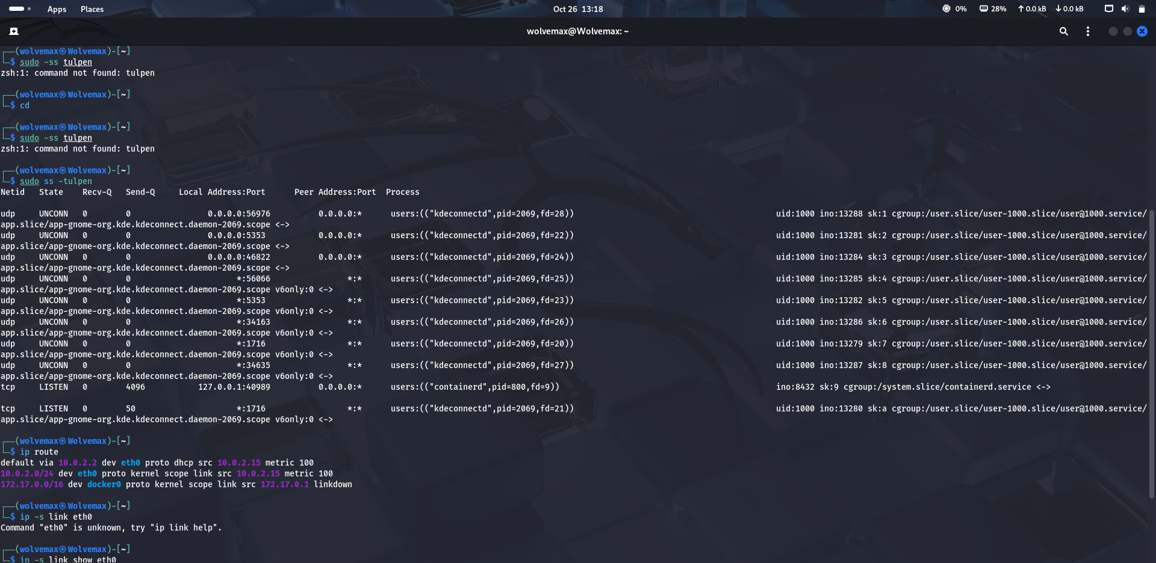
Screenshot file: Screenshot From 2026-10-26 13-18-32.png

2 — Interface counters
eth0 UP; RX 24 packets / 5,736 bytes; TX 51 packets / 8,608 bytes; displayed errors and drops zero.
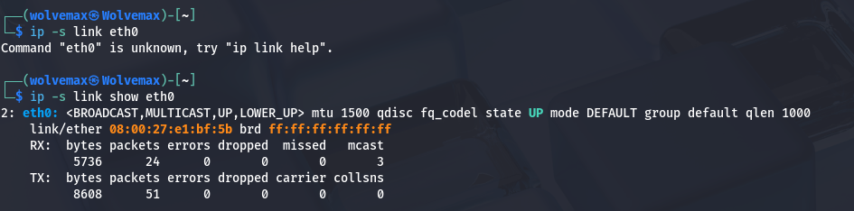
Screenshot file: Screenshot From 2026-10-26 13-19-19.png

3 — System logs
Repeated GNOME Shell warning: VPN IP update parsing failed (`ipOutput.match(...) is null`). This is not, by itself, evidence of compromise.
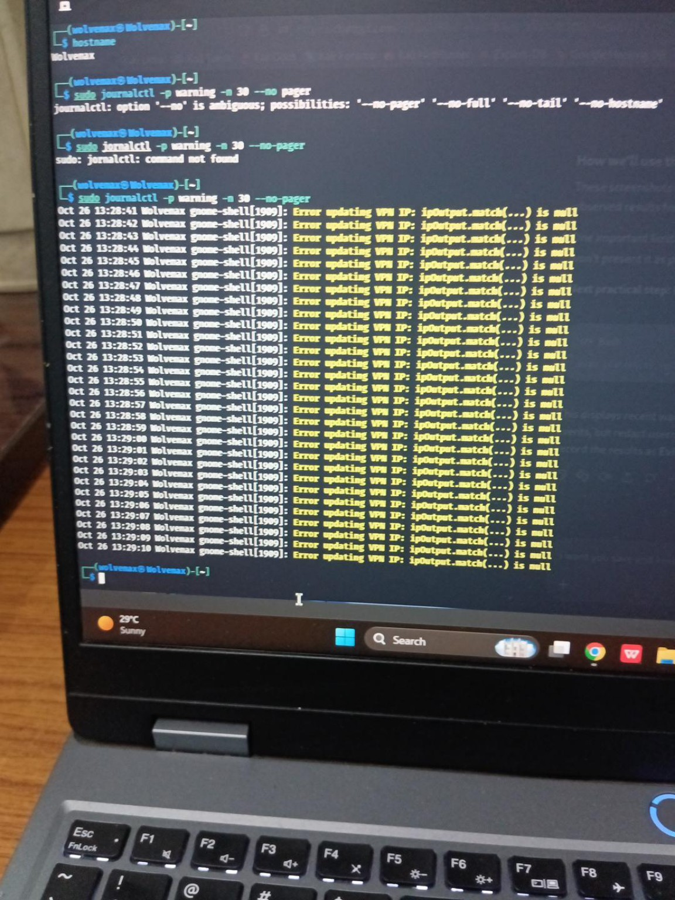
Screenshot file: image-1793001574723.jpg

4 — iptables inspection
UFW not found; nft and iptables available. INPUT ACCEPT, OUTPUT ACCEPT, FORWARD DROP; Docker chains present.
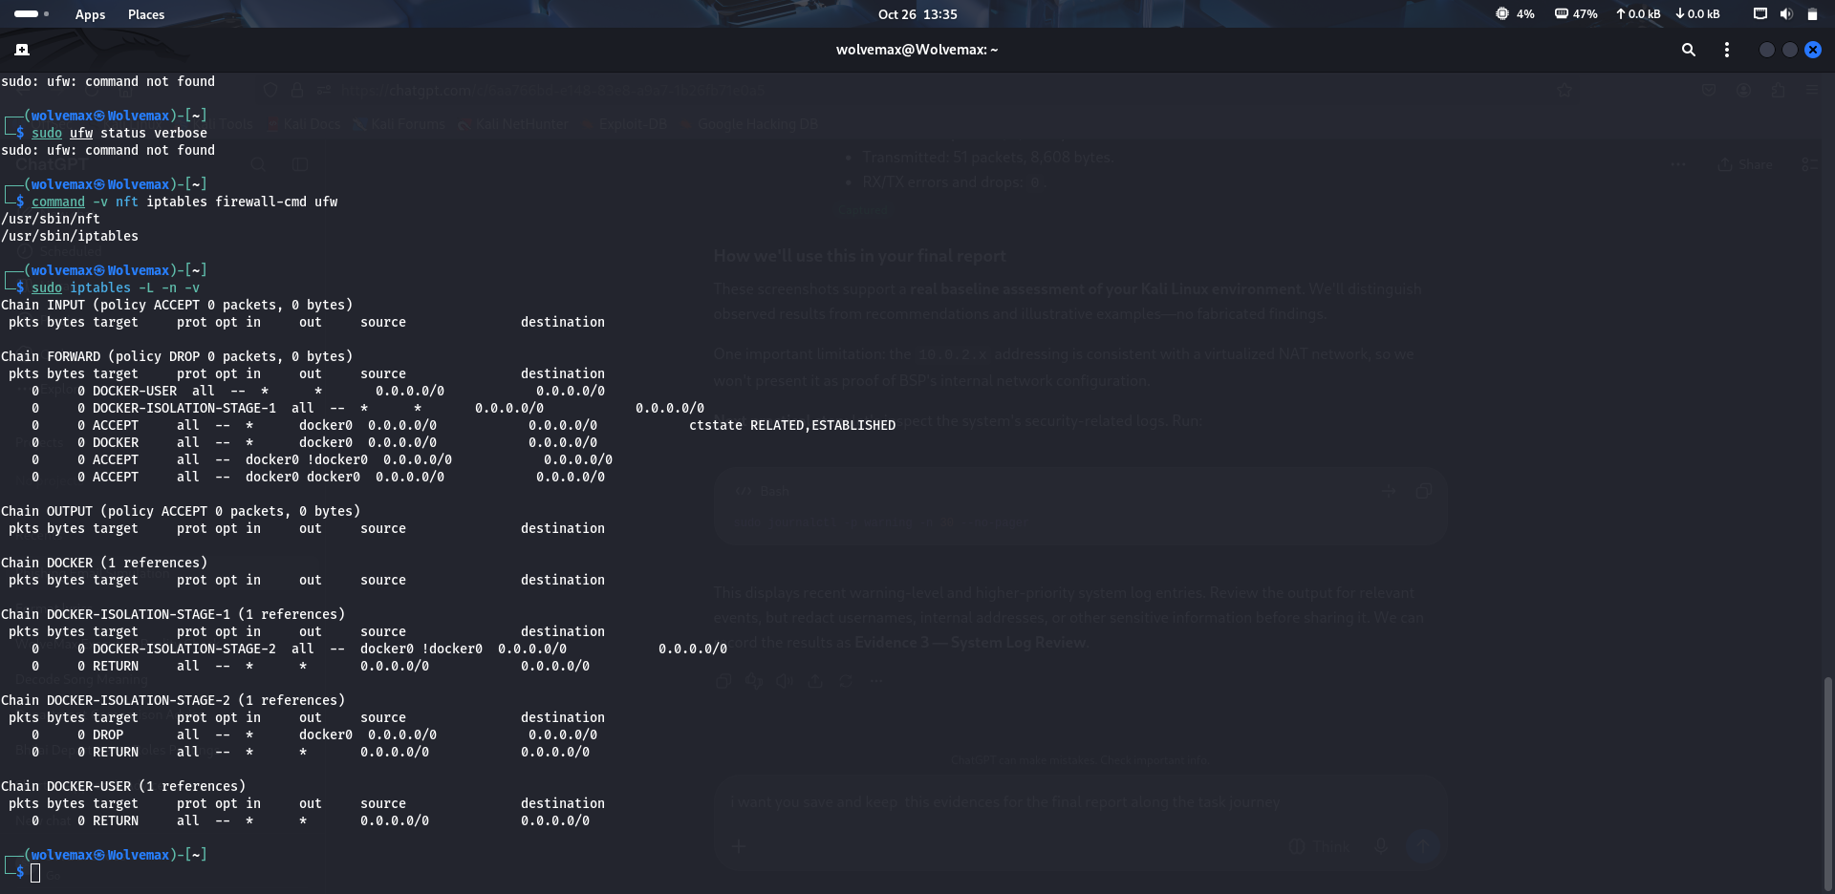
Screenshot file: Screenshot From 2026-10-26 13-36-00.png

5 — nftables rules
Rules are managed by iptables-nft; warning says not to touch directly. Docker NAT masquerading for 172.17.0.0/16 via docker0.
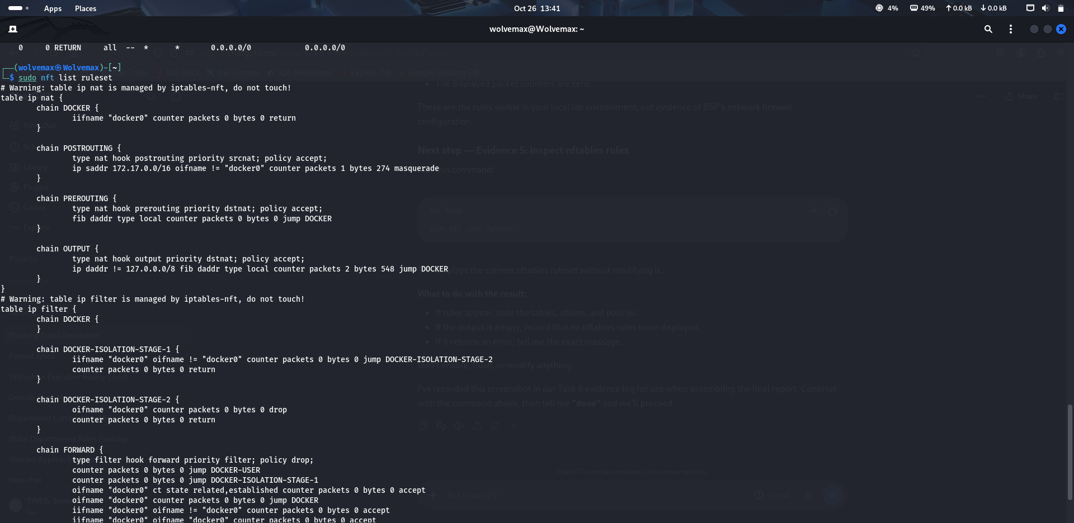
Screenshot file: Screenshot From 2026-10-26 13-41-44.png

6 — Uptime and memory
Uptime 40 minutes; load averages 1.25, 0.64, 0.54. RAM 4.8 GiB total, 2.4 GiB used, 975 MiB free, 2.4 GiB available; swap 3.1 GiB, 0 used.
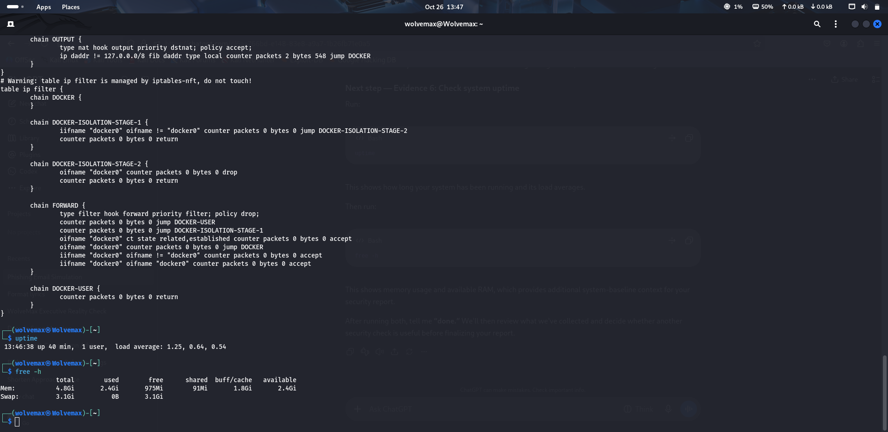
Screenshot file: Screenshot From 2026-10-26 13-47-08.png

7 — DNS
NetworkManager resolver file lists 10.0.2.3 and fd17:625c:f037:2::3. `getent hosts google.com` returned IPv6 addresses.
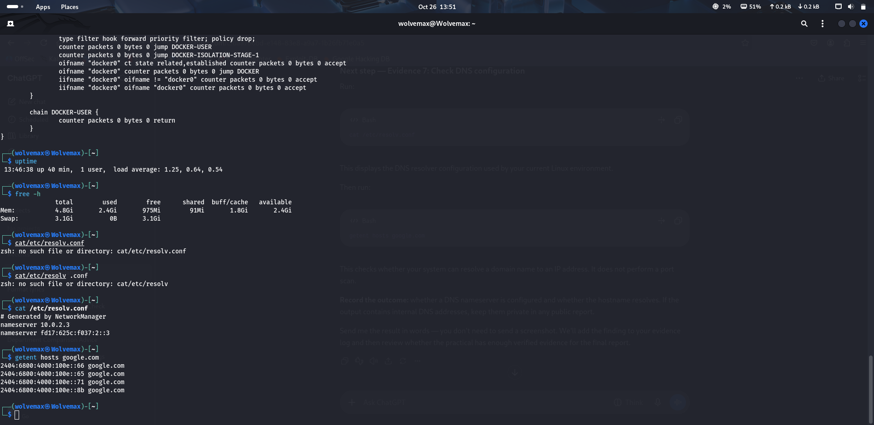
Screenshot file: Screenshot From 2026-10-26 13-51-06.png

8 — Interface inventory
lo 127.0.0.1/8 and ::1/128; eth0 UP, 10.0.2.15/24 plus IPv6; docker0 DOWN, 172.17.0.1/16.
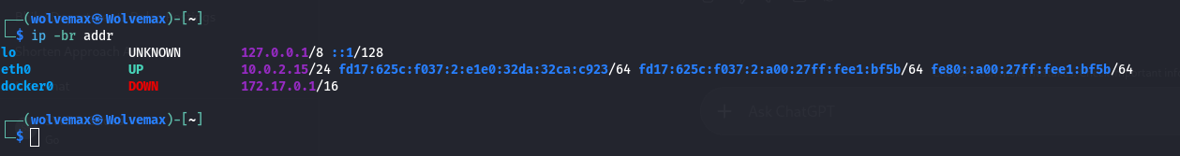
Screenshot file: Screenshot From 2026-10-26 13-54-07.png

9 — Tools available
nmap, wireshark, tshark, tcpdump available at /usr/bin paths.
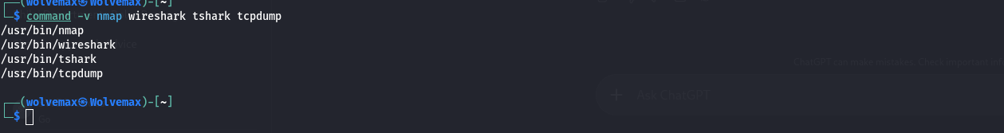
Screenshot file: Screenshot From 2026-10-26 13-57-24.png

10 — Live packet sample
20 packets displayed; 27 received by filter, 0 dropped by kernel. Visible IPv4 TCP traffic involving local 10.0.2.15 and remote port 443.
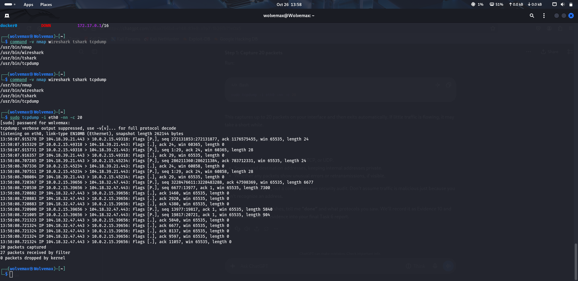
Screenshot file: Screenshot From 2026-10-26 13-58-18.png

11 — PCAP created
50 packets captured to ~/task6_capture.pcap; 70 received by filter; 0 dropped. File shown as about 34K.
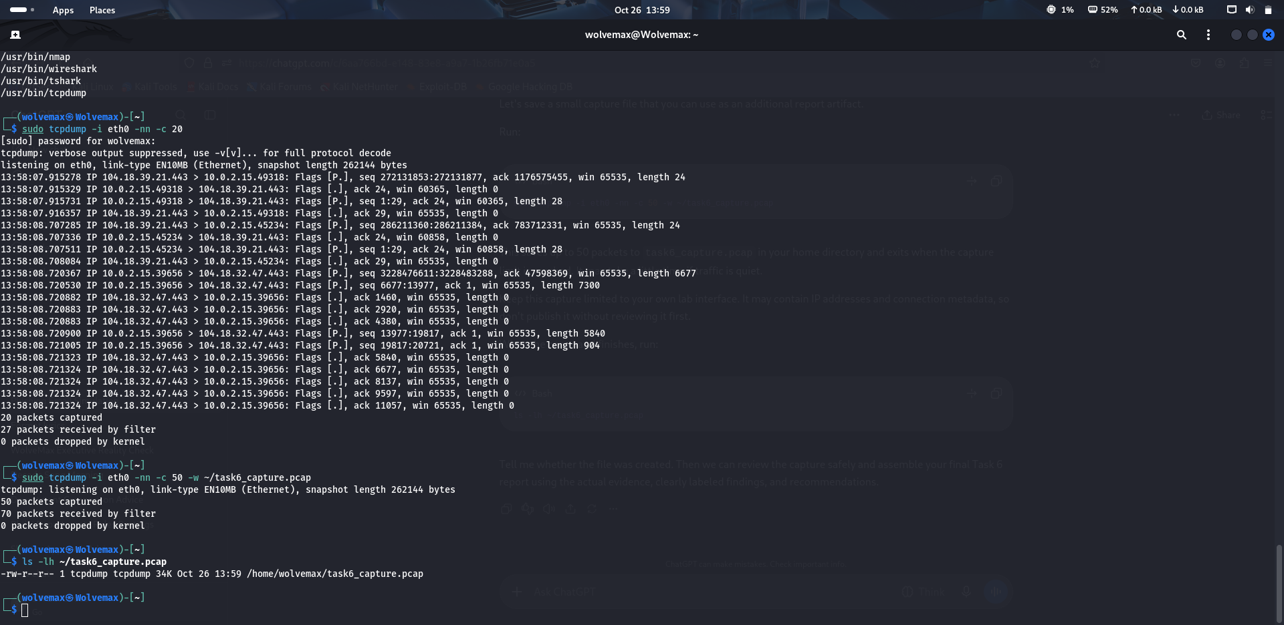
Screenshot file: Screenshot From 2026-10-26 13-59-59.png

12 — TShark analysis
50 Ethernet frames / 33,616 bytes; TCP 44 / 33,080 bytes; TLS 13 / 22,462 bytes; UDP 6 / 536 bytes; DNS 6 / 536 bytes. Counts overlap by protocol layer.
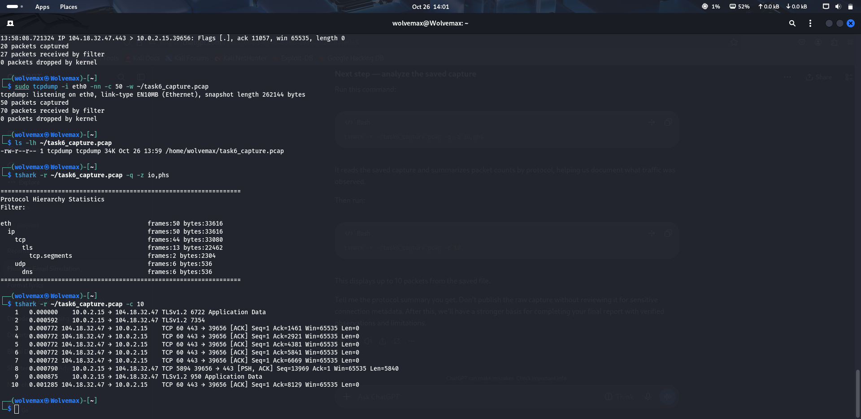
Screenshot file: Screenshot From 2026-10-26 14-01-06.png

13 — PCAP format
`file` identified PCAP version 2.4, little-endian, Ethernet, microsecond timestamps, capture length 262144. chmod failed: Operation not permitted.
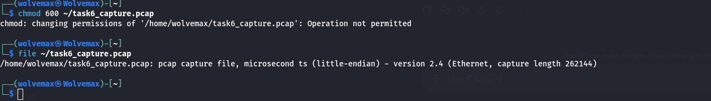
Screenshot file: Screenshot From 2026-10-26 14-02-28.png

14 — PCAP ownership
File size 34,440 bytes, owner/group tcpdump:tcpdump, permissions -rw-r--r--. Permissions were not changed.
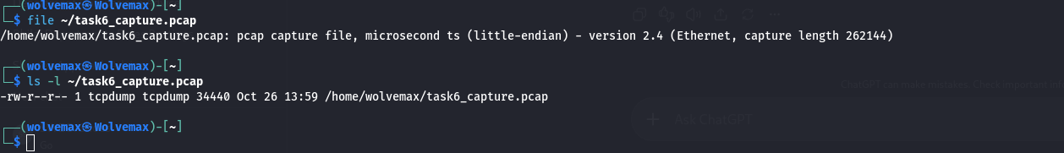
Screenshot file: Screenshot From 2026-10-26 14-03-21.png

Appendix B — Commands Used
- sudo ss -tulpen
- ip route
- ip -s link show eth0
- hostname
- sudo journalctl -p warning -n 30 --no-pager
- command -v nft iptables firewall-cmd ufw
- sudo iptables -L -n -v
- sudo nft list ruleset
- uptime
- free -h
- cat /etc/resolv.conf
- getent hosts google.com
- ip -br addr
- command -v nmap wireshark tshark tcpdump
- sudo tcpdump -i eth0 -nn -c 20
- sudo tcpdump -i eth0 -nn -c 50 -w ~/task6_capture.pcap
- ls -lh ~/task6_capture.pcap
- tshark -r ~/task6_capture.pcap -q -z io,phs
- tshark -r ~/task6_capture.pcap -c 10
- file ~/task6_capture.pcap
- ls -l ~/task6_capture.pcap

References
NIST SP 800-41 Rev. 1, Guidelines on Firewalls and Firewall Policy.
NIST SP 800-92, Guide to Computer Security Log Management.
NIST SP 800-207, Zero Trust Architecture.
CISA cybersecurity best practices and network segmentation guidance.
These references inform the general recommendations. Empirical observations come from the user's local-lab screenshots; no external network assessment was conducted.

