What Drives Bike-Share Demand?
Required Capstone Assignment 20.1: Initial Report and Exploratory Data Analysis (EDA)
Author: Amit Kumar Ray
Data: UCI Bike Sharing Dataset (Capital Bikeshare, Washington D.C., 2011-2012)
Jupyter notebook: https://github.com/YOUR-USERNAME/bike-sharing-capstone/blob/main/bike_sharing_demand_eda.ipynb
GitHub repository: https://github.com/YOUR-USERNAME/bike-sharing-capstone

Research question
How much of the hourly demand for shared bikes can be explained and predicted from the time of day, the calendar and the weather, and which of those factors matter most?
Why it matters: an operator has to put the right number of bikes in the right place at the right time. Too few bikes means lost rentals; too many means idle bikes and wasted rebalancing trips. A demand forecast can drive rebalancing, staffing and maintenance schedules.

Data
17,379 hourly records (731 days) of total rentals, with the hour, month, season, year, weekday, working-day and holiday flags, weather type, temperature, humidity and wind speed. The target is the number of rentals in the hour. The two types of rider counts (casual and registered) add up to the target, so they were excluded as features.

Summary of findings
Headline result. A gradient-boosting model, tested on three months of data it never saw (October-December 2012), predicts hourly demand with a typical error of 39 bikes per hour (18% of average demand; RMSE 64) and explains 90% of the variation in demand (R² = 0.90). That is about 45% less average error than a simple "typical day" lookup table.
- Time of day matters most. Working days have two commuter peaks (about 480 rentals per hour at 08:00 and 525 at 17:00); weekends and holidays have a single afternoon hump (about 370 at 13:00). Removing hour of day from the model cuts R² from 0.90 to 0.19.
- Weather is second. Rain or snow cuts demand by almost half (112 vs 205 rentals per hour in clear weather). Demand rises steadily with temperature (about 50 per hour below 5 °C, over 300 above 30 °C) and falls when humidity is above 40%.
- Fast growth and strong seasonality. Average hourly demand was 63% higher in 2012 than in 2011, and winter demand is about half of summer demand.
- The biggest errors are holidays, not hurricanes. The model handled Hurricane Sandy well (15 predicted vs 22 actual rentals on 29 October), but badly over-predicted Thanksgiving weekend and Christmas week, because the data only flags the official holiday and treats the quiet days around it as normal days.
- Feature engineering helped. A cyclical hour, a weekend flag and a commute-hour flag cut the linear model's RMSE from 122 to 108 and the boosting model's from 66 to 64.

Results
Model | RMSE | MAE | R²
Overall mean | 204 | 157 | -0.03
Typical-day lookup (hour × day type × year) | 114 | 72 | 0.68
Linear regression | 108 | 79 | 0.71
Random forest | 68 | 43 | 0.89
Gradient boosting (baseline carried forward) | 64 | 39 | 0.90
Test period October-December 2012. RMSE and MAE are in bikes per hour (average demand in the test period: 219).
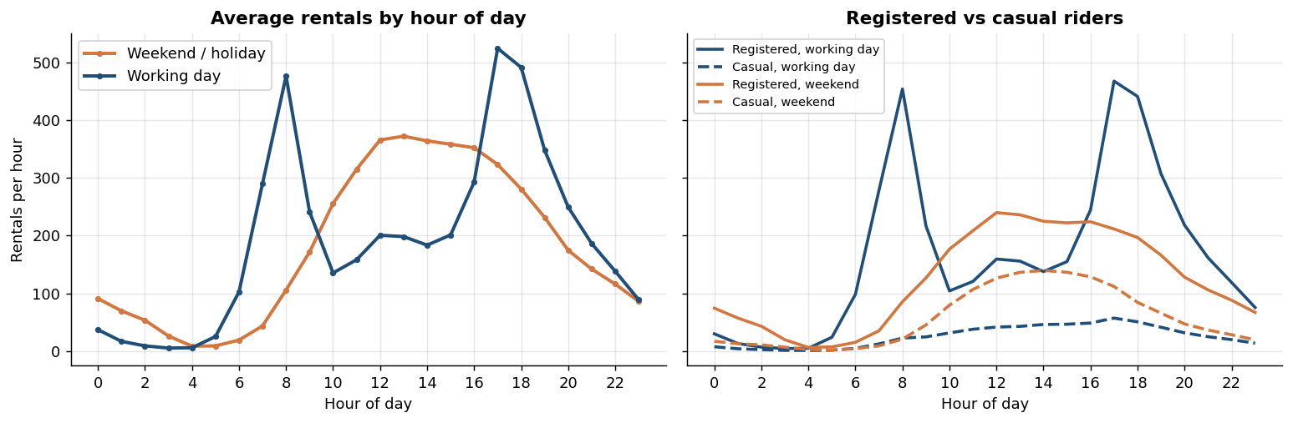
Figure 1. Demand follows different daily rhythms on working days and weekends.
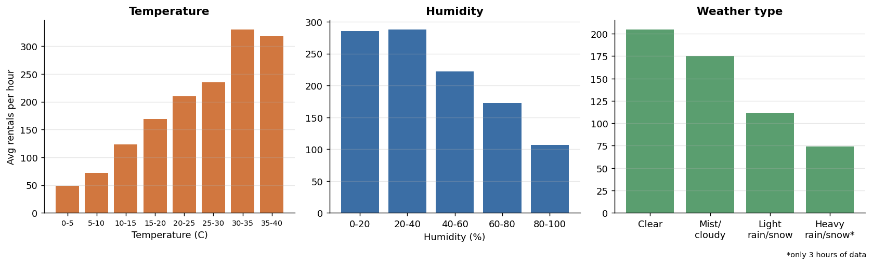
Figure 2. Demand by temperature, humidity and weather type.
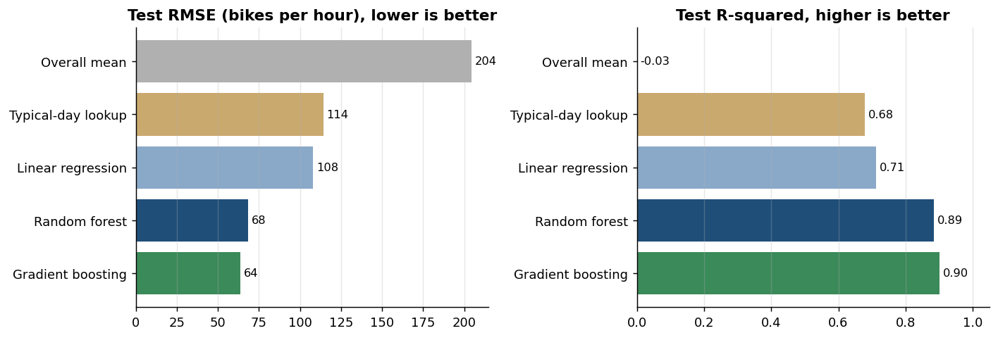
Figure 3. Test-set RMSE and R² of the models.
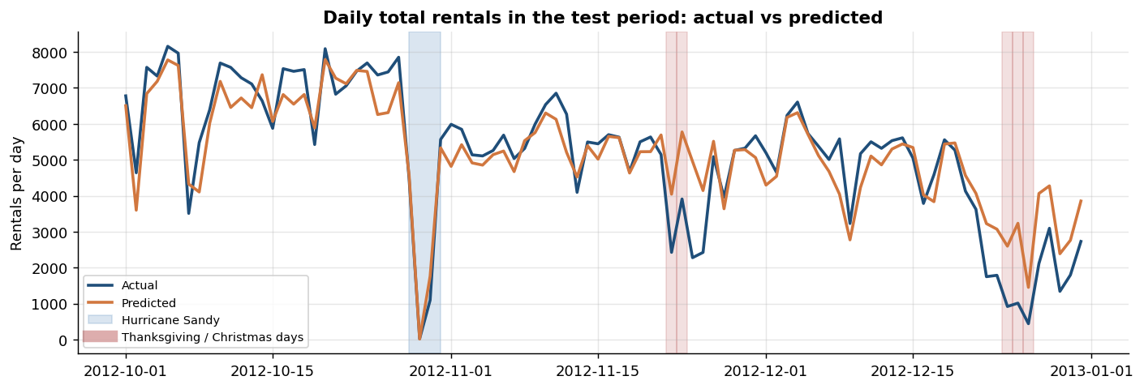
Figure 4. Daily totals in the test period: the model misses the Thanksgiving and Christmas days.

Approach
- Cleaning. Checked for missing values and duplicates (none). Found and fixed 22 hours of impossible 0% humidity (one sensor day) by interpolation, kept 165 absent mostly-overnight hours (genuine zero-rental hours) and relabelled the dataset's wrong season codes.
- Outliers. Box plots and a robust daily anomaly check found 13 abnormally quiet days (Hurricane Sandy, Thanksgiving and Christmas periods, storm days). They are real events, so they were kept.
- EDA and feature engineering. Demand by month, hour, day type and weather; correlations; holidays. Created `hr_sin`, `hr_cos`, `is_weekend` and `commute_hour` from the raw columns.
- Modelling. Trained on everything before 1 October 2012 and tested on October-December 2012 (a random split would leak information between neighbouring hours). Compared an overall mean, a typical-day lookup, linear regression, a random forest and gradient boosting, tuned with time-series cross-validation.

Evaluation metric
RMSE (root mean squared error, in bikes per hour) is the primary metric. It is in the same unit as the target, so it reads as the typical size of a miss, and because it squares errors it punishes large misses, which are the costly ones for an operator (being hundreds of bikes short at a rush hour). MAE shows the typical miss without the pull of a few extreme days, R² shows the share of the variation explained compared with simply predicting the average, and RMSLE checks relative error in quiet hours. The best model's RMSE of 64 is 44% below the lookup table (114) and about 29% of average demand; its MAE of 39 means a typical forecast is off by about 39 bikes in an hour.

Recommendations for the operator
- Schedule rebalancing before the commute peaks (before 08:00 and 17:00 on working days) and before the midday window at weekends; do maintenance on working-day nights (about 01:00-05:00).
- Link the forecast to the weather forecast: rain and cold are the main reasons for demand falling short of a normal day.
- Treat holiday periods manually for now, and re-train regularly because the system is growing fast.

Limitations
- Two years from one city and a single three-month test window; summer was not tested.
- The model uses observed weather; real use would rely on forecasts, so accuracy would be somewhat lower.
- System-wide totals cannot say where bikes should go, and the findings show association, not cause.

Next steps
- Add a holiday-period feature (days around Thanksgiving, Christmas etc.) and test whether it fixes the largest errors.
- Add recent-demand features (same hour yesterday or last week) and an explicit trend to deal with growth.
- Model casual and registered riders separately, validate across several time windows and add prediction intervals.

