Value Stream Mapping – Evening Routine Optimization
This Value Stream Map (VSM) focuses on my evening routine after work. The process begins at 5:00 PM when I finish work and ends at 9:30 PM after my reading session. This routine occurs on weekdays and reflects my typical activities during that time.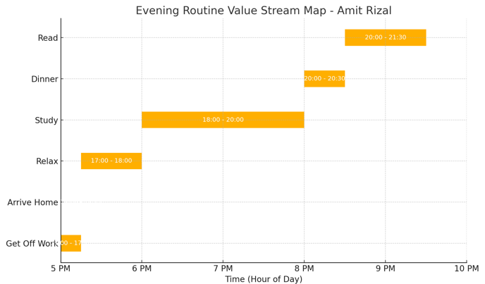 Lean Metrics Analysis
Estimated Cycle Time: 4.5 hours
Average Flow Time per Stage: Approximately 45 minutes
Wastes Identified:
- Relaxation period sometimes exceeds 6:00 PM, affecting study time
- Study time is occasionally disrupted by phone or noise
- Dinner preparation may cut into reading time
- Reading while tired reduces retention and satisfaction
Optimization Suggestions
Eliminate Waste:
- Use alarms or reminders to limit relaxation to 6:00 PM sharp
- Prepare dinner earlier or batch cook to save time
- Turn off notifications during study and reading
Workflow Orchestration:
- Consider switching reading to before dinner for better focus
- Combine light dinner and reading time if schedule gets tight
Governance Controls:
- Set evening routine alarms
- Track productivity with a checklist or habit tracker app
This exercise helped identify key inefficiencies in my evening routine. By visualizing my activities and analyzing their time frames, I was able to suggest ways to optimize time use and minimize disruptions. Applying VSM in personal routines is a powerful way to gain better work-life balance.

