Amit Rizal   
CSD-325  
Assignment 8.2

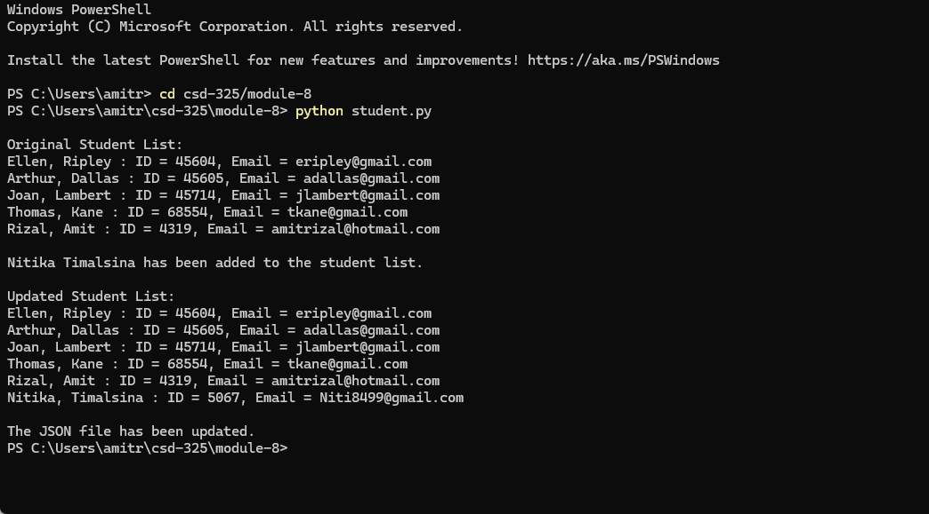

JSON file.

[

{

"F_Name": "Ellen",

"L_Name": "Ripley",

"Student_ID": 45604,

"Email": "eripley@gmail.com"

},

{

"F_Name": "Arthur",

"L_Name": "Dallas",

"Student_ID": 45605,

"Email": "adallas@gmail.com"

},

{

"F_Name": "Joan",

"L_Name": "Lambert",

"Student_ID": 45714,

"Email": "jlambert@gmail.com"

},

{

"F_Name": "Thomas",

"L_Name": "Kane",

"Student_ID": 68554,

"Email": "tkane@gmail.com"

},

{

"F_Name": "Rizal",

"L_Name": "Amit",

"Student_ID": 4319,

"Email": "amitrizal@hotmail.com"

},

{

"F_Name": "Nitika",

"L_Name": "Timalsina",

"Student_ID": 5067,

"Email": "Niti8499@gmail.com"

}

]

