**Homework 2**

**CMSC 498F/828K due 3/9/2016**

**1.)** Consider a differential drive robot with distance d = 20cm between the wheels. The wheels are of radius r = 10 cm. The robot is at (x,y, θ) = (0,0,0). It then moves for 3 seconds with wheel angular velocities $\dot{Φ_{L }}$ = 0.1 rad/sec and $\dot{Φ_{R }}$ = 0.15 rad/sec. What is the pose (x’,y’, θ’) of the robot after the motion?

**2.)** Let there be three coordinate frames : frame A with axes (Xa, Ya, Za) at center 0a, frame B with axes (Xb, Yb, Zb) at 0b, and frame C with axes (Xc, Yc, Zc) at 0c, as shown in the figure. You will compute the values of the transformation ${}_{C}^{A}T$ which will transform the coordinates from frame C to frame A. Carry out the computations in steps, as explained in a.) to c.)

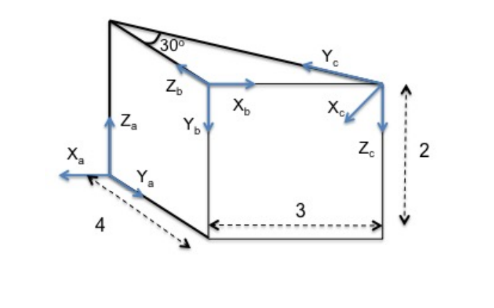

0a

0c

0b

1. Let the vectors Xa, Ya, Za, Xb, Yb, Zb be of unit length, then the rotation matrix taking coordinates from frame B to frame A is computed from the scalar product of these vectors as:

$${}_{B}^{A}R=\left[\begin{matrix}Xb ∙Xa & Yb ∙Xa & Zb ∙Xa \\ Xb ∙Ya & Yb ∙Ya & Zb ∙Ya \\ Xb ∙Za & Yb ∙Za & Zb ∙Za\end{matrix}\right]$$

Derive ${}_{B}^{A}R$ and ${}_{C}^{B}R$.

1. Derive AOb and BOc
2. Derive the complete transformation ${}_{C}^{A}T$

**3.)**

a.) What is meant by *static stability* and what by *dynamic stability*? Given an example of a dynamically stable, but statically unstable vehicle.

b.)What is a castor wheel? What are the degrees of freedom of an office chair with all castor wheels?

c.) What is a Swedish wheel?

d.) What is a spherical wheel? Why are spherical wheels not used very much in Robotics?

**4.)** a.) For the graph shown below, show step by step, how Dijkstra’s algorithm computes the shortest path from A to G.

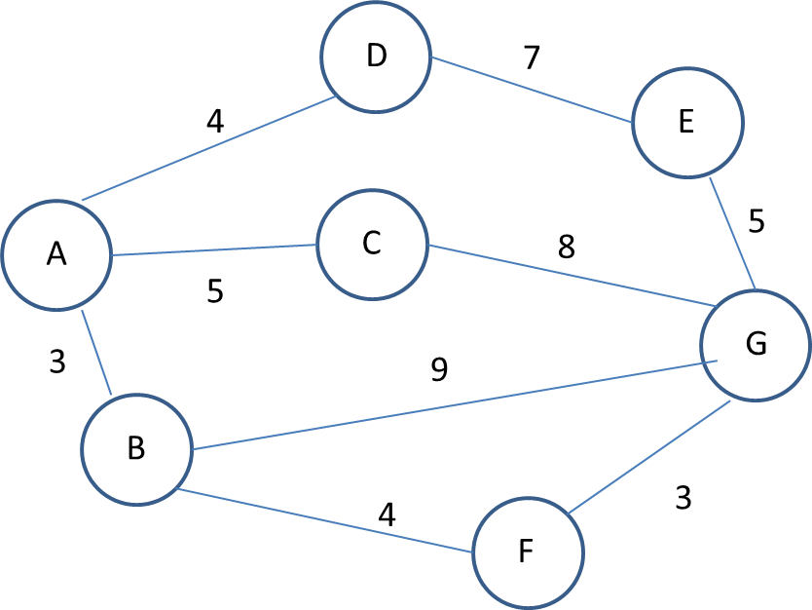

b.) Suggest a useful heuristic for solving this graph problem with the A* algorithm.

1. What is the complexity of Dijkstra’s algorithm? How will it change when moving from a 2D to a 3D search space?