Twitter Integration Module

|  |  |
| --- | --- |
| **Canada Office** | **Global Development Centre** |
| 120 -  1412 7th Ave W   Vancouver,  BC, V6H1C1, Canada.  🕾:+1.604.601.2185 | H 110, Sector 63,  NOIDA, U.P. 201 301 India  🕾 +91-9810286872 |

**Manual**

1. To use this application, make sure that you have a twitter account. If not then create a twitter account.

Next you have to define your application and register it.

2. Go to the following URL and sign into your twitter account

https://dev.twitter.com

3. You will see a page similar to the following :

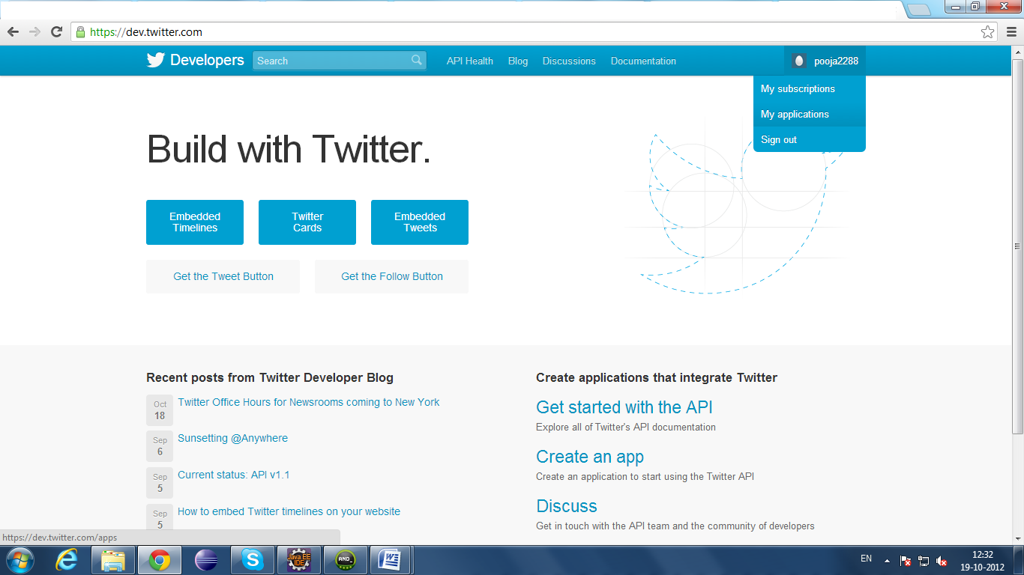

4. Move the cursor on your username on the top right corner and you will see a dropdown menu with "My Application" as one of the option

5. Click on the My Application option

6. Then click on "create new application" button

7.You will get a screen similar to the following :

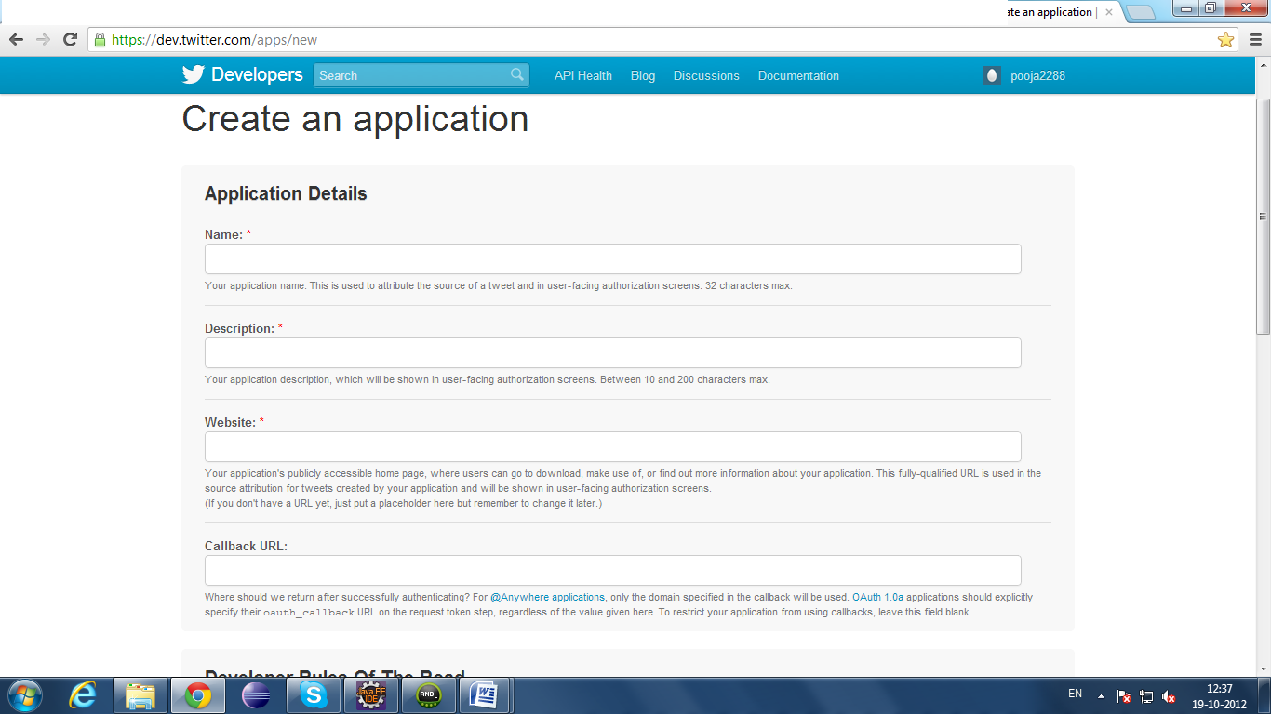

8. Enter the details required.

**Note :** **The callback URL specified here is just a required field that we need to fill in, but is not used in our application. Instead, we define our own callback URL that we’ll pass on when authenticating the user.**

9.Once the application is registered, you will get the following information associated with your application:

**Consumer key**  
************************

**Consumer secret**  
************************

**Request token URL**  
https://api.twitter.com/oauth/request_token

**Access token URL**  
https://api.twitter.com/oauth/access_token

**Authorize URL**  
https://api.twitter.com/oauth/authorize

**Registered OAuth Callback URL**  
http://someurl.com

10. Now import this application in your eclipse workspace

11. Change the Constants.java class under the src folder

12. Put your consumer key and secret values that you have got for your registered application

13. Also change the values of following constants :

REQUEST_URL, ACCESS_URL, AUTHORISE_URL to the values you have received.

13. Now you can Run this application

14. This application supports following functions :

* Login
* Logout
* Tweet
* Show Tweet