Artificial Intelligence in Health Care – Lecture 2
Sydney University Health Executive Education – 29 June 2026


Amit Saha
amit@commonloopworks.com

AI Case Study – Computer Vision
Today:
- How is computer vision used in healthcare?
- Barriers and enablers for adoption of Computer Vision in clinical workflows

About me
- Ph.D. researcher, School of public health, University of Sydney
- Research focus – Fairness in ML driven Clinical Decision Support Systems
- Software engineering background – 15+ years
I bring a measured approach to my belief in getting AI to do ALL THE THINGS – so, you might find me leaning towards that in the rest of my lecture.
Example of how I see the world:
What are some no fluff use cases for AI/ML powered computer vision in surgery?

What is computer vision?

How does a computer “see”?

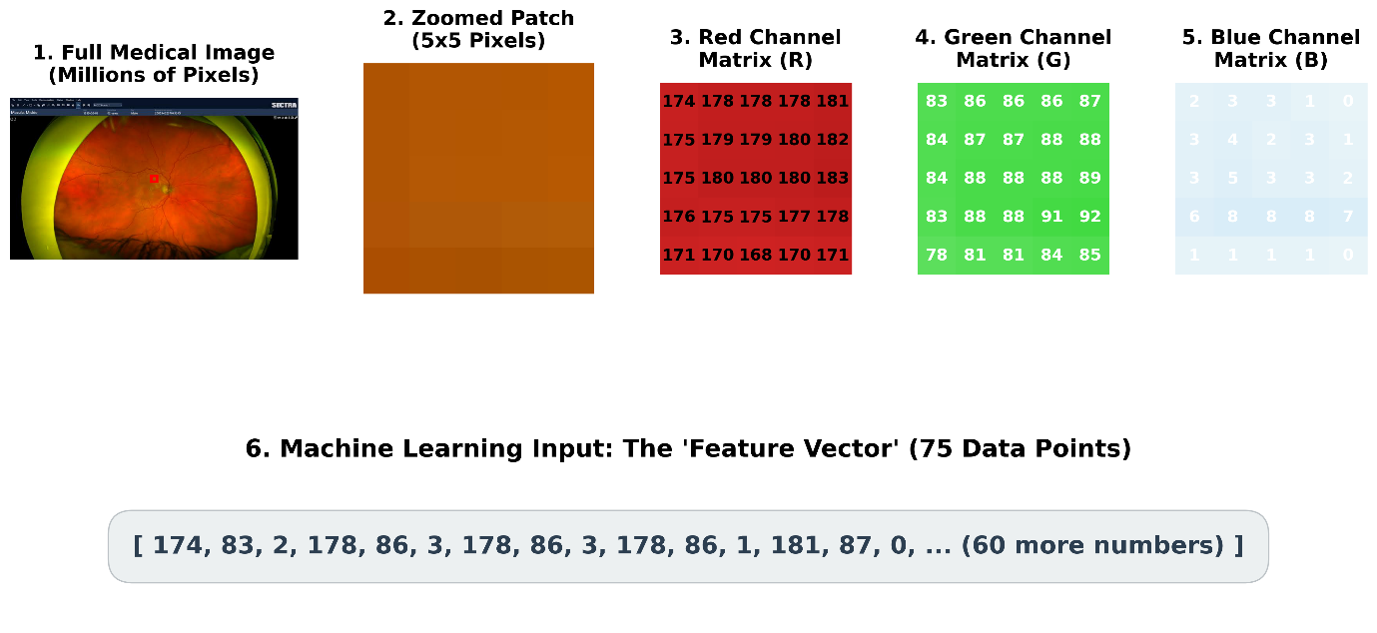

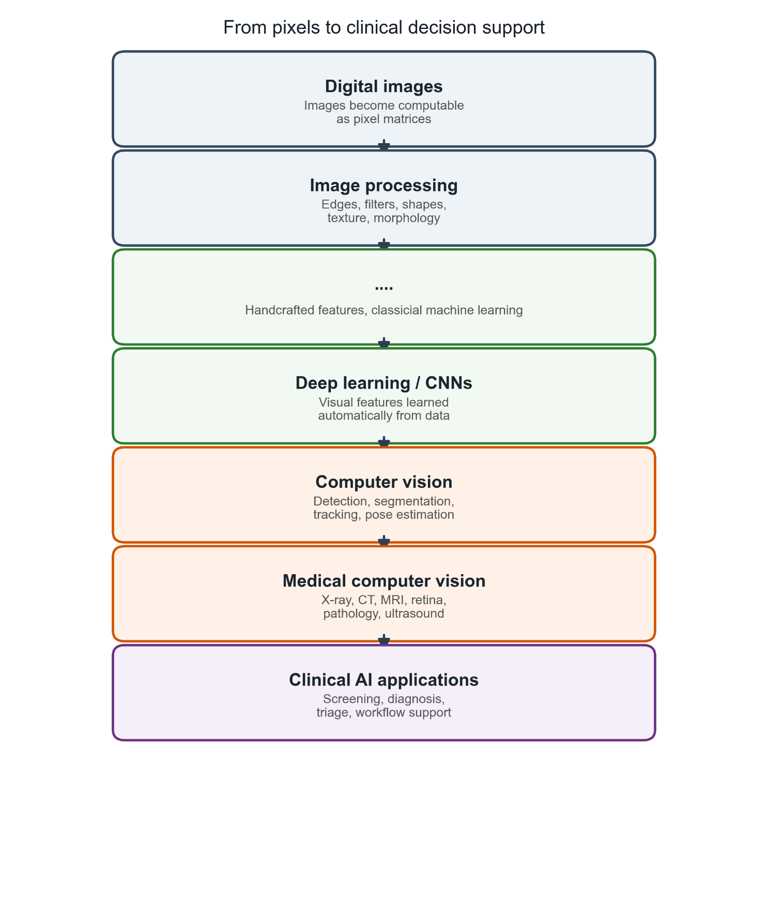

Computer vision in healthcare

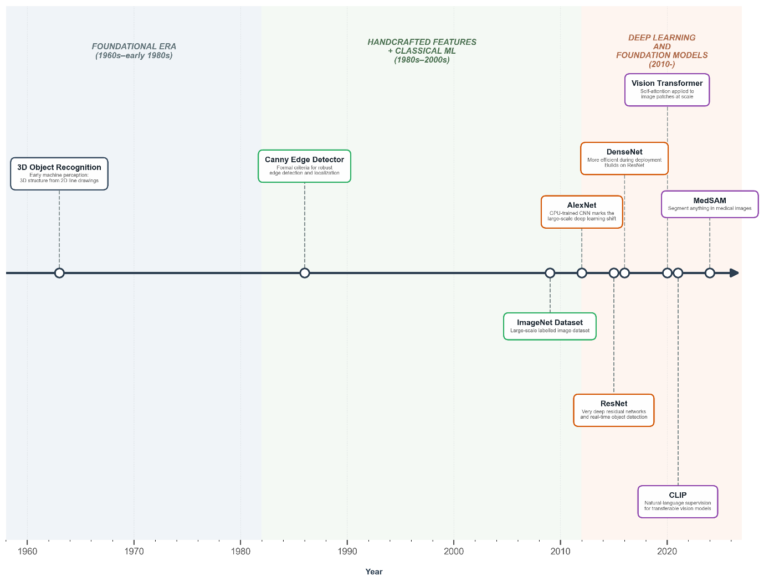
“Automated grading of diabetic retinopathy has potential benefits such as increasing efficiency, reproducibility, and coverage of screening programs; reducing barriers to access; and improving patient outcomes by providing early detection and treatment” – Development and Validation of a Deep Learning Algorithm for Detection of Diabetic Retinopathy in Retinal Fundus Photographs, 2016

Technical milestones in computer vision and what they enabled in healthcare:
- Edge detection → organ boundaries
- Tomographic reconstruction → CT/MRI as digital data
- Segmentation models → tumours, organs, vessels
- Registration → multimodal fusion (CT/MRI/PET)
- Statistical shape models → anatomical priors
- Deep learning architectures → modern radiology AI
- Digital standards → large-scale clinical deployment

Common applications
- Classification: Is a disease present?
- Object detection: Where is the lesion?
- Segmentation: What are the exact boundaries of the tumour?
- Tracking: Surgery

Integrating AI into existing workflows

- Primary decision maker
- Secondary/assistance

Why?

- Shortage of specialists (based on what I read)
- Saving time per diagnosis, and thus better patient care (?)
- Vision/images lend itself well to computer’s ability to identify patterns – FAST!
Democratization of care. Instant, Speed!

Australia’s first AI in radiology trial secures landmark funding
“She highlights the project’s direct response to the chronic shortage of radiologists in Australia, which has resulted in extended waiting times, delayed diagnoses, and increased risks of disease progression.”

“Writing medical image diagnostic reports is time-consuming, laborious, and professionally demanding for radiologists” (https://www.mdpi.com/2306-5354/10/8/966)

Examples from specific domains

Ophthalmology
Diabetic Retinopathy

This study proved to be a launchpad – a watershed moment for computer vision in healthcare:
“Development and Validation of a Deep Learning Algorithm for Detection of Diabetic Retinopathy in Retinal Fundus Photographs” – 2016

The proposed algorithm exceeded the diagnostic accuracy of board-certified ophthalmologists in identifying "referable diabetic retinopathy"

Glaucoma assessment/prediction progression
Age-Related Macular Degeneration (AMD) Classification

Radiology

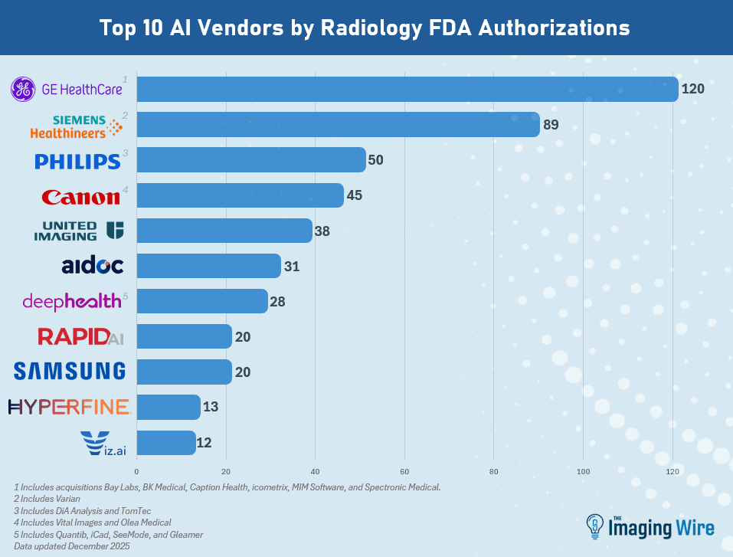
Source

Triaging and Prioritization
Breast cancer screening
Anomaly detection – subtle tissue density patterns
Report generation
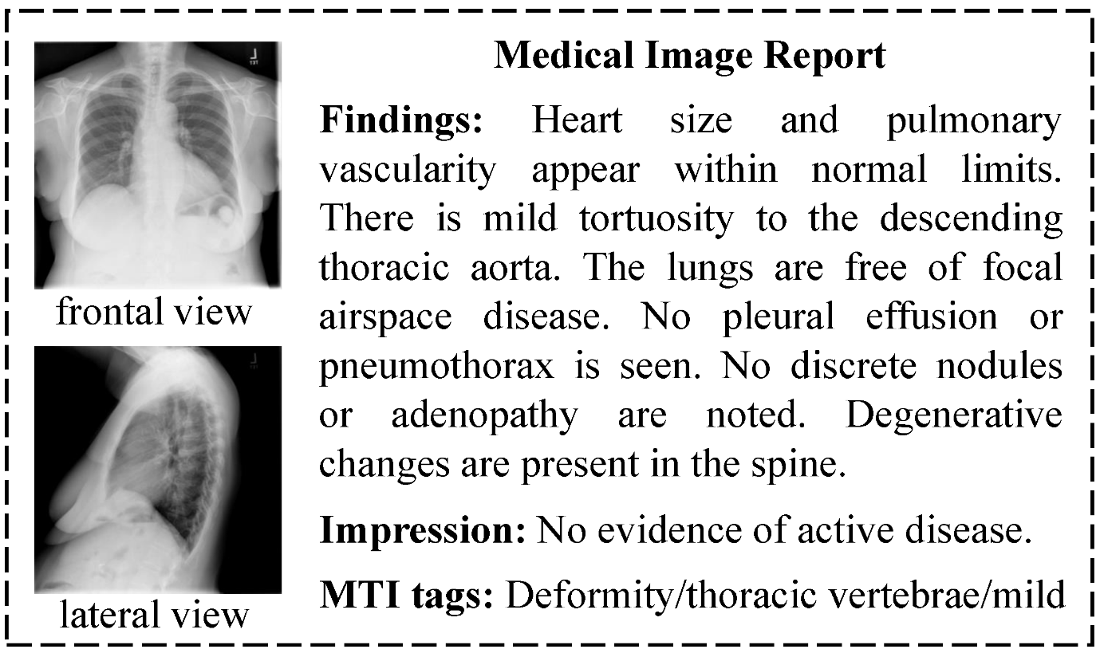
Source: “Automatic Medical Report Generation Based on Cross-View Attention and Visual-Semantic Long Short Term Memorys”
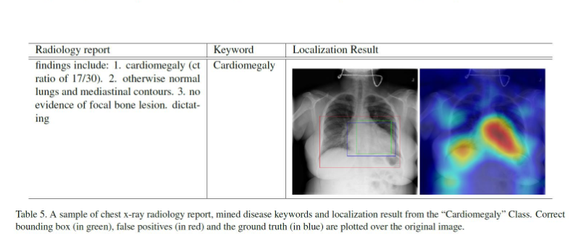

Diagnosis
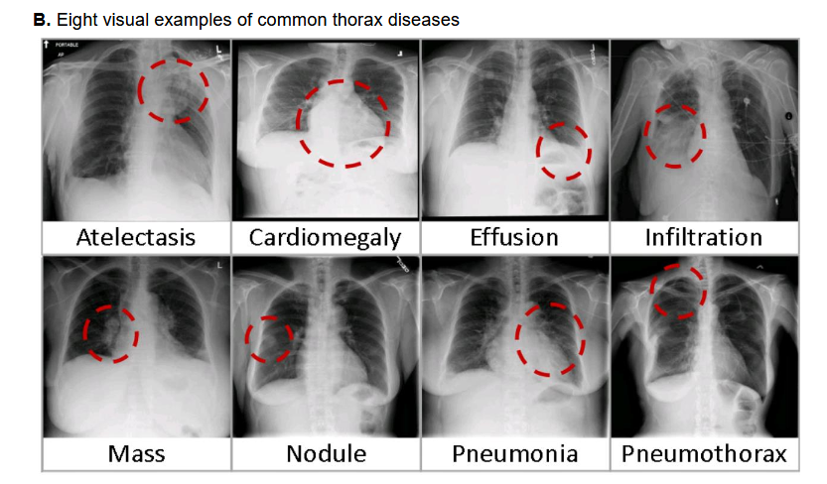
Source: “NIH Chest X-ray Dataset of 14 Common Thorax Disease Categories”

Image reconstruction, denoising

Surgery

Identification of surgical anatomy for real time guidance

Pedagogical tool – identify steps of a surgery – automatic segmentation

Instrument tracking

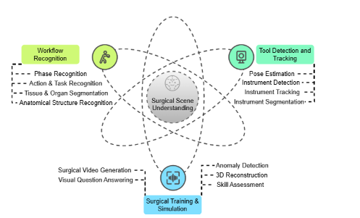
Source: Surgical Scene Understanding in the Era of Foundation AI Models: A Comprehensive Review

Summary
We have looked briefly at a few examples from three specific domains.
My reading of the limited amount of research I have done so far, for this lecture as well as my Ph.D, research so far tells me about the promise of what AI can do, it might do and what it is doing are sort of running in parallel, with a potential of convergence at some point (hopefully).

Building blocks of Computer vision

Image to numbers



Numbers to learning
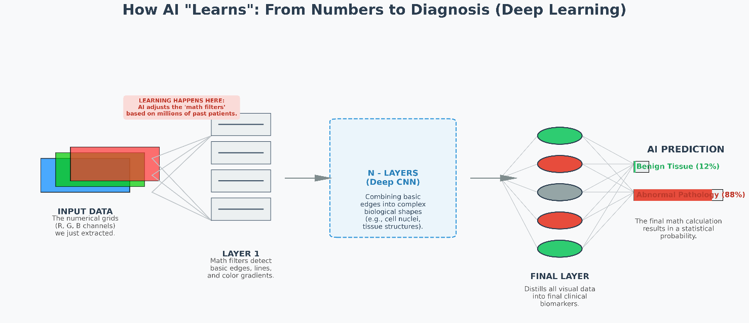

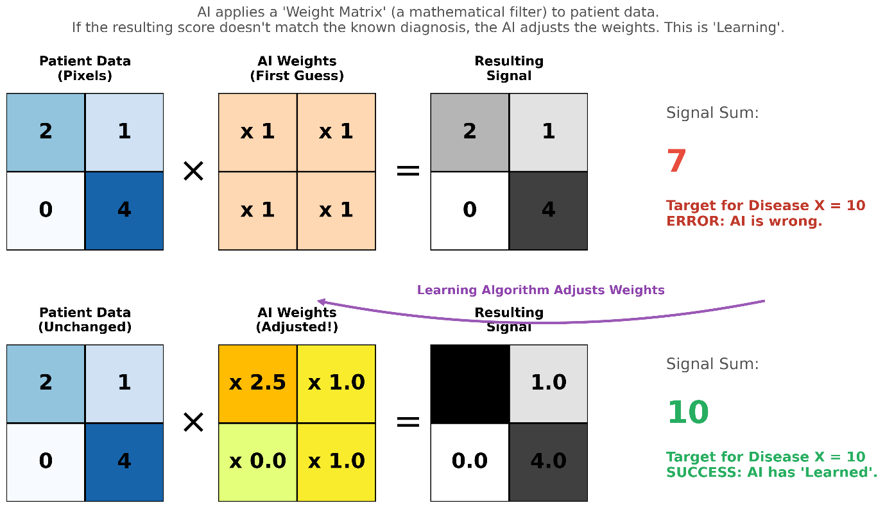

The implementation gap

AI chasm, “Last mile problem”

Academic research is not translating into real-world clinical deployments at the same rate.

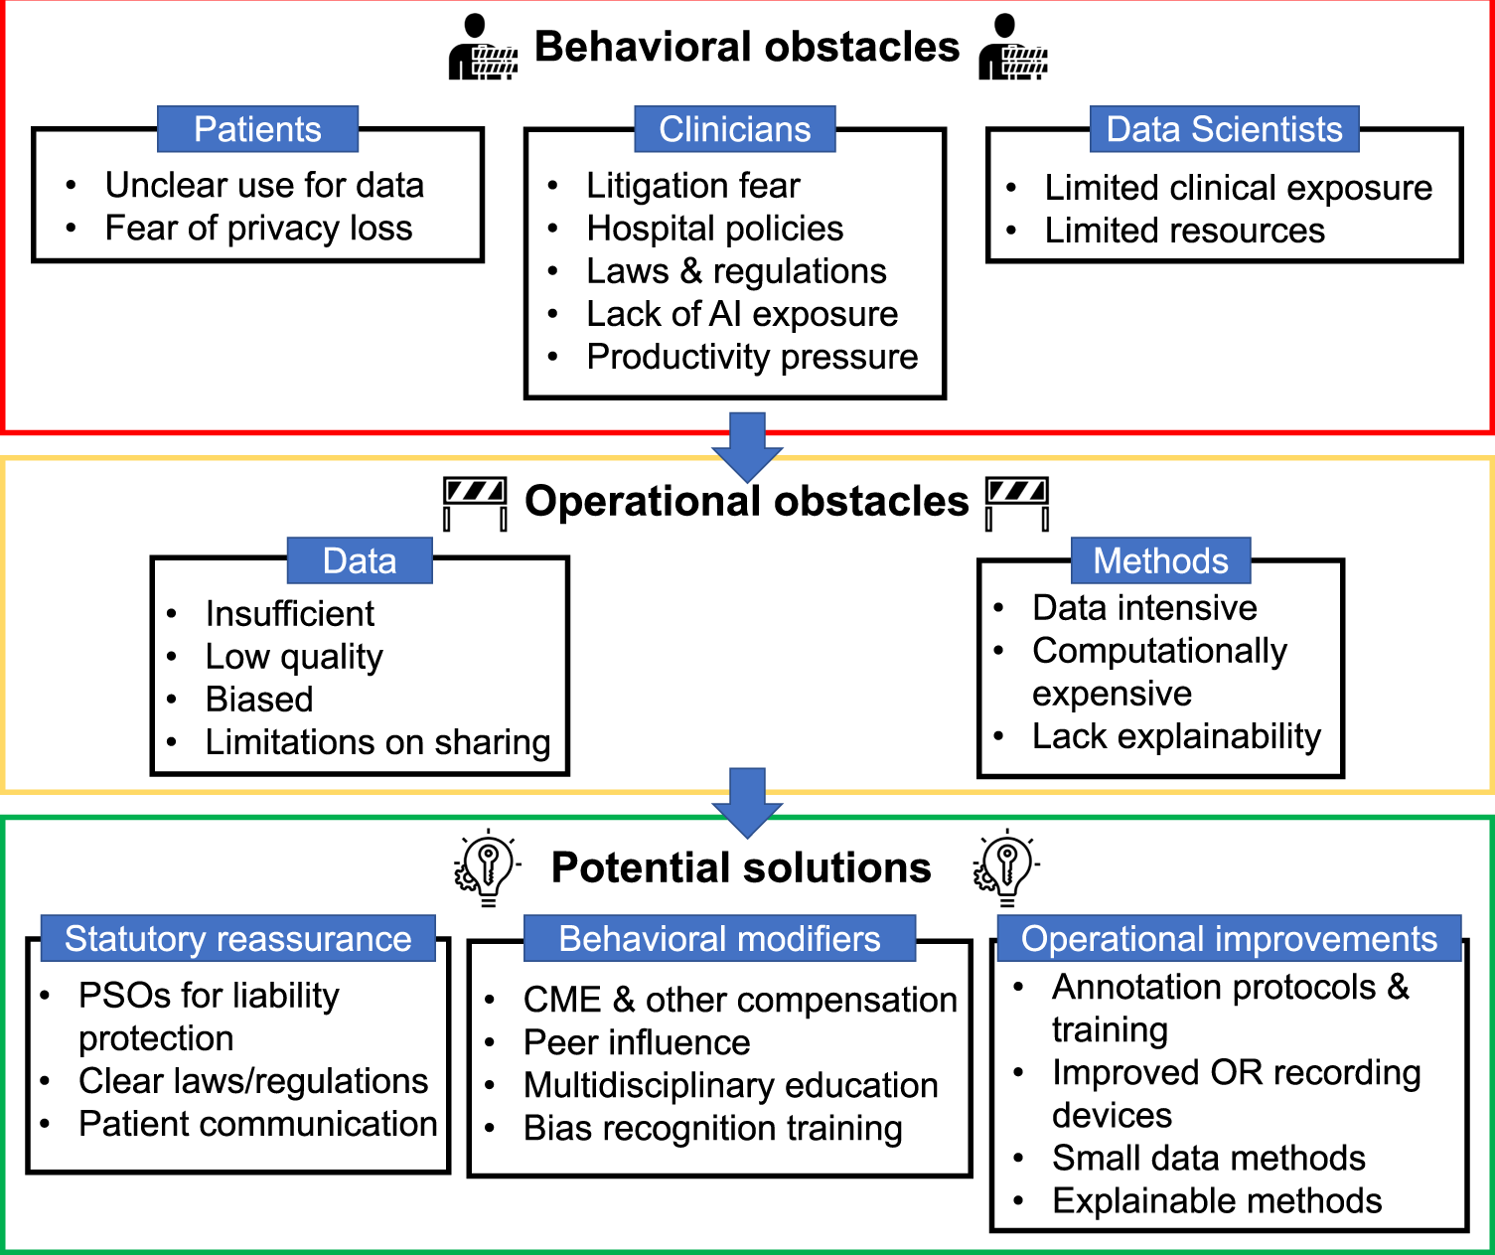
Source: Computer vision in surgery: from potential to clinical value

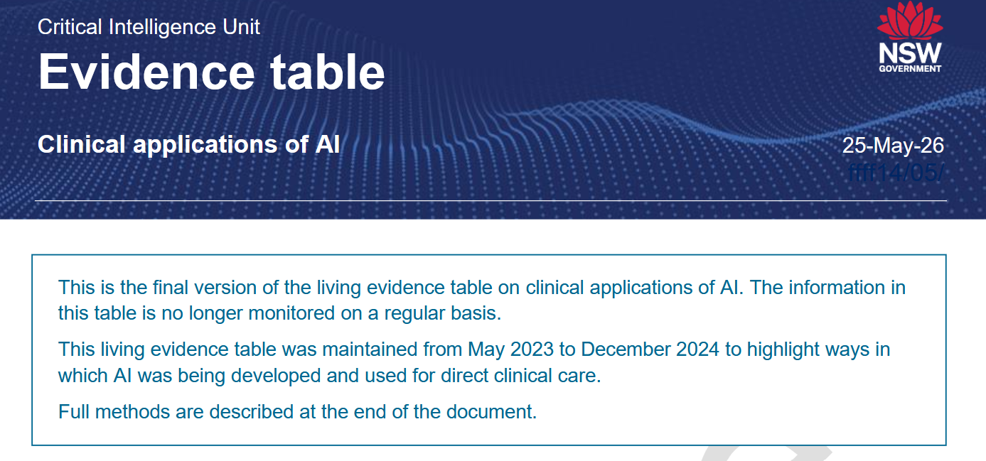
Reference
“Meta-analyses show high diagnostic accuracy, often comparable to clinicians, in imaging-heavy domains including radiology, dermatology, and pathology.
However, limitations include high-risk of bias and poor generalisability to real-world practice.”


Reference

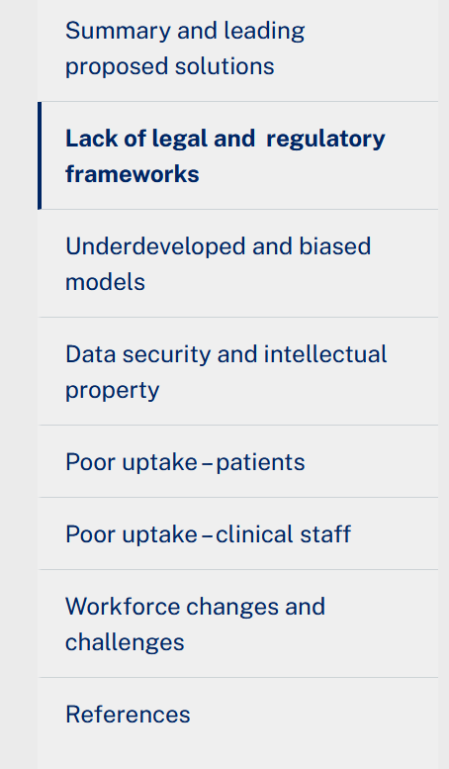 | “Many of the best bets in this brief, however, are theoretical, advocated by subject matter experts or policy-driven, rather than strategies that have been tested or implemented in actual healthcare systems.”  This brief has been developed via a PubMed search of relevant AI literature, targeted searches of the grey literature, and via a weekly screening process of top medical journals since 2023 (e.g. Nature, JAMA, Lancet, BMJ, etc).

Key challenges

Ideal goals from parties with commercial interests

Non-technical
There is a sense of idealism in what AI can enable – but – for whom?

Patient care is the goal of healthcare – right?

Aurelia Sauerbrei, “AI saves time—but for whom? A qualitative study of clinicians, AI developers and competing notions of efficiency in healthcare”

Policy and industry documents often suggest that, besides making processes faster, efficiency savings resulting from the use of AI can be reinvested in the doctor–patient relationship.5 6
..

A systematic review and meta-analysis has shown that these ideal characteristics have a small but significant effect on health outcomes.9

Distribution shift

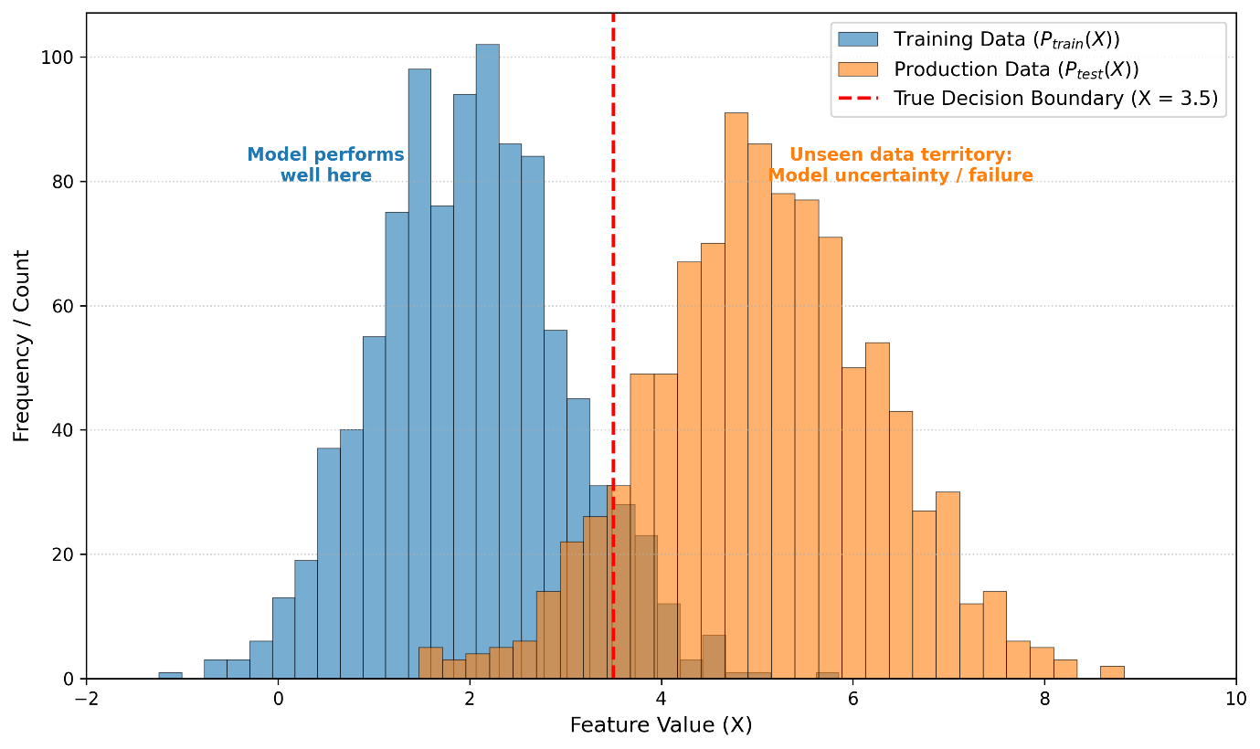

The data that is used to train the machine learning model – the computer vision model usually differs from the data that is then evaluated on

And thus, the machine learning model suddenly is faced with data patterns that it hasn’t seen before – and thus comes up with an answer – how accurate? We don’t know till we investigate

Biased Behaviour
The behaviour of the AI solution prefers one group over another
For example, higher underdiagnosis of females, over males
Violation of principles such as equality of opportunity, equalized odds (borrowed from the social sciences)
Two key reasons:
- Training data gap
- Algorithm behaviour
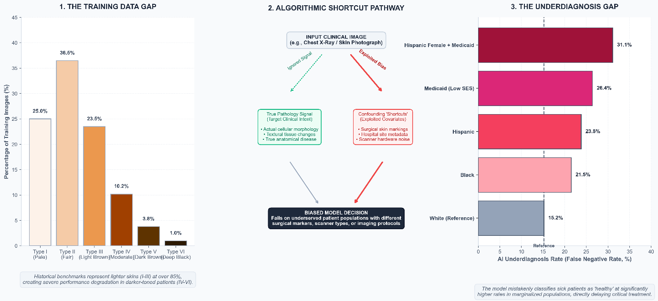

Automation Bias

Automation changes the behaviour of the humans – “Complacency and bias in human use of automation: an attentional integration” is a paper from 2010 – multi-field study of how automation affects human decision making:
“Automation bias results in making both omission and commission errors when decision aids are imperfect. Automation bias occurs in both naive and expert participants, cannot be prevented by training or instructions, and can affect decision making in individuals as well as in teams.”
“Narrative review Artificial intelligence, bias and clinical safety” – 2019
Automation complacency – confirmation bias, to add to another of human’s cognitive biases

“..transferring responsibility for decision-making onto the machine - an effect reportedly strongest when a machine advises that a case is normal..”
.. For example, given the sensitivity to distributional shift described, the usually reliable ML system that encounters an out-of-sample input may not ‘fail safely’ but continue confidently to make an erroneous prediction of low malignancy risk and not be questioned by the busy clinician who then ceases to consider alternatives.”

Summary

- Computer vision in healthcare grew out of computer vision
- Research continues to explode, in lock step with the parallel developments of machine learning in general
- There is potential for genuine solutions – just like any other forms of technology, but there is a need for a measured approach
- A bit of a chicken and egg – advancement and guardrails
Where do you want it to head?

Contact

- https://www.linkedin.com/in/amitsaha0
- amit@commonloopworks.com

