**PAYMENT PROCEDURE VULCANZY- 2K19**

**ONLY UPI/WALLET PAYMENTS ARE ACCEPTED**

**UPI NUMBER : 8790576557**

**UPI ID : banshidhars337@okicici**

1. **GOOGLE PAY (TEZ)**

**FORMAT:**

**AMT:<YOUR AMOUNT>**

**Message: username: <YOUR USERNAME> ; TYPE: <TYPE OF PAYMENT>**

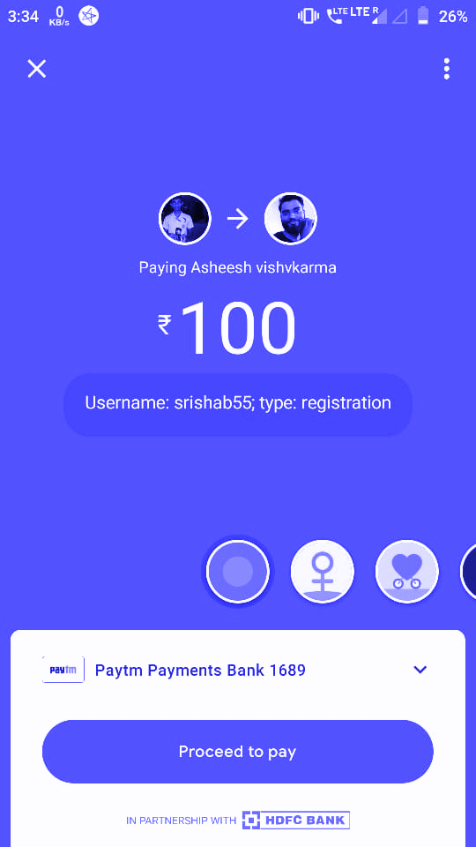**1. For Registration**

**2. FOR Event Registration fees**

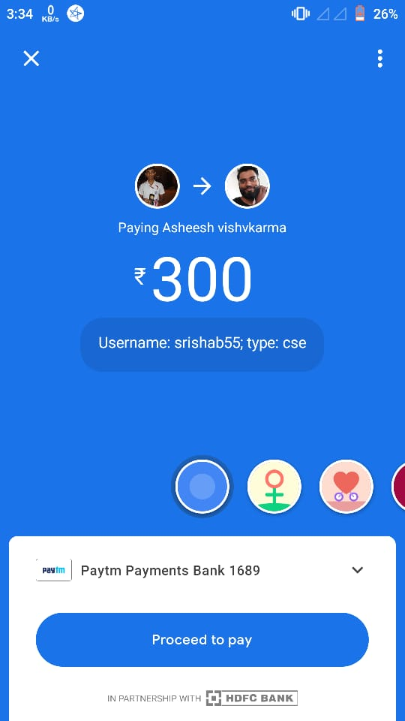

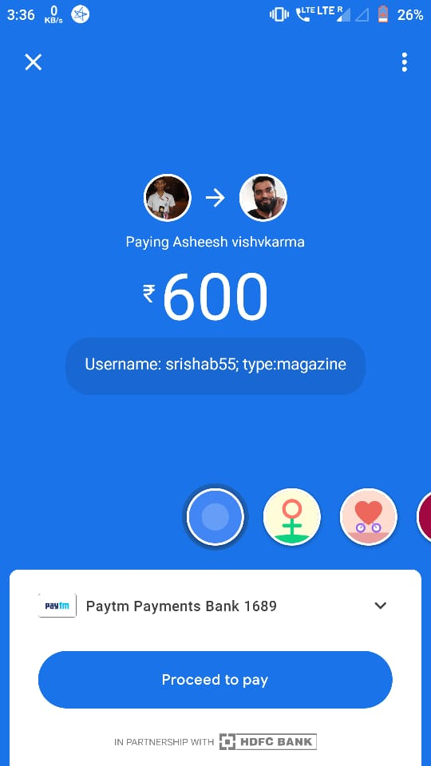

**B. PHONEPE**

**FORMAT:**

**AMT: <YOUR AMOUNT>**

**Message: username: <YOUR USERNAME> ; TYPE: <TYPE OF PAYMENT>**

**Ex.:**

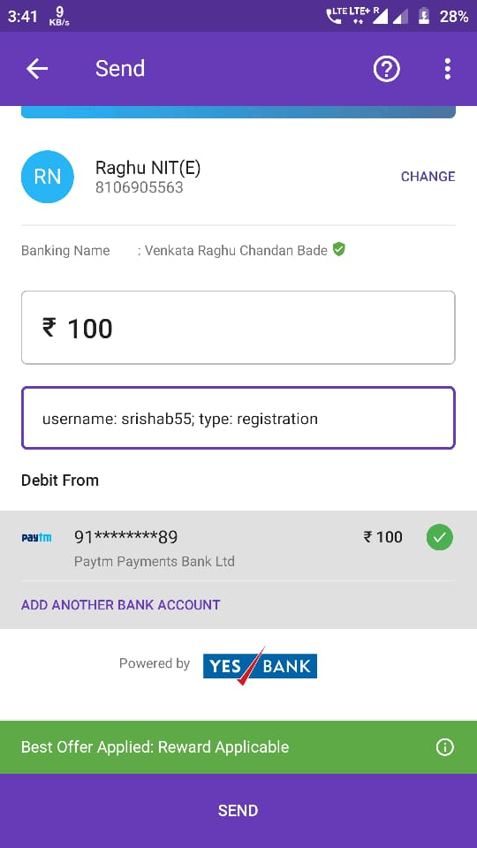

**\*\*NOTE :**

1. **In- case of any problems for the fee payment contact us**
2. **Please follow the given instructions while paying the money**
3. **You can use any UPI method for paying the Fees**
4. **Please pay fees for complete branch wise events only(all event in a branch at once & NOT TWO branches at once)**

**E.g if you filled for ECE events and MECH events then pay for 1st ECE (All events )with above given method and then MECH (all events) with above method**