## RESUME

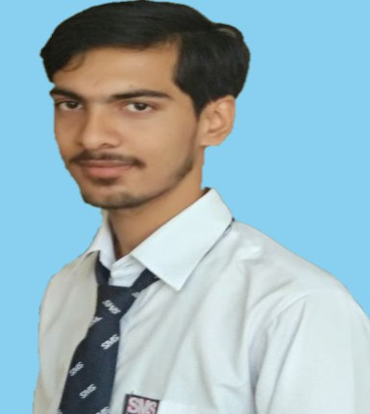

**MUKESH PANDAY**

**Mobile: 7678997505**

**E-mail Id.:** [**mukesh7890pandey@gmail.com**](mailto:mukesh7890pandey@gmail.com) **LinkedIn:**[**https://www.linkedin.com/in/mukesh-pandey-6b07b51b3**](https://www.linkedin.com/in/mukesh-pandey-6b07b51b3)

**CAREER OBJECTIVE**

To associate with an organization which progresses dynamically and gives me a chance to Put into use my knowledge and also provide me a platform to enhance my skills, in the state of art technologies and be a part of the team that excels in work to words, the growth of organization and my satisfaction thereof.

|  |  |  |  |  |
| --- | --- | --- | --- | --- |
| **ACADEMIC QUALIFICATION** | | | | |
| **QUALIFICATION** | **SPECIALIZATION / BRANCH** | **INSTITUTE / UNIVERSITY** | **YEAR** | **% or**  **CGPA** |
|  |  |  |  |  |
| **B.TECH** | Computer Science &  Engineering | School of Management Sciences Lucknow | 2021 | 68.12 |
| **10th+2** | Physics, Chemistry, Mathematics | Diamond Inter College Rampur Bhagan Faizabad | 2016 | 63.4 |
| **10th** | Science | DGIC Madhu Pur Miran Pur Ambedkar Nagar | 2014 | 75.50 |

* Android App Development

**CERTIFICATION**

(INTERNSHALA)

Certification Number- 896FAAA2-D04E-1F7E-C463-5FEE963D3AE7

**SKILLS**

* HTML, Core Python, Basic C Language, Kotlin
* MySQL ,Data Structures and Algorithms
* IDE- Intellij IDEA, Android Studio
* Android App Development

**PROJECTS**

# Students Information System

A student information system is a web application which is used to manage student information/student's data as well as faculty's data. This system is very useful for schools, colleges, and universities

**Workshops/ Seminars**

1. **Ethical Hacking-** Workshop attended in School of Management Sciences, Lucknow. It was useful in gathering basic knowledge about ethical hacking and also to understand Ethical hacking as a career opportunity.
2. **Internet Of Things-** Workshop attended in School of Management Sciences, Lucknow. It was to useful understanding the robotics future and scope Understanding the different microcontroller available in the industry & their use

**EXTRA ACTIVITIES**

1. Industrial Visit to UP 112

**AREA(S) OF INTEREST**

* + Android Development
  + Web Development

**INTERESTS & HOBBIES**

* + Listening to music
  + Playing Cricket
  + Bike Riding
  + Traveling
  + Chess

**STRENGTHS**

* + Ability to grasp new skills very fast.
  + Flexibility and Adaptability
  + Tolerance: Stress tolerance.
  + Learning agility: Quick learner.
  + Critical thinking: Decision making skills.

|  |  |
| --- | --- |
| **ADDITIONAL INFORMATION / OTHER DETAILS** | |
| **Father’s Name: Banshraj Panday Mother’s Name: Reeta Panday**  **Date of Birth:04-08-1999**  **Languages Known: Hindi, English**  **Postal Address: Cahacikpur , Ambedkar Nagar, Chachikpur, Uttar Pradesh 224141**  **Place: Lucknow**  **Date: (Mukesh Panday)** |  |
|  |  |