**ICS 3U1 PAINT PROGRAM**

Your assignment will be to create your own paint program using Turing. You paint program screen may look like the following (below right) but the design of the screen is up to you.

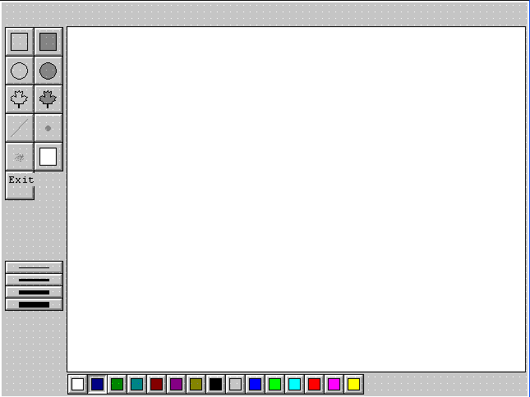

You must have the following elements in your program:

Drawing tools: pencil, line, rectangle, oval, maple leaf. Also include other tools such as erase and clear screen. Spray paint will be an optional bonus.

Colour palette. Use at least 8 colours.

Close program. Use an X button at the top right.

**KEEPING TRACK OF THE OBJECTS AND COLOURS**

Create two integer variables for your program: ***ObjectType*** and ***ColourNum***.

When the user clicks on one of the drawing tools (pencil, line, box, etc.), set **ObjectType** to a different number. For example: 1 for pencil, 2 for line, 3 for box, 4 for fill box, etc.

Similarly, when the user clicks on one of the colours, set **ColourNum** to a specified number. For example, 0-white, 1-blue, 2-green, 3-cyan, etc.

**PROCEDURES**

1) draw a button up 2) draw a button down 3) draw a button flat (optional)

**MAIN PROGRAM**

The main program will be quite large. It will be one loop inside of which you will perform three major functions.

LOOP

IF user clicks on one of the drawing tools then

set ObjectType to the appropriate number

ELSEIF the user clicks on one of the colour buttons then

set ColourNum to the appropriate number

ELSEIF the user button clicks on the canvas area THEN

remember the mouse co-ordinates

ELSEIF the user drags the mouse on the canvas area THEN

erase and draw the object, depending on the value of ObjectType

ELSEIF the user releases the button while on the canvas area THEN

draw the object, depending on the value of ObjectType

END IF

END LOOP

Bonus:

As you draw your objects, you do not erase over other objects already on the canvas.

Save your picture as a meta file, not as a bitmap, so that you can open it later and continue drawing.