

**Computer Networks - 2**

**(20ECSC303)**

TEAM 4

visit to

**University of Agricultural Sciences,**

**Dharwad**

| Name | Roll | USN |
| --- | --- | --- |
| Aryan Narayan | 415 | 01FE19BCS215 |
| Bodhi Satwa Mishra | 422 | 01FE19BCS222 |
| Amit S Godikar | 412 | 01FE19BCS212 |
| MD Kaif Alam | 425 | 01FE19BCS225 |

**Submitted By:**

Amit S Godikar

01FE19BCS212

**SCHOOL OF COMPUTER SCIENCE & ENGINEERING**

**HUBLI – 580031**

**Academic year 2021-22**

**ABSTRACT**

**Computer networks have a significant impact on the working of an organization. Universities depend on the proper functioning and analysis of their networks for education, administration, communication, e-library, automation, etc. An efficient network is essential to facilitate the systematic and cost-efficient transfer of information in an organization in the form of messages, files, and resources. The project provides insights into various concepts such as topology design, IP address configuration, and how to send information in the form of packets to the wired networks of different areas of a University.**

**The aim of this project is to design the topology of the university network using the software Cisco Packet Tracer with the implementation of wired networking systems. This university network consists of the following devices:**

**1) Router (2911)**

**2) Switches (2960-24TT)**

**3) Journal server**

**4) PCs**

**5) Laptops**

**6) Outside Server**

**7) Smartphone**

**8) Printer**

**The design includes the following parts of the University:**

**Administrative building**

**Library**

**Other departments**

**● Project Statement**

In this project, we defined a simulation of university networks. The network is divided into three sets: one for the administrative building, one for the library and the other for other departments.

We have added Email, and HTTP servers for the maximum utilization of resources.

Hence the campus network provides different services such as connecting the user to the internet, data sharing among users (students, teachers, and different university members), accessing different web services for different functionalities.

**● Simulation Environment**

The simulations of our network topology can be easily achieved using cisco packet tracer. Using a simulation mode, you can see packets flowing from one node to another and can also click on a packet to see detailed information about the OSI layers of the network. Packet Tracer offers a huge platform to combine realistic simulations and visualize them simultaneously. Cisco Packet Tracer makes learning and teaching significantly easier by supporting multi-user collaboration and by providing a realistic simulation environment for experimenting with projects.

**Network Architecture**

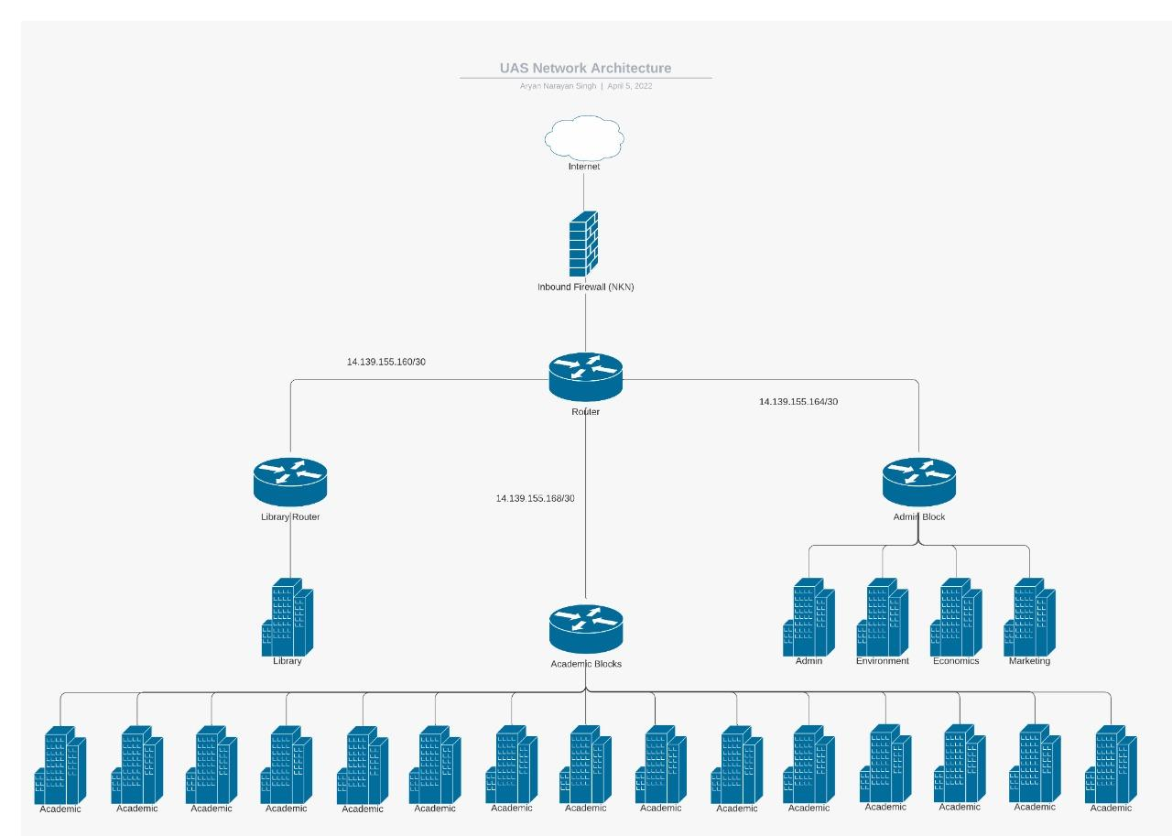

**Mind Map**

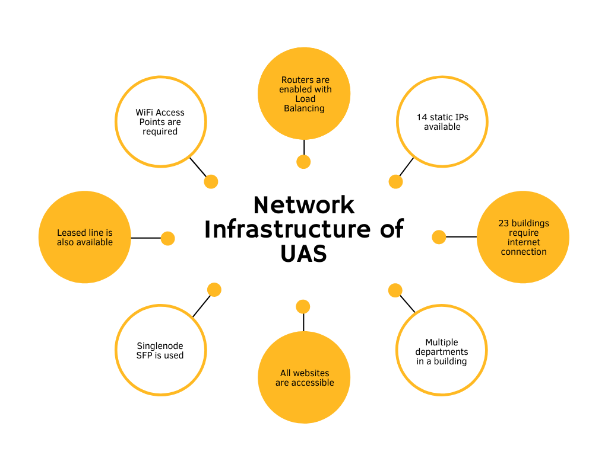

**Gaps Identified**

* **No firewall for outbound traffic**

In the visited university there is no internal firewall installed for the incoming traffic which makes the infrastructure vulnerable to attack. Instead they are dependent on NIC for traffic monitoring.

* **No antivirus**

No antivirus is applied in the network due to which most functionality provided by antivirus is not there. Antivirus software looks at data — web pages, files, software, applications — traveling over the network to your devices. It searches for known threats and monitors the behavior of all programs, flagging suspicious behavior. It seeks to block or remove malware as quickly as possible

* **No topology**

There is no particular topology that persists. Since the university is very old and they do not renovate the network infrastructure, only add components as required. Due to non implemented the particular topology, it is hard to know the system performance and throughput.

* **IP address is statically assigned to end devices**

Due to non implementation of DHCP servers, all nodes in the system have to manually assign the IP address, due to which in case of some trouble in the network, tracking of problem is very hard as well as it is a hectic and tedious job to manually assign the address.

* **Single ISP provides all the connections**

There is sole dependency on only one ISP due to which if the ISP has some problem from their end then the whole campus will be under network breakdown.

* **WAP is not enabled**

They have wireless access points but they have not enabled it due to which one cannot browse wirelessly. This is done due to the us

**Proposed Solution**

* Hybrid Topology
  + Mesh Topology for connecting buildings
  + Star Topology for connecting departments inside a building
* Firewall with outbound rules
* Wireless Access Points

**Architecture simulated in cisco**

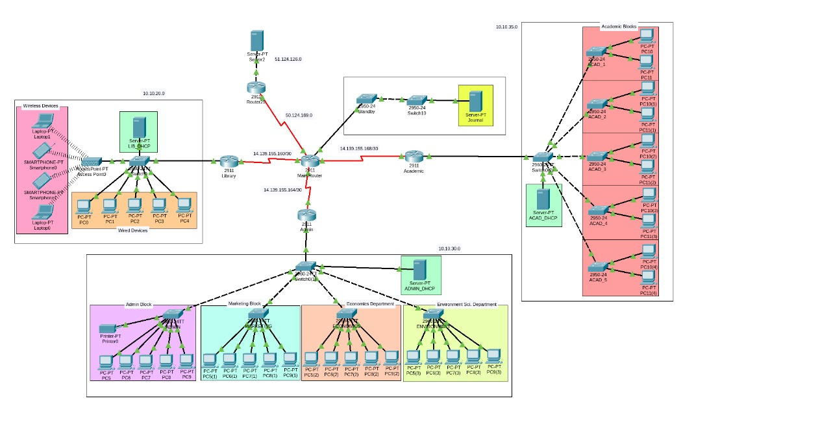

**Library**

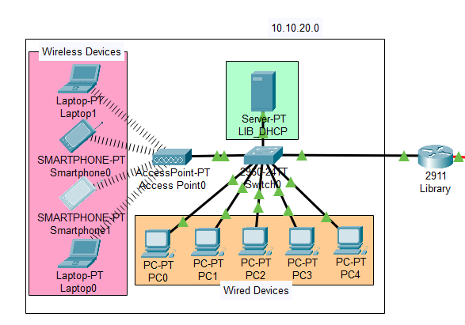

**Admin Block and other Blocks**

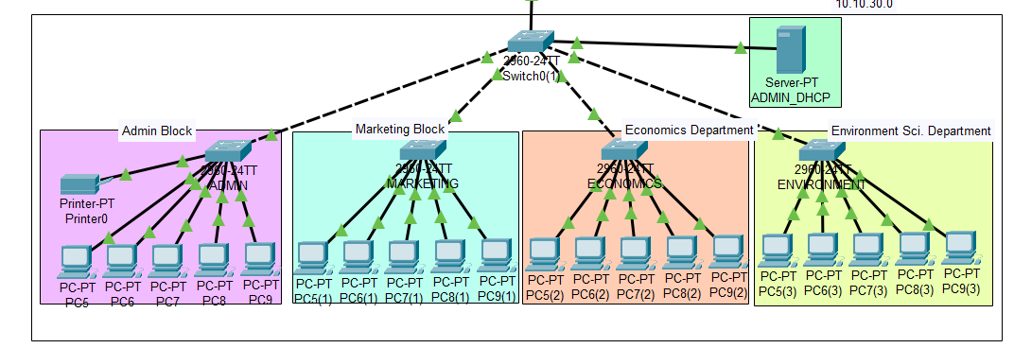

**Other Academic Blocks**

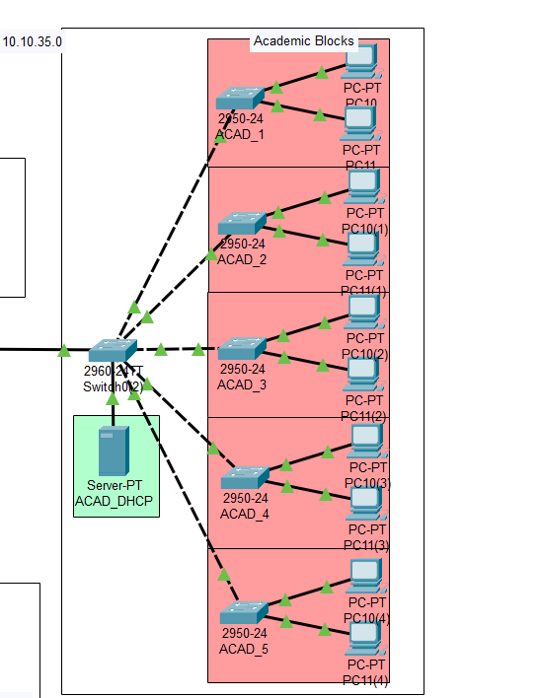

**Servers and standby switch**

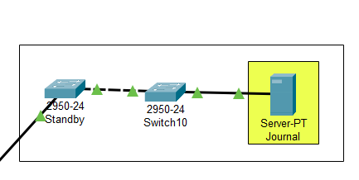

**Outside Network**

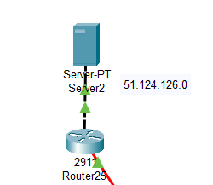

**Configuration**

**Library’s PC**

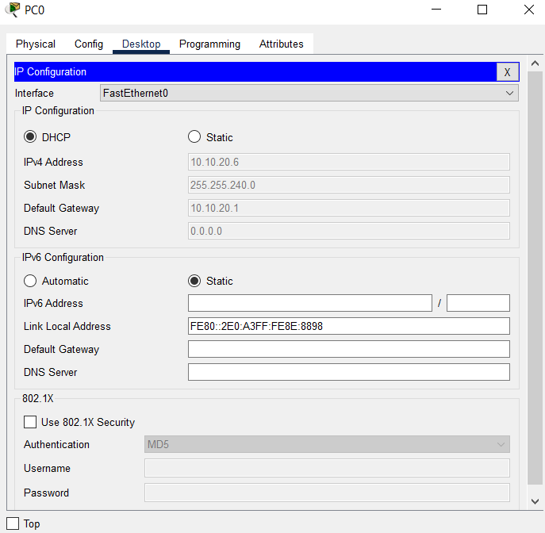

**Administrative Building’s PC**

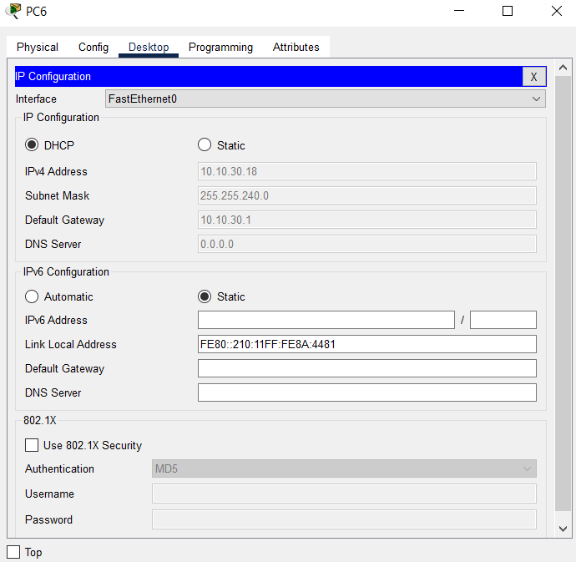

**Other Academic Building’s PC**

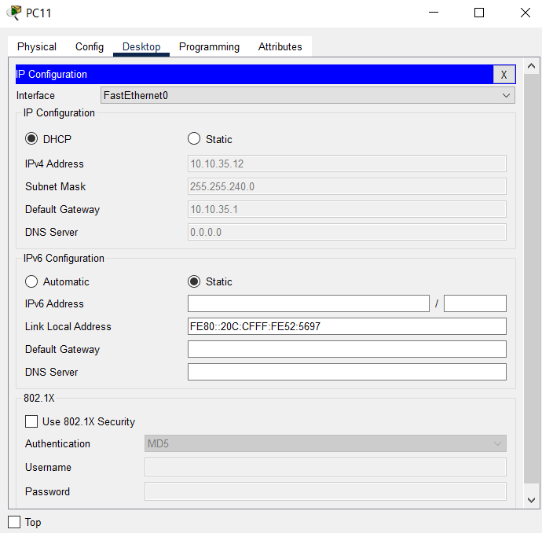

**Server outside the Campus**

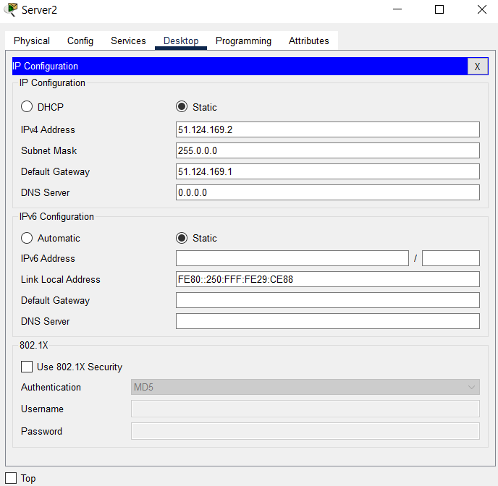

**Journal Server**

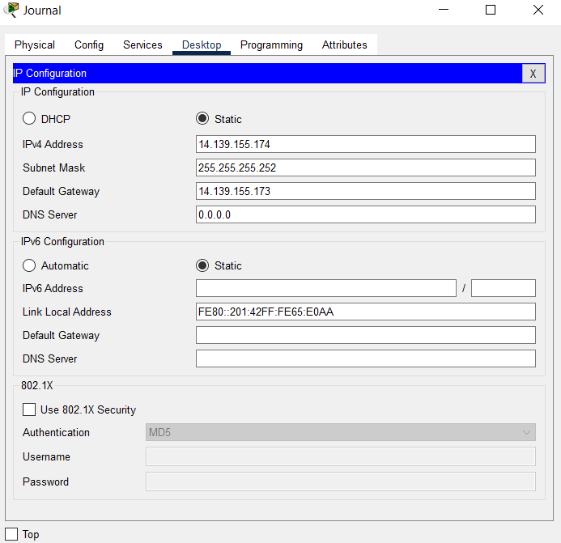

**Visiting Journal site with random PC**

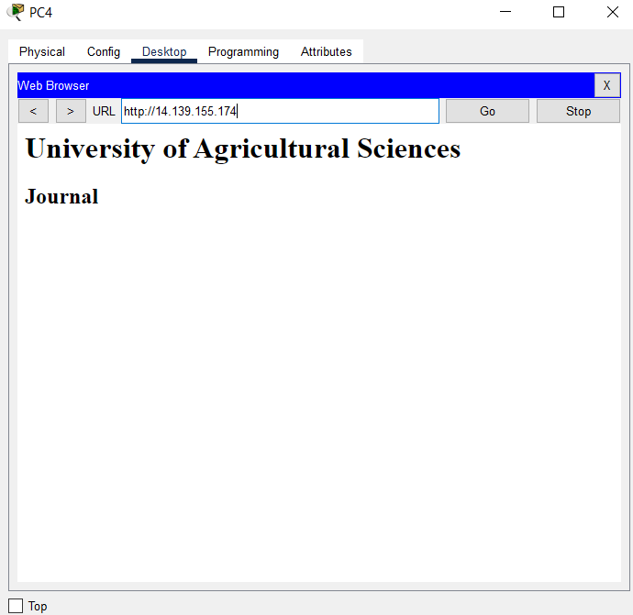

**Visiting KLETech Website from inside the campus**

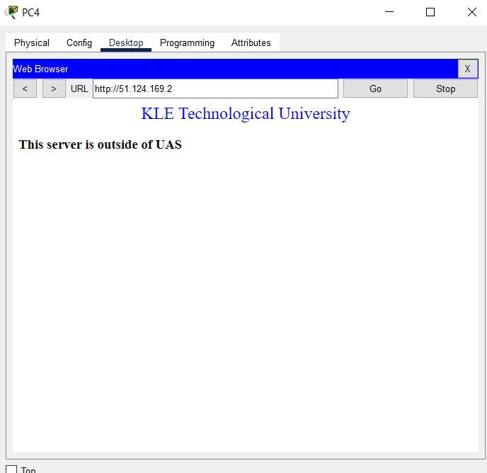

**Smartphone**

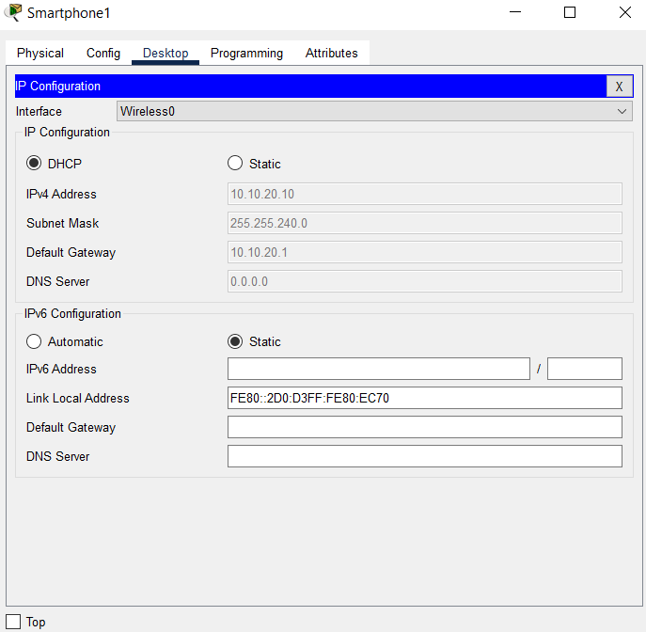

**Proposed Architecture**

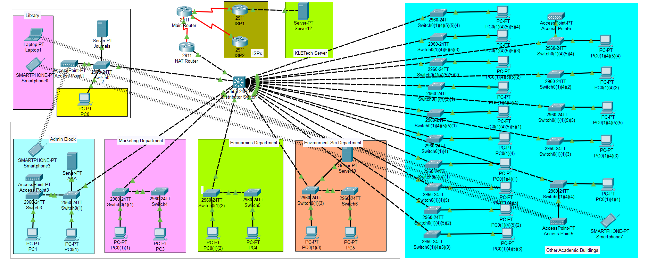

**Network Comparison**

* Less use of routers.

More are the routers, the more will be the redundancy, so we reduced the use of routers and we used the L3 switch for similar functionality.

* Creation of VLANs

Instead of dividing networks physically, we divided it logically.

* AAA server is implemented.

AAA server is implemented for the authentication process, so that only authorized users can access the resources.

* DHCP is implemented.

Instead of allocating IPs statically, we implemented DHCP in the router, now it assigns IPs dynamically.

* Wifi access points implemented.

More wireless access points are given.

* Lease line is implemented.

To increase reliability, lease line is provided as a backup line

**Learnings and Experience**

While doing this project i have learnt:

* How to do a campus survey and understand network architecture.
* How to find gaps in the existing architecture.
* How to apply academic concepts in real architecture.
* How to find a solution for gaps identified