Liat Cohen- 205595283

Amit Shakarchy- 313278889

# Deep Learning

# Assignment 1

## network configuration

|  |  |
| --- | --- |
| **parameter** | **value** |
| Network dimensions | [784, 20, 7, 5, 10] |
| Learning rate | 0.009 |
| Validation set size | 20% |
| Stopping criteria | No improvement (or a very small one) for 100 training steps |
| Batch size | 64 |
| Batchnorm | **False** (No batch normalization) |

Number of iterations and epochs that were needed to train the network: 4400 training steps and 5 epoches

Final accuracy values:

Train- 0.863

Validation- 0.869

Test- 0.868

Cost value for each 100 training steps: ____ (graph)

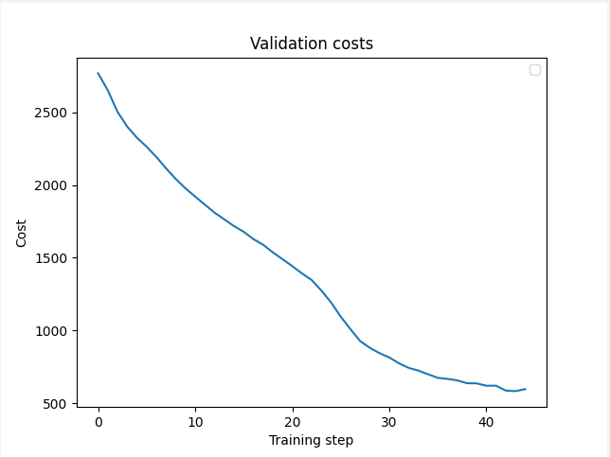

Print the values from the L_layer_model

Running time: 3.835 sec