Docker

- Docker: It is virtualisation tool same as virtual machine. It virtualise the application layer and it use the kernel of the host operating system. It does not have its own kernel.

- Docker vs Virtual Machine: Docker use the kernel of host whereas the VM has its own kernel that is why they are very large in size.

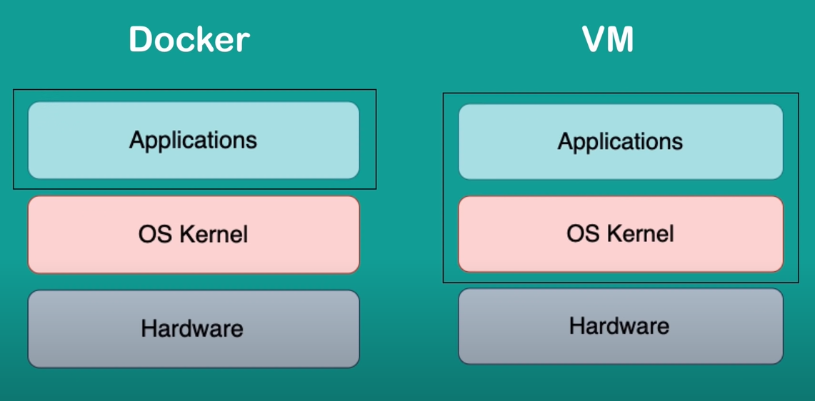
we can run VM of any OS over any other OS as it has its own kernel, but it docker it is only possible to as we can not run the linux based docker image on windows kernel. This problem arise in older windows version and mac and to solve this problem we have something called docker toolbox.
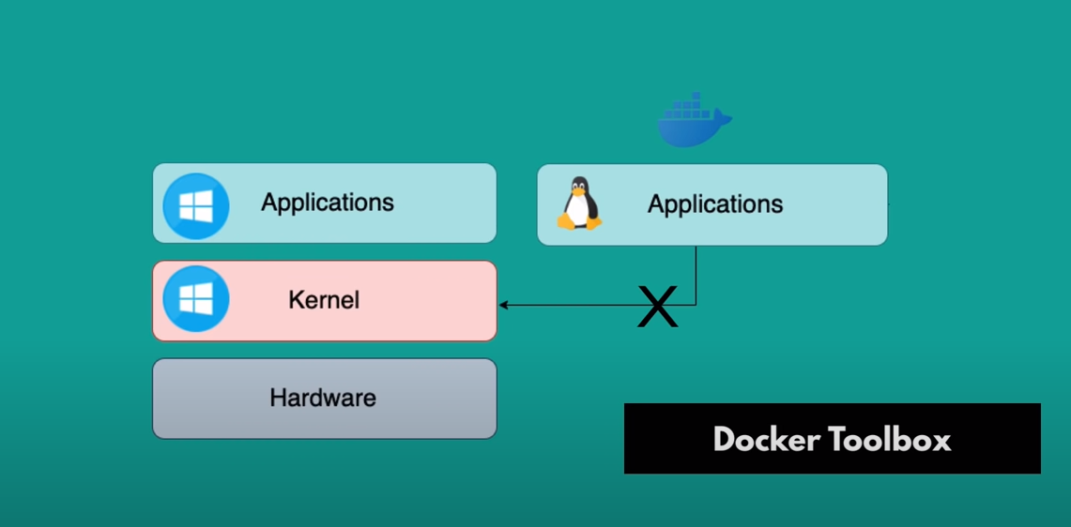

- Docker Image: it is a set of files required to run a given software on any operating system. For Example when we say we have mysql image that means these are the set of files that is required to run the image on any operating system. All the docker images are linux based only.

- Docker Container: It is running instance of any docker image. In layman terms we can say docker image is the class and the docker container is the object of that class. We can create multiple container from the single docker image.
In technical terms container is a place where the application runs isolately.

- Running multiple container from Same Image: If we want to run multiple container from same image we will have to map the computer port to container port so that every container run on different port.

eg: docker run -p6000:6379 redis:4.6
this means this container redis will run on computer 6000 port
docker run -p6001:6379 redis:4.6
this means this container redis will run on computer 6001 port

- Docker Network: Docker network is a network in which multiple docker containers can run. And these containers can talk to each other just by specifying the name of other containers. We dont need to specify localhost port name etc.
Any application running outside the docker network will have to specify port name etc to talk to containers running inside the network.

- Workflow with Docker:
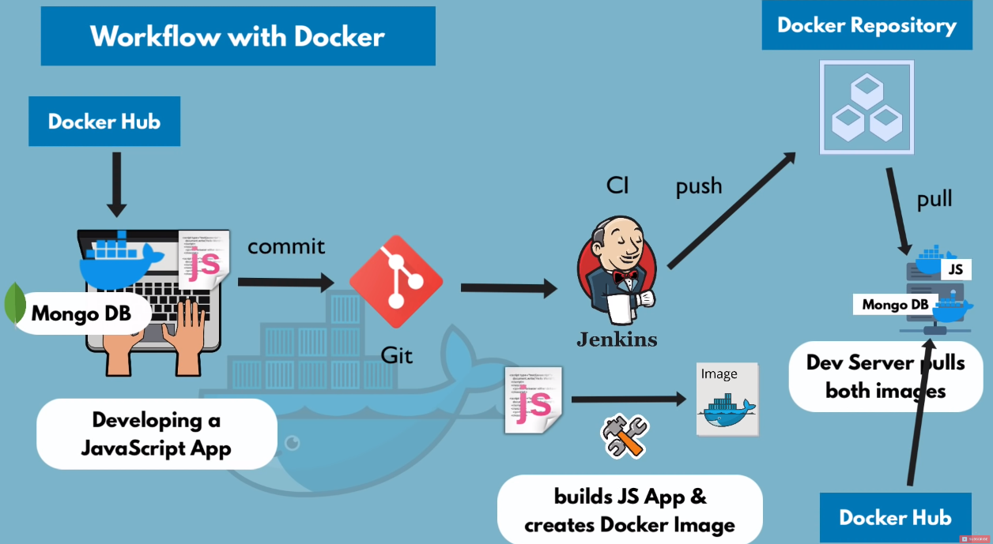

- Docker Compose : In this we convert the normal docker command into the yaml file and instead of running the multiple comands again and again to start the multiple docker containers. We simply run the docker compose command over the yaml file and that will start the all containers simultaneously.

Lets map the givern 2 docker commands into to yaml file that we want to run simultaneously.
1)
docker run -d \
-p8081:8081 \
-e ME_CONFIG_MONGODB_ADMINUSERNAME=admin \
-e ME_CONFIG_MONGODB_ADMINPASSWORD=passwd \
--net mongo-network \
--name mongo-express \
-e ME_CONFIG_MONGODB_SERVER=mongodb \
mongo-express

2)
docker run -d \
-p27017:27017 \
-e MONGO_INITDB_ROOT_USERNAME=admin \
-e MONGO_INITDB_ROOT_PASSWORD=passwd \
--net mongo-network \
--name mongodb \
mongo

Yaml file conversion of above 2 commands:

version: ‘3’ # version we cant change it
services: # fixed tag
mongodb: # this is the container name that we want to give
image: mongo
ports:
- 27017:27017
environment:
- MONGO_INITDB_ROOT_USERNAME= admin
- MONGO_INITDB_ROOT_PASSWORD=passwd
mongo-express:
image: mongo-express
ports:
- 8080:8080
environment:
- ME_CONFIG_MONGODB_ADMINUSERNAME= admin
- ME_CONFIG_MONGODB_ADMINPASSWORD=passwd
- ME_CONFIG_MONGODB_SERVER=mongodb
restart: unless-stopped

we did added anything for network configuration because docker comopse will give the same network to the all containers that we mention in given yaml file.

Dockerfile:
=> It is a blueprint for building the docker image. Basically with the help of dockerfile we create our own image from our contents.
=>FROM: First line of each docker file is “FROM image” and this image is the base image on which our image is build upon.
=>ENV: We set environmental variable using ENV variables.
=>RUN: To run any linux command on our docker image we use RUN Keyword. Very important to note here that these commands will be executed on the linux container not the host machine.
=> COPY : it copies the files form host machine to our container environment. The main difference between the RUN and COPY command is that Run command run on container only where the COPY command copy the content from host computer to container
=> CMD: it is the entry point command to our service running on
docker container. The difference between CMD and RUN command
is that there can be only one CMD command but there will be multiple RUN command.
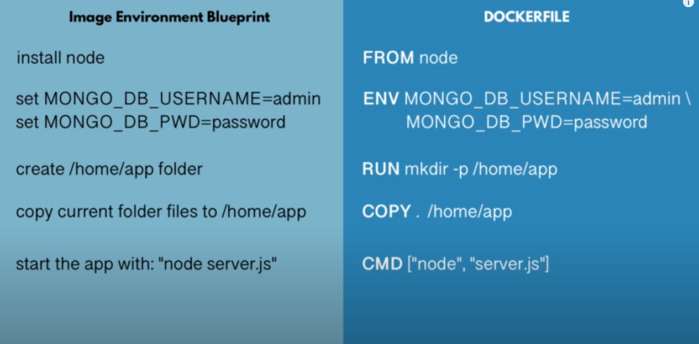

Docker file vs docker compose:
with the help of dockerfile we create our own image. And then we can use our personal image inside the docker compose file. And With the help of docker compose we can run our personal image with all the interdependent images.
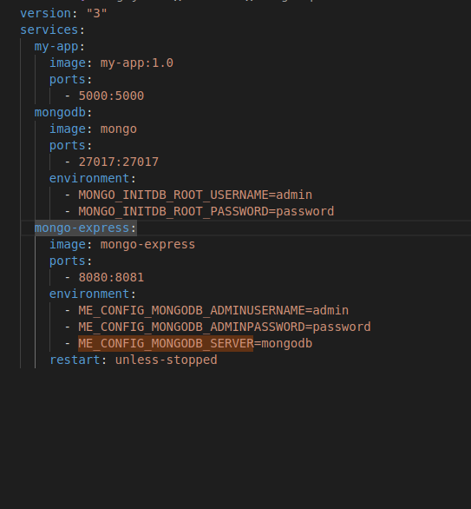
The first image my-app:1.0 is self created image that we are using with docker hub image mongo and mongo-db

Docker Volumes:
Whenever we restart our container all the data present inside the container get lost and to persist the data between container restarts we use docker volumes. In docker volumes we plug the host machine file system path with docker file system path. So that docker can use the file system of host machine and save the data there.

There are 3 types of docker volumes so there is also 3 ways to create the docker volume:
1. Using docker run Command: Host Volume
docker run -v <host file system path>: <docker file system path>
eg:
docker run -v /home/mount/data : /var/lib/mysql/data

in this technique we decide where on host file system the reference is made
2. Anonymous Volumes:
docker run -v <docker container file system path>
eg:
docker run -v /var/lib/mysql/data

in this docker automatically create the folder on host file and mount that with the docker container file system.

3. Named Volumes:
docker run -v <name>:<docker container file system path>
eg:
docker run -v name:/var/lib/mysql/data

in this we can reference the volumes by names. And this is most widely used

Docker volume with Docker compose

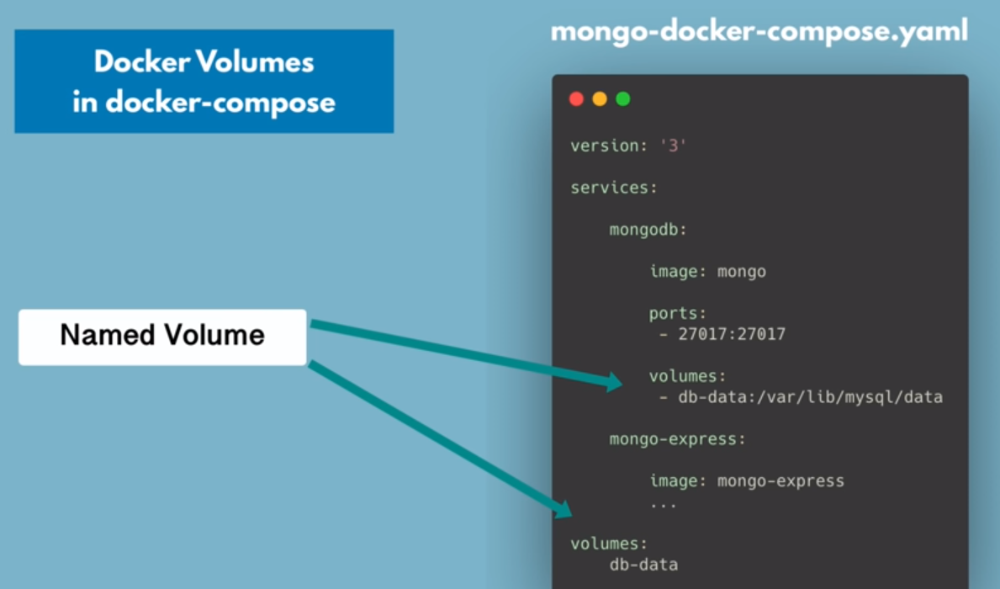
docker compose final yaml file:
