Docker

- Docker: It is virtualisation tool same as virtual machine. It virtualise the application layer and it use the kernel of the host operating system. It does not have its own kernel.

- Docker vs Virtual Machine: Docker use the kernel of host whereas the VM has its own kernel that is why they are very large in size.

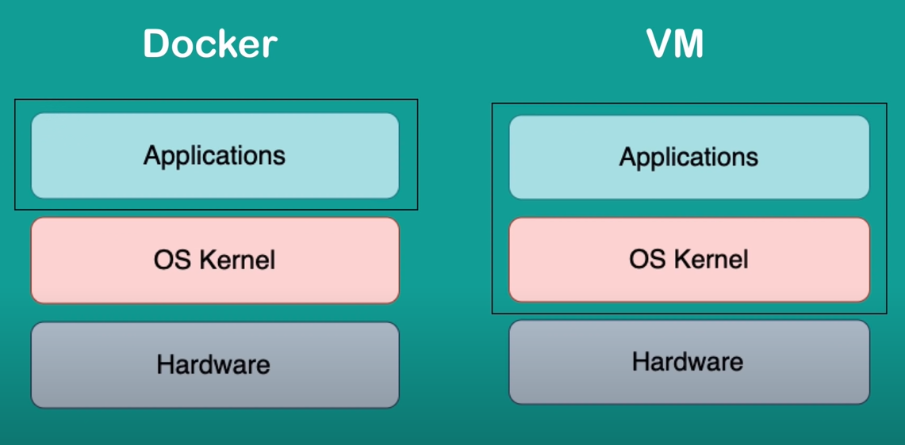
we can run VM of any OS over any other OS as it has its own kernel, but it docker it is only possible to as we can not run the linux based docker image on windows kernel. This problem arise in older windows version and mac and to solve this problem we have something called docker toolbox.
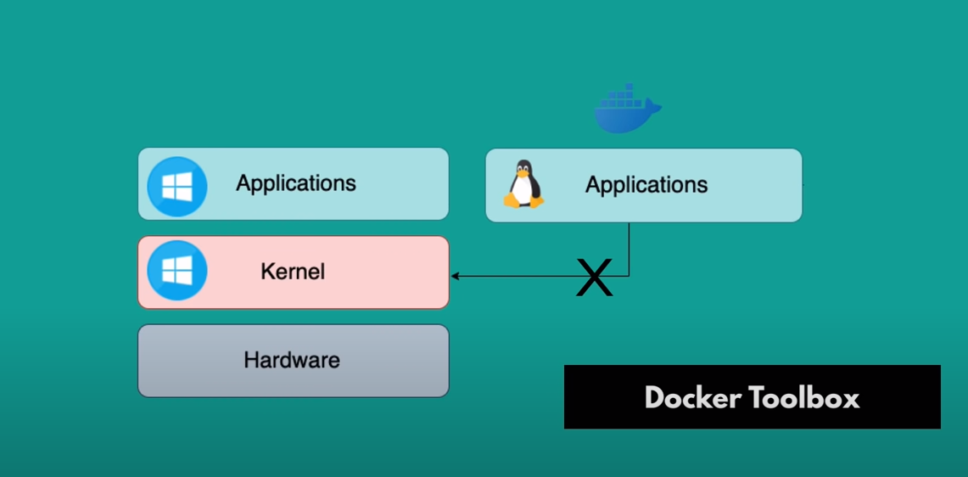

- Docker Image: it is a set of files required to run a given software on any operating system. For Example when we say we have mysql image that means these are the set of files that is required to run the image on any operating system. All the docker images are linux based only.

- Docker Container: It is running instance of any docker image. In layman terms we can say docker image is the class and the docker container is the object of that class. We can create multiple container from the single docker image.
In technical terms container is a place where the application runs isolately.

- Running multiple container from Same Image: If we want to run multiple container from same image we will have to map the computer port to container port so that every container run on different port.

eg: docker run -p6000:6379 redis:4.6
this means this container redis will run on computer 6000 port
docker run -p6001:6379 redis:4.6
this means this container redis will run on computer 6001 port

