What is Kubernetes?
Kubernetes is container orchestration tool. On foundation it manages the containers it can be docker containsers or some other technology containers. So basically kubernetes help us to manage the application that is made up of many containers. It help us to manage those containers in different environments.

What Features does kubernetes offer?
1) high availability
2) Scalability
3) Disaster Recovery

What is Kubernetes Component?
1) POD
- Smallest Unit of K8S.
- Abstraction over docker container: pod create the running environment of layer on top of the container. It does So that we dont have to work directly with the container technologies like docker. We only interact with the kubernetes layer.
- Although we can run multiple containers inside the pod but usually we run 1 application container per pod.
- Each pod has its own ip address and with the help of these ips the pods can interact with each other.
- If the pod gets killed due to error the new pod will be created in place of that and for that new pod will have different ip address which is bad as we dont want to change the ip address of pod so to solve this problem we have another component of kubernetes known as service.
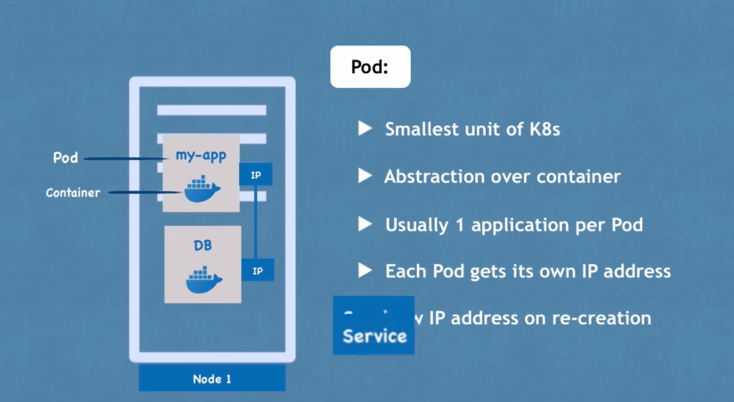

2) Service:
- It is a permanent IP address that can be attached to the each pod. The life cycle of pod and service is not connected means if pod die service still exist and thus when new pod is created he will get the same ip address from the service.
- There are 2 types of services: internale service (that is only accesible from within the node), external service(that can be accessible from the outside of the node).
- Services also do the load balancing.
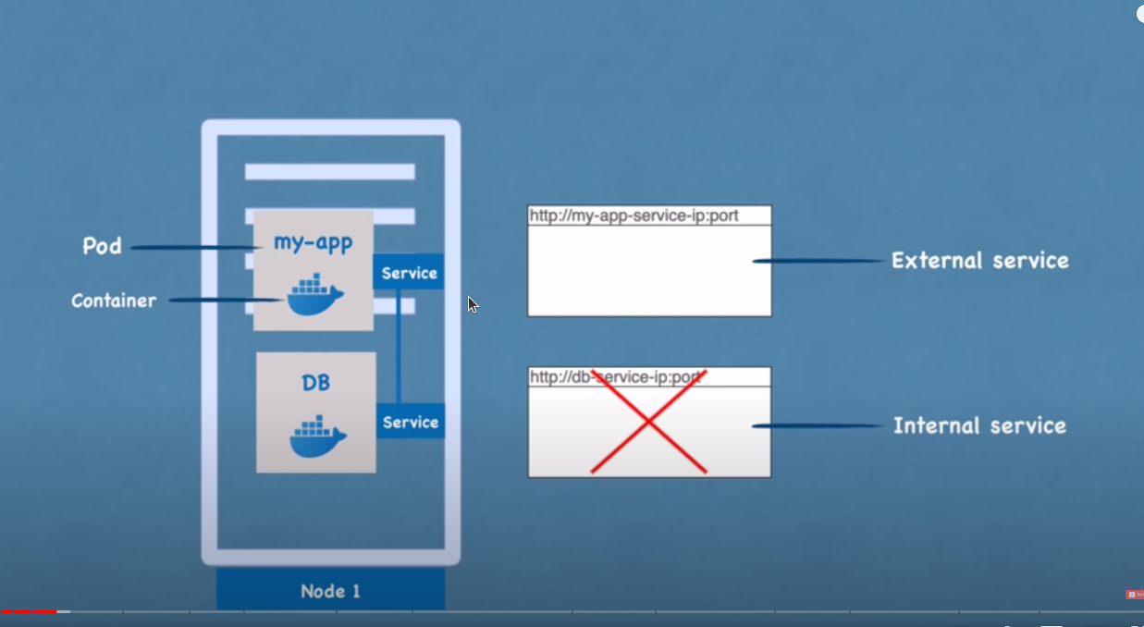

3) Ingress:
- The request coming from the outside first goes to ingress and then ingress forward that request to the service.

4) configMap:
- suppose we have nodejs application and we are connecting the database with that. So usually we put the database configuration like ports etc inside application.properties files. But suppose we need to change the url of db then we will follow following steps:
1) change in local
2) rebuild image
3) push the image into repo
4) pull that image in to pod
this is so much work to do for just simple task. So for this kubernetes
config map.
- ConfigMap conatins the configuration of application like database url etc.
- We connnect the ConfigMap with pod and pod gets the application data
- Now if we want to make some changes in the properties we will just change those inside configMap and the changes will be reflected in the pod.

5) Secret:
- Usually the username and password of admin also come inside application properties file but putting them directly in configMap in plain text is not secure so for this kubernetes have component called Secret.
- Everything in secret and configMap is same the difference comes in data storage. Secret keep data in base64 encoded format whereas the configMap store data in plain text.
- We can read the data from configMap and secret with the help of environment variables.
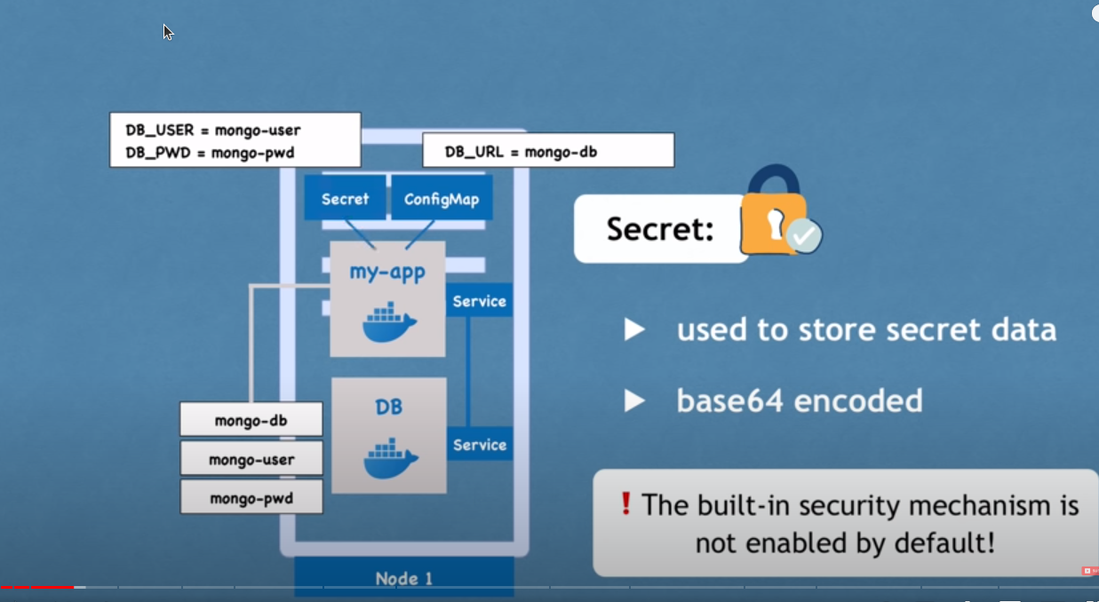

6) Volumes:
- If the pod gets restarted or killed than the data associated with that will be deleted permanently and that is problamatic.
- So to avoid this we use concept of volumnes.
- In volumnes we plug the physical data storage with the pod.
- The physical data storage can be either on same node. Or it can be some another storage outside the kubernetes cluster for eg on s3 etc.

7) Deployment:
- it is abstaction on top of pods. So we dont directly work with the pods but we work with the deployment and in deployment we mention all the things like how many replica will be there for given pod etc.

7.1) Distributed System and Containers:

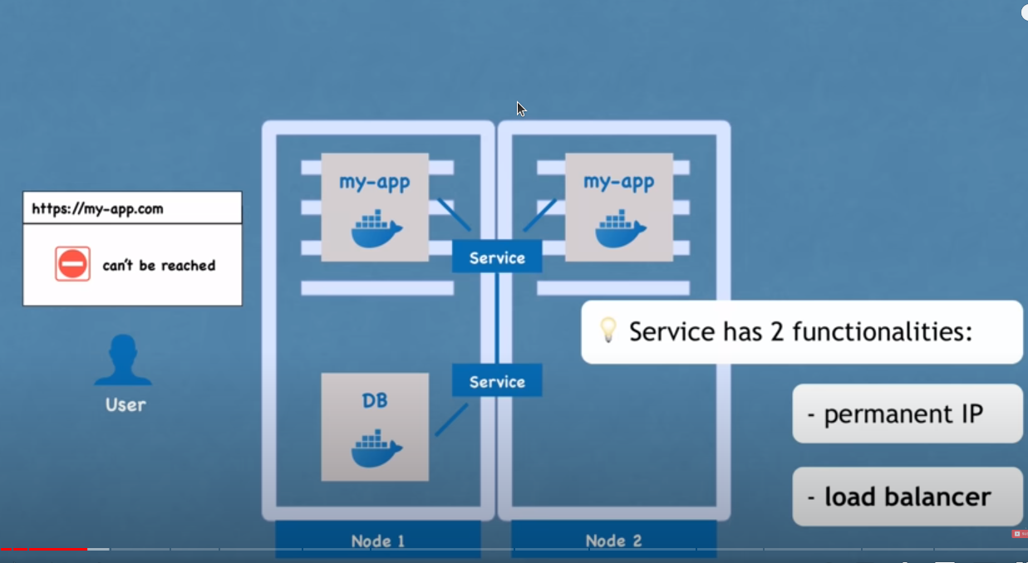
- in the above image we have 2 pods for my-app. We have not created the new pod for the replication but we have used the replication that we define inside the Deployment.
- The main advantage of replication is that we one of the pod is dead the service will forward the request to the replica and user will get the high availability.

8) StatefulSet:
- We can not replicate the database pod from Deployment. The reason for that is database has a state which is its data meaning that if we have clones and replica of database they will need to access the same shared data storage. And here we need some kind of mechanism that can tell us which pod is currently reading and writing data to storage in order to avoid data inconsistancy and this feature is offered by StatefulSet component of kubernetes.
- So all the database and other container that use file storage should be replicated using StatefulSet not deployment.

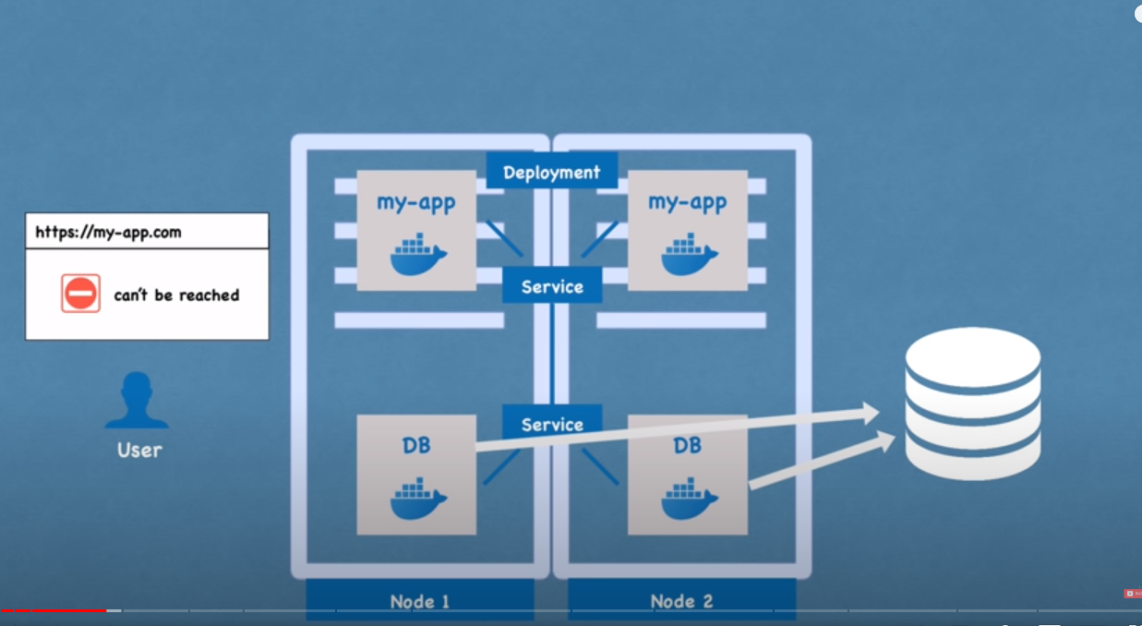

9) Nodes:
- A pod always run on a node.
- A node is a worker machine in kubernetes and maybe either a physical and virtual machine, depending on the cluster
- Each node is managed by the control plane
- A node can have multiple pods running on it.
KUBERNETES ARCHITECTURE:

