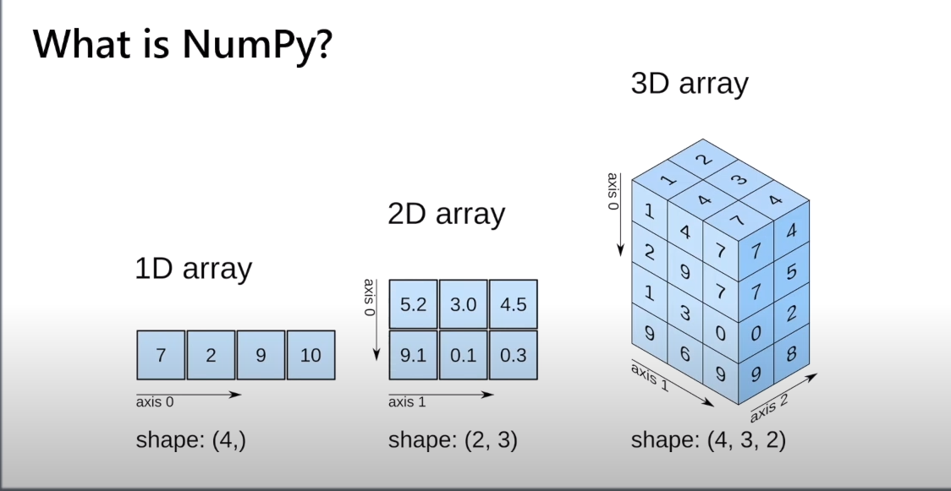

Why Use Numpy over lists:
- Because it is fast as compared to list.
- It is fast because it uses the fixed types. And it store less info regarding each element less info means less bytes. And thus the numpy is fast as compared to the list.
- Numpy store array in continous location whereas list store the array elements at scatterred positions. Lists are kind of linked list in c++.




