
FRTB INTERNAL MODELS APPROACH · MAR32 BACKTESTING
Actual P&L and Hypothetical P&L
What each one is, exactly where they diverge,
and why the backtest runs against both

Two measures built from one book on one day — what goes into each,
why the difference is narrower than it looks, and what a breach costs
Prepared by · Market Risk — FRTB Programme
Monetary figures in the exhibits are illustrative

Contents
1. Executive summary — two measures, one governing rule
2. What the two measures are
3. Why the backtest runs against both
4. What the backtested model must contain
5. The boundary — what is in each measure, item by item
6. Valuation adjustments — the branching half of the boundary
7. What a breach triggers
8. Check your own implementation
9. Bottom line
Appendix — Scope note: what this document deliberately excludes
References

1. Executive summary — two measures, one governing rule
A bank using the internal models approach must show that its value-at-risk model stands up against what actually happened. The one-day VaR measure is compared against each of the actual P&L (APL) and the hypothetical P&L (HPL) over the prior 12 months (MAR32.4). Two comparisons, not one, and neither is optional.
The two measures are built from the same book on the same day. They differ only in what they are permitted to contain. HPL freezes the book at the previous day's close and revalues it with today's market data — it is the market's effect on a book nobody touched. APL is the desk's real P&L for the day, so it also carries intraday trading and new deals. Both, however, are stripped of the same set of items: fees, commissions, and any valuation adjustment that is capitalised elsewhere in the framework.
THE ONE-LINE VERSION HPL asks whether the model captures the market; APL asks whether the model's static-book assumption survived contact with a real trading day. Exceptions are counted separately against each, and the number that governs the capital consequence is the greater of the two.
The two measures do carry different diagnostic information — an APL breach points at the trading day, an HPL breach at the model — and Section 4 uses that. The consequence, though, is common to both. Exceptions are tallied separately for APL and for HPL, and the number that counts is the greater of the two, at bank-wide and desk level alike (MAR32.5(1), MAR32.18(1)); the backtesting add-on is set on that same maximum (MAR33.42(4)). A desk comfortably inside the limit on APL and outside it on HPL has failed, and the reverse holds equally.
2. What the two measures are
2.1 Hypothetical P&L
Hypothetical P&L revalues the positions held at the end of the previous day using the market data of the present day (MAR32.25). The book is static: positions from yesterday, market data from today. Reversing those two dates is the most common error in circulating summaries of this measure, so it is worth fixing the direction before anything else.
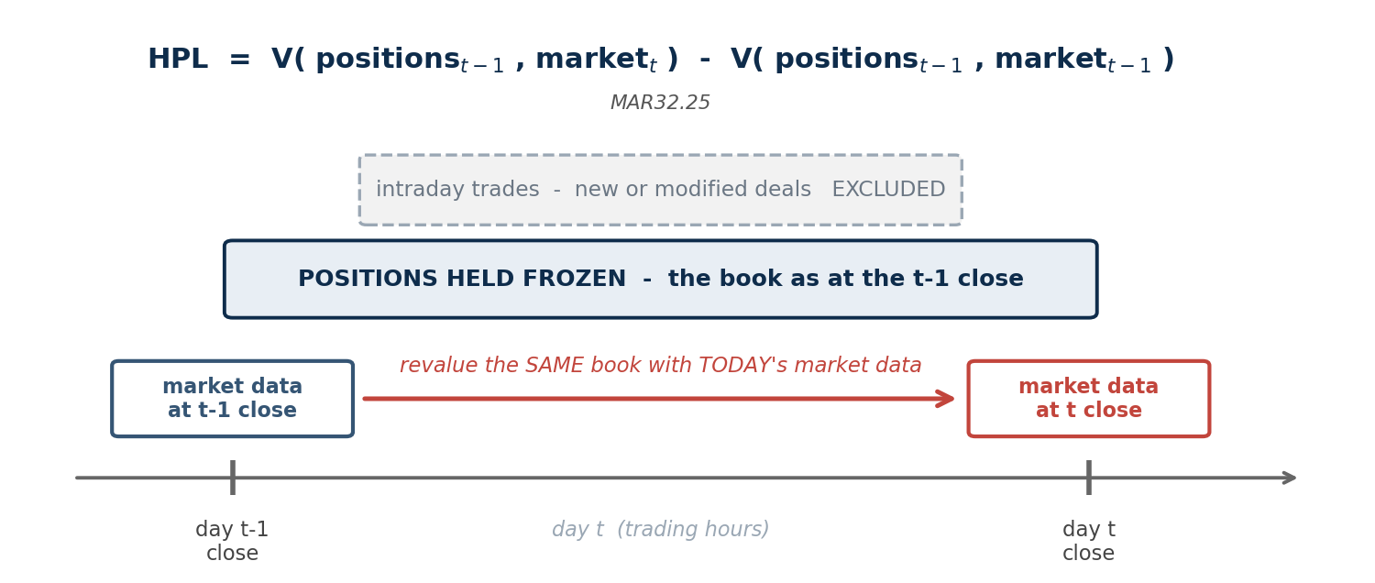
Exhibit 1. The HPL construction under MAR32.25. The book is frozen at the previous day's close and revalued forward onto today's market data. Anything the desk did during the day — intraday trades, new or modified deals — is excluded by construction. Reversing the two dates is the single most common error in internal summaries.
Because the book is held still, HPL takes in no intraday trading and no new or modified deals — the point on which it parts company with APL (MAR32.25). Two scope items travel with both measures and are easy to drop when a desk assembles its P&L feed: foreign denominated positions, and commodities held in the banking book.
2.2 Actual P&L
Actual P&L starts from the P&L the bank genuinely books and reports, and is then adjusted. Both APL and HPL are computed on the same pricing models as that reported figure — the same pricing functions, pricing configurations, model parametrisation, market data and systems (MAR32.29). From that starting point, fees, commissions and the valuation adjustments capitalised elsewhere in the framework are removed (MAR32.26 to MAR32.28, set out in Sections 5 and 6). What remains — market movement, intraday trading, new and modified deals, and market-risk valuation adjustments — is APL.
WHERE APL COMES FROM Both measures are tied to the pricing stack behind the bank's reported daily P&L, so APL derives from the official books and records rather than from a desk's own view of its day. That anchoring is what gives the backtest its bite: a comparison against a P&L the bank does not actually report would discipline nothing.
3. Why the backtest runs against both
Both comparisons are required (MAR32.4). Each carries information the other cannot, and the reason follows directly from the boundary in Sections 5 and 6.
3.1 What HPL tests
HPL holds the book still, and that is what makes it a controlled experiment. To see why, follow the timing rather than the definitions.
When | What happens | Which book
End of day t-1 | The risk system takes a position snapshot. | book B
End of day t-1 | VaR is computed from that snapshot: on this book, tomorrow, a 1% chance of losing more than the stated amount. | book B
Day t | The market moves. The desk may also trade. | —
End of day t | HPL revalues the snapshot at today's prices. | book B
End of day t | APL reflects the day the desk actually had. | book B + whatever was traded
Exhibit 2. VaR is a forecast about one specific portfolio. HPL scores that forecast against the same portfolio; APL scores it against a portfolio the model never saw.
That like-for-like property is the whole point. The VaR number was a statement about book B, and HPL measures what happened to book B. APL deliberately does not. It scores that same forecast against the book the desk actually ran — which is precisely how it catches a snapshot that stopped being representative of the day.
Because trading is excluded by construction, an HPL exception has only two possible causes, and both of them are the model's.
What failed | What it means | How it usually shows up
The forecast distribution is too narrow | The model assumes market moves are less extreme than they are — understated volatility, correlation, or tail weight. The 99% line is drawn too close in, so it is crossed more often than one day in a hundred. | Exceptions spread across many desks and many days
The pricing of the frozen book is wrong | The model gets the market move right but the portfolio's response to it wrong — a missed convexity, a delta approximation where gamma matters, a mispriced exotic. | Exceptions concentrated in particular products
Exhibit 3. The two ways a risk model can fail an HPL backtest. Neither has anything to do with how the desk traded, which is what makes the diagnosis actionable.
3.2 What APL tests
APL is the book the desk actually ran. The VaR number was produced from a position snapshot and rests on the assumption that the snapshot is representative of the day. APL is what tests that assumption. A desk can start the day inside its limits, build and unwind a far larger position during the session, and end flat — a sequence that leaves HPL untouched while generating real P&L and real risk.
THE PRACTITIONER'S FRAMING HPL tests the model. APL tests the assumption the model is entitled to make — that a once-a-day position snapshot describes the desk's exposure. Dropping either comparison leaves one of those two questions unasked.
3.3 Why the control matters — two days on one desk
Take a desk whose VaR is EUR 2m, and compare two days. The contrast shows what would be lost if only one of the two measures were backtested.
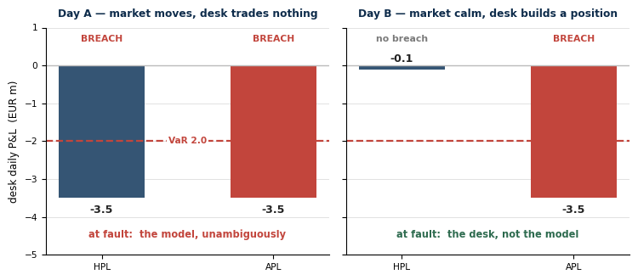
Exhibit 4. Same desk, same VaR threshold, two different days. On Day A nothing changed except the market, so an HPL breach can only be the model. On Day B the frozen book barely moved while the desk's real book lost 3.5 — the model is exonerated by HPL and the desk is caught by APL. Illustrative.
THE ATTRIBUTION PROBLEM HPL SOLVES On Day B, a bank holding only APL would face an unanswerable question: was that the model underestimating risk, or the desk taking on more than the snapshot implied? HPL settles it — it did not breach, so the model was sound and the exposure was built during the day. Running both measures is what converts a breach into a diagnosis rather than an argument.
4. What the backtested model must contain
4.1 Three models, three risk-factor scopes
A natural question at this point is which risk factors the VaR measure being backtested has to carry — and in particular whether non-modellable risk factors belong in it. They do, and the requirement is explicit. The confusion arises because three different things get called “the model”, and they have deliberately different scopes.
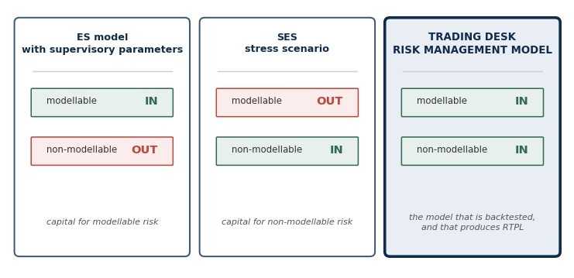
Exhibit 5. Three models, three risk-factor scopes. Only the trading desk's risk management model carries both sets — and that is the model the backtest assesses.
Two provisions settle it. First, it is the desk's risk management model whose performance is tested: MAR32.16 states that its performance “will be tested through daily backtesting”. Second, MAR32.22(1) tells you what that model must hold — all risk factors in the bank's expected shortfall model with supervisory parameters, and any risk factors deemed not modellable which are consequently excluded from the ES model and capitalised as non-modellable risk factors instead. The converse also binds: RTPL must not take into account any risk factor the bank does not include in that model (MAR32.22(2)).
THE IMPLEMENTATION TRAP Building the backtesting VaR from the capital ES factor set. That set deliberately omits non-modellable risk factors, because MAR33.16 capitalises them separately through the stress scenario requirement. Inherit that scope and the model breaches MAR32.22(1) — and PLA breaks at the same time, since RTPL is produced by the same model.
There is a structural reason the requirement has to work this way. HPL contains the non-modellable risk factor's move. The front office revalues everything it holds; it does not consult the risk factor eligibility test before pricing. A VaR measure that cannot see the factor would therefore be tested against a P&L that can — and the same asymmetry would sink the PLA test, where RTPL is compared with that identical HPL.
4.2 How a non-modellable factor is actually carried
Being non-modellable means the factor failed the real-price criteria of the risk factor eligibility test. It does not mean the bank is barred from forecasting it. MAR32.23 draws exactly that distinction: movements in all risk factors contained in the model “should be included, even if the forecasting component of the internal model uses data that incorporates additional residual risk”.
The paragraph then works an example — a multifactor beta-based index model capturing event risk, where “alternative data” calibrates the residual component to reflect potential events absent from the name-specific history. Because the name is a risk factor in the model, the bank includes its actual return in RTPL and in HPL, and “receive[s] recognition for the risk factor coverage of the model”.
The requirement | What it means in practice
The risk factor must be represented in the model | It appears in the factor set, drives revaluation, and its actual return flows into RTPL and HPL.
Its forecasting component may use other data | Proxy series, related-factor mapping, alternative or augmented data — whatever supports a defensible distribution where real prices are sparse.
Anything capitalised by neither ES nor SES | Is excluded from the risk-theoretical P&L altogether (MAR33.16 FAQ1). The model's factor set is the union of what ES covers and what SES covers, and nothing beyond it.
Exhibit 6. Representation and calibration are separate obligations. The eligibility test governs how a factor is capitalised, not whether the risk model is allowed to contain it.
5. The boundary — what is in each measure, item by item
The whole distinction reduces to the table below, and the useful surprise in it is how narrow the gap is. Only two things separate the two measures: intraday activity, and the treatment of valuation adjustments that are not updated daily. Every other line is either in both or out of both.
Component | In APL? | In HPL? | Provision
Market moves on end-of-previous-day positions | Yes | Yes | MAR32.25
Intraday trading | Yes | No | MAR32.25
New or modified deals | Yes | No | MAR32.25
Fees and commissions | No | No | MAR32.26
CVA and its associated eligible hedges | No | No | MAR32.26
VAs deducted from CET1 (eg DVA) | No | No | MAR32.26
Other market-risk VAs, updated daily | Yes | Yes | MAR32.27
Other market-risk VAs, not updated daily | Yes | No* | MAR32.27
P&L from the passage of time (theta, carry, funding) | Yes | Consistent with APL and RTPL | MAR32.27
FX positions and banking-book commodities | Yes | Yes | MAR32.25
VAs not computable at desk level | Bank-wide only | Bank-wide only | MAR32.28
Exhibit 7. The complete APL/HPL boundary under MAR32.25–32.28. *Included in HPL only if updated daily, unless the bank has specific supervisory agreement to exclude; smoothing of valuation adjustments that are not calculated daily is not allowed.
5.1 Fees and commissions leave both measures
Fees and commissions are excluded from both APL and HPL, together with valuation adjustments that are capitalised elsewhere in the framework — credit valuation adjustment and its eligible hedges — and those deducted from Common Equity Tier 1, such as the debt valuation adjustment (MAR32.26).
WHY THIS MATTERS MORE THAN IT LOOKS It answers a question desks often get stuck on: *how does a VaR model account for fees and commissions?* It does not have to. They are taken out of both measures before the comparison happens, so no model is asked to forecast them and no reserve mechanism is needed to explain the gap.
Bid-ask behaves differently, and the two are often bracketed together by mistake. A close-out or bid-ask valuation adjustment is a market-risk valuation adjustment, so it stays in APL however often it is updated, and enters HPL only if it is updated daily (MAR32.27). Fees leave; bid-ask does not.
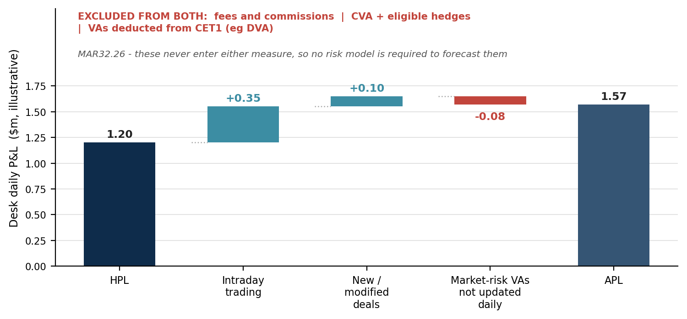
Exhibit 8. From HPL to APL. Only intraday activity and the non-daily market-risk valuation adjustments sit between them. The block along the top never enters either measure, which is why no risk model is asked to forecast it. Figures are illustrative.
6. Valuation adjustments — the branching half of the boundary
6.1 Four questions, in order
Valuation adjustments take up half the boundary table because they are the only part of it with real branching. The standard does not hand you a list of adjustments and their destinations; it gives a test, and the bank applies it to whatever sits on its own books. Four questions settle any adjustment, and the order matters — the first one that answers *yes* stops the process.
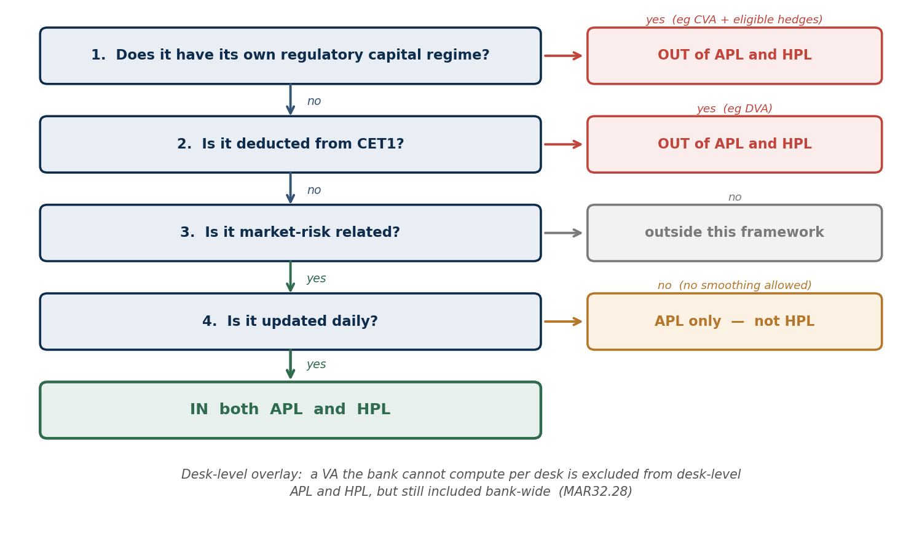
Exhibit 9. The test from MAR32.26 to MAR32.28. Questions 1 and 2 remove an adjustment from both measures; question 4 is the only one that creates a difference between them. The desk-level overlay is applied last, and only to desk-level backtesting.
Question 1 is about double-counting: if an adjustment is already capitalised under its own regime, letting it into a market-risk backtest would charge for the same risk twice. Question 2 is the mirror image — an adjustment already deducted from CET1 has been taken out of capital directly, so it does not belong in the P&L being tested. Both tests are about the treatment the adjustment receives elsewhere, not what it is called.
WHY “DEDUCTED FROM CET1” DOES NOT MEAN PENALISED Question 2 reads like a punishment and is the opposite. DVA is the gain a bank books when its own credit quality deteriorates: its liabilities are worth less, so fair value accounting records a profit — the bank looks more profitable as it moves closer to failing. The capital standard is precise about the remedy, and the verb it uses is derecognise, not penalise. It removes a profit the bank could never realise as a going concern, since monetising it would mean defaulting, or buying back its own debt at distressed prices with cash it would not have. Once capital has derecognised it, admitting it to APL or HPL would test the model against P&L carrying no capital consequence.
CAP30.15 sets it out directly. Banks must “derecognise in the calculation of Common Equity Tier 1, all unrealised gains and losses that have resulted from changes in the fair value of liabilities that are due to changes in the bank's own credit risk”, and “in addition, with regard to derivative liabilities, derecognise all accounting valuation adjustments arising from the bank's own credit risk.” Three things follow from that sentence.
- It is symmetric. Gains *and* losses go. An own-credit improvement is filtered out on the same basis, so this is full derecognition rather than a one-way ratchet.
- Derivative DVA is caught explicitly. The second limb names derivative liabilities separately, so the treatment does not depend on whether the exposure sits in issued debt or in a swap book.
- CVA and DVA may not be netted. CAP30.15 closes with the rule that “the offsetting between valuation adjustments arising from the bank's own credit risk and those arising from its counterparties' credit risk is not allowed.”
THE MIRROR, AND WHY IT DOES NOT CLOSE CVA and DVA are economic reflections of each other, and both leave these measures — CVA at question 1 because it has its own capital regime, DVA at question 2 because it has been derecognised. The netting prohibition is what stops a bank treating them as a single pair that cancels: they are removed separately, by different gates, and a P&L feed that nets one against the other before applying the test has already gone wrong.
Prudent-valuation adjustments sit in a different chapter again — CAP50 — which is not held locally, so the AVA treatment described earlier remains the reading rather than a quoted rule.
Question 4 is the one that separates APL from HPL, and it is a fact about the bank's process, not about the adjustment itself. The same reserve sits in both measures at a bank that recalculates it daily, and in APL alone at a bank that recalculates it monthly.
Valuation adjustment | Where it lands | Which question decides it
Credit valuation adjustment (CVA) and its eligible hedges | Out of both | Q1 — own capital regime. Named in MAR32.26.
Debt valuation adjustment (DVA) | Out of both | Q2 — deducted from CET1. Named in MAR32.26.
Prudent-valuation AVAs (close-out, model risk, concentration …) | Out of both | Q2 — AVAs are a CET1 deduction, so the Q2 test catches them even though MAR32.26 names only DVA.
Bid-offer / close-out cost reserve, recalculated daily | Both | Q4 — market-risk related and daily, so it reaches HPL too.
Model-uncertainty reserve, recalculated monthly | APL only | Q4 — market-risk related but not daily. No smoothing.
Concentration reserve, recalculated monthly or on review | APL only | Q4 — same reasoning.
Funding cost / carry on the position | APL | Not an adjustment at all — a time effect, named in the MAR32.27 footnote, and treated consistently across APL, HPL and RTPL.
Funding valuation adjustment (FVA) | APL; HPL if daily — but see note | Not Q1: unlike CVA, FVA has no separate capital regime. Q2 does bite on any own-credit portion derecognised alongside DVA. The remainder is market-risk related and falls to Q4.
Any VA assessed on the bank's overall position, not per desk | Bank-wide only | MAR32.28 desk-level overlay.
Exhibit 10. Only the first two rows are named in the standard. The rest show where the test lands on adjustments a trading book commonly carries — each remains the bank's own determination, and the update frequency describes a process, not a property of the adjustment.
FVA DESERVES ITS OWN LINE Two distinct quantities travel under the funding heading and they are governed by different rules. Funding cost or carry is the daily cost of holding the position — a time effect (Section 6.4), not a valuation adjustment. FVA is an adjustment to the fair value of uncollateralised derivatives reflecting expected funding over the life of the trade, and it runs the four questions. It is not caught by question 1: unlike CVA, FVA has no separate regulatory capital regime, which is itself an argument for its market risk being captured here. But its own-credit component overlaps DVA, and any portion derecognised from CET1 on that basis leaves both measures at question 2. MAR32 never names FVA, so the split is the bank's determination — and one worth documenting.
WHAT ACTUALLY STOPS AN ADJUSTMENT BEING DAILY Rarely the arithmetic. Bid-offer spreads on liquid instruments arrive from data providers and market makers every day, and most banks do recalculate and post that reserve daily — so it clears the question 4 test and reaches both measures. What blocks a daily calculation is the input: exotic and illiquid positions have no observable two-way market, so their spreads come from monthly consensus services or periodic broker surveys. Concentration add-ons depend on an exit-horizon judgement that is reviewed, not observed. Where the input refreshes monthly, the adjustment cannot be daily however capable the engine is.
6.2 What the non-daily rule does to a desk's P&L
The prohibition on smoothing is what gives question 4 teeth. Take a desk carrying a model-uncertainty reserve of EUR 4.0m that is recalculated and posted monthly. At the next review it moves to EUR 4.6m. That EUR 0.6m lands in APL in full, on the single day the reserve is recalculated — it may not be spread across the month — and it never enters HPL at all, because the reserve is not updated daily.
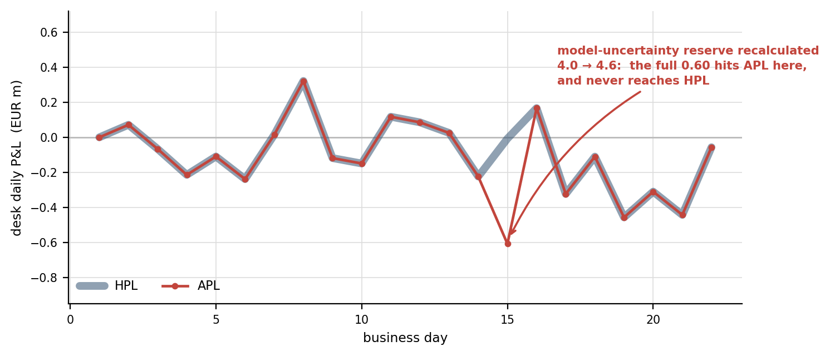
Exhibit 11. The same desk, the same market, two measures. For twenty-one days APL and HPL track each other; on the day the reserve is recalculated they separate by the full EUR 0.6m and then converge again. Illustrative.
WHAT THIS MEANS ON A BACKTESTING DAY A reserve revision can push APL through the VaR threshold on a day when HPL is unremarkable — an exception driven entirely by a valuation process, not by the market or the model. It still counts. This is worth knowing before it happens, because MAR32.12 requires an explanation for every exception, and *“the monthly reserve was recalculated”* is a far easier answer to give if the calendar was understood in advance.
6.3 Bid-offer: one reserve, two different books
Bid-offer is the adjustment worth working through in full, because its split between the two measures lands precisely on the theme of this note. Trading books are marked at mid, but a position is exited at the bid or the offer. A bid-offer reserve bridges that gap, sized in the usual way as the net risk in each bucket multiplied by half the quoted spread. The standard does not prescribe that methodology — it only decides where the resulting P&L goes.
The reserve therefore moves for two reasons: the market's spread changes, and the desk's net position changes. That second driver is what splits APL from HPL. Take a EUR swaps desk in the 10-year bucket, with the reserve recalculated daily so it qualifies for both measures.
 | At t-1 close | At t close
Net PV01, 10y bucket | EUR 80,000 / bp | EUR 140,000 / bp (desk added risk during the day)
Half bid-offer spread | 0.20 bp | 0.30 bp (spreads widened)
Bid-offer reserve | EUR 16,000 | see below
Both measures now apply the same formula and the same widened spread. They differ only in which book they apply it to — and HPL, by construction, is still holding the previous day's positions.
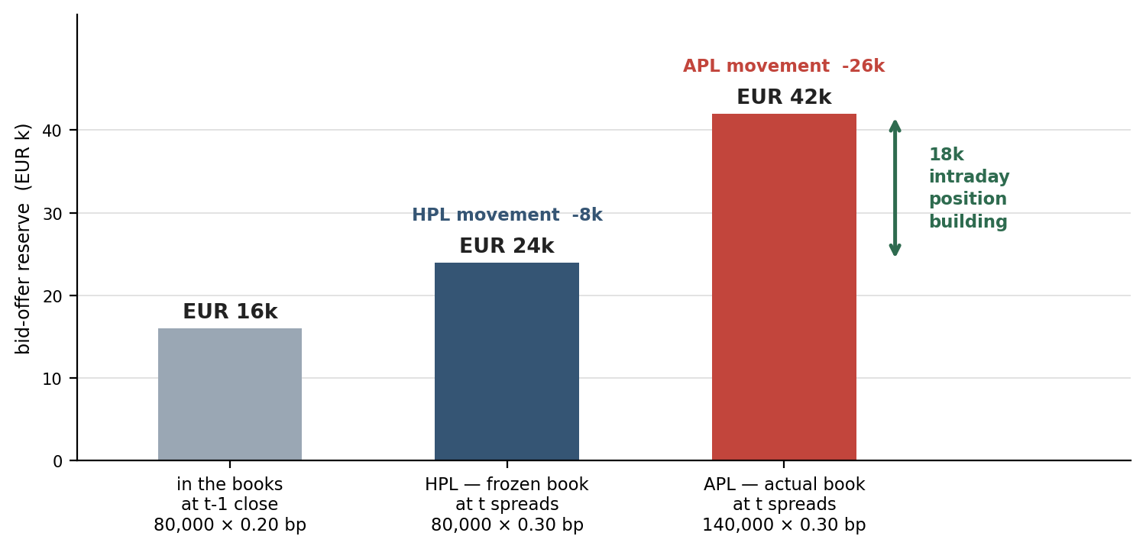
Exhibit 12. A rising reserve is a loss, so both movements are negative. HPL records −8k: the spread widening acting on a book nobody touched. APL records −26k: the same widening on the larger book the desk actually built. Illustrative figures.
WHERE THE 18k COMES FROM Not a market move, and not a model failure. The desk simply carried more risk through the widening than the frozen book did, and the bid-offer reserve priced it. The gap between the two measures on this one adjustment is the intraday position effect, expressed in euros — the same effect Section 3 describes in the abstract.
Two traps sit close to this example. The first is concluding that bid-offer is excluded because VaR is a mid-to-mid measure; what VaR does has no bearing on what APL and HPL contain, and a daily bid-offer reserve is in both. The second is confusing the accounting bid-offer reserve above, which hits fair value and P&L, with the close-out cost AVA under prudent valuation, which is a CET1 deduction and therefore leaves both measures at question 2. Same underlying spread, opposite destinations, and a genuine reconciliation break if the two are run together.
6.4 Time effects
P&L arising from the passage of time belongs in APL, and must be treated consistently across APL, HPL and RTPL (MAR32.27). Time effects here mean theta — the sensitivity of price to the passage of time — together with carry and funding costs. Note what the obligation is: consistency of treatment, not a particular treatment. Inconsistent handling of theta and carry between the front-office and risk engines is a routine source of attribution noise, and it is avoidable.
7. What a breach triggers
7.1 How the VaR you are measured against is calibrated
Before counting breaches it is worth being precise about the threshold they are counted against, because the calibration is prescribed and is not what most people assume. MAR32.18 requires the desk's one-day VaR to be calibrated to “the most recent 12 months' data, equally weighted”. Every observation in the window carries the same weight — roughly 1/250 — so yesterday's return and one from eleven months ago count identically.
What that rules out is exponential decay, the EWMA scheme in which recent observations are weighted more heavily. Decay makes VaR responsive: it jumps after a turbulent day and falls away quickly in calm markets. Equal weighting removes that responsiveness deliberately.
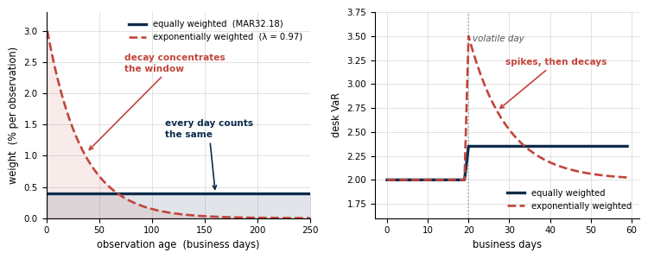
Exhibit 13. Left: how the twelve months are weighted under each scheme — under decay the oldest half of the window is close to weightless. Right: what that does to VaR after a volatile day. The decay factor would otherwise be a free parameter, and a bank could choose it to suppress its own exception count.
The MAR32.18 FAQ marks the boundary precisely, and the asymmetry in it is deliberate. Volatility scaling “at the discretion of the bank that results in a shorter observation period being used is not allowed”. But a bank “may scale up the volatility of all observations for a selected (group of) risk factor(s) to reflect a recent stress period”, and may use that scaled data “only after ex ante notification of such a scaling to the supervisory authority”. Scaling up uniformly is permitted with prior notice; anything that effectively shortens the window is not.
DO NOT CARRY THIS ACROSS TO THE CAPITAL MODEL This specifies the backtesting VaR only. The expected shortfall model used for capital is calibrated under entirely different rules in MAR33 — a stress period, liquidity horizons, and the scaling those require. The two calibrations answer different questions and should not be reconciled to each other.
7.2 The counting rule
An exception occurs when either the actual loss or the hypothetical loss exceeds the corresponding daily VaR measure. Exceptions for actual losses are then tallied separately from those for hypothetical losses, and the overall number is the greater of the two tallies — the same rule at bank-wide and at desk level (MAR32.5(1), MAR32.18(1)). Where either the P&L or the risk measure is unavailable or impossible to compute, that day counts as an outlier.
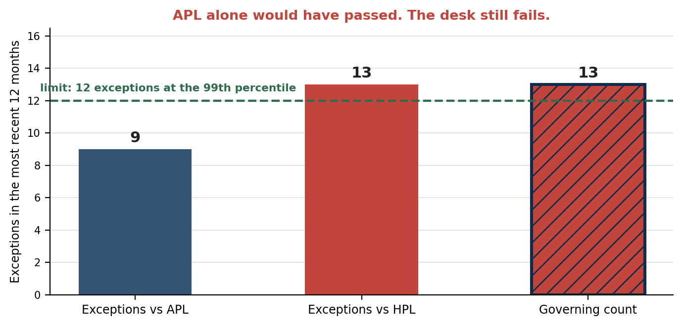
Exhibit 14. The counting rule, illustrated at the 99th percentile desk-level limit of 12. APL and HPL exceptions are tallied separately and the larger tally governs, so a desk cannot pass on the strength of the more favourable measure. Counts are illustrative.
Level | VaR percentile | Governing count | Consequence
Bank-wide | 99th | Greater of the APL and HPL exception counts | Backtesting zones: green 0–4 (multiplier 1.50), amber 5–9 (1.70 / 1.76 / 1.83 / 1.88 / 1.92), red 10 or more (2.00)
Trading desk | 97.5th and 99th | Greater of the APL and HPL exception counts | More than 12 exceptions at the 99th percentile, or 30 at the 97.5th, in the most recent 12 months: the capital requirement for all positions in the desk is determined under the standardised approach
Exhibit 15. Backtesting consequences. Bank-wide zones and multipliers from MAR32.8–32.9 Table 1; desk-level thresholds from MAR32.18–32.19; the maximum rule from MAR32.5(1), MAR32.18(1) and MAR33.42(4).
7.3 Desk exceptions do not add up to bank exceptions
A natural but incorrect reading of the table above is that desk exceptions aggregate into the bank-wide count — that four desks with four exceptions each somehow contribute sixteen at bank level. They do not. Bank-wide backtesting is a separate test on a separate aggregate: MAR32.5(1) counts an exception when the actual or hypothetical loss of the bank-wide trading book exceeds the corresponding daily VaR measure. Total P&L against total VaR. Desk results are never summed.
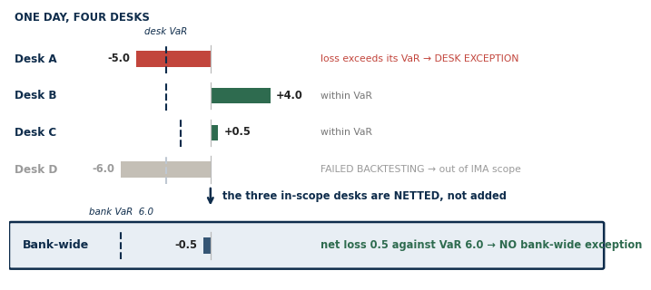
Exhibit 16. One day, four desks. Desk A breaches its own VaR and Desk D has already failed backtesting and left IMA scope. The three remaining desks net to a loss of 0.5 against a bank-wide VaR of 6.0, so there is no bank-wide exception at all. Illustrative.
Two things stop the arithmetic the intuition expects. Netting: desks that lose on a given day are offset by desks that gain, and the bank-wide measure sees only the net. Timing: desk exceptions rarely fall on the same day, and a bank-wide exception requires the bank total to breach on one specific day. Four desks with four exceptions each can therefore produce zero bank-wide exceptions.
On the related question of what happens to a failed desk: MAR32.7 requires that “the scope of the portfolio subject to bank-wide backtesting should be updated quarterly based on the results of the latest trading desk-level backtesting, risk factor eligibility test and PLA tests.” A desk that fails moves to the standardised approach under MAR32.19, and the bank-wide portfolio is re-cut to the currently model-eligible desks — quarterly, not on the day.
7.4 Why MAR32.6 still exists
If non-modellable risk factors sit inside the backtested model, the carve-out below can look contradictory. It is not, because inclusion is not calibration. A factor is non-modellable precisely because it lacks sufficient real price observations, so the twelve months of equally weighted data that MAR32.18 requires will be thin, proxied or stale for it. The factor is in the model; its forecast is weak. A genuine large move can breach VaR anyway — while the stress scenario requirement is already capitalising that same factor far above the level VaR implies.
READ THE CARVE-OUT THIS WAY MAR32.6 is not a patch for non-modellable risk factors being absent from VaR. They are required to be present. It is relief from paying twice: capital is already held for the factor through the stress scenario, so where that capital exceeds the loss, the exception need not also count against the desk.
7.5 Documentation and the carve-out conditions
Two further rules shape how exceptions are handled in practice. Every exception must be documented with an explanation (MAR32.12) — which is where the APL-versus-HPL diagnostic reasoning legitimately belongs. And an outlier may be disregarded where the bank can show it relates to a non-modellable risk factor whose capital requirement exceeds the loss for that day, with the supervisory authority notified and not objecting (MAR32.6). That carve-out extends to desk-level backtesting; the stress scenario capital requirement must be calculable for the specific desk, and must exceed the loss itself rather than the excess over VaR (MAR32.6 FAQ1). The companion note on MAR32.6 works that test through.
7.6 When APL breaches and HPL does not
The standard prescribes the consequence, not the cure. An APL-only exception counts exactly as an HPL exception does — the greater of the two tallies governs — and it walks the desk toward the MAR32.19 limits whether or not the model is at fault. Beyond documenting it (MAR32.12), MAR32 says nothing about what to do. What follows is practice rather than text, and is marked as such.
THE REFLEX TO RESIST Recalibrating the model. An APL-only breach is evidence the model did its job — HPL, the measure that isolates it, did not breach. Inflating VaR so it covers intraday activity would raise capital for risk the snapshot never held, and would break the PLA test, because RTPL must continue to track that same unbreached HPL.
The diagnosis follows from the decomposition. Since APL − HPL = intraday trading + new or modified deals + market-risk valuation adjustments not updated daily, only three things can be responsible. Identify which, then treat accordingly.
Cause | The tell | Where the remedy sits
Intraday position building | Peak intraday risk far above the end-of-day snapshot | Intraday VaR, PV01 or delta limits, intraday monitoring and escalation. Desk and market risk — not modelling.
Execution loss on round-trips | High turnover; P&L lost on fills rather than on direction | Execution quality review, transaction cost analysis.
A new or modified deal | One large trade booked during the day | Day-one P&L review, new-product approval, pricing validation for that instrument.
A non-daily valuation adjustment | The breach falls on the reserve calendar date | Nothing to remediate on risk — a valuation-process artefact (Section 6.2). Consider whether more frequent recalculation is warranted.
Booking or feed error | A divergence attributable to none of the above | Reconcile. MAR32.29 requires both measures on the pricing stack behind reported P&L, so an unexplained gap is a data-integrity problem.
Exhibit 17. A differential diagnosis for the APL-only exception. The fourth row is the cheapest to clear and the most often missed — check the reserve calendar before opening an investigation. Remedies are practice; MAR32 is silent on them.
This is where the two measures repay the cost of running both. The MAR32.12 explanation can then read: *APL breached, HPL did not; the divergence is attributable to intraday position building peaking at X against an end-of-day snapshot of Y. The market risk model performed within expectation on the static book.* That is a diagnosis with evidence. Without HPL the same entry could say only that the desk lost more than VaR predicted, which invites the model to be questioned when the model was not the problem.
WHERE THE REAL COST LANDS A desk with recurring APL-only breaches reaches 12 exceptions at the 99th percentile, or 30 at the 97.5th, and moves to the standardised approach — with a sound model. The effective remedy is therefore preventive and behavioural: intraday limits and monitoring, because those are what stop the count accumulating. The exception avoided is worth more than the explanation written.
8. Check your own implementation
Each row below is a belief that circulates widely and changes an implementation decision if acted on — not merely a form of words. Worth checking your own documentation and P&L feed against.
Common belief | The position | Reference
HPL reprices today's book using yesterday's market data | Inverted. Positions from the end of the previous day, market data of the present day. | MAR32.25
APL includes execution fees and commissions | Fees and commissions must be excluded from both APL and HPL. | MAR32.26
APL is the accounting P&L — what hits the ledger | APL is anchored to the reported daily P&L but with fees, commissions, CVA and CET1-deducted VAs removed. | MAR32.26, 32.29
The supervisory response depends on which measure breached | Exceptions are counted separately; the governing number is the greater, and the add-on is set on that maximum. | MAR32.5(1), 32.18(1), MAR33.42(4)
Bid-ask is excluded from APL along with fees | Market-risk-related VAs, which include close-out and bid-ask, remain in APL regardless of update frequency. | MAR32.27
Desk backtesting is run at the 99th percentile | Desk-level backtesting is run at both the 97.5th and the 99th percentile. | MAR32.18
VaR/ES models the intraday P&L component | Nothing in the standard asks the model to. Intraday activity is excluded from HPL by construction; APL is the control that detects it. | MAR32.25, 32.4
Exhibit 18. Beliefs that change an implementation decision. The first two rows are the ones that most often survive into production documentation.
9. Bottom line
- HPL = the previous day's book, revalued on today's market data. Positions from yesterday, prices from today (MAR32.25).
- APL = the reported daily P&L, less fees, commissions, CVA and its eligible hedges, and CET1-deducted valuation adjustments (MAR32.26, 32.29).
- Fees and commissions sit in neither. No risk model is required to forecast them (MAR32.26).
- Bid-ask and other market-risk valuation adjustments sit in APL irrespective of update frequency, and in HPL only if updated daily (MAR32.27).
- Time effects — theta, carry, funding — belong in APL and must be treated consistently across HPL and RTPL (MAR32.27).
- Both measures are backtested against the one-day VaR over the prior 12 months (MAR32.4).
- The greater of the two exception counts governs, at both bank-wide and desk level (MAR32.5(1), 32.18(1), MAR33.42(4)).
BOTTOM LINE APL and HPL are not competing views of the same day and neither is “the real one”. They are two deliberately narrow measures built from one book, differing only in intraday activity and the treatment of non-daily valuation adjustments — and the capital consequence always follows the worse of the two.

Appendix — Scope note: what this document deliberately excludes
This note covers the two backtesting P&L measures. The adjacent topics below belong to the P&L attribution workstream and are covered in its own material — listed here so you know where the boundary falls.
- Risk-theoretical P&L (RTPL) — its definition and required risk factor coverage, including the requirement at MAR32.22(1) that it carry non-modellable risk factors even though they sit outside the expected shortfall model.
- The P&L attribution test itself — the Spearman correlation and Kolmogorov-Smirnov metrics, the 250-day window, the green, amber and red zone thresholds, and the capital consequences.
- PLA data input alignment — MAR32.30 to 32.33, including the asymmetry that RTPL may be aligned to HPL inputs but not the reverse, and the prohibition on adjusting for residual operational noise.
- The 10 per cent internal models coverage requirement at MAR32.2 and the quarterly reassessment cycle.
ONE CROSS-REFERENCE WORTH CARRYING HPL is the single measure that appears in both regimes: the HPL used for the PLA test must be identical to the HPL used for backtesting (MAR32.24). So the definition in Section 2.1 is doing double duty — get the direction of it wrong and the error lands in the backtest and the attribution test at the same time.

References
Paragraph numbers cited in the body resolve here. Sources are the BCBS consolidated framework chapters held locally in ..\Regulatory texts\; no secondary source is relied on.
Provision | Subject | Where used
MAR32.4 | VaR compared against each of APL and HPL over the prior 12 months. | Sections 1, 3
MAR32.5 | Bank-wide backtesting at the 99th percentile; separate counting; the greater of the two amounts. | Sections 1, 7
MAR32.6 (+FAQ1) | Non-modellable risk factor carve-out for outliers. | Section 7
MAR32.8–32.9 | Backtesting zones and multipliers, Table 1. | Section 7
MAR32.12 | Documentation and explanation of every exception. | Section 7
MAR32.18 | Desk-level backtesting at the 97.5th and 99th percentiles; separate counting. | Sections 7, 8
MAR32.19 | Desk-level exception limits and the consequence of breaching them. | Section 7
MAR32.24 | The HPL used for PLA must be identical to the HPL used for backtesting. | Appendix
MAR32.25 | Definition of HPL; exclusion of intraday trading and new or modified deals; FX and banking-book commodities. | Sections 2, 5
MAR32.26 | Exclusions from both APL and HPL: fees, commissions, separately capitalised VAs, CET1-deducted VAs. | Sections 1, 5, 8
MAR32.27 | Valuation adjustment asymmetry between APL and HPL; time effects and its footnote. | Section 6
MAR32.28 | Valuation adjustments not computable at desk level. | Section 6
MAR32.29 | Both measures on the same pricing models as the reported daily P&L. | Sections 2, 5
CAP30.15 | Derecognition from CET1 of own-credit gains and losses on fair valued liabilities, and of derivative DVA; netting against counterparty-credit adjustments prohibited. | Section 6.1
MAR33.42(4) | Backtesting add-on set on the maximum of the APL and HPL exception counts. | Sections 1, 7

