Passing Both VaR Backtests on a Short Options Portfolio
GJR-GARCH, regime-aware trading, and causal HMM filtering

The result
A $65M equity portfolio with 150 weekly short SPX calls. 783 out-of-sample backtest days. Both Kupiec and Christoffersen pass simultaneously. Here is what the backtest looks like:
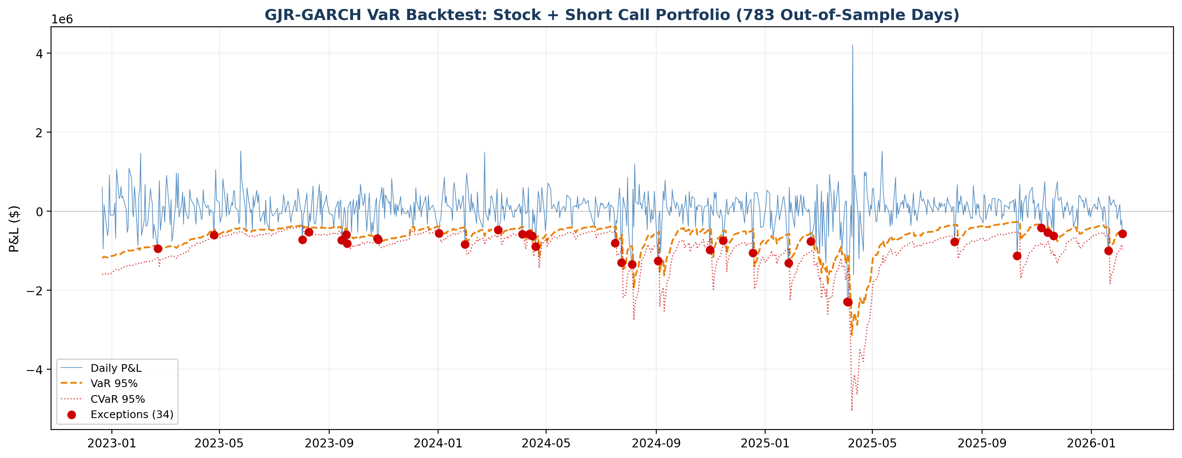
Daily P&L vs VaR threshold. 34 exceptions out of 783 days (4.3%). Red dots are VaR breaches. No persistent clustering.
Metric | Standard GARCH | GJR-GARCH
Exceptions | 37 / 783 | 34 / 783
Exception rate | 4.7% | 4.3%
Kupiec p-value | 0.722 (PASS) | 0.388 (PASS)
Christoffersen p-value | 0.006 (FAIL) | 0.061 (PASS)
Exception clusters | 6 | 4

Standard GARCH fails the independence test. One parameter change fixes it.
The difference is GJR-GARCH: a single asymmetry parameter (o=1 in the arch package) that lets negative returns spike the volatility forecast harder than positive returns. Two exception clusters eliminated. Christoffersen moves from p=0.006 to p=0.061. No regime scaling, no added complexity. Just a better volatility model for a short-gamma book.

The strategy: weekly premium capture
Every Monday, sell 150 contracts of weekly SPX calls at delta 0.25 (roughly 75% probability of expiring worthless). Hold to Friday, with two exit rules: close at 80% premium capture, or stop-loss at 2x the premium received.
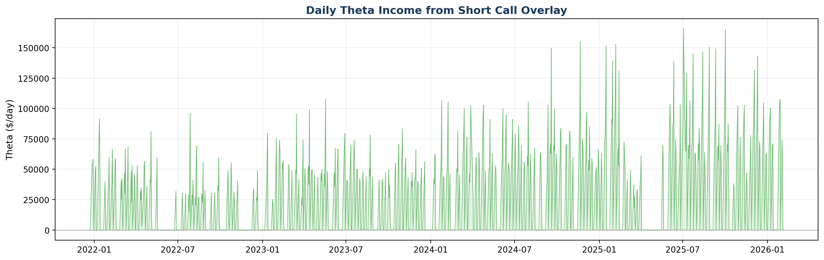
Daily theta income from the short call overlay. The steady positive theta is the premium earned through time decay.
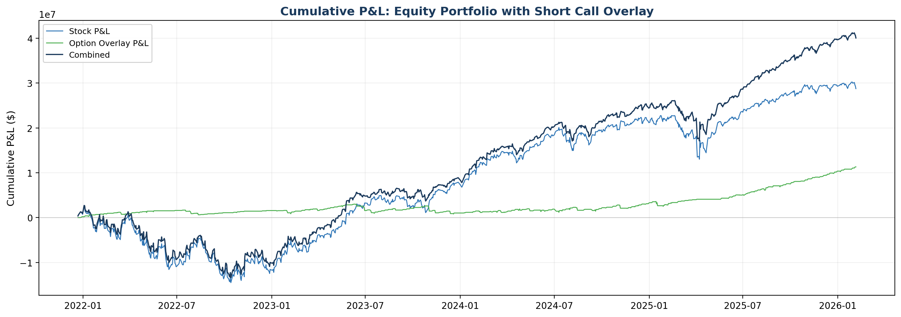
Cumulative P&L: the option overlay adds steady income on top of the equity portfolio returns.
The strategy generates steady premium income through theta decay, partially offsetting losses during flat or declining markets. Over 170 out-of-sample trades, the win rate exceeds 80%. The stop-loss at 2x premium limits damage on sharp SPX rallies where gamma acceleration would otherwise compound losses. The net contribution is modest relative to the equity book's total return; the primary purpose is volatility reduction and income smoothing, not alpha generation.

Using a regime detector for trading decisions
A 3-state Hidden Markov Model classifies each day as Calm, Caution, or Crisis using five market features: SPX returns, 21-day realized vol, credit spread changes, 10Y rate changes, and VIX.
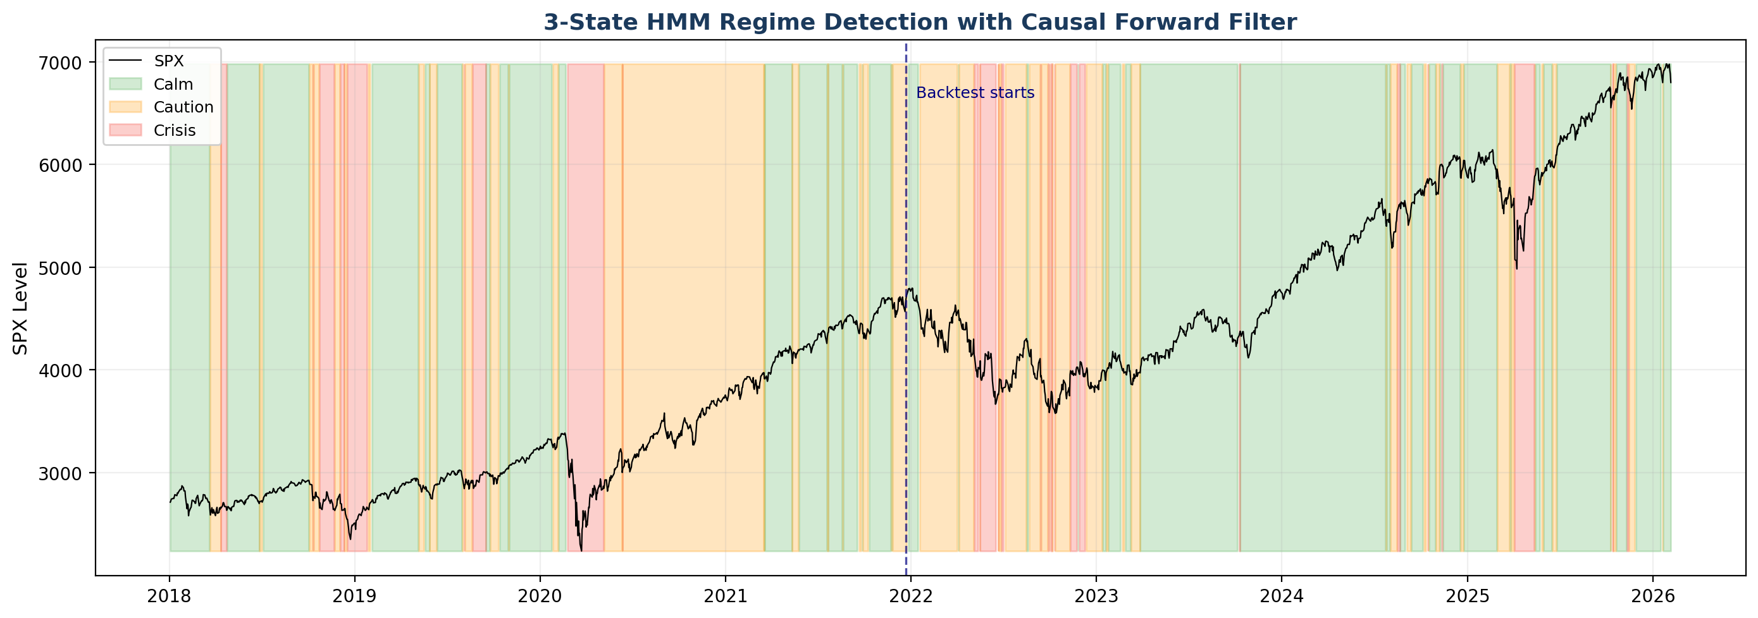
SPX with regime overlay. Green = Calm, orange = Caution, red = Crisis. Dashed line marks where the out-of-sample backtest begins.
Regime | % of days | Ann. return | Sharpe | Action
Calm | 55.7% | +20.6% | 2.03 | 150c @ d0.25
Caution | 32.4% | +17.3% | 0.88 | 100c @ d0.15
Crisis | 11.9% | -31.0% | -0.76 | No selling

In Calm markets, sell the full 150 contracts at delta 0.25. In Caution, reduce to 100 contracts at a more defensive delta of 0.15 (further out-of-the-money). In Crisis, stop selling entirely. The regime model adapts position sizing to the environment rather than running the same strategy into a crisis.
The regime model was tested for VaR scaling and deliberately excluded. It worsened the backtest by making VaR too conservative. It belongs in trading decisions, not risk measurement.
This is a deliberate design choice. With regime VaR multipliers set to 1.0, GJR-GARCH passes both backtests on its own. Adding a 1.3x Crisis multiplier pushed the exception rate to 4.2% (too conservative) and made Kupiec worse. The regime detector earns its place in trading decisions, where it genuinely adds value, not in VaR scaling, where it does not.

Greeks monitoring and risk alerts
Every active option position is repriced daily using Black-Scholes. The system tracks four portfolio-level greeks continuously and runs automated risk checks against calibrated thresholds:
Alert | Trigger | Why it matters
High gamma | Gamma loss on 1% SPX move > 0.5% of portfolio | Short gamma near expiry is where blow-ups happen
Low theta/gamma | Premium earned does not justify convexity risk | Holding for $2k theta while carrying $50k gamma risk
High delta | Option delta notional > 10% of portfolio | Directional exposure becoming material
Regime shift | Transition from Calm to Caution or Crisis | Time to review position sizing and exit rules

The 80% premium capture exit is itself a greeks-driven decision. By Thursday, most of the theta has decayed but gamma is exploding as the option approaches expiry. Closing at 80% locks in the income and eliminates the final-hours gamma risk, where a 50-point SPX move can swing a near-expiry option from worthless to deep in-the-money.
The stop-loss at 2x premium is the hard limit. At 150 contracts with $100 multiplier, a typical weekly premium is $150,000-$200,000, so the stop-loss triggers at roughly $300,000-$400,000 in unrealized loss. Over the backtest, approximately 10-15% of trades hit the stop-loss, predominantly during regime transitions.

Why 783 out-of-sample days matters
Passing Christoffersen on a 200-day window is not hard. On a short sample, clustering patterns may not reach statistical significance. The test has limited power.
This backtest covers 783 trading days from late 2022 through early 2026: the 2023 regional banking stress, the 2024 summer volatility spike, multiple Fed rate decisions, and the 2025 tariff-driven selloff. It includes 170 option trades with regime-aware sizing across all three market states. The longer the backtest, the more opportunities for clustering to appear, and the harder it is to pass Christoffersen. A p-value of 0.061 over 783 days with an active short gamma overlay is a genuinely demanding result.
Under the Basel framework, clustered VaR exceptions attract supervisory scrutiny and can trigger model risk adjustments to the capital charge. Passing both tests on a rigorous out-of-sample window avoids this entirely, directly benefiting capital efficiency.

DEEP DIVE

How GJR-GARCH breaks the clustering
The standard GARCH(1,1) variance equation treats positive and negative returns identically:
σ²(t) = ω + α × r²(t-1) + β × σ²(t-1)
GJR-GARCH adds the leverage term:
σ²(t) = ω + α × r²(t-1) + γ × r²(t-1) × I(r<0) + β × σ²(t-1)
When γ > 0, a negative return on day t-1 produces a higher variance forecast for day t than a positive return of the same magnitude. This is the leverage effect, well-documented in equity markets.

The scaling mechanism
The VaR model uses GARCH-filtered Historical Simulation. Each of the 250 historical returns in the lookback window is scaled by:
scaled_return[t] = raw_return[t] × (forecast_vol / conditional_vol[t])
The forecast vol is a single number: the model's prediction for tomorrow. The conditional vol is different for each historical day. After a negative return, GJR-GARCH produces a higher forecast vol than standard GARCH. That higher forecast vol is the numerator in every single scaling ratio. The entire 250-day distribution stretches wider. VaR, which is the 5th percentile of this distribution, moves further out. The next day's loss, which would have breached under standard GARCH, no longer breaches. The cluster is broken.
Critically, after a positive return, the γ term is zero and both models produce identical forecasts. The asymmetry only activates when it matters: after losses, which is precisely when consecutive breaches occur.

Replacing Viterbi with the causal forward filter
The standard approach to HMM state classification uses the Viterbi algorithm, which finds the globally optimal state sequence across all observations. This is a smoothing problem: day 1,001's regime label is influenced by data from day 2,000 because Viterbi optimizes the entire path using forward-backward information.
For a backtest, this is look-ahead bias. The model knows the future when it classifies the present. The fix: replace Viterbi with the HMM forward algorithm.

Filtering vs smoothing
Viterbi asks: given the entire sequence of observations from day 1 to day 2,000, what is the single most likely path of hidden states? This looks backward and forward.
The forward filter asks: standing on day t, having seen only days 1 through t, what is the most probable state right now? This is exactly what a risk manager does each morning. No peeking at next week's VIX.
The implementation uses the textbook forward recursion with log-space normalization at each step to prevent numerical underflow:
P(state_t | obs_1..t) = normalize[ P(obs_t | state_t) × Σ P(state_t | state_{t-1}) × P(state_{t-1} | obs_1..{t-1}) ]
Causality was empirically verified: day 500's regime label is identical whether the forward filter runs on 501 days or 2,000 days. The forward filter agrees with Viterbi on 94% of days. The 6% disagreement concentrates at regime transitions, where the forward filter is slightly laggier because it lacks future data to confirm the shift. This is not a flaw; it is the correct causal behaviour.

Three sources of look-ahead bias, eliminated

1. HMM training bias
The HMM trains on the first 1,000 days. The option backtest starts at day 1,001. Every regime label driving a trading decision is genuinely out-of-sample.

2. Viterbi sequence bias
Replaced with the causal forward filter (described above). Day t's classification uses only observations up to day t.

3. Feature construction bias
All HMM features are z-scored using expanding windows: the mean and standard deviation on day t use only days 1 through t. No forward-looking statistics in the inputs.

System architecture
Nine Python modules, each with a single responsibility:
Module | Responsibility
config.py | All tunable parameters in one place
data_loader.py | Excel data ingestion and preparation
option_pricer.py | Black-Scholes pricing and closed-form greeks
option_strategy.py | Weekly short call simulation with regime-aware sizing
var_engine.py | GJR-GARCH filtering, time-weighted VaR/CVaR, Kupiec and Christoffersen
regime_detector.py | 3-state HMM with causal forward filter
risk_alerts.py | Greeks-based and regime transition alerts
reporting.py | Console output and chart generation
Orchestrator | Main pipeline: load, fit, simulate, backtest, export

The configuration file centralises every parameter, from GARCH distribution choice and asymmetry toggle to option strategy sizing and regime thresholds. Switching between standard GARCH and GJR-GARCH is a single config change (GARCH_ASYMMETRY = 0 or 1). No model code touched.

Design philosophy
The most important decisions in this system were about what not to do. The regime model was tested for VaR scaling and excluded when it worsened results. Viterbi was replaced with the forward filter not because it changed the numbers dramatically but because it is the methodologically correct choice. The option backtest starts at day 1,001, sacrificing coverage for intellectual honesty about look-ahead bias.
A risk system should be defensible under scrutiny, not just numerically convenient. Both backtesting standards pass. The methodology is transparent. The capital implications are tangible.

