Docker Hub account: amitsingh583

Benefits of Container over othe VM’s:
1. Lighter weight: Unlike VMs, containers don’t carry the payload of an entire OS instance and hypervisor. They include only the OS processes and dependencies necessary to execute the code. Container sizes are measured in megabytes (vs. gigabytes for some VMs), make better use of hardware capacity, and have faster startup times.

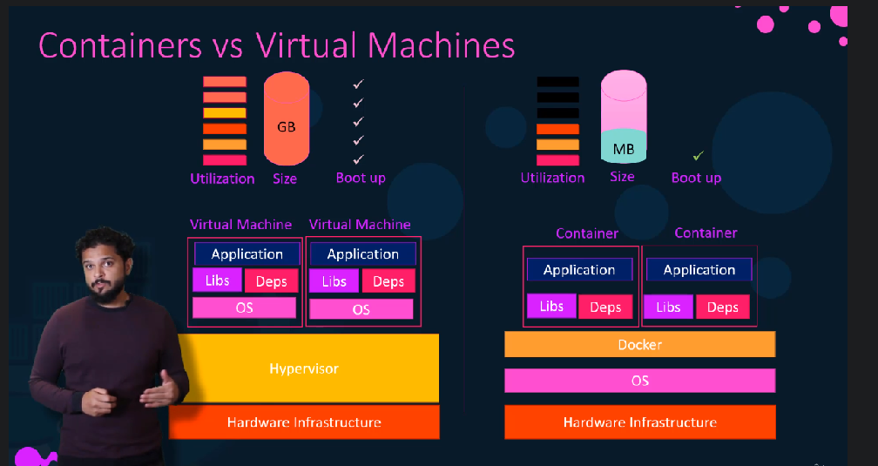

2. Improved developer productivity: Containerized applications can be written once and run anywhere. And compared to VMs, containers are faster and easier to deploy, provision and restart. This makes them ideal for use in continuous integration and continuous delivery(CI/CD) pipelines and a better fit for development teams adopting Agile and DevOps practices.

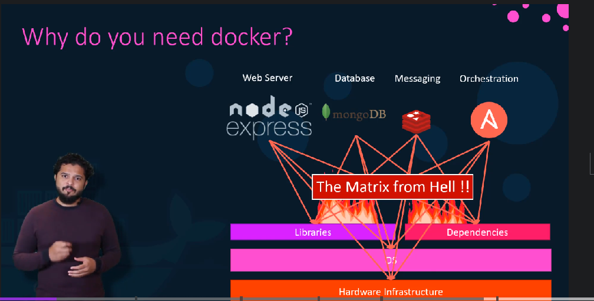

What is a container?
a container:
- is a runnable instance of an image. You can create, start, stop, move, or delete a container using the DockerAPI or CLI.
- can be run on local machines, virtual machines or deployed to the cloud.
- is portable (can be run on any OS).
- is isolated from other containers and runs its own software, binaries, and configurations.
What is a container image?
Since the image contains the container’s filesystem, it must contain everything needed to run an application - all dependencies, configurations, scripts, binaries, etc. The image also contains other configuration for the container, such as environment variables, a default command to run, and other metadata.

Shell is a CLI(Interface present between the kernel and the user.
Kernel (A kernel is the very core of a typical OS, a type of low-level program that has its interfacing with the hardware on top of which all the applications run (disks, RAM, CPU, etc.)

The Linux kernel 'user namespace”:
It allows a container to have a unique range of user and group IDs which are outside the traditional user and group range utilized by the host system.

Docker:
Docker is a containerization platform that packages your app and all its dependencies together in the form called a docker container to ensure that your application works seamlessly in any environment.

Docker helps you to create, deploy and run applications using containers.

Containerize an application:

1. Clone the getting-started repository using the following command:
$ git clone https://github.com/docker/getting-started.git

2. View the contents of the cloned repository. Inside the getting-started/app
DOCKERFILE;

A Dockerfile is simply a text-based file with no file extension. A Dockerfile contains a script of instructions that Docker uses to create a container image.DockerFile automates the process of Docker image creation
docker build -t getting-started .

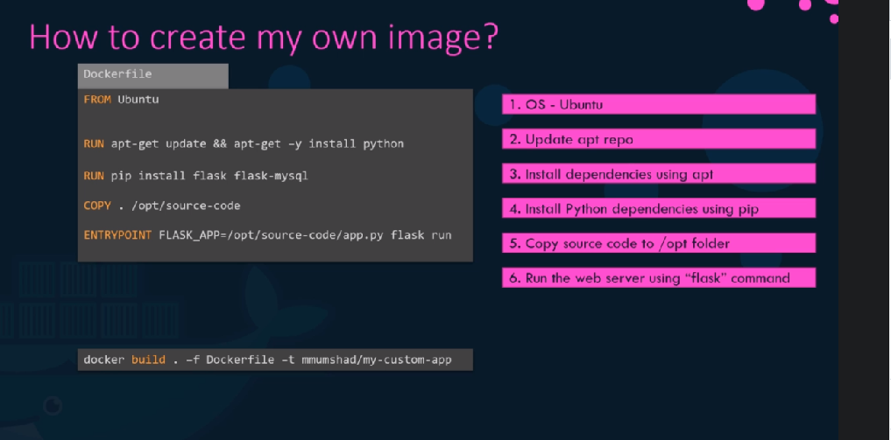

4. docker run -dp 3000:3000 getting-started
naming docker container: docker run -d -p 8000:8000 --name amit getting-started

-d flag for detached mode in background
-p flag for mapping/publishing/expose port(host’s port is mapped with container’s port)

SOME Docker file components:
RUN: execute the default command, when we are building the image.
CMD: commands given under cmd will be executed only when you run container.
If more than one instructions are there then all will be ignored because all will be overwritten by last one. See bellow examples:
FROM busybox
CMD echo "Executing CMD"
CMD echo "Executing CMD 2"

So the output of that container will be:
Executing CMD 2
Entry Point: more powerful than cmd (instructions will not be ignored)

Remove a container using the CLI:
docker ps
docker stop <the-container-id>
docker rm <the-container-id>
docker rm -f <the-container-id>(forcefully stop and remove container)

docker search imagename
docker pull imgename
docker images(all available images on local)
docker ps (all running container)
docker ps -a (all container)
docker start container-id (starting stooped container)
docker attach container-id (entering inside container)
docker diff container-id (to see all changes done after creation of container)

DOCKER EXEC:
(docker exac command Run a command in a running container)

examples:
docker exec -d mycontainer touch /tmp/execWorks
docker exec -d mycontainer pwd
docker exec -it mycontainer sh
(execute an interactive sh shell on the container)

docker rmi command:
Removes (and un-tags) one or more images from the host node.
docker rmi test1:latest (untag first all the duplicates images having different tag given to same image)
docker rmi test:latest(Now this will untag as well as delete all images )
docker rmi -f fd484f19954f(more forcefully delete all image along with other tag)

Share the application:

we’ve built an image, let’s share it! To share Docker images, you have to use a Docker registry. The default registry is Docker Hub and is where all of the images we’ve used have come from.

Docker ID
Docker ID allows you to access Docker Hub which is the world’s largest library and community for container images.

Create a repo
To push an image, we first need to create a repository on Docker Hub.
- Sign up or Sign in to Docker Hub.
- Click the Create Repository button.
- For the repo name, use getting-started. Make sure the Visibility is Public.

Private repositories
Docker offers private repositories which allows you to restrict content to specific users or teams.

4. Click the Create button.

NOTE: All the images can be pushed to a particular username.
Tag the locally created image to the docker hub. This means we have to tag the image with the docker hub username.
docker tag getting-started:1.0 amitsingh583/getting-started:1.0
docker push amitsingh583/gettingstarted:1.0

Once your docker hub account is ready: amitsingh583
docker tag amit amitsingh583/amit_1:1.0
docker login
(Enter username and passwd)
sudo docker tag amitsingh583/amit_2:1.2 amitsingh583/amit_2:1.3
(To chnage existing tag name)
docker push amitsingh583/amit_1:1.0

NOTE: The docker image prune command allows you to clean up unused images. By default, docker image prune only cleans up dangling images. A dangling image is one that is not tagged and is not referenced by any container
How do I clean up all docker containers?
docker-compose down
docker rm -f $(docker ps -a -q)
docker volume rm $(docker volume ls -q)

prune means remove unwanted one:
docker image prune
docker volume prune
docker network prune

Multi-stage build:
One of the most challenging things about building images is keeping the image size down. Each RUN,COPY, and ADD instruction in the Dockerfile adds a layer to the image, and you need to remember to clean up any artifacts you don’t need before moving on to the next layer.
Note:
We have to compress two RUN commands together using the Bash &&operator, to avoid creating an additional layer in the image.

DOCKER DEPLOYMENT AND ORECHESTRATION:
When running just a few containers, it’s fairly simple to manage an application within Docker Engine. But for deployments comprising thousands of containers and hundreds of services, it’s nearly impossible to manage the workfloW without the help of some purpose-built tools.

STORAGE:
An easy way to visualize the difference among 1.volumes 2.bind mounts and 3. tmpfs mounts is to think about where the data lives on the Docker host.
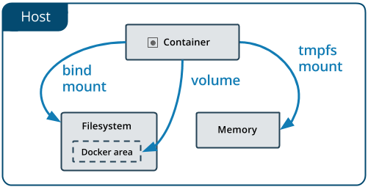
1. Volume are stored in a part of the host filesystem(DRIVE) which is managed by Docker (/var/lib/docker/volumes/ on Linux). When you mount the volume into a container, this directory is what is mounted into the container.
2. Bind mount may be stored anywhere on the host system. They may even be important system files or directories.
3. Tmpfs mounts are stored in the host system’s memory only, and are never written to the host system’s filesystem.
Volumes have several advantages over bind mounts:
- Volumes are easier to back up or migrate than bind mounts.
- You can manage volumes using Docker CLI commands or the Docker API.
- Volumes work on both Linux and Windows containers.
- Volumes can be more safely shared among multiple containers.
- Volume drivers let you store volumes on remote hosts or cloud providers, to encrypt the contents of volumes, or to add other functionality.
- New volumes can have their content pre-populated by a container.
- Volumes on Docker Desktop have much higher performance than bind mounts from Mac and Windows hosts.

Volumes:(we can use -–mount or -v)
docker volume create my-vol
docker volume ls
docker volume inspect my-vol

docker run -d ---mount source=myvol2, target=/app nginx:latest

BIND MOUNT:
sudo docker run -d -it --name devtestt -v /home/amit/Desktop/amit:/amit nginx
where home/amit/desktop is host location
and /amit is target containers location to which host volume is mounted.

Limitations of tmpfs mounts
- Unlike volumes and bind mounts, you can’t share tmpfs mounts between containers.
- This functionality is only available if you’re running Docker on Linux

