KUBERNETES SHORT NOTRES:

Refer this Blog for better clarity and revise quicky:
https://sunnykkc13.medium.com/deep-dive-into-kubernetes-238258c9a536
Refer this below site for better understanding of Autoscaling in Kubernetes:
https://cloudyuga.guru/hands_on_lab/autoscaling-k8s
Refer this below site for better understanding of Monitoring in Kubernetes:
https://levelup.gitconnected.com/kubernetes-monitoring-101-core-pipeline-services-pipeline-a34cd4cc9627

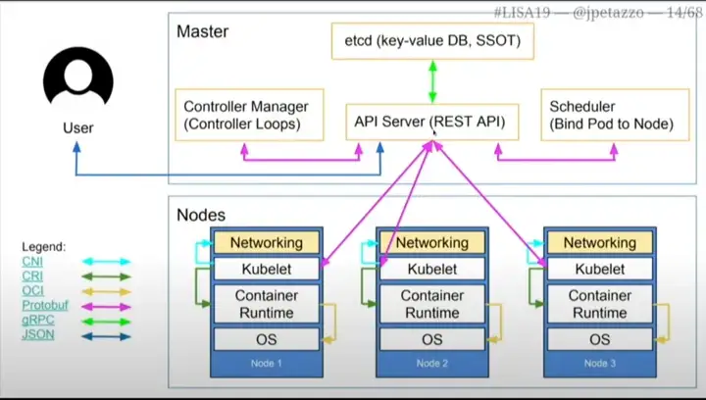
In post kubernetes -0 we saw how the infrastructure was and the deployment was happening in the pre-container era. Understood the deployment of the applications in the physical machines and moved to virtualization and introduced the concept of Containers and Kubernetes.Kubernetes - 1 There are lot of container orchestration tools available, but k8s, becoming the standard way of orchestrating the containers for application deployment, scaling and management. With this k8s, all our tasks we need to do for our site is automated and dynamic. The best way of utilizing resources, reducing blast-radius, high-availability and resiliency via dynamic autoscaling.VM’s Vs CONTAINER:VMs run several different operating systems on one compute node, container technology offers the opportunity to virtualize the operating system itself. So with that kind of virtualization, the application can share the resources they need and the organizations can run multiple applications with minimal operational cost.
1.User wants to deploy nginx pods with 3 replica and wrote a deployment in YAML.
apiVersion: apps/v1
kind: Deployment
metadata:
name: nginx-deployment
labels:
app: nginx
spec:
replicas: 3
selector:
matchLabels:
app: nginx
template:
metadata:
labels:
app: nginx
spec:
containers:
- name: nginx
image: nginx:1.14.2
ports:
- containerPort: 80

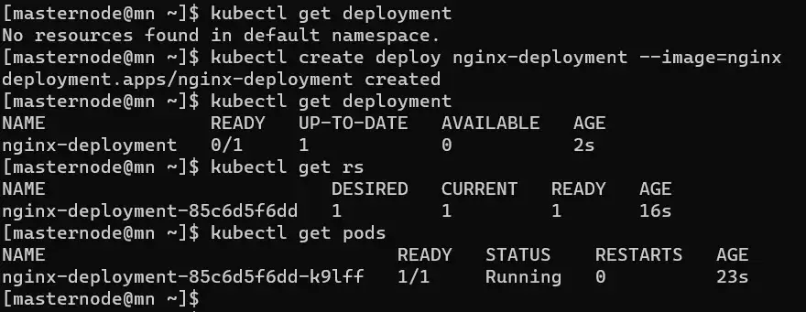
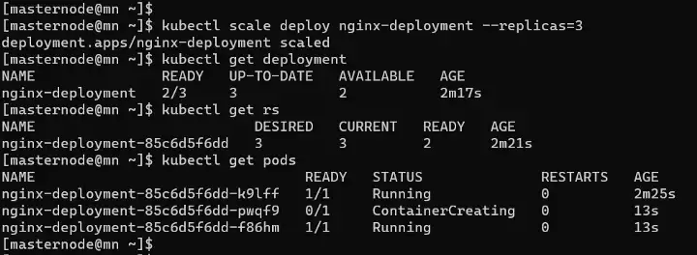

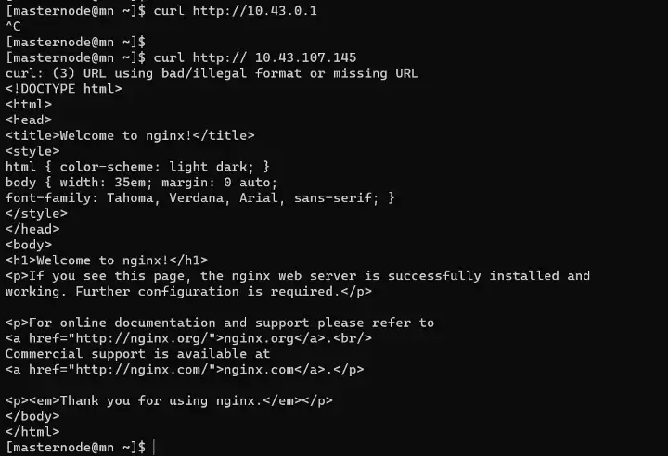

EXPLAINATION:

What happened behind the scene?
- User declares what he/she wants(image 1)and pass that to K8S using kubectl command. We all know that API-Server is the only component that can talk to user, master node other components and worker nodes.
- kubectl interacts with API-Server and generates a manifest(we can say a description of user wants).
- This manifest is written in ETCD(key-value database and single source of truth) by API-Server.
- API-Server got a deployment of nginx so it stores a deployment in ETCD.
- As soon as there is something in ETCD, controller manager wakes up and respond according to the requirement. For deployment, a Deployment controller wakes up and check the requirement. It says replica is needed so, it’ll create a replica set(a bunch of item that goes into the pods) and goes to sleep. The ReplicaSet get stored in ETCD and the flow was [controller manager → API-Server → ETCD ].
- Now, the controller responsible for replica take its turn and create 3 replicas(Image 4) of pod(just create the pods). The pods details get stored in ETCD.
- A ReplicaSet ensures that a specified number of pod replicas are running at any given time. However, a Deployment is a higher-level concept that manages ReplicaSets and provides declarative updates to Pods along with a lot of other useful features(Image 2).
- Schedular wakes up and see that there are pending pods without any nodes assigned. So, it will assign the nodes and goes to sleep.
- kubelet(on worker node) asks API-Server whether it has something for them? Now nodes has been assigned to pods kubelet will pull the image, networking and response back to API-Server that pods are running and API-Server writes the update to ETCD.
- As you can see everything is being written to ETCD from deployment to pods health.
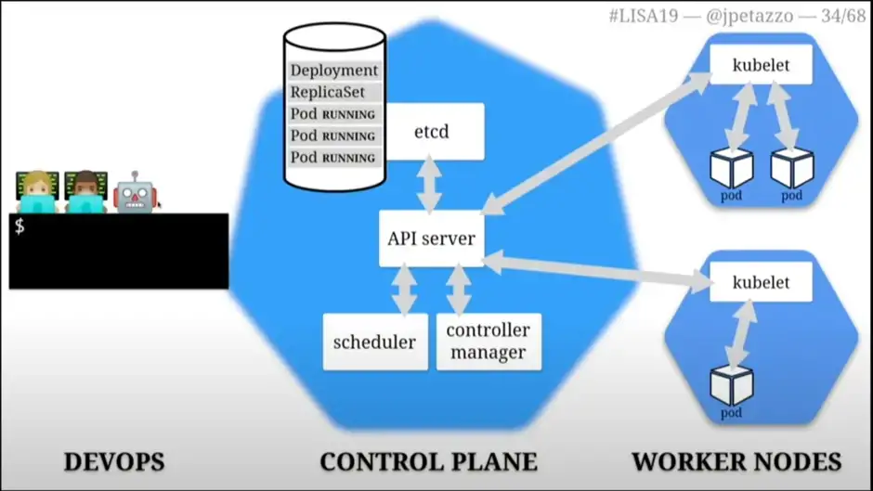

ReplicationController:
YAML FILE:

apiVersion: v1
kind: ReplicationController
metadata:
name: myapp-rc
labels:
app: myapp
type: front-end
spec:
template:

metadata:
name: myapp-pod
labels:
app: myapp
type: front-end
spec:
containers:
- name: nginx-container
image: nginx
replicas: 3

ReplicaSet:
YAML FILE:

apiVersion: apps/v1
kind: ReplicaSet
metadata:
name: myapp-rs
labels:
app: myapp
type: front-end
spec:
template:

metadata:
name: myapp-pod
labels:
app: myapp
type: front-end
spec:
containers:
- name: nginx-container
image: nginx
replicas: 3
selector:
matchLabels:
type: front-end

Deployment(Deploy):
YAML FILE:
apiVersion: apps/v1
kind: Deployment
metadata:
name: myapp-deploy
labels:
app: myapp
type: front-end
spec:
template:

metadata:
name: myapp-pod
labels:
app: myapp
type: front-end
spec:
containers:
- name: nginx-container
image: nginx
replicas: 3
selector:
matchLabels:
type: front-end

What is a Namespace?
>>Used to organize resources.
>>You can think of it as a virtual cluster inside a cluster.
4 default Namespaces provided by Kubernetes:
→ kube-system namespace — Not created for general use, you should should not create anything or modify anything in kube-system namespace. The components that are deployed in the kube-system namespace are the system processes that are from master processes or kubectl etc.
→ kube-public namespace — Contains the publicly accessible data, it contains a configmap that has cluster information that is accessible even without authentication.
→ kube-node-lease namespace — It looks after the health of the nodes, each node is assigned an object inside the kube-node-lease namespace which contains the information about the nodes availability.
→ default namespace — This is the namespace is used to create the resources if you have not created a new namespace.

2 ways to create a namespace
→ By using the kubectl command -
kubectl create namespace my-namespace
→ By using the yaml file — You basically just have to add a key in the metadata section of the yaml file like this :-
eg.-
metadata:
name : my-configmap
namespace : my-namespace
So, now the configmap(a type of resource) will be created inside the namespace my-namespace.
Why to use namespaces?
→If you just have one namespace and you create all your resources in the same namespace, it will be difficult to keep track of the components and you will not be able to effectively manage the pods, replicasets, deployments and all the other resources that you have created.
→ Using namespaces when you are working with different teams is quite beneficial.

KUBERNETES NETWORKING FUNDAMENTALS:
Deployment, ReplicaSet and pods are done, we understood maximum of it. But we haven’t talked out the networking interface and we exposed the pods so that it can be curled on port 80(Image 5 and Image 6).

NEED OF SERVICE:
If a pod restarts or dies, its IP address may change since IP addresses are dynamic; however, how do other pods learn that they must now connect to a different IP address? Example:
One deployment is for a web application, the other is for a database, for instance. As soon as MySQL pod died, K8S launched a new one with a different IP, and the web application needed the IP of the database to connect to it. Now that our webapp cannot connect to the database, we risk losing our customers.
To resolve this we use service component. Service assign static IPs to the pods, hence whether under the hood pods IP get changed static IP will be the same and customer can use the webapp smoothly.
But how service component works? in above simple architecture(Image 1) it is not mentioned.

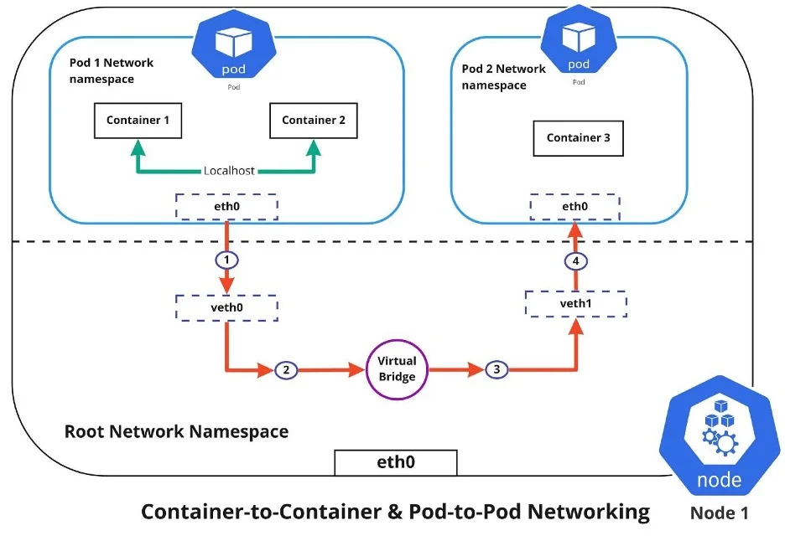
Kube-proxy is a network proxy that runs on each node in your cluster, implementing part of the Kubernetes Service concept. kube-proxy maintains network rules on nodes. These network rules allow network communication to your Pods from network sessions inside or outside of your cluster.It generates the IP tables rules that is where to redirect, forward the traffic.Kubernetes networking is designed to ensure that the different entity types within Kubernetes can communicate.

Container-to-container networking
Container-to-container networking happens through the Pod network namespace. Network namespaces allow you to have separate network interfaces and routing tables that are isolated from the rest of the system and operate independently. Every Pod has its own network namespace, and containers inside that Pod share the same IP address and ports. All communication between these containers happens through localhost, as they are all part of the same namespace. (Represented by the green line in the diagram.)

SERVICE:
An abstract way to expose an application running on a set of Pods as a network service.
Need of Service:
Kubernetes Pods are created and destroyed to match the desired state of your cluster. Pods are nonpermanent resources. If you use a Deployment to run your app, it can create and destroy Pods dynamically.
Each Pod gets its own IP address, however in a Deployment, the set of Pods running in one moment in time could be different from the set of Pods running that application a moment later.
This leads to a problem: if some set of Pods (call them "backends") provides functionality to other Pods (call them "frontends") inside your cluster, how do the frontends find out and keep track of which IP address to connect to, so that the frontend can use the backend part of the workload?

Note: A Service can map any incoming port to a targetPort. By default and for convenience, the targetPort is set to the same value as the port field.Accessing a Service without a selector:
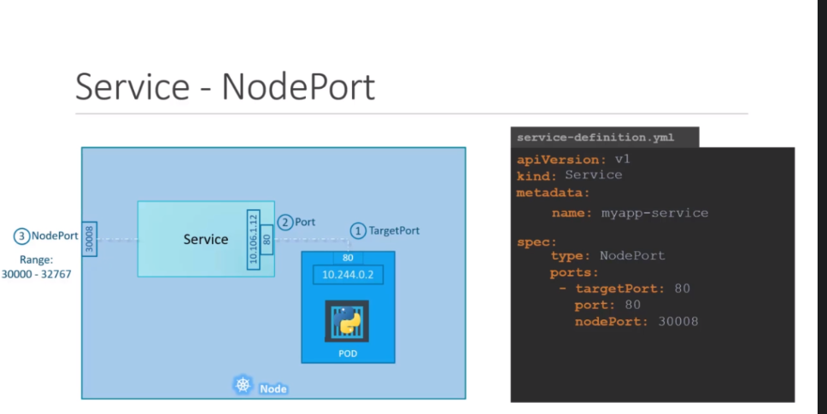
An ExternalName Service is a special case of Service that does not have selectors and uses DNS names instead. For more information, see the ExternalName section later in this document.
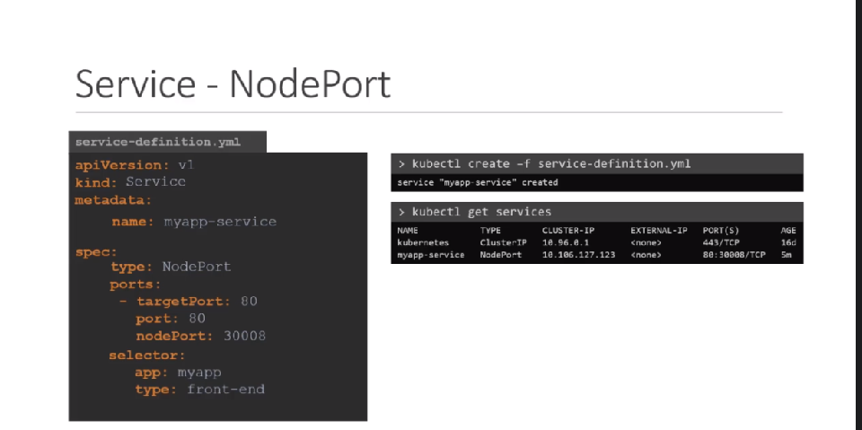
Nodeport service yaml file:

apiServer: v1
kind: Service
metadata:
name: myapp-service
spec:
type: NodePort
ports:
- port: 80
targetPort: 80
nodeport: 30008
selector:
app:myapp

This Nodeport sevice we have written for previous deployment object (deploy1.yaml)
sudo kubectl -it exec myapp-deploy-688df6b9d5-gv54x /bin/bash
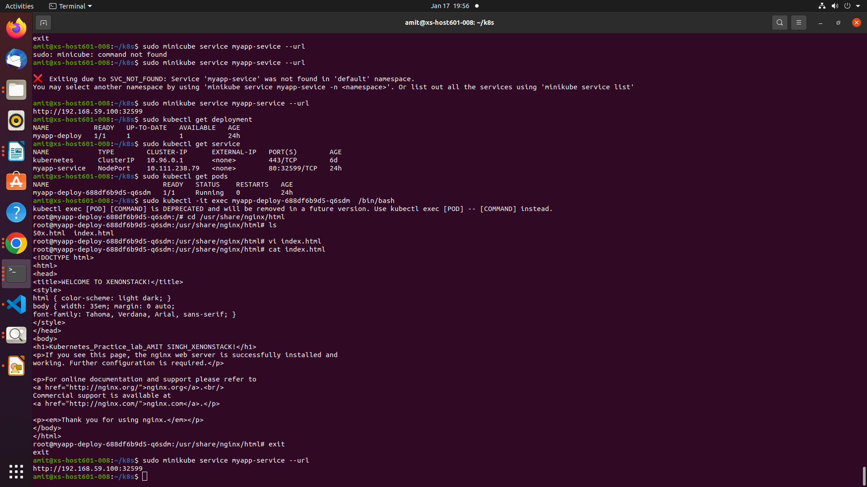

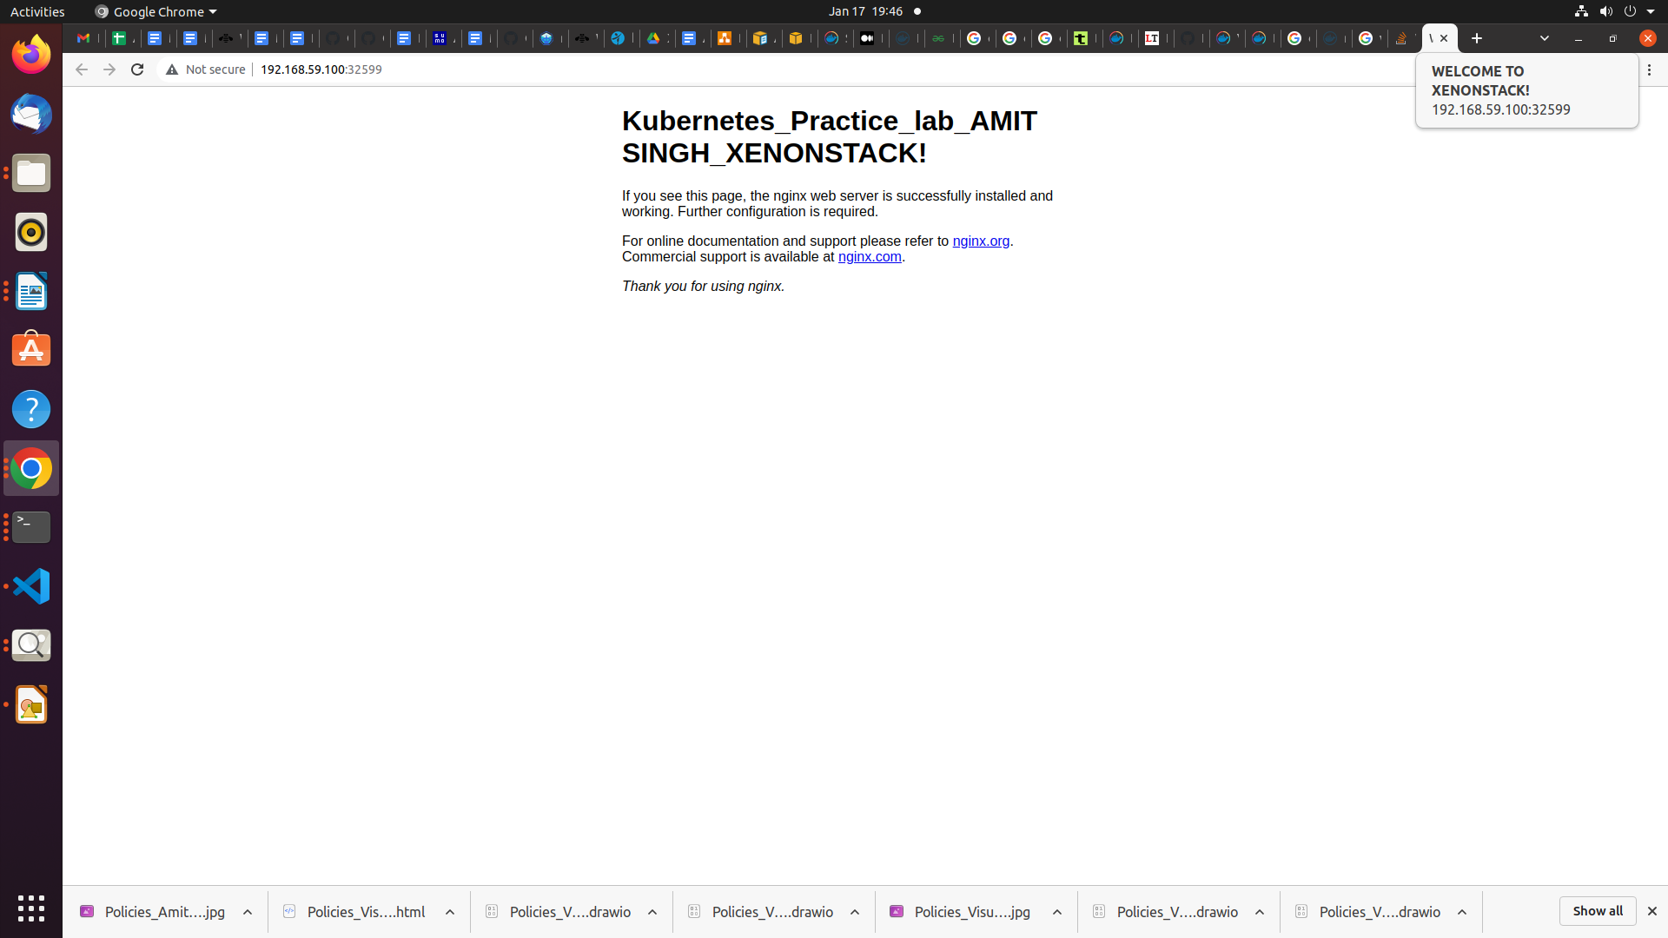
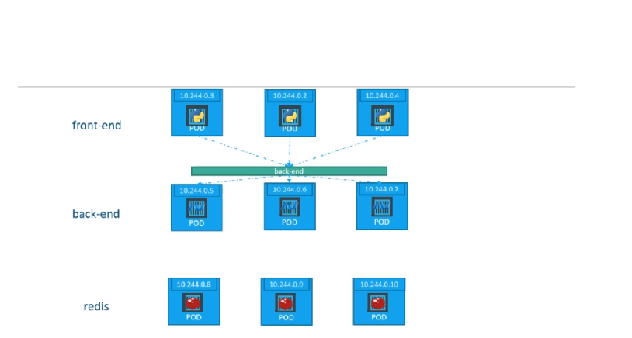
2.CLUSTER IP:

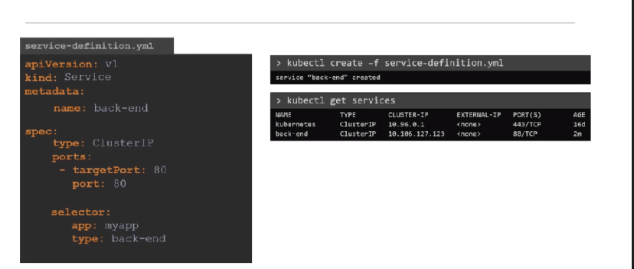
Kubernetes Monitoring:
Understanding Kubernetes monitoring pipeline(s) is essential to help us diagnose run-time problems and to manage manage the scale of your pods and cluster.

Core Monitoring Pipeline:
The core monitoring pipeline is installed with every distribution. It provides enough details to other components inside the Kubernetes cluster to run as expected, such as the scheduler to allocate pods and containers, HPA and VPA to take proper decisions scaling pods.
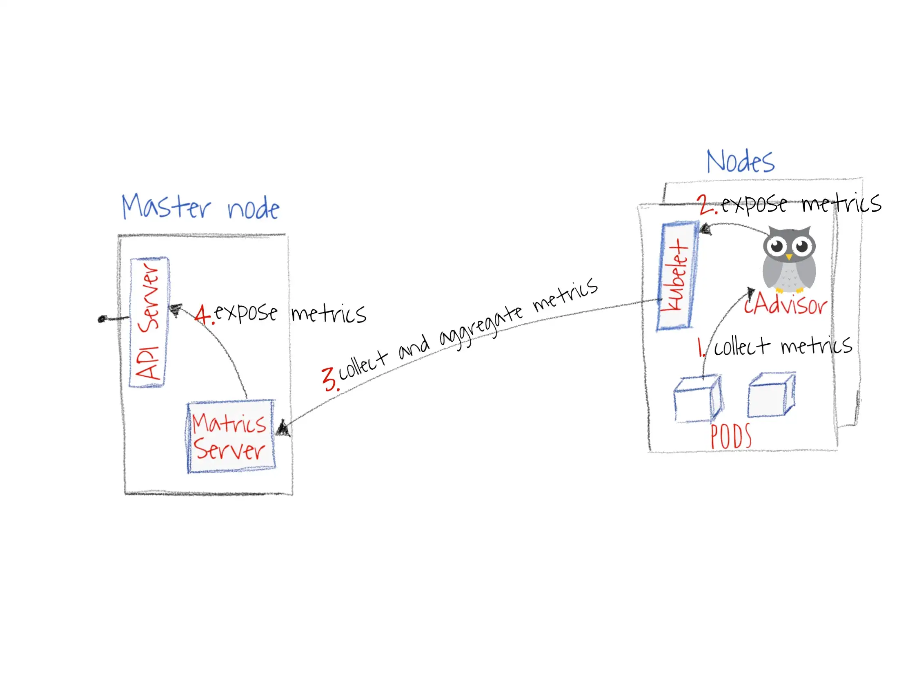
Note:
Prometheus is the official monitoring server sponsored and incubated by CNCF. It integrates directly with cAdvisor.

KUBERNETES EXTERNAL STORAGE(PERSISTENT VOLUME):
Here we will create PersistentVolume backed by physcical storage(this will be present in the vm node inside virtual box) and then we create a PersistentVolumeClaim for a pod that is automatically bound to a suitable PersistentVolume. And finally we create a Pod that uses the above PersistentVolumeClaim for storage
YAML file for PersistentVolume:
apiVersion: v1
kind: PersistentVolume
metadata:
name: task-pv-volume
labels:
type: local
spec:
storageClassName: manual
capacity:
storage: 500Mi
accessModes:
- ReadWriteOnce
hostPath:
path: "/amit"

YAML file for PersistentVolumeClaim:
apiVersion: v1
kind: PersistentVolumeClaim
metadata:
name: task-pv-claim
spec:
storageClassName: manual
accessModes:
- ReadWriteOnce
resources:
requests:
storage: 400Gi
YAML file to Create a Pod that uses your PersistentVolumeClaim as a volume.:
apiVersion: v1
kind: Pod
metadata:
name: task-pv-pod
spec:
volumes:
- name: task-pv-storage
persistentVolumeClaim:
claimName: task-pv-claim
containers:
- name: task-pv-container
image: nginx
ports:
- containerPort: 80
name: "http-server"
volumeMounts:
- mountPath: "/usr/share/nginx/html"
name: task-pv-storage

