
Mini Project Report
AI-Driven Cyber Threat Intelligence
and Attack Campaign Correlation System
Submitted in partial fulfilment of the requirements for the award of degree of
Bachelor of Technology
in
Computer Science and Engineering
Database Management Systems Project
Submitted by
AMIT | PES2UG24CS624
M SANGAMESH PRASAD | PES2UG24CS640
Under the guidance of
[Faculty Guide Name]
[Designation]
PES University
DEPARTMENT OF COMPUTER SCIENCE AND ENGINEERING
FACULTY OF ENGINEERING
PES UNIVERSITY
Electronic City, Hosur Road, Bengaluru - 560 100, Karnataka, India
2026

PES UNIVERSITY
FACULTY OF ENGINEERING

CERTIFICATE
This is to certify that the DBMS mini project entitled “AI-Driven Cyber Threat Intelligence and Attack Campaign Correlation System” is a bonafide work carried out by the following students in partial fulfilment of the requirements for the Database Management Systems project in the Bachelor of Technology program in Computer Science and Engineering at PES University.
Student Name | SRN
AMIT | PES2UG24CS624
M SANGAMESH PRASAD | PES2UG24CS640

The work presented in this report describes the PostgreSQL database design and SQL implementation demonstrated in the project execution evidence.
______________________________ ______________________________
Faculty Guide Signature Project Coordinator Signature
[Faculty Guide Name and Designation] [Coordinator Name and Designation]

DECLARATION
We hereby declare that the DBMS mini project entitled “AI-Driven Cyber Threat Intelligence and Attack Campaign Correlation System” has been carried out by us and is submitted in partial fulfilment of the requirements for the Database Management Systems project in the Bachelor of Technology program in Computer Science and Engineering at PES University.
We further declare that this report presents the database design and SQL implementation associated with our project. The work and supporting execution evidence are identified in the report references.
AMIT | PES2UG24CS624 M SANGAMESH PRASAD | PES2UG24CS640
Signature: ____________________ Signature: ____________________

ACKNOWLEDGEMENT
We express our sincere gratitude to our project guide, [Faculty Guide Name], and the Department of Computer Science and Engineering at PES University for their guidance and support during this DBMS mini project. We also thank the faculty members who provided feedback on the database design and SQL implementation. Finally, we are grateful to our classmates, friends, and families for their encouragement throughout the project.

ABSTRACT
The AI-Driven Cyber Threat Intelligence and Attack Campaign Correlation System is a relational database project for organizing security intelligence and connecting related threat records. Implemented using PostgreSQL, the database represents organizations and their assets, threat actors and campaigns, intelligence sources and indicators of compromise, MITRE ATT&CK techniques, malware samples, vulnerabilities, alerts, users, and reports. The model uses primary and foreign keys and associative tables to represent relationships such as campaigns to indicators, campaigns to techniques, and indicators to malware samples. The submitted execution evidence demonstrates insertion and retrieval, joins across related tables, update operations, grouped aggregates, subqueries, CASE expressions, a view, EXISTS and NOT EXISTS checks, indexes, and transaction control with savepoints, rollback, and commit. The resulting database supports structured lookup and analysis of security events, while keeping threat intelligence records connected to organizational assets and analyst alerts.
Keywords: PostgreSQL, DBMS, threat intelligence, indicators of compromise, attack campaigns, relational database, SQL.

TABLE OF CONTENTS
Chapter | Title | Page
1 | INTRODUCTION | 8
2 | PROBLEM DEFINITION | 9
3 | ER MODEL | 10
4 | ER TO RELATIONAL MAPPING | 12
4.1 | Mapping procedure | 12
4.2 | Relational schema overview | 12
5 | DDL STATEMENTS | 14
6 | DML STATEMENTS | 16
7 | QUERIES | 17
7.1 | Aggregate query | 17
7.2 | Update operation | 18
7.3 | Delete operation | 18
7.4 | Correlated query | 18
7.5 | Nested query | 18
8 | STORED PROCEDURES, FUNCTIONS AND TRIGGERS | 20
9 | DATABASE INTERFACE AND EXECUTION | 21
10 | CONCLUSION | 23
 | REFERENCES | 23
 | APPENDIX A - ACRONYMS | 23

LIST OF TABLES
Table No. | Title | Page
2.1 | Functional requirements and database support | 9
4.1 | Relational entities and key relationships | 12
5.1 | Core tables and representative attributes | 14

LIST OF FIGURES
Figure No. | Title | Page
3.1 | Logical entity relationship overview | 10
5.1 | PostgreSQL schema evidence | 15
6.1 | Indicator records | 16
7.1 | Alert count grouped by severity | 17
7.2 | Alert status update and verification | 18
7.3 | CASE alert priority classification | 19
9.1 | PostgreSQL index listing | 21

1. INTRODUCTION
Cybersecurity teams collect information from many sources, including endpoint and network telemetry, public intelligence feeds, incident reports, and vulnerability advisories. The value of this information increases when records can be connected: an indicator can be tied to a malware sample, a campaign can be associated with a threat actor and ATT&CK techniques, and an alert can be traced to the affected organizational asset.
This project implements a PostgreSQL database to store and relate these records. The design focuses on normalized entities, referential links, and SQL operations that help analysts retrieve and summarize intelligence. The submitted execution report shows sample data and query results for the implemented database.

1.1 Objectives
• Represent threat intelligence records and organizational assets in related relational tables.
• Connect campaigns with indicators and MITRE ATT&CK techniques using associative relations.
• Relate indicators to malware samples and vulnerabilities.
• Record alerts against assets and support analyst-oriented retrieval.
• Demonstrate joins, aggregates, subqueries, views, indexes, and transaction control in PostgreSQL.

1.2 Scope
The report documents the database model and SQL evidence supplied for the project. The evidence is based on PostgreSQL command-line output. It covers the schema concepts and query features visible in the project execution PDF; it does not describe an unshown web or desktop application.

2. PROBLEM DEFINITION
Threat intelligence data is difficult to analyze when indicators, actors, campaigns, techniques, malware, vulnerabilities, assets, and alerts are stored independently. Analysts need a consistent way to trace relationships and retrieve contextual information without duplicating the same facts in multiple places.
The project addresses this data-management problem by defining relational entities with identifiers and foreign-key relationships. It supports questions such as which indicators are associated with a campaign, which malware samples are linked to an indicator, which assets have alerts, and which campaigns show stronger correlation values.

2.1 Functional requirements
Requirement | Database support
Maintain reference records | Tables for organizations, assets, users, actors, sources, techniques, malware, and vulnerabilities
Record campaign intelligence | Campaign records and associative campaign-indicator and campaign-technique relations
Track observable indicators | Indicator type, value, confidence, source, and observation dates
Manage alert context | Join alert, asset, indicator, and user records
Analyze data | Joins, grouped aggregates, subqueries, views, CASE, and existence checks
Preserve query consistency | Transactions, savepoints, rollback, commit, and indexes

3. ER MODEL
The logical ER model separates the main entities and uses associative entities to resolve many-to-many relationships. The diagram is an overview of the implemented project concepts; table columns and constraints should be read together with the PostgreSQL schema output.
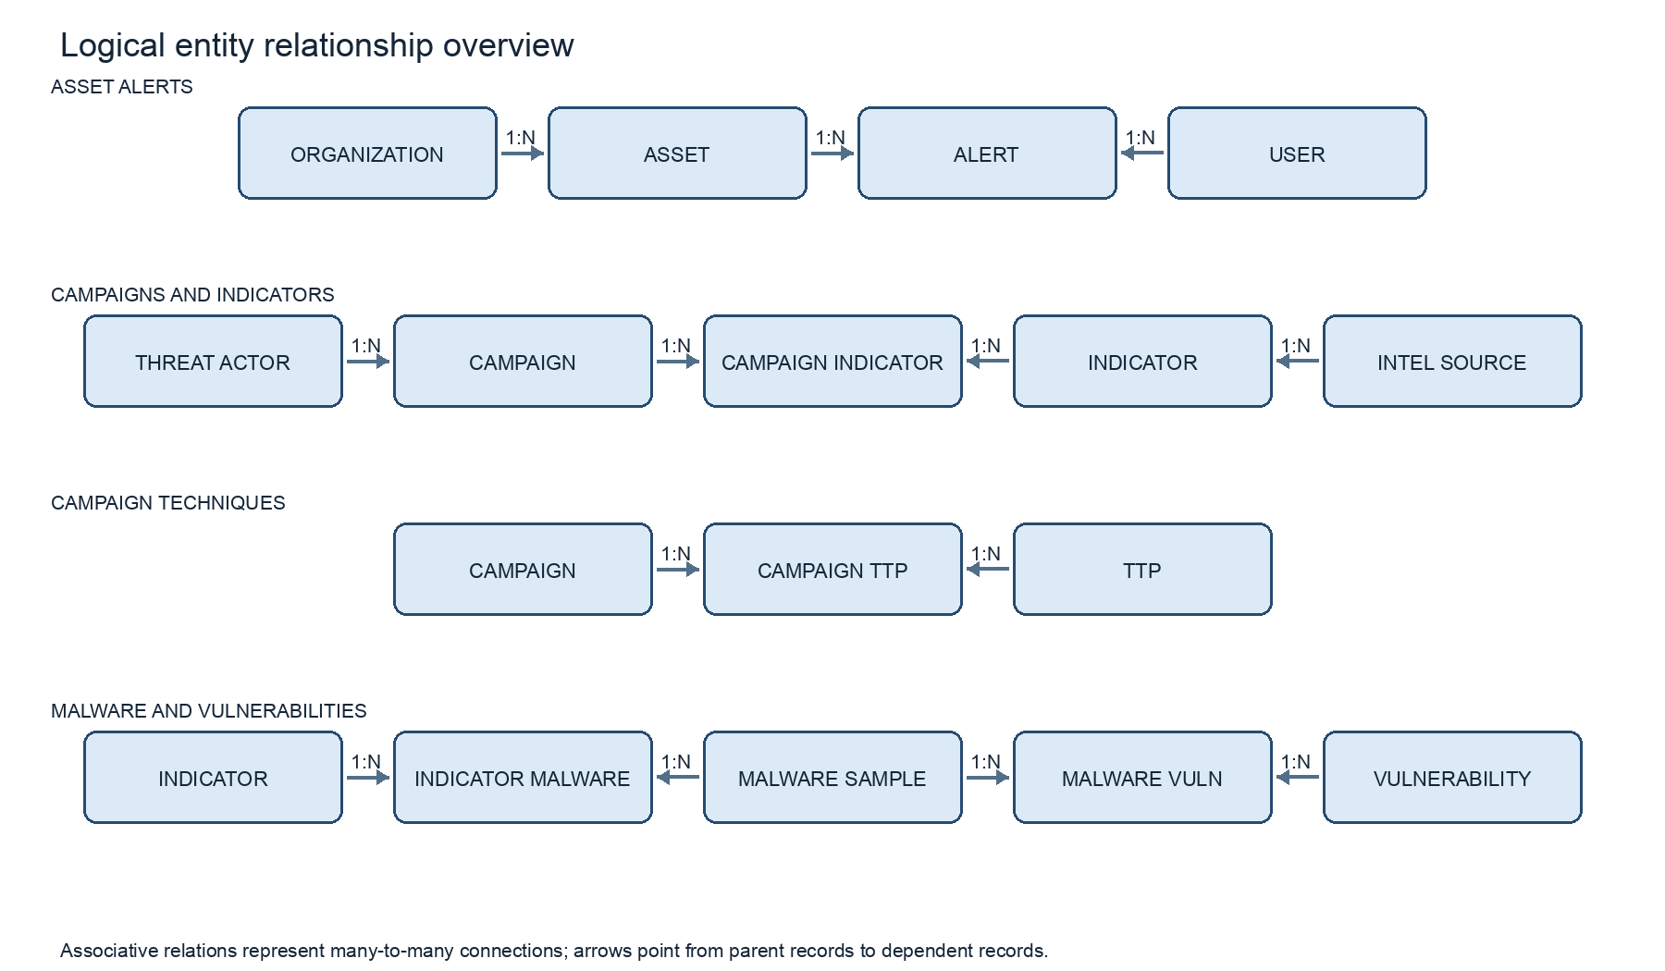
Figure 3.1. Logical entity relationship overview

3.1 Entity relationship summary
Relationship | Meaning
Organization - Asset | An organization can contain multiple assets.
Asset - Alert | An asset can be associated with multiple alerts.
User - Alert | A user may be assigned to or associated with alerts.
Threat Actor - Campaign | A threat actor may be linked to multiple campaigns.
Campaign - Indicator | Many-to-many relationship represented by CAMPAIGN_INDICATOR.
Campaign - TTP | Many-to-many relationship represented by CAMPAIGN_TTP.
Indicator - Malware Sample | Many-to-many relationship represented by INDICATOR_MALWARE.
Malware Sample - Vulnerability | Many-to-many relationship represented by MALWARE_VULN.
Intelligence Source - Indicator | An intelligence source can provide multiple indicators.

4. ER TO RELATIONAL MAPPING
The ER model is mapped to relations by assigning a primary key to each entity, representing one-to-many relationships with foreign keys, and creating associative relations for many-to-many relationships. The project evidence confirms tables and indexes for the central entities and association tables, including campaign_indicator, campaign_ttp, indicator_malware, and malware_vuln.

4.1 Steps of algorithm for chosen problem
1. Create one relation for each independent entity, such as organization, asset, threat_actor, intel_source, indicator, campaign, ttp, malware_sample, vulnerability, alert, user, and report.
2. Choose a stable identifier for each entity as its primary key.
3. For each one-to-many relationship, place the parent key in the child relation as a foreign key. Examples include organization to asset, threat_actor to campaign, and intel_source to indicator.
4. For each many-to-many relationship, create a junction relation containing the keys of the participating entities. Examples include campaign_indicator and campaign_ttp.
5. Add relationship-specific attributes to the relation that owns the fact, such as confidence_score and observation dates on indicator records, or severity and status on alert records.
6. Apply constraints and indexes to protect referential integrity and support frequently used lookups.

4.2 Complete diagram of relational mapping
The relational mapping is summarized below. Exact column definitions for all tables should match the schema output used in the PostgreSQL implementation.
Relation | Key / relationship summary
organization | organization_id (PK); organization details
asset | asset_id (PK); org_id (FK to organization)
user | user_id (PK); analyst identity and role
alert | alert_id (PK); asset_id (FK), indicator_id (FK), optional user_id
threat_actor | actor_id (PK); actor name, aliases, origin and sophistication
campaign | campaign_id (PK); actor_id (FK); campaign description and status
intel_source | source_id (PK); source type and reliability score
indicator | indicator_id (PK); source_id (FK); IOC type, value, confidence and dates
campaign_indicator | Campaign and indicator keys
ttp | Technique identifiers and MITRE ATT&CK attributes
campaign_ttp | Campaign and technique keys
malware_sample | malware_id (PK); hash, family, file type and first-seen date
indicator_malware | Indicator and malware keys
vulnerability | CVE identifier and vulnerability attributes
malware_vuln | Malware and vulnerability keys
report | report_id (PK); report metadata, user and campaign links

5. DDL STATEMENTS
The submitted PostgreSQL evidence shows a relational schema with primary keys, foreign keys, check constraints, and indexes. A visible schema inspection for INTEL_SOURCE reports a generated integer primary key, a reliability score default of 0.50, a bounded score check, and an enumerated source-type check.

5.1 Core tables and representative attributes
Table | Representative attributes visible in the project evidence
USER | user_id, full_name, email, role, created_at
ORGANIZATION | organization identifier and organization details
ASSET | asset_id, org_id, hostname, ip_address, criticality
THREAT_ACTOR | actor_id, name, aliases, origin_country, sophistication
INTEL_SOURCE | source_id, name, source_type, reliability_score
INDICATOR | indicator_id, source_id, ioc_type, value, confidence_score, first_seen, last_seen
CAMPAIGN | campaign_id, actor_id, name, objective, start_date, end_date, status
TTP | technique identifiers and MITRE ATT&CK attributes
MALWARE_SAMPLE | malware_id, sha256_hash, family_name, file_type, first_seen
VULNERABILITY | CVE identifier and vulnerability attributes
ALERT | alert_id, asset_id, indicator_id, severity, status, detected_at
REPORT | report_id and campaign/user associations

5.2 DDL pattern
The following example expresses the visible INTEL_SOURCE definition pattern. It is included as a readable DDL summary; the project evidence itself displays the resulting schema inspection.
CREATE TABLE intel_source (
source_id SERIAL PRIMARY KEY,
name VARCHAR(150) NOT NULL,
source_type VARCHAR(30) NOT NULL
CHECK (source_type IN ('OSINT', 'Commercial', 'ISAC', 'Internal')),
reliability_score NUMERIC(3,2) NOT NULL DEFAULT 0.50
CHECK (reliability_score >= 0.00 AND reliability_score <= 1.00)
);
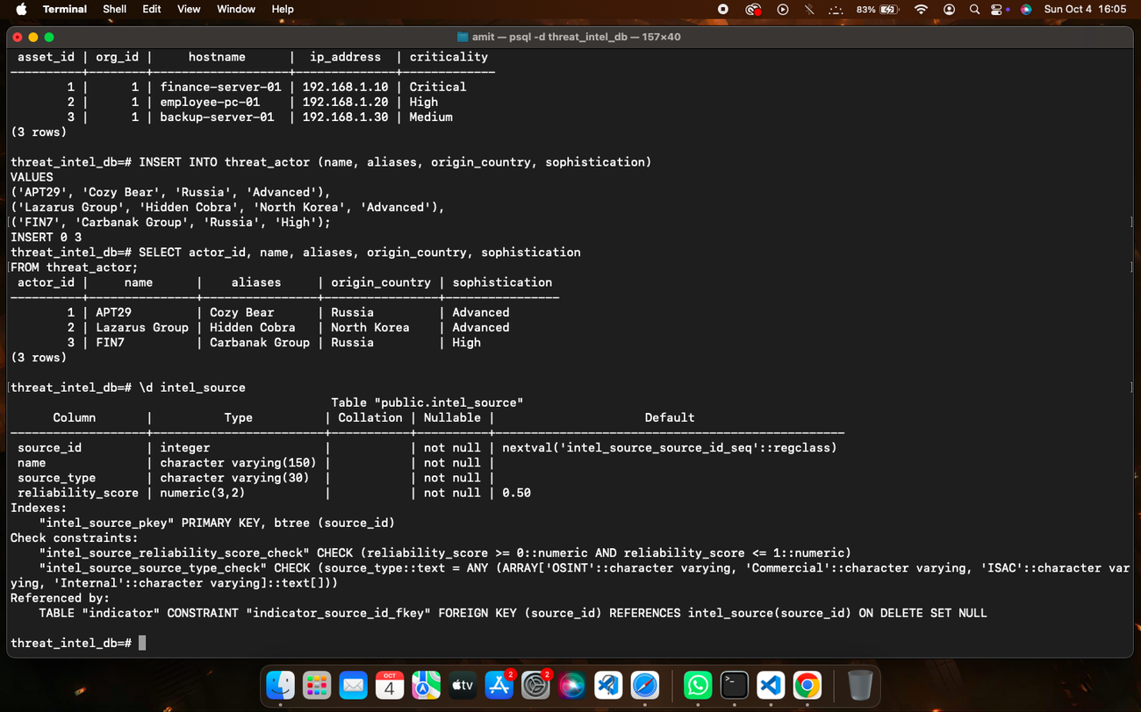
Figure 5.1. PostgreSQL schema and relationship evidence from the implementation

6. DML STATEMENTS
The implementation inserts sample records into project entities and retrieves them using SELECT statements. The evidence includes actor, source, indicator, campaign, asset, user, and malware records. A representative insert-and-read pattern for threat actors is shown below.
INSERT INTO threat_actor (name, aliases, origin_country, sophistication)
VALUES
('APT29', 'Cozy Bear', 'Russia', 'Advanced'),
('Lazarus Group', 'Hidden Cobra', 'North Korea', 'Advanced'),
('FIN7', 'Carbanak Group', 'Russia', 'High');
SELECT actor_id, name, aliases, origin_country, sophistication
FROM threat_actor
ORDER BY actor_id;
The following captured output shows indicator values and confidence scores, first-seen dates, and last-seen dates.
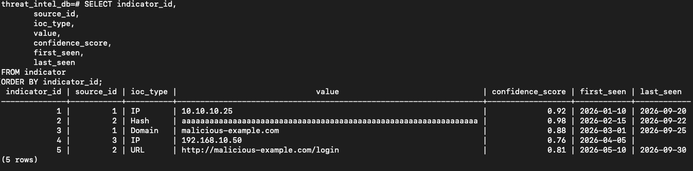
Figure 6.1. Indicator records retrieved from PostgreSQL

7. QUERIES
The SQL evidence demonstrates relationship queries, updates, grouped aggregates, subqueries, CASE expressions, views, EXISTS and NOT EXISTS checks, transaction commands, indexes, and project-specific correlation queries.

7.1 Simple query with GROUP BY and aggregate
This query counts alerts within each severity group and orders the most common severity first.
SELECT severity, COUNT(*) AS alert_count
FROM alert
GROUP BY severity
ORDER BY alert_count DESC;
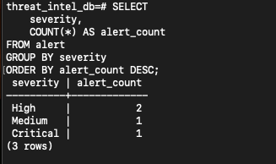
Figure 7.1. Alert count grouped by severity

7.2 Update operation
The execution evidence updates an alert status and confirms the resulting row.
UPDATE alert
SET status = 'Investigating'
WHERE asset_id = 1
AND indicator_id = 1;
SELECT alert_id, asset_id, indicator_id, severity, status
FROM alert
WHERE asset_id = 1 AND indicator_id = 1;
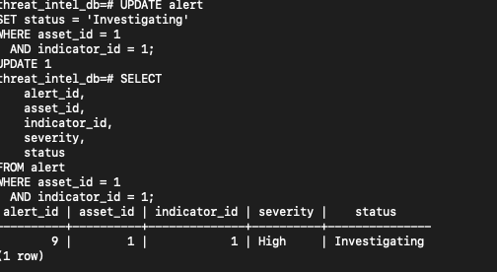
Figure 7.2. Alert status update and verification

7.3 Delete operation
A delete statement should target a specific record using its primary key and should be run only after reviewing dependent foreign-key relationships. The supplied execution PDF does not include a DELETE command or result; the following is a review template, not executed evidence.
-- Example template only: replace values after confirming the target row.
DELETE FROM indicator_malware
WHERE indicator_id = <indicator_id>
AND malware_id = <malware_id>;

7.4 Correlated query
A correlated query evaluates its inner condition against each outer row. This example lists campaigns whose correlation score exceeds the average for the same threat actor. Align the score column with the final implemented schema before submission.
SELECT c.campaign_id, c.name, c.actor_id, c.correlation_score
FROM campaign AS c
WHERE c.correlation_score > (
SELECT AVG(c2.correlation_score)
FROM campaign AS c2
WHERE c2.actor_id = c.actor_id
);

7.5 Nested query
The supplied SQL execution report demonstrates a nested query for indicators whose confidence is above the database-wide average.
SELECT indicator_id, ioc_type, value, confidence_score
FROM indicator
WHERE confidence_score > (
SELECT AVG(confidence_score)
FROM indicator
);

7.6 Additional demonstrated queries
The evidence also includes multi-table joins across malware and vulnerabilities, campaigns and indicators, campaigns and techniques, alerts and assets, and reports and campaigns. Additional features include grouped HAVING conditions, an AVG aggregate, CASE-based priority labels, a campaign threat-summary view, EXISTS and NOT EXISTS queries, and transaction/savepoint operations.
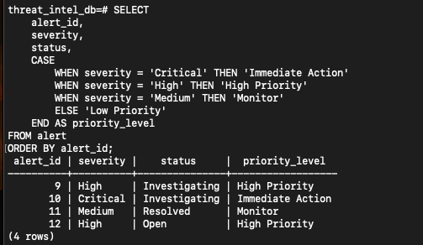
Figure 7.3. CASE expression classifying alert priority

8. STORED PROCEDURES, FUNCTIONS AND TRIGGERS
The supplied project execution report documents PostgreSQL DDL, DML, analytical queries, views, indexes, and transaction control. It does not show a stored procedure, user-defined function, or trigger definition or execution result. Add these items if they are part of the final database implementation.

8.1 Stored procedures or functions
No procedure or function is evidenced in the provided SQL execution report. Insert the final CREATE FUNCTION or CREATE PROCEDURE statement and a representative call/result here if implemented.

8.2 Triggers
No trigger definition or trigger execution is evidenced in the provided SQL execution report. If the implementation contains a trigger, document its table, event, purpose, trigger function, and observed result here.

8.3 Suggested extensions
The following are design ideas for a future version and are not represented as completed project features.
Extension | Possible use
Stored procedure | Generate a campaign summary for a selected actor or reporting period.
Function | Return a consistent priority label from an alert severity value.
Trigger | Record changes to alert status in an audit history relation.

9. DATABASE INTERFACE AND EXECUTION
The submitted execution evidence shows the database being accessed through the PostgreSQL command-line client (psql). The project database is named threat_intel_db in the displayed terminal sessions. The evidence covers table inspection, sample data retrieval, joins, updates, aggregates, advanced queries, transactions, and index inspection. No separate web or desktop front end is shown in the supplied project material.

9.1 Indexes
The database includes primary-key indexes and targeted indexes for alert severity/status, asset organization, campaign actor, indicator confidence/source/value, malware hash, and report campaign lookup. The index listing in the execution evidence contains 29 relations.
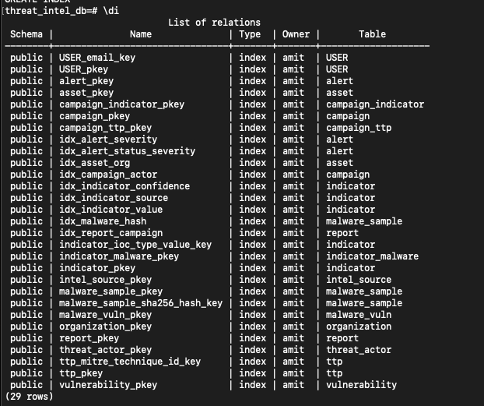
Figure 9.1. PostgreSQL index listing

9.2 Transaction control
The SQL execution report demonstrates BEGIN, SAVEPOINT, ROLLBACK TO SAVEPOINT, and COMMIT, as well as a full transaction ROLLBACK. These operations allow a sequence of database changes to be committed together or reverted when a review step identifies an issue.

10. CONCLUSION
The project implements a PostgreSQL relational database for connecting cyber threat intelligence with campaigns, indicators, malware, vulnerabilities, assets, alerts, and analysts. The executed SQL evidence demonstrates core data manipulation and retrieval alongside joins, grouped analysis, nested queries, views, existence checks, indexes, and transaction management. Together, these features provide a structured base for investigating how observed indicators relate to campaigns and organizational security events.
Future extensions can add verified stored procedures, functions, triggers, a user-facing application interface, and additional analytics after those components are implemented and documented.

REFERENCES
[1] PostgreSQL Global Development Group, PostgreSQL Documentation, SQL Commands and Data Definition.
[2] MITRE, ATT&CK Enterprise Matrix and technique knowledge base.
[3] Project SQL implementation and execution evidence supplied by the authors, PES2UG24CS624 and PES2UG24CS640.

APPENDIX A ACRONYMS
Acronym | Definition
DBMS | Database Management System
IOC | Indicator of Compromise
SQL | Structured Query Language
TTP | Tactics, Techniques, and Procedures
CVE | Common Vulnerabilities and Exposures
OSINT | Open-Source Intelligence
ISAC | Information Sharing and Analysis Center
PK | Primary Key
FK | Foreign Key

GitHub repository: [Insert project repository link if available]

