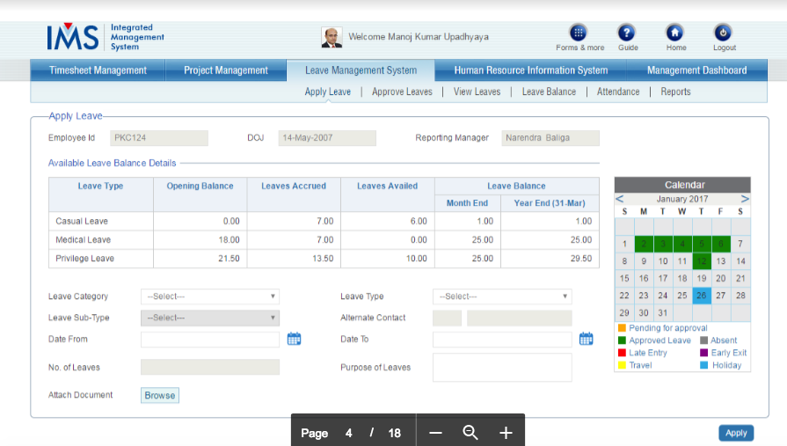
Apply Leave page is the page where employees will have their leave details and may apply for leaves.
This page is available to all employees and will having three main elements:
‘Available Leave Balance’ Table
I. Leave Type: This will show the Leave Type: SL (Sick Leave), CL (casual Leave) and EL (Earned
Leave).
Below details will be available for each leave type:
II. Opening Balance: This will show the total leaves credited to user in the beginning of current
financial year.
III. Leaves Accrued: This will show the no. of leaves accrued in current month. To employee. The
leaves will be credited as below.
• SL/CL Category
o SL/CL: 01.5 leave will credit in beginning of each month. for a complete quarter
in advance. These will credit in the last month of the running quarter.
o For new joining:
▪ Joining date &lt;= 15 (credit full leave)
▪ Joining date &gt; 15 (No leave credit)

• EL: 1.5 monthly leaves will credit in the end of the thateach month
o For new joining:
▪ Joining date &lt;= 15 (credit full leave)
▪ Joining date &gt; 15 (0.5 credit in EL)

IV. Leaves Availed: This will show the total no. of leaves availed by the employee.
V. Leave Balance for QuarterMonth End: This will keep the record of leaves left in the
monthquarter. (Opening Balance+ Leaves accrued in that monthquarter-Leaves Availed)
VI. Leave Balance for Year End: This will show the leave balance left for the complete financial year.
(Opening Balance+ Total Leaves accrued in financial year-Leaves Availed)

