**Assignment-1 Amit Kumar Srivastava**

1. **Write a program (WAP) to print INEURON using pattern programming logic.**

**Answer-**

public class Assign1

{

public static void main(String[] args)

{

int n=14;

for(int i=1; i<=n; i++)

{

//printing 'I'

for(int j=1; j<=n; j++)

{

if(i==1 || i==n || j==n/2)

System.out.print("*");

else

System.out.print(" ");

}

System.out.print(" ");

//printing 'N'

for(int j=1; j<=n; j++)

{

if(j==1 || j==n || i==j)

System.out.print("*");

else

System.out.print(" ");

}

System.out.print(" ");

//printing 'E'

for(int j=1; j<=n; j++)

{

if(i==1 || i==n/2 || i==n ||j==1)

System.out.print("*");

else

System.out.print(" ");

}

System.out.print(" ");

//printing 'U'

for(int j=1; j<=n; j++)

{

if(i<n-1 && (j==1 || j==n))

System.out.print("*");

else if(i>=n-1 && (j==i-n+3 || j==n-i+(n-2)))

System.out.print("*");

else if(i==n && j>i-n+3 && j<n-i+(n-2))

System.out.print("*");

else

System.out.print(" ");

}

System.out.print(" ");

//printing 'R'

for(int j=1; j<=n; j++)

{

if(i==1 && j<=n-2)

System.out.print("*");

else if(i>1 && i<4 && j==n-3+i)

System.out.print("*");

else if(i>3 && i<n/2-1 && j==n)

System.out.print("*");

else if(i>=n/2-1 && i<n/2 && j==n/2+i)

System.out.print("*");

else if(i==n/2 && j<n-2)

System.out.print("*");

else if(j==1)

System.out.print("*");

else if(i>=n/2 && (j==(i-n/2)*2))

System.out.print("*");

else

System.out.print(" ");

}

System.out.print(" ");

//printing 'O'

for(int j=0; j<=n; j++)

{

if((i==1 || i==n) && (j>2 && j<n-1))

System.out.print("*");

else if((i==2 || i==n-1) && (j==2 || j==n-1))

System.out.print("*");

else if((i>=3 && i<=n-2) && (j==1 || j==n))

System.out.print("*");

else

System.out.print(" ");

}

System.out.print(" ");

//printing 'N'

for(int j=1; j<=n; j++)

{

if(j==1 || j==n || i==j)

System.out.print("*");

else

System.out.print(" ");

}

System.out.println();

}

}

}

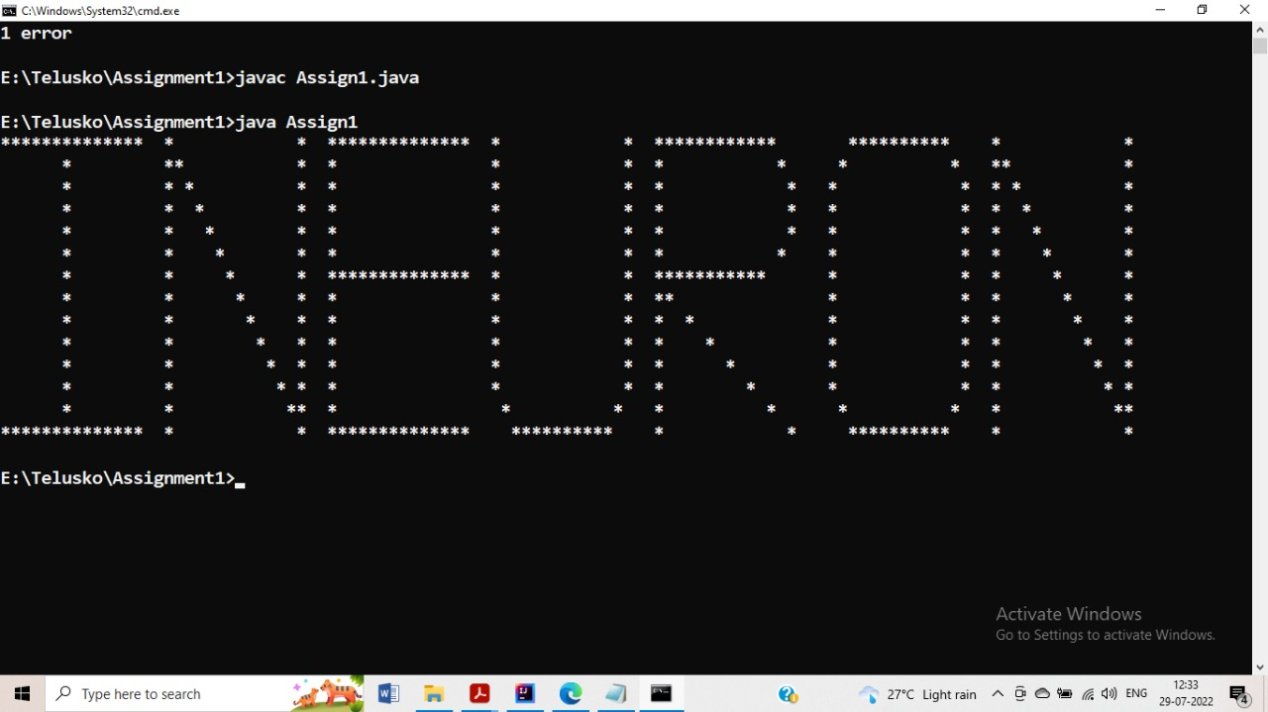

**2. Write a program to print**

**1 1 1 1**

**2 2 2 2**

**3 3 3 3**

**4 4 4 4**

**Answer –**

public class Assign2

{

public static void main(String[] args)

{

int n=4;

for(int i=1; i<=n; i++)

{

for(int j=1;j<=n; j++)

{

System.out.print(i);

}

System.out.println();

}

}

}

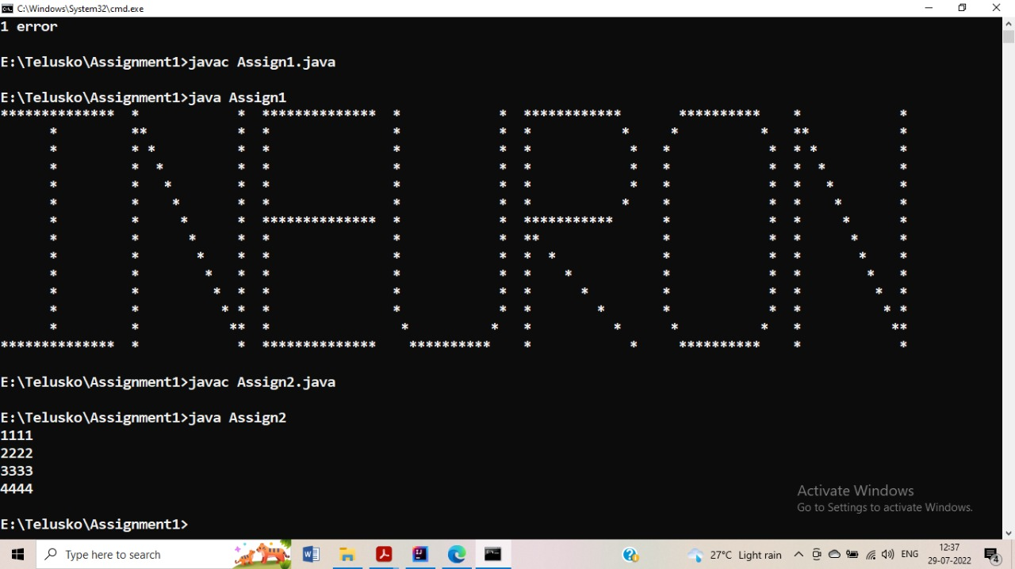

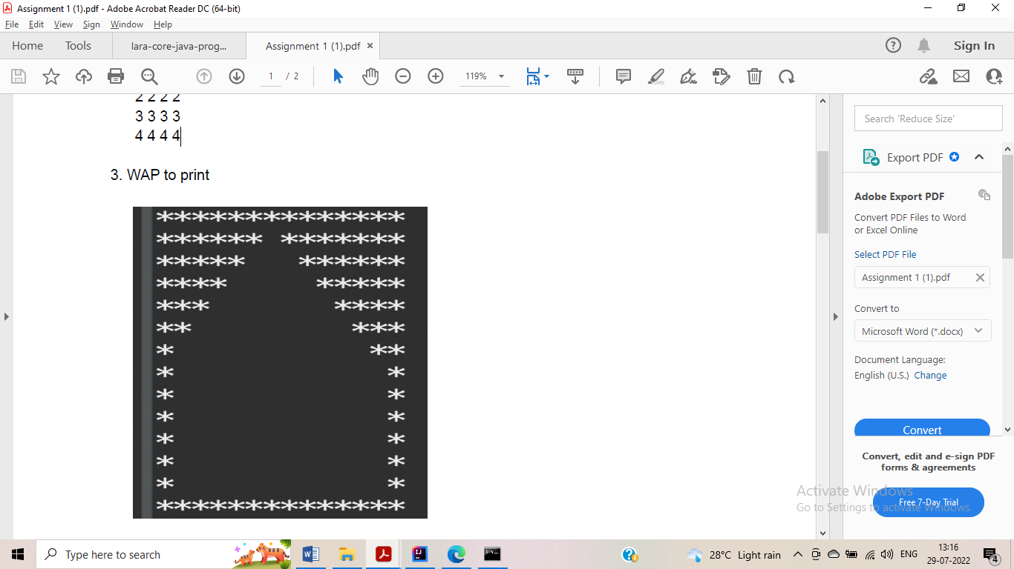

**Answer-**

public class Assign3

{

public static void main(String[] args)

{

int n=14;

for(int i=1; i<=n; i++)

{

for(int j=1; j<=n; j++)

{

if(i==1 || j==1 || i==n || j==n)

System.out.print("*");

else if(i<n/2 && j<=(n/2)-i+1)

System.out.print("*");

else if (i<=n/2 && j>=n/2+(i-1))

System.out.print("*");

else

System.out.print(" ");

}

System.out.println();

}

}

}

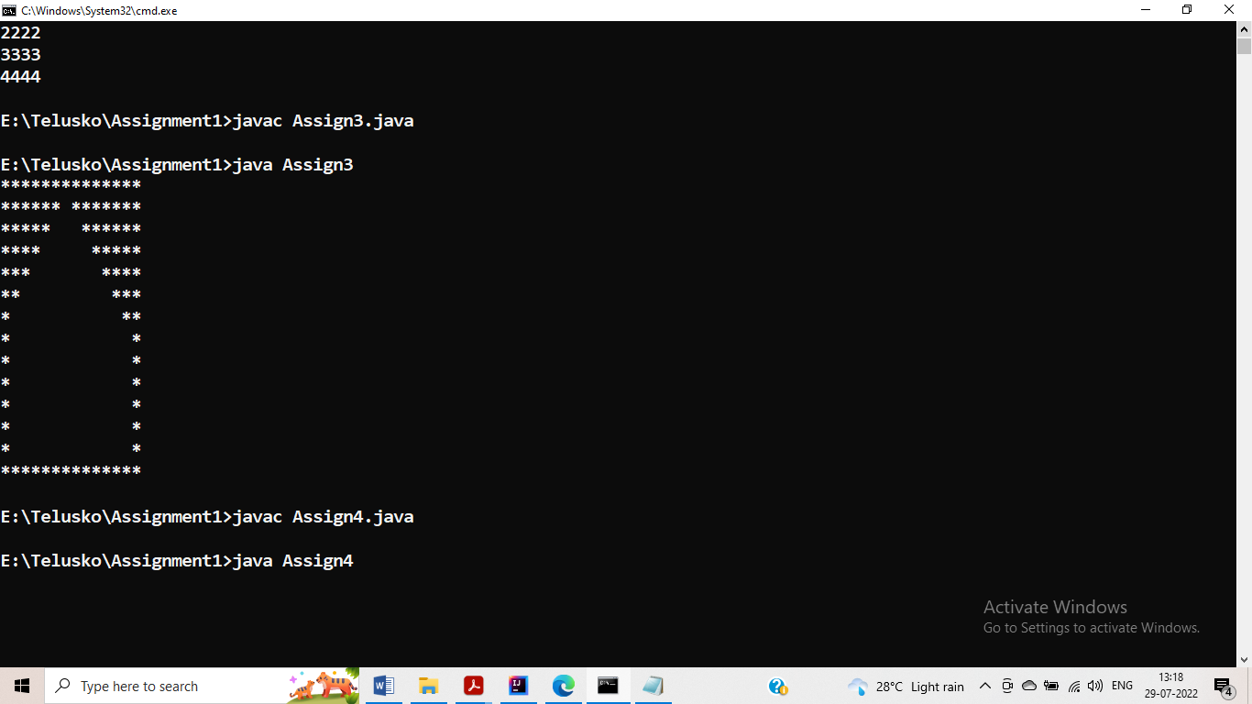

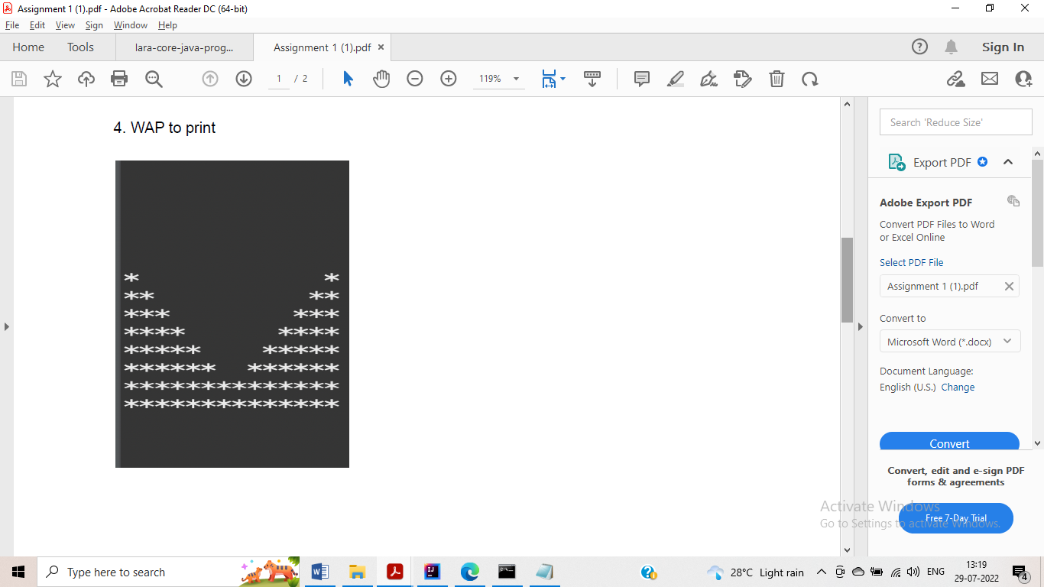

**Answer-**

public class Assign4

{

public static void main(String[] args)

{

int n=14;

for(int i=1; i<=n; i++)

{

for(int j=1; j<=n; j++)

{

if(i>=n/2 && i<=n-2)

{

if (j <= i - n / 2 + 1)

System.out.print("*");

else if(j>=n+n/2-i)

System.out.print("*");

else

System.out.print(" ");

}

else if(i>n-2)

System.out.print("*");

else

System.out.print(" ");

}

System.out.println();

}

}

}

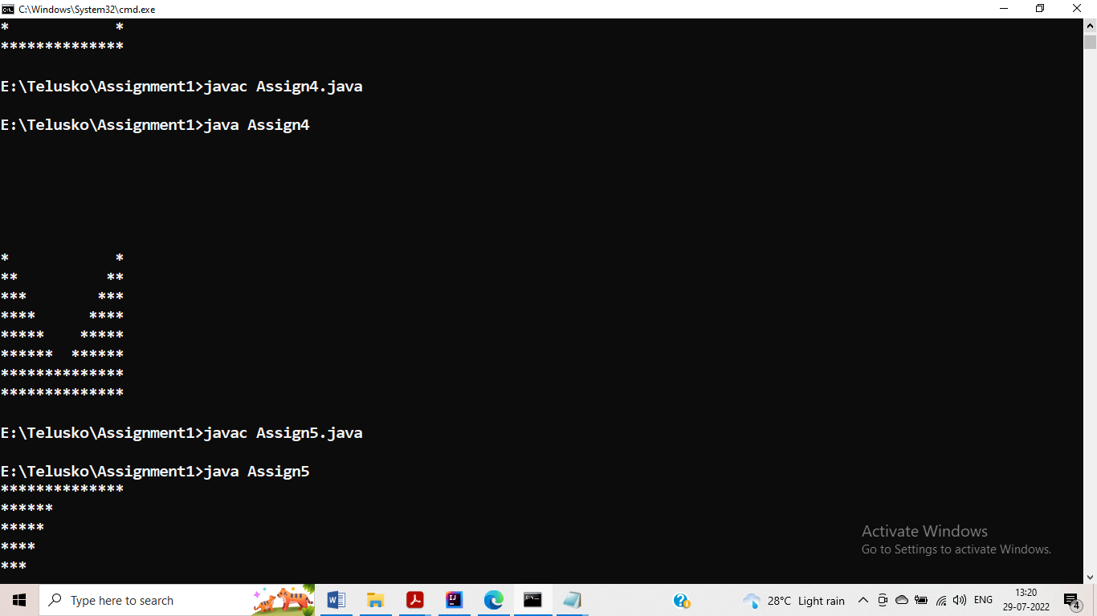

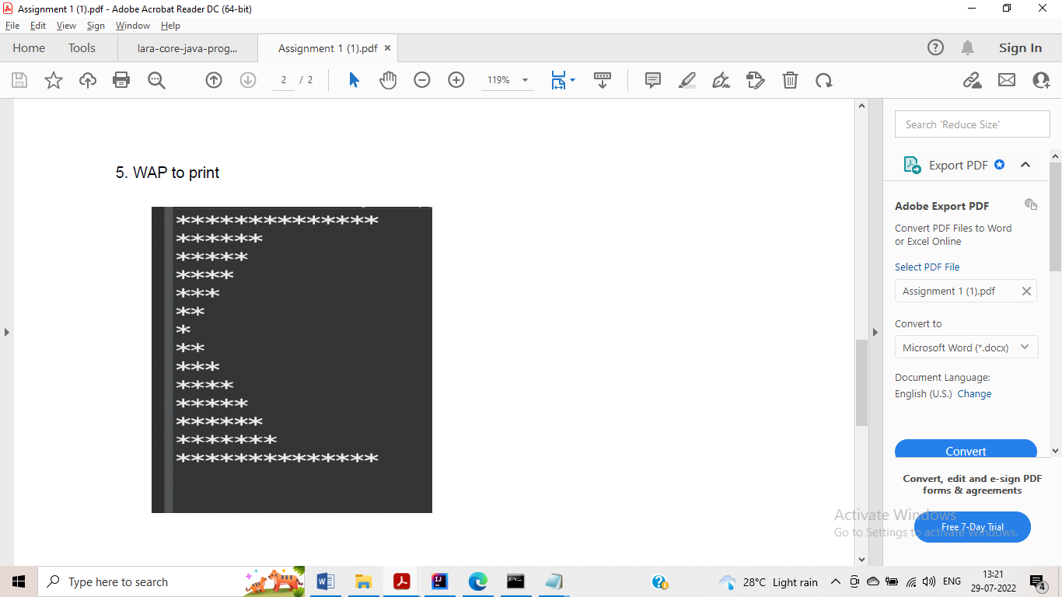

**Answer-**

public class Assign5

{

public static void main(String[] args)

{

int n=14;

for(int i=1; i<=n; i++)

{

for(int j=1; j<=n; j++)

{

if(i==1 || i==n )

System.out.print("*");

else if(i<n/2 && i>1 && j<=n/2-i+1)

System.out.print("*");

else if(i>=n/2 && i<n && j<=i+1-n/2)

System.out.print("*");

else

System.out.print(" ");

}

System.out.println();

}

}

}

