

**A** **PROJECT REPORT**

**ON**

“**Medical Emergency Service [MES]**”

## Submitted in partial fulfillment for the Course of

**Database Management System Laboratory**

Submitted by:

|  |  |  |
| --- | --- | --- |
| **S/L** | **Name** | **ID** |
| **1** | **Amit Golder** | **201-15-3058** |
| **2** | **Marcel David Baroi** | **201-15-3421** |
| **3** | **Tanvir Niaz Khan** | **201-15-3593** |

Submitted to

|  |
| --- |
| **Rubel Sheikh**  Lecturer  Department of Computer Science and Engineering Daffodil International University |

**TABLE OF CONTENTS**

**ABSTRACT**

1. INTRODUCTION
   1. PROJECT AIMS AND OBJECTIVES
   2. BACKGROUND OF PROJECT
   3. SCOPE OF THE PROJECT
2. SYSTEM ANALYSIS
   1. SOFTWARE REQUIREMENT SPECIFICATION
   2. EXISTING VS PROPOSED
   3. SOFTWARE TOOL USED
3. SYSTEM DESIGN
   1. TABLE DESIGN
   2. E-R DIAGRAM OF THE SYSTEM
4. SYSTEM IMPLEMENTATION
   1. MODULE DESCRIPTION
   2. SCREEN SHOTS
5. SYSTEM TESTING
   1. UNIT TESTING
   2. INTEGRATION TESTING
6. CONCLUSION & FUTURE SCOPE
7. REFERENCES

CHAPTER 1

INTRODUCTION

* 1. **PROJECT AIMS AND OBJECTIVES**

Our aim and the main objective is to digitalize the whole medical system. To get all the medical services on one platform

* We want to build an ambulance service system where anyone can get the ambulances nearby and don't need to pay extra bills.
* We want to create a relationship between the doctor and the patient.
* We want to give all the flexibility to the user as they can get all the medical services they want and need.
* We want to ensure the customers that the price of medicines is appropriate as the govt rules. So, that anyone doesn't need to buy the medicines paying extras.
* We want to ensure that the medicines are authentic to avoid further casualties because of fake and lower quality medicines.
* We want to build awareness among the people about their health issues.
* We want to create mass awareness about advanced medical services in rural areas.
* We also want to research with the experts to face the future pandemic situations
  1. **BACKGROUND OF THE PROJECT**

We wanted to solve a real-life problem using our technology and benefit a large population. Going through several brainstorming sessions and idea gathering, one hits hard. As a developing country, we didn't have sufficient infrastructure to provide medical information and services. We have seen so many scenarios where people are suffering because of the lack of proper treatment, transportation like an ambulance on time, and lack of information when they are in serious health conditions like heart attack, stroke, or pregnancy. We don't know where to call or where the ambulance is. The time gap between 5-10 minutes is valuable and, it becomes a life and death situation. If we call the ambulance, we don't know where the ambulance is and how much time will it take over that we don't know whether the driver is lying or not. So, we wanted to solve that problem along with many others by building a platform where people can see where the nearby ambulance is. Also, the user can communicate with the service provider in real-time and can see the locations. We want to save many lives.

We also want to work with the pharmacies system. Consumers had to face hassle when they want to buy medicines. If we think about post covid situation. People are being much more conscious about safety. So, we also want to solve that problem. Anyone can get medicines anywhere in the country. We are continuously witnessing scenarios like people are being sick by eating fake drugs. We want to decrease and gradually end this problem

* 1. **SCOPE OF THE PROJECT**
* Anyone can consult with foreign experts throughout our platform.
* We can make business opportunities for foreign investors.
* Can introduce different brands of medicines to the consumer and help this business to expand
* It will create job opportunities for unemployed people.
* can bring advancements in technologies and infrastructure
* Gaining competitive advantage
* Providing a unique experience to different types of users based on their location
* Easy availability and use
* Flexibility and affordability

CHAPTER 2

SYSTEM ANALYSIS

**2.1 SOFTWARE REQUIREMENT SPECIFICATION**

User needs: In our platform anyone can solve his medical emergency problems. From an user, they always expect to have good ui and also the flexibility. They actually find the comforts in less complex ui and interactions.

Performance: We will give a better user experience.

Safety: We will secure our sites in many layers. So that anyone feels safety in our site. We want to get their trust and want to be reliable.

System features: We will try to give more features like medicine taking alarms, daily health analysis.

**2.2 EXISTING VS PROPOSED**

There are some similar apps like us. But they don’t have the ambulance service. Its very necessary in daily life. If I talk about daktarbhai. They are working in the similar fields. But not giving users the comfort what they need.

We will try to have a user friendly ui. It will be more secure than the existing platforms. Their field work is so poor. So we will try to gather the informations and have the best analysis.

These similar apps are not updating as much as it should. We will try to provide that.

**2.3 SOFTWARE TOOL USED**

We have used Adobe XD for the ui section. For client side we will write codes in VS code. For server side we will use node js and tools like Xampp. We will use mysql commands for database management system.

CHAPTER 3

SYSTEM DESIGN

**3.1 TABLE DESIGN**

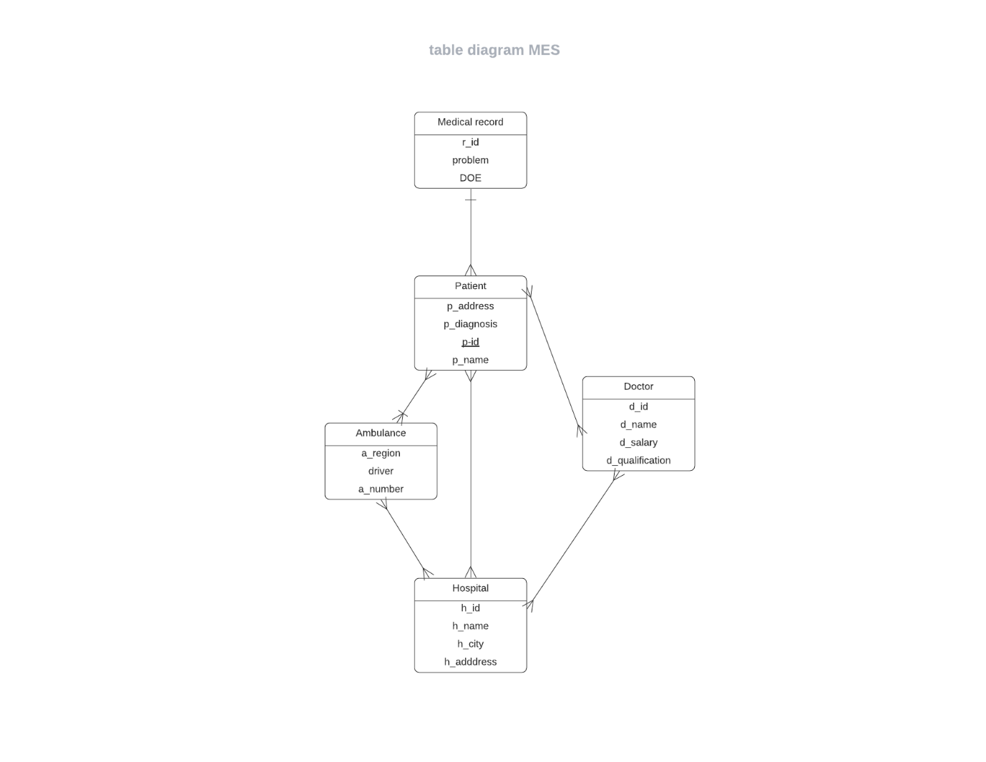

Link:

<https://lucid.app/lucidchart/ddd5a0d2-2515-46d2-b1b3-2db0638fd419/edit?invitationId=inv_f1a3bf6a-058e-48c8-ba87-6cc273e26688>

**3.2 E-R DIAGRAM OF THE SYSTEM**

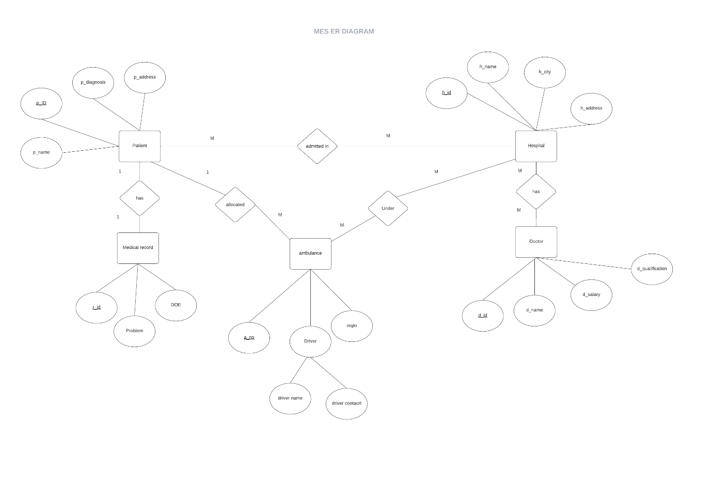

Link:

<https://lucid.app/lucidchart/06f169ef-5e7c-4570-ad86-07dfdeced1bc/edit?invitationId=inv_079ac745-fb90-4139-b98e-4e72ca47c4f0>

CHAPTER 4

SYSTEM IMPLEMENTATION

CHAPTER 5

SYSTEM TESTING

CHAPTER 6

CONCLUSION AND FUTURE SCOPE

CHAPTER 7

REFERENCES