8051 (AT89C51) external interrupt (INT0) code + Proteus simulation
This post provides the external interrupt (INT0) code ( using c language ) for 8051 microcontroller ( e-g for AT89C51 or AT89C52 etc ). In this code neg-edge triggered interrupts are enabled on INT0 pin as an example of demonstrating usage of INT0 pin. You can use this code for many purposes, for example when you need to control servo motor which has position encoder, with your 8051 microcontroller, then external interrupt handling is required.
The code and Proteus simulation is given in the 'Downloads' section at the bottom of this page. It is assumed that you know how to blink an LED using 8051 micro-controller. If you don't, then please read this post first.
The result of the Proteus simulation is shown below.
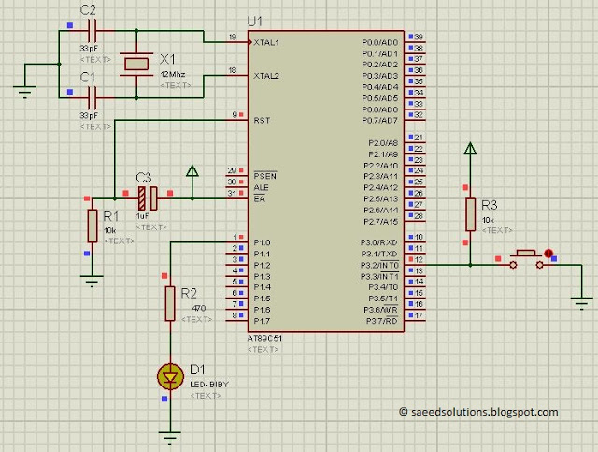
Figure 1. External interrupt detection circuit for 8051
In the above figure, when ever user presses the push button, then state of the LED attached on the P1.0 pin is toggled. This is done in the ISR^{[1]} function of the INT0 pin.

Code
The code for the main function is shown below.
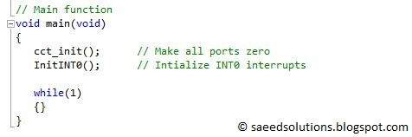
Figure 2. Main function code for usage of external interrupts in 8051
In this main function, INT0 interrupts are initialized by calling the InitINT0() function. Rest of the work is done in the INT0 ISR function.
InitINT0() function and INT0 ISR function, both are shown below.
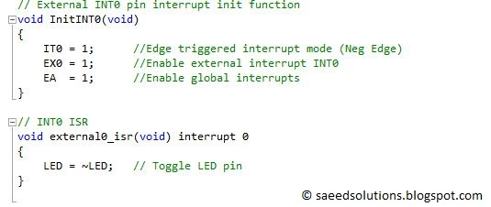
InitINT0() function just declares the INT0 pin interrupt source as neg-edge triggered. After that, external interrupt INT0 bit as well as global interrupt bit is enabled. Only this small, 3 line code is required to setup INT0 interrupts.
Whenever INT0 interrupt occurs^{[2]}, then external0_isr function is executed. In this function, LED pin is toggled every time.
Using the code given in this post you will be able to easily handle interrupts in the 8051 microcontroller. As an example, when you need to control servo motor (which has position encoder), then you can attach the output of position encoder on your 8051 P3.2 pin and capture interrupts on it. Whenever servo motor moves one position, then you will receive one interrupt. By incrementing a variable on each interrupt you can always keep track of servo motor position in real time.

Notes and References
^{[1]} Interrupt Service Routine. In exact words external0_isr() function.
^{[2]} For example, by pressing the push button in the Proteus simulation.

