Git Location::

https://github.com/amittarzaan/SpringCore/tree/master

Crete a project on

<https://console.developers.google.com>

Create a project if you do not have,

For my case I have already created.

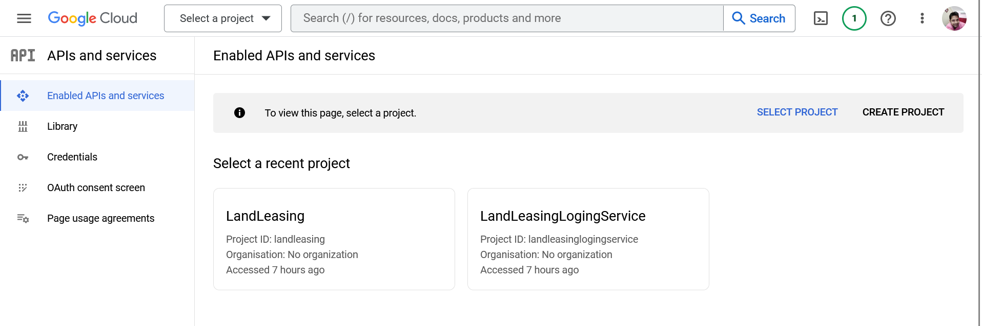

Auth concent link provide the user and token expired date, I have given 1 day

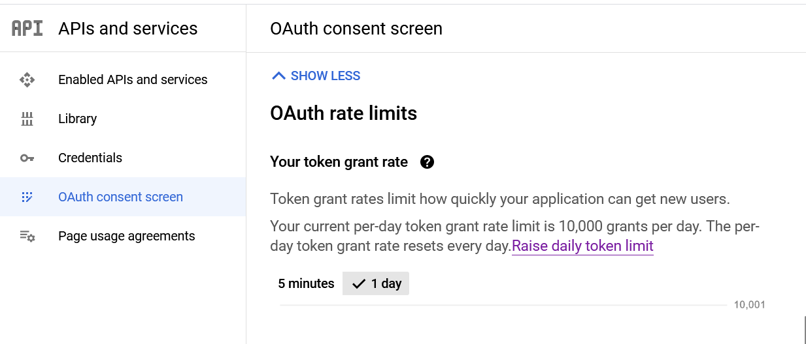

Now create credential.

Select oauth2 and Web aplcation, provide the json and redirect URL as per your app hostname. For local I have given like .

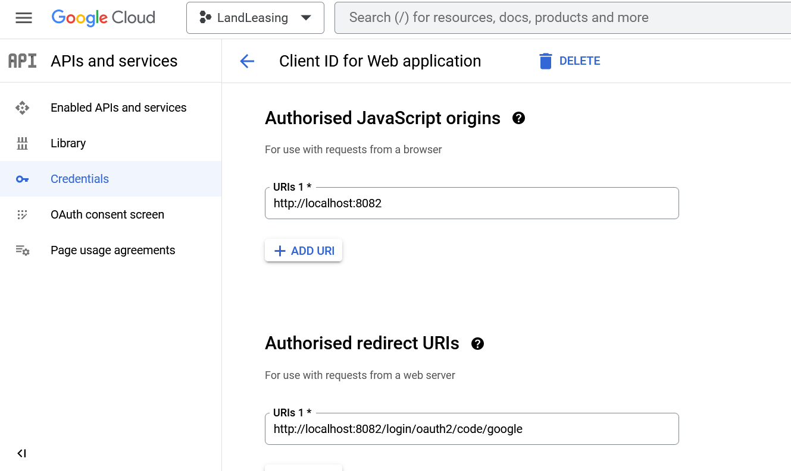

Now copy the secret and client id.

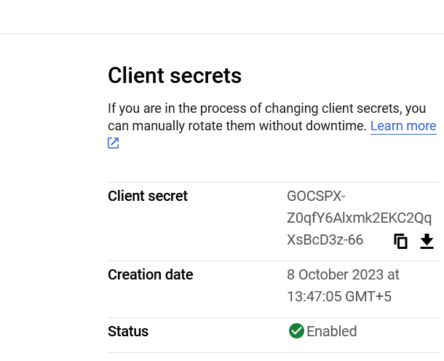

Notedown both keys.

Now come to the development.

Create Project using spring initializer. Use below pom.xml

This project is created based on spring-boot 3.0 and java 8.

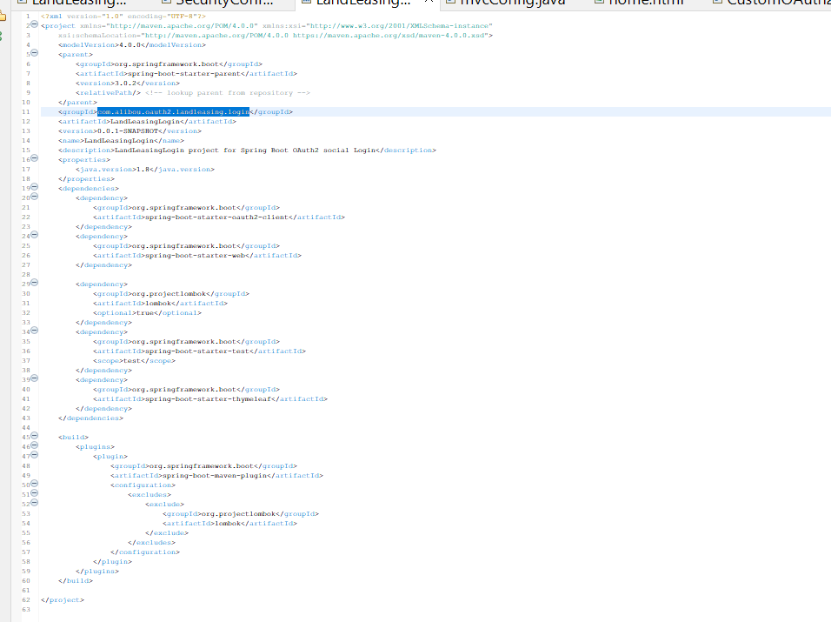

Now create the OauthSecurity class which basically filter URL.

Here We are allowing /static/\*\*…. hostname/static/home

This means if We navigate URL having this patter, We do not need to login.

In othersite if the URL pattern is mached with “/dynamic/\*” We will call google for authenticate and authorize.

Lets register the profile page for Spring MVC

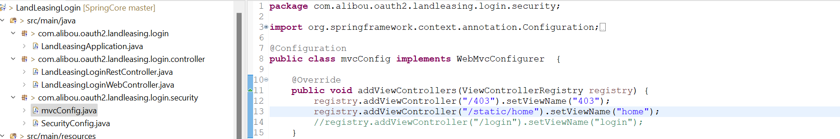

Create Controller for Web request and return view

Create a Rest Controller for returning success response after loging.

Server port,Client secret and id are configured in application.yml file

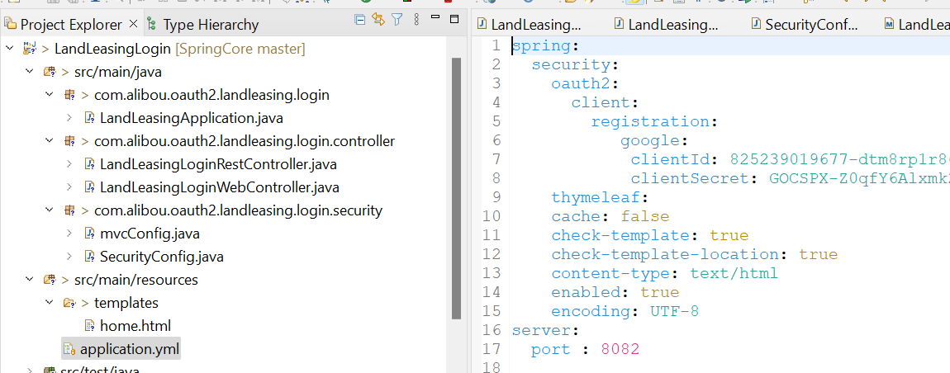

Run the project and check the output

Click on login with google

After 2 steps varification

