**“APPOINTMENT”**

APPOINTMENT APP

(ANDROID)

Functional Document

Version No. : 1.0

March: 2015

Prepared By: Amit Thapar/ Devendra Singh

# Document Release Note

**Notice No.:** Appointment 1.0

**Customer:**  Generic

**Project:** Appointment App (Android)

**Document details**

|  |  |  |
| --- | --- | --- |
| **Name** | **Version no.** | **Description** |
| Appointment_Functional | Version 1.0 | Defines the overall end to end functional features involved in the Appointment App. |

The document or revised pages are subject to document control.

Please keep them up-to-date using the release notice from the distributor of the document.

These are confidential documents. Unauthorized access or copying is prohibited.

Approved by: Date

User Approved by: Date:

Authorized by: Date:

# Release History

|  |  |  |  |  |
| --- | --- | --- | --- | --- |
| **Name** | **Ver. No.** | **Description** | **Client Approved By** | **Approved On** |
| Appointment_Functional | 1.0 | Defines the overall end to end functional features involved in the Appointment App. | NA | NA |
|  |  |  |  |  |

**Contents**

1. Document Release Note 2

2. Release History 3

3. Screen Design 5

# Screen Design

**Screen 1:-** Generic appointment booking application screen enables the user to perform following three steps at the high level:

1. Book Your Appointment to select today, future dates.
2. Select date for Appointment.
3. Show the screen -2 slot options based on step 2.

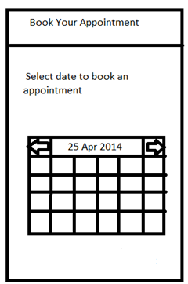

**Process Flow:**

1. User selects the date on the calendar.
2. The system fetches all the available time slots for the business unit in a day.

* System checks for the Threshold criteria to determine the number of users serviced in

a particular timeslot in a single day.

* System won’t show that timeslot to the user if the threshold criteria for that timeslot are not met.

**Screen 2**:- Generic appointment booking application screen 2 enables the user to Book the available slot. User can perform the below steps:

1. Book the Slot to select slot available.
2. Select appointment slot.

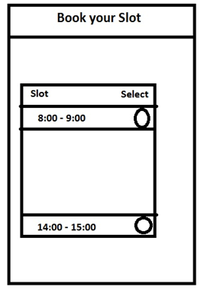

**Process Flow:**

1. User selects the timeslot on the screen.
2. As soon as the User selects the timeslot on the screen, the system will check if the customer exists in the system.

**A. Customer not exists in the system.**

* The user will be shown with the new customer registration screen if the customer is not in the system.
* The user will fill in the required details (mobile number, name, state) in the customer screen

and press the submit button.

* The data will be saved in the Reservation table.

**B. Customer exists in the system.**

* As soon as the User selects the timeslot on the screen, the data will be saved in the Reservation table