**Installation Of NodeJS Documentation**

**Overview**

* Node.js is also used for developing desktop applications and for deploying tools that make developing web sites simpler.
* Using NPM — a tool that makes installing and managing Node modules — it’s quite easy to add many useful tools to your web development toolkit.

## **Prerequisites**

To use Node you must type command-line instructions, so you need to be comfortable with (or at least know how to start) a command-line tool like the Windows Command Prompt.

## **Installation Steps**

1. **Download the Windows installer from the** [**Nodes.js® web site**](https://nodejs.org/en/)**.**
2. **Run the installer** (the .msi file you downloaded in the previous step.)
3. **Follow the prompts in the installer** (Accept the license agreement, click the NEXT button a bunch of times and accept the default installation settings).

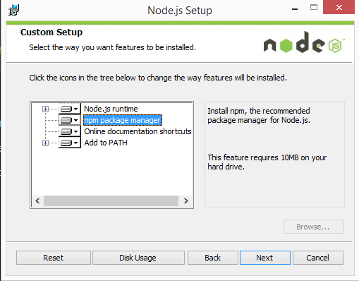

4. **Restart your computer.** You won’t be able to run Node.js® until you restart your computer.

5. Set the path variable in environment variables up to the bin folder eg

**C:\Program Files\nodejs\node_modules\npm\bin**

## **Test it!**

Make sure you have Node and NPM installed by running simple commands to see what version of each is installed and to run a simple test program:

* **Test Node.** To see if Node is installed, open the Windows Command Prompt, Powershell or a similar command line tool, and type node -v. This should print a version number, so you’ll see something like this v0.10.35.
* **Test NPM.** To see if NPM is installed, type npm -v in Terminal. This should print NPM’s version number so you’ll see something like this 1.4.28
* **Create a test file and run it.** A simple way to test that node.js works is to create a JavaScript file: name it hello.js, and just add the code console.log('Node is installed!');. To run the code simply open your command line program, navigate to the folder where you save the file and type node hello.js. This will start Node and run the code in the hello.js file. You should see the output Node is installed!.

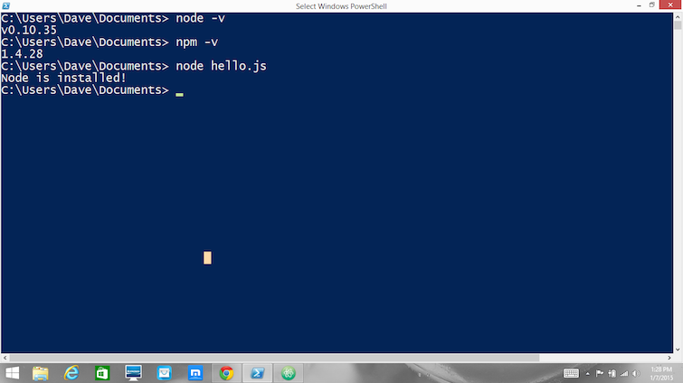

**How to Update Node and NPM**

New versions of Node and NPM come out frequently. To install the updates, just [download the installer](https://nodejs.org/en/) from the Nodejs.org site and run it again. The new version of Node and NPM will replace the older versions.

**How to uninstall Node and NPM**

You uninstall Node.js and NPM the same as you would most Windows software:

1. Open the Windows Control Panel
2. Choose the “Programs and Features” option
3. Click the “Uninstall a program” option
4. Select Node.js, and click the Uninstall link.