OrangePay

Introduction:
OrangePay is an Attendance & Payroll Management Software to keep track of attendance, leaves and processing / disbursing of salary. The main segments of this awesome tool are as below.
Who can benefit from this?
OrangePay helps the smaller and mid-sized organization to manage the attendance, timesheet and payroll of their workforce. It will benefit the buyers being a very cost effective and easy to use application developed on latest platform with a responsive UI/UX (can be accessed on any device with ease).

Features:
- Branch Management
This is the initial step, where we need to setup the organization. Multiple branches can easily integrate for start exploring. You can enable/disable a branch anytime.
The below operations can be done as listed below:
  - Add/update branch
  - Enable/Disable a branch
  - Multiple branch management
  - Listing of all branches
- User Management
This section is meant for invite and managing users for the application. They have the limited power to manage the system unlike the Admin.
The below operations can be done as listed below:
  - Invite/update User(s) to the system
- Leave Type Management
This section is meant for creating and managing various leave types (for example: SL, CL, PL and so on) as per the terminology used in the company. This is made flexible such a way that, the admin user has option to create and name the leave type as desired. It’s required during employee creation to allocate max number of leave.
The below operations can be done as listed below:
  - Add/update Leave type information
  - Listing of all leave types.
- Employee Management
This section is meant for creating and managing employee’s information. Categories the employee in branch wise is so simpler. Storing of Employee information with number of leave allocated at one place.
The below operations can be done as listed below:
  - Add/update Employee information
  - Allocate leave during employee creation
  - Employee profile page
  - Listing of all employees with sorting, searching and pagination functionality
  - Manage employees branch wise
- Pay Head Management
This section is meant for creating and managing various pay heads (for example: Basic, DA, PF and so on) as per the terminology used in the company. This is made flexible such a way that, the admin user has option to create and name the pay heads as desired. No limitation for creating number of pay heads is it “earnings” or “deductions”.
The below operations can be done as listed below:
  - Add/Update earning heads
  - Add/Update deduction heads
  - Pay head calculation using slab
  - Pay head listing page
- Generate Payroll
This section is meant to generate and manage the salary month wise of each employee with respect to the organization. The Payroll form is so simple for unlimited number of employee. Saving of salary details of each employee for further usage is quite easy. Preview your salary before publish and email to the employee as PDF is just a matter of click.
The below operations can be done as listed below:
  - Flexible to create payrolls with unlimited number of employees with respect to the branch
  - User friendly payroll form
  - Draft functionality to save the unpublished payroll
  - Publish payroll of individual or all the employees
  - Send payroll to the employee(s) on a single click
  - PDF view and print of payroll
- Daily Register
This feature will allow you to manage daily attendance of the employees with respect to the branch. Just need to enter only the In-Time and Out-Time, the status will be updated automatically. Monthly attendance view will give the clear picture of an employee’s attendance information.
The below operations can be done as listed below:
  - Daily attendance with excel like input day wise with respect to branch
  - Listing of daily register in same grid
  - Monthly attendance view for an employee in a grid
- Report
This section is meant for generating a customized report. Just select the fields, branch and month; it will generate the report for you instantly.
The below operations can be done as listed below:
  - Generate customized report for selected month according to branch
  - Customized your report view by selecting the checkbox fields
  - Monthly report generation
- Dashboard
It provide at-a-glance views of attendance, leave details for the day along with the last month payroll and monthly leave report. Also having the feature to get the attendance and leave details of any previous day with respect to the branch.
The below operations can be done as listed below:
  - Quick view of Attendance for the day or selected day
  - Leave status of employees for the day or selected day
  - Last month payroll view
  - Monthly Leave report with graphical chart view
- Holiday List
This section in meant for managing the holidays provided by the organization for the financial year. Keep track of your every year’s holiday and with option to download as PDF.
The below operations can be done as listed below:
  - Add/Update/Delete a holiday
  - Listing of holiday according to the financial year
  - Download holiday list in PDF
- Leave Management
By this feature you can create and manage the Leave. Monthly leave calendar view will display each employees leave details for the month.
The below operations can be done as listed below:
  - Add/Update/Delete a leave of an employee
  - Listing of leave with sort, pagination and search functionality
  - Monthly leave calendar view
GETTING STARTED: 1. Branch Management
Branch management is the FIRST step of using OrangePay, where we need to setup the organization with following details to start using app.
  - Name
  - Logo
  - Address
  - City
  - State
  - Pin
  - Country
Multiple branches can be created for an organization.
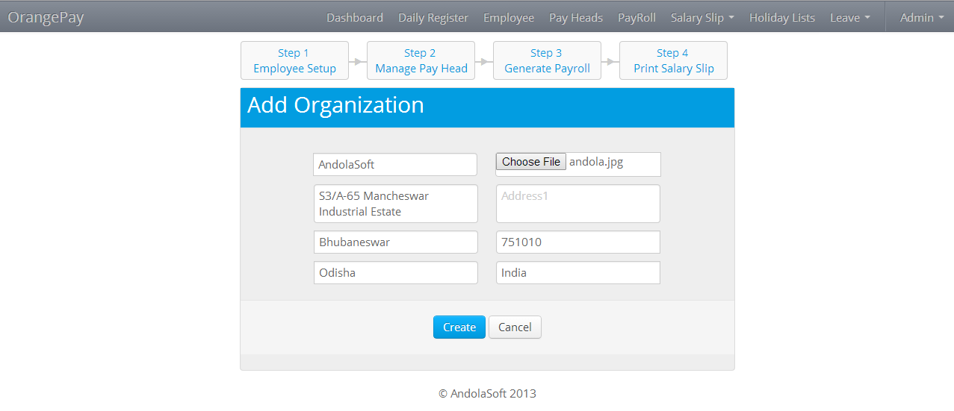

  - Listing of branch can easily view with edit and disable option
  - Disable option will treat the branch as inactive throughout the organization
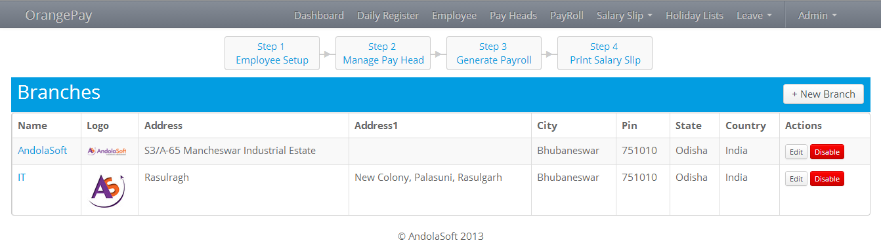
2. Dashboard
- Quick view of Attendance for the day or selected day
- Leave status of employees for the day or selected day
- Last month payroll view
- Monthly Leave report with graphical view

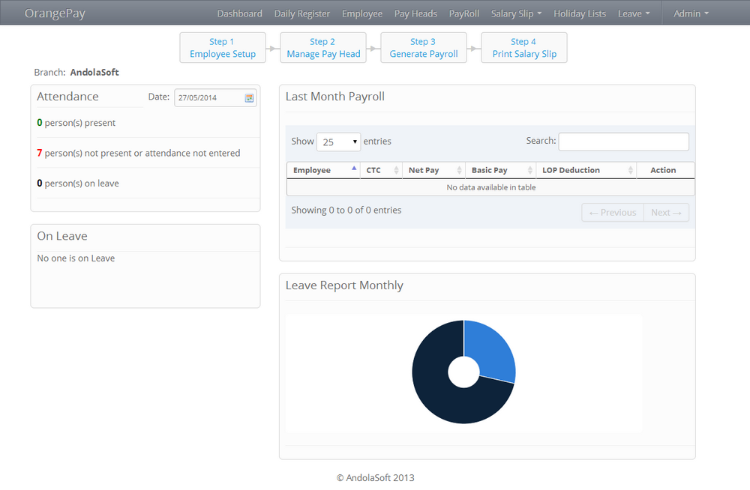
3. Leave Type Management
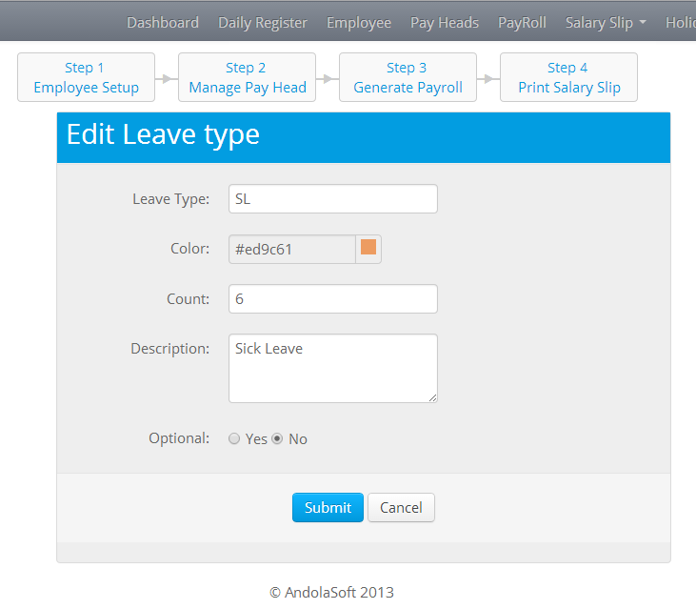
  - Setting up of the leave types of an organization before adding an employee
            - SL(Sick Leave)
            - PL(Privilege Leave)
            - CL(Casual Leave)
            - ML(Maternity Leave)
  - Following are the options for a leave type
            - Leave type Name
            - Color (Will display the leave in calendar view as background)
            - Count(Max allocation)
            - Optional(optional for an employee during allocation of Leave type)
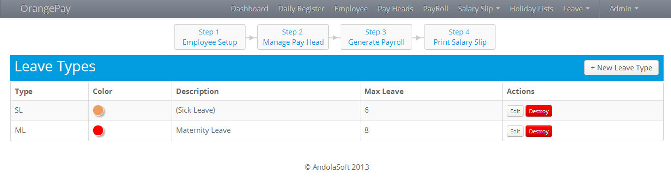
4. Leave Calendar view
  - Monthly Leave calendar view

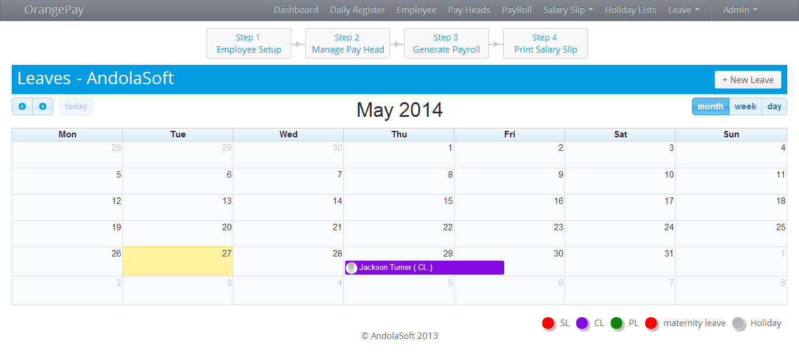
  - It helps you to know the leaves taken by employees on a particular day with leave type.
Add Leave information
  - Add new leave according to branch
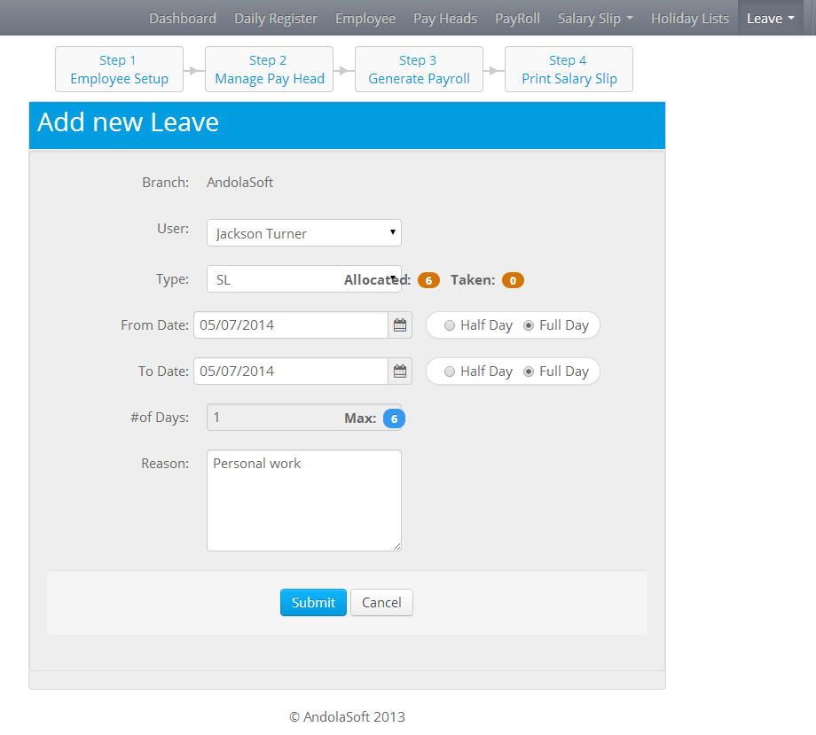

  - Add the leave details of an employee with the leave type according to the branch.
5. Employee Management
  - Employee information is the vital for the App so, we need to setup first with information
  - Setup Employee Information
      - Fill up the forms with right information about an employee according to the branch
  - Allocate Leave
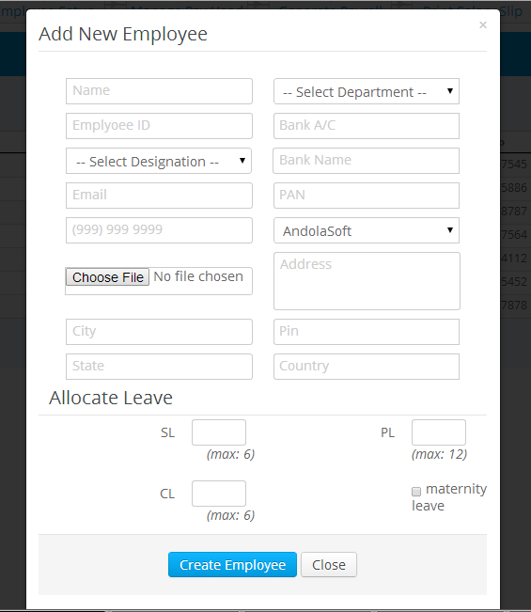
  - Enter the count of leave type to be allocated for an employee and it should not exceed from the max count set at the leave type management
  - Listing of employee in a tabular view with sorting, searching and pagination functionality
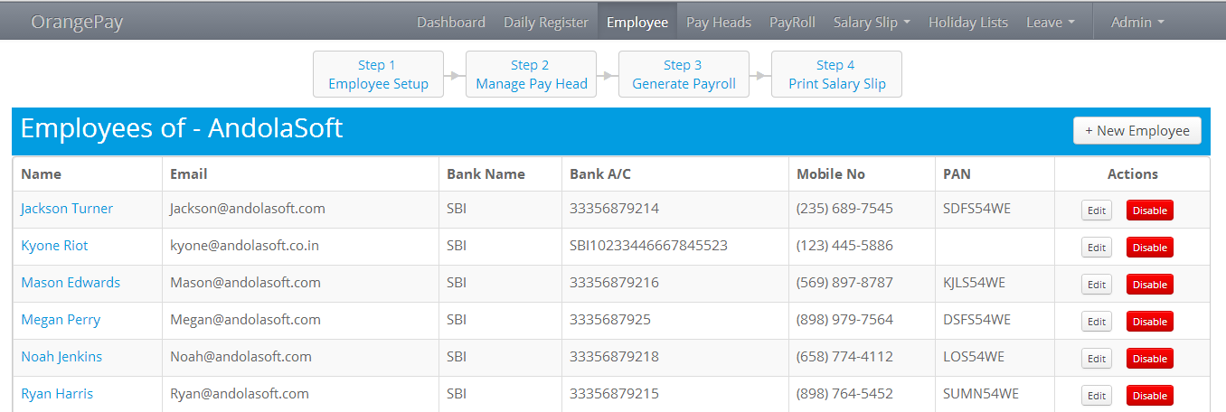
6. Pay Head Management
  - The salary components constituting Pay Structures are called Pay Heads. A Pay Head may be an earning, which is paid to an employee, or a deduction, which is recovered from his/her salary. The value of these Pay Heads could be either fixed or variable, for each Payroll period.
- Earning
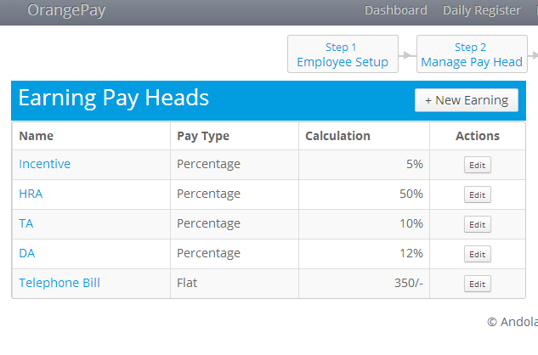
  - Add the Earning details of an employee with calculation type
  - Enter calculation value which is paid to an employee
- Deduction

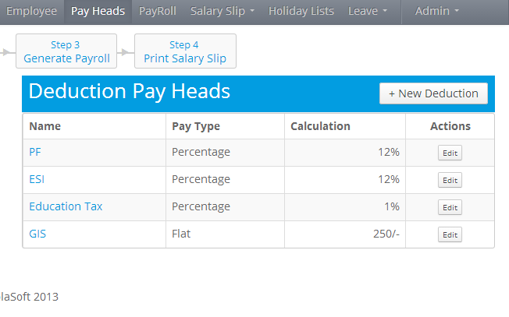

  - Add the Deduction details of an employee with calculation type.
  - Enter calculation value which is recovered from his/her salary.
- Calculation information

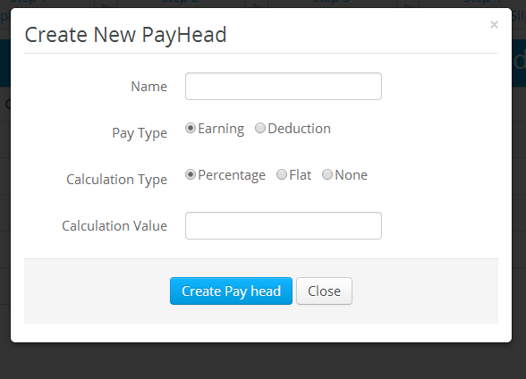
  - Fill Up the form with the following details
- Name of the pay head
- Pay type (Earning or Deduction)
- Calculation Type
- Percentage (calculation will be in percentage)
- Flat (calculation value in fixed as mentioned in calculation value)
- None (It means earnings & deductions are provided at the time of payroll generation)

7. Generate Payroll

- We can generate payroll according branch wise
- Listing as well as entry grid has the sorting and searching functionality which helps to filter data instantly
- Auto calculation according to CTC, Basic and absent days
- We can copy the payroll from desired month in a single click
- Save salary details of an employee for further use

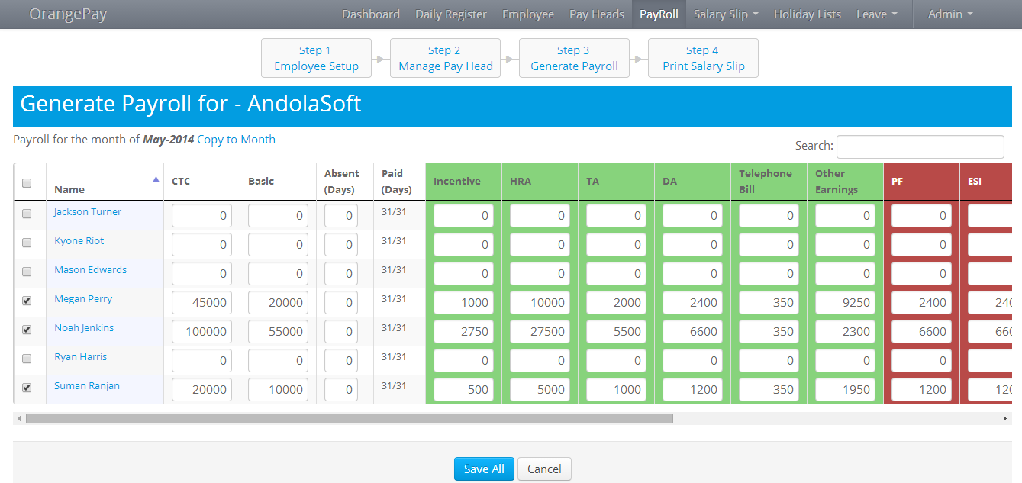

8. Salary Slip
- Draft
- Store the salary before publish
- We can update/delete/publish a salary details
- Listing the salary in a grid with pagination, searching and sorting functionality according to branch wise

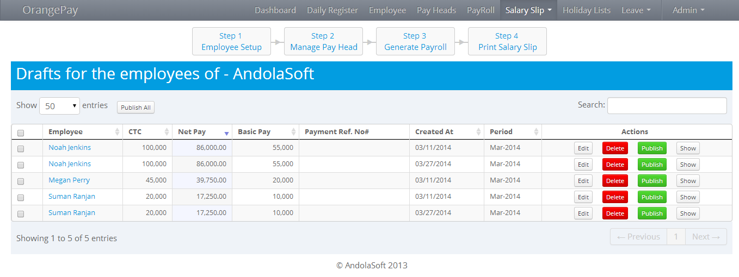

- History
- It’s a quick view of previous month salary details according to branch wise
- Displaying the salary in grid with pagination, sorting and searching functionality

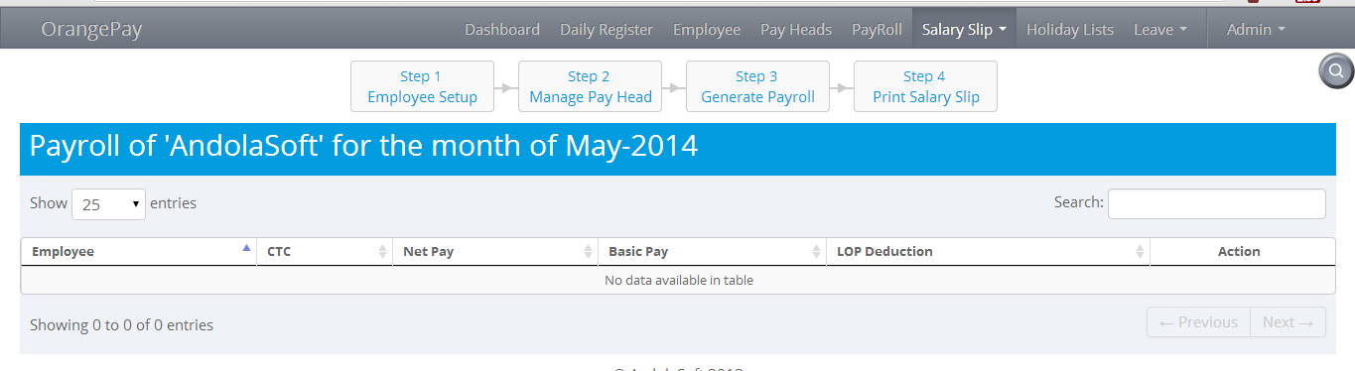
- Print
      - Preview and Print salary according to employee and month Wise

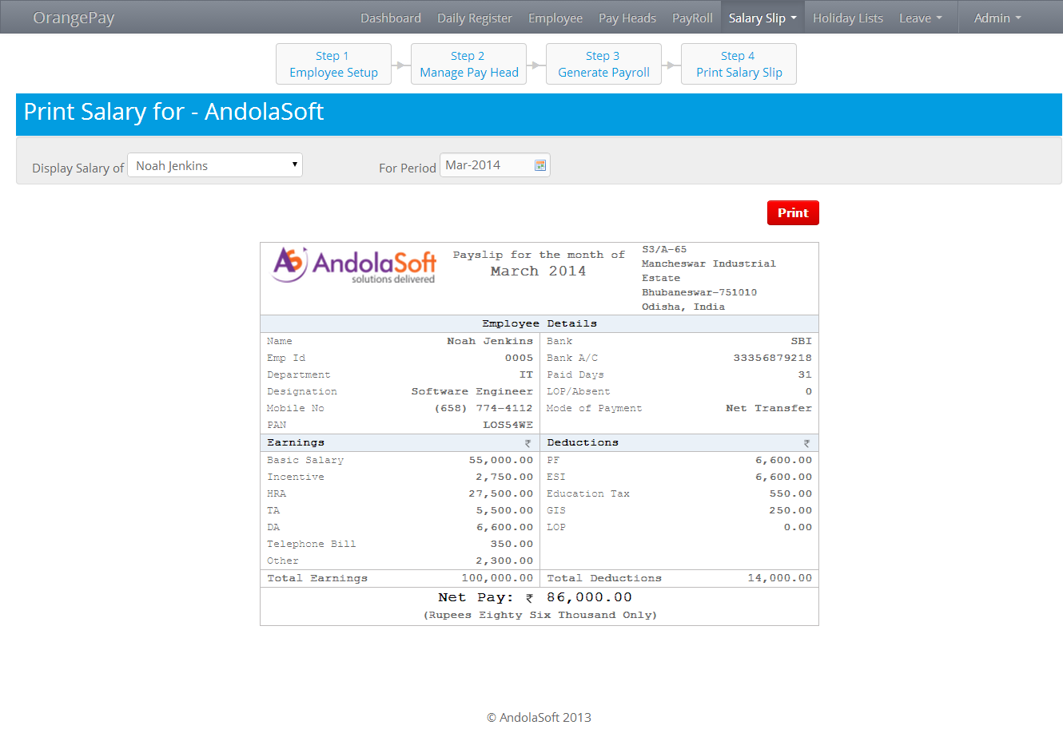

9. Holiday List
      - Easy to record the holiday of an organization for the financial year
      - Listing of holiday in a grid with pagination, sorting and searching functionality according to the financial year
      - Fill up the Holiday form for the financial year
      - Download holiday list in PDF and share with all employee.

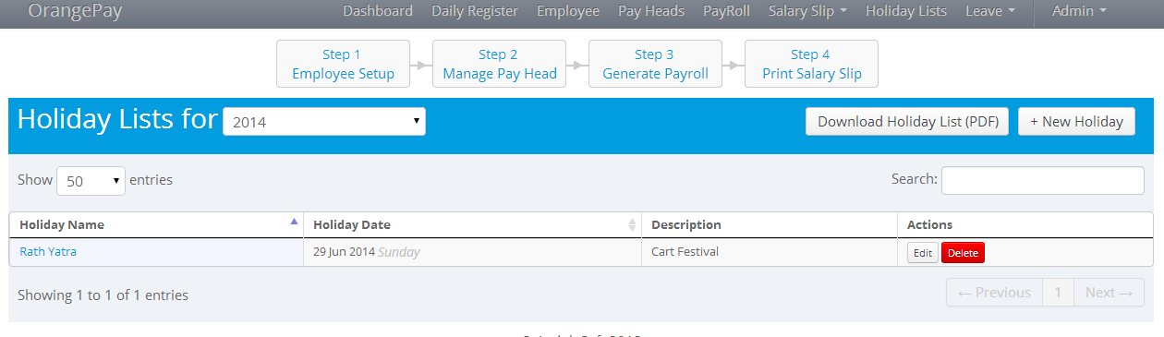

- Daily Register
      - Daily attendance with excel like input according to branch and day wise
      - Listing of daily register in same grid
      - Enter in time and out time for the day of an employee is quite easy
      - Status automatically updated after entering the in time and out time

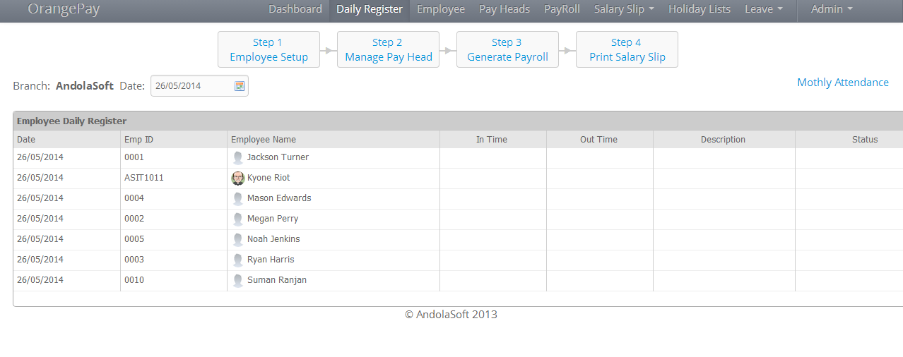
Monthly Attendance
      - It’s a monthly view of daily register with in time and out time for every employee
      - Listing of all employee with latest day's information shows here
      - After clicking a particular employee all the information for the information shows

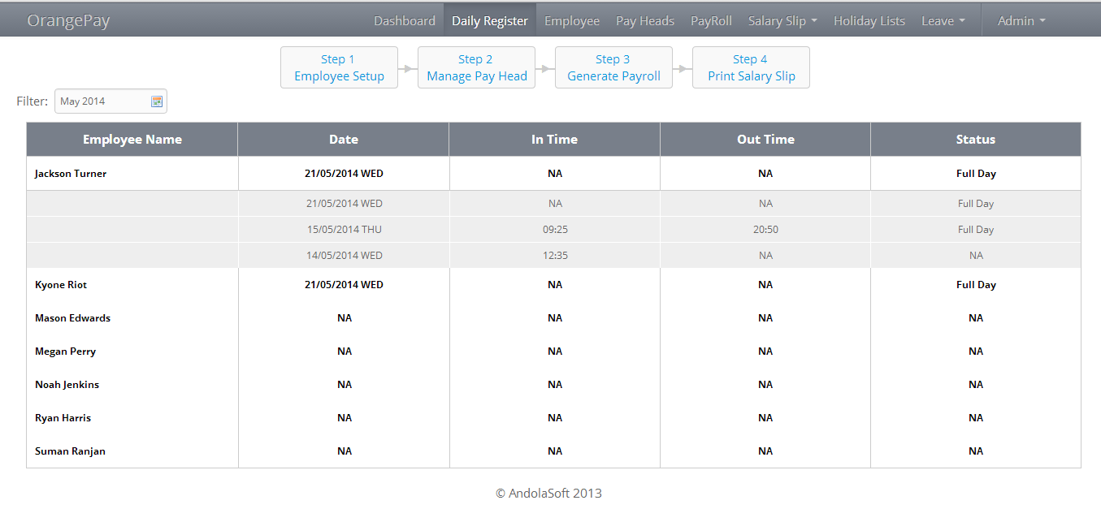

11. Reports
      - Generate customized report for selected month according to branch wise
      - Select the checkbox fields to include in the report
      - A page comes with data of selected field after clicking the “Generate Report” Button

