

**Proposal and Specification for:**

**Web developer + Designer for a new Ruby on Rails project**

Presented by

**Nasim**

Submitted to:

Client-name

Presented by:

**Nasim**

*Date: 15th November, 2016*

Hello,

It is with great pleasure that I present to you our proposal. Having recently developed an in-depth understanding of the proposed work, I believe I would make an ideal partner to design and develop the Web application. Being an expert developer and creative talent are a perfect match to meet the technical and aesthetic vision of website work.

My proven track record for projects large and small, including numerous startups, gives us the ability to create a product based on prior successes as well as collective insight.

I appreciate your consideration and confidence. Please contact Nasim, at [email-id](mailto:anurag.pattnaik@andolasoft.com) with any questions.

Best Regards,

Nasim

**Executive Summary**

This Business Proposal represents a combination of strategic startup guidance as well as best practices in user experience design and Web development.

Based on the requirement, I understand the goal of initial engagement is the building the MVP of a functioning Web application. The web application will be developed from scratch in Ruby On Rails. The web application will have **bootstrap layout** with same colour combination to make the website default **responsive**.

The web application will be developed in RoR. The backend/database will use MySQL.

**TABLE OF CONTENT**

1 Company Portfolio 4

2 Proposed Milestone & Strategy; 8

3 Deliverables 8

4 Support & Maintenance Service (Optional); 9

5 Communication & Scrum 10

6 Time Estimation for the Web Application Development 10

7 Resource Plan &Cost Estimation for Web application Development (Phase#1) 10

8 Payment Method and Phases 12

9 Change Request Process 12

10 Terms & Conditions 12

INTELLECTUAL PROPERTY INFRINGEMENT 13

INDEMNIFICATION CLAUSE 13

# Portfolio

**Some of my Recently Developed Web Applications**



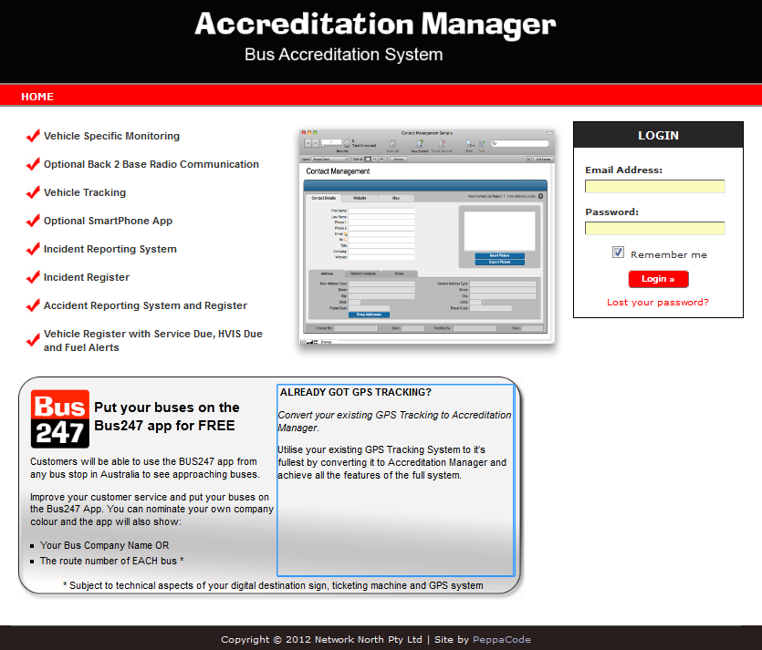







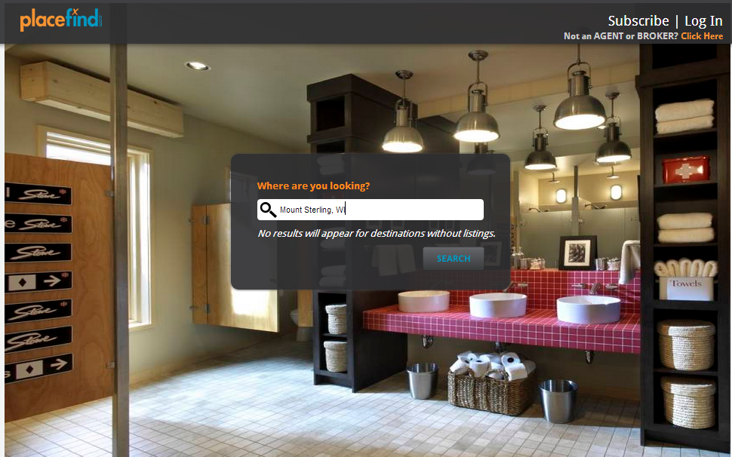

# Proposed Milestone & Strategy;

This proposal clearly focuses on developing the MVP in RubyOnRails from scratch.

The specifications outlined below encompass the Scope of Work (SOW) required to develop the web application from scratch in RoR. The app will be built with ***RoR v4.X*** as Frontend language & ***MySQL*** as backend technology. The application will be hosted on Cloud platforms which will be accessible through a browser equipped with internet connection.

The web application will be developed in **RoR** framework, which is the most popularMVC framework based on **Ruby** language. Normally MVC architecture is very easier to maintain and much faster in performance. From the very beginning of the development **Bootstrap** layout will be integrated which will make the site responsive.

# Deliverables

**General**

* External User registration
* Login and logout functionality
* Change password
* Forgot password
* Edit profile
* All Static Pages

**ADMIN / Div_Admin / Agents**

* ARTIST – List CRUD with Print
* ARTIST – News CRUD
* ARTIST – Riders/Admats CRUD
* ARTIST – Portfolio CRUD
* ARTIST – Photo gallery CRUD
* ARTIST – Artist Links CRUD
* ARTIST – Media Links CRUD
* ARTIST – View Artist Info
* EVENTS CRUD
* DIVISIONS CRUD
* USER / AGENT CRUD
* WEBSTATS
* SEARCH
* BOOKS CRUD
* CAREERS

**External**

* Motion Pictures
* Television
* Music – Print and PDF and html view
* Corporate Events – Print and PDF and html view
* Live Performance / Comedy
* Motion Picture Finance
* Alternative Programming
* Theatre
* Digital Media
* Book Publishing
* Commercials / Endorsements
* Literary Rights
* Voiceover

# Support & Maintenance Service (Optional);

We would like to elaborate our Support & Maintenance services.

The monthly retainer fee for monitoring and support is **$699**. The package includes the following;

* **Security monitoring and patching**: Including server OS, CakePHP
* **Application uptime monitoring**: If the app experiences an outage due to an attack, hardware failure, or DNS issue, we will diagnose, triage, and send alerts. while we provide 24/7 Email/Phone support
* **Hardware utilization monitoring**: Hard drive space, memory usage, disk i/o will all be monitored, and notifications sent when action is required.
* **Up to 2 hour / month of non-critical upgrades**
* 24*7 server monitoring through Nagios
* Real-time server health tracking using Nagios.
* Application performance monitoring through NewRelic

We would like to offer development support as and when required by you. We are happy to provide on an hourly rate basis for **$30**/hour.

# Communication & Scrum

Andolasoft will provide the email address, Skype of the Sr. developer/Project Manager for direct communication. OrangeScrum will be used for the project related communication. Weekly scrum will be arranged between OmniPointDesign and Andolasoft team to discuss the project development. The date & time for the weekly scrum can be decided on the Project Kick-off meeting. For Scrum Skype/GoToMeeting/Webex will be used as per convenience of OmniPointDesign and Andolasoft.

Apart from Weekly Scrums, meetings can be happen on demand as requested by OmniPointDesign or Andolasoft for any clarification or discussion on project modules. Daily Updates would be sent through OrangeScrum.

# Time Estimation for the Web Application Development

The work required to complete migration of the web application development would take approximately 8 weeks of time from the date started. The project is most likely to be started by 3rd week of August.

# Resource Plan &Cost Estimation for Web application Development (Phase#1)

|  |  |  |  |  |
| --- | --- | --- | --- | --- |
| **Resource type** | **Count** | **Pricing/Hour** | Engagement time  (**Man Hours**) | **Total** |
| PHP Developer | 1 | $25 | 360 | $9,000 |
| Front end developer (UI & UX) | 1 | $15 | 100 | $1,500 |
| Project Manager | 1 | $35 | 160 | $5,600 |
| QA | 1 | $20 | 120 | $2,400 |
| Dev OPS | 1 | $25 | 40 | $1,000 |
|  |  | **Grand Total** | | **$19,500** |

# 

# Payment Method and Phases

|  |  |  |
| --- | --- | --- |
| **Payment Milestones** | % | Amount in **USD** |
| Advance on signing up the contract | 25% | $4,875 |
| On completion of the Release#1 demo | 25% | $4,875 |
| On completion of the Release#2 demo | 25% | $4,875 |
| On completion of the Release#3 demo | 25% | $4,875 |

* 25% of advance payment after signing of the contract. 25% of payment after 1st demo done for the release#1. 25% amount need to be released each time after the completion of Release#2 & Release#3 demo. All the demo releases are mentioned in the Milestone wise delivery.
* All the payment shall be done through ***PayPal payment***, details sent through the invoice. Alternative method for payment would be ***Bank of America account deposit*** mentioned below.
* The final instalment of the payment shall be released after completion of the Web app development
* After the final instalment is paid the source code will be handed over

**PayPal Account**

PayPal id to make the payment is ***pgharai@andolasoft.com***

**Bank of America details**

Bank Name: Bank of America

Bank Address: Cambrian Park,14396 Union Ave,San Jose CA 95124

Account Name: Andolasoft Inc.

Account No:0494667925

Routing No: 026009593 (wires)

Bank of America's SWIFT Code number is BOFAUS3N.

# Change Request Process

Our technical team will analyse every change requests received from client. If the change requires significant time and effort, the same will be notified to client and appropriate effort and schedule slippage will be notified to client for approval.

# Terms & Conditions

* Communication and scrum are done as per mentioned in ***section#6***
* Please note that the payments to be made prior to the starting of the milestone in ***Section#8***. The release of each milestone for demo purpose is listed under ***Section#4***.
* FREE support of 30 days would be provided by Andolasoft after deployment to production for any issues/defects/ to ONLY the features to be delivered as per the specification discussed in Milestone. All the cases will be created in OrangeScrum, technical team member will respond to it.
* UAT document will be provided by the OmniPointDesign during the development
* However, any work related to further addition and/or modification and/or deletion by OmniPointDesign to the web app development are chargeable on anhourly basis. Rate will be **$30/hour.**
* The renewal of Certificate, SSL cost to be undertaken by OmniPointDesign. It is the sole responsibility of OmniPointDesign to provide legal graphical properties (free from copyright)
* Otherwise, OmniPointDesign can authorise Andolasoft to buy images on their behalf
* Any relevant database or API to be provided by OmniPointDesign on the beginning of the project.
* AndolaSoft would provide free support to deploy the web app on the Cloud platforms like Amazon, Rackspace etc… for which OmniPointDesign need to provide the cloud platform credential. AndolaSoft would provide free support & service if any issue found during the deployment of the web app.
* Feedback loop has to be closed by the OmniPointDesign by 24 hours in-case of weekdays & 48 hours in-case of weekends

## INTELLECTUAL PROPERTY INFRINGEMENT

* Andolasoft wouldn’t use/copy codes/images/files copyright by other vendor during development of the OmniPointDesign web application. All the development will be made from scratch by Andolasoft. Andolasoft will not use the source code developed for OmniPointDesign in any other work.
* All the source code, business logic & intellectual property should be transferred to OmniPointDesign after the final payment is received by Andolasoft.
* OmniPointDesign will have the ownership of the source code including images, third party libraries/license owned which are used in development

## INDEMNIFICATION CLAUSE

*Andolasoft, Inc. agrees to indemnify and hold harmless OmniPointDesign against loss or threatened loss or expense by reason of the liability or potential liability of OmniPointDesign for or arising out of any claims for damages.*

IN WITNESS WHEREOF, the parties have executed this Agreement as of the Effective Date.

**For and on behalf of Andolasoft Inc.:For and on behalf of OmniPointDesign**:

By: _____________________ By: _______________________

Print Name: Priyabrata Gharai Print Name: E. Scott Espenshade

As Its: CEOAs Its: CEO - Founder