**Terminal server Installation & configuration**

**Hardware & Software requirement :**

Size your terminal servers with sufficient CPU, memory, and disk resources to handle the client demand. For adequate performance, a terminal server requires a minimum of 128 megabytes (MB) RAM, plus additional RAM for each user running applications on the server, depending on the type of user.

**Processor**: 2.5 gigahertz (GHz)

**RAM**: 1 gigabyte (GB)

**Disk**: NTFS file system–formatted partition with a minimum of 100 MB of free space

**Display**: 1024 × 768

**Prerequisites**  
Before installing Terminal Services Log you need to install .NET Framework 2.0 or later.           

**Operating system**

Terminal Services Log runs on Windows Server 2000 with SP4 or later. We recommend that you apply all critical updates. You can use the following Windows Server editions:

* Windows Server 2008, All editions
* Windows Server 2003, All editions
* Windows Server 2000, All editions.

**Terminal server Installation on Windows 2003 Server**

First we have to Install Terminal services by following process: Install all the application before configure terminal server. Install Active directory before terminal server. So that user permission & rights will be applied for security purpose .But here don’t install active directory just simply install TS only.

Go to start >Control Panel>Add/remove Program>Add/Remove Windows Components>select & checked Terminal server & terminal server Licensing.

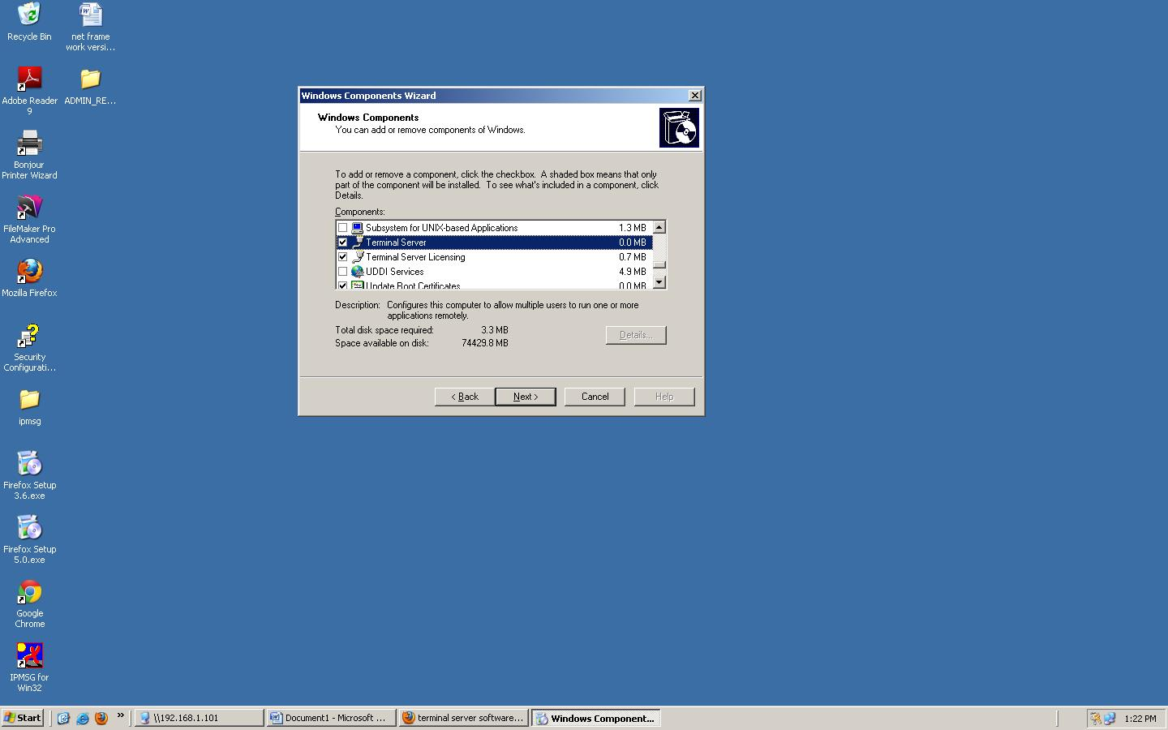

After that it will ask for OS disk1 to install some files.

So put appropriate windows CD & press next.

Then restart the server if it prompt.

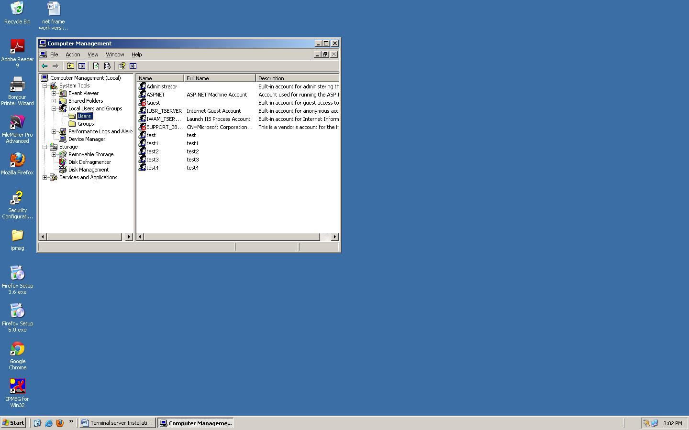

Right click on system properties –manage –local users & groups-then create user (right click user-new user). Then add those users in RDC group.

(D.C on user –select member of – add- advance -find now-remote desktop users.

Now go to windows – system32-clients-tsclient-win32-copy “**msrdpcli.msi**” file to clients pc & install this file .after that logon through RDC menu to the terminal server.