STAMP is an modern hazard analysis method which is used to identify or predict erroneous behavior. Instead of treating safety as a Reliability problem, STAMP treat as Control problem. Control is broad, it can be human operators, system design, process or even through social controls such as governmental or regulatory. STAMP essentially has 6 steps as follows:

1. Identify system objectives, system hazard, hazard and safety constraint
2. Create the Hierarchical Control Structure (HCS)
3. Control structure under normal condition
4. Identifying potential Unsafe Control Actions(UCA)
5. Using unidentified safe control to create safety requirements
6. Determining how each potentially hazardous control action could occur to enable mitigation action.
7. **Identify system objectives, system hazard, hazard and safety constraint**

**STAMP basic concept**

|  |  |
| --- | --- |
| Traditional VIEW | STAMP View  (Control Loops & Structure) |
| Accidents are: chains of directly related events | Accidents involve: complex dynamic processes |
| Defines safety: “Management of Faillure” | “Dynamic Control” |
| Prevent Accidents by: Preventing failure | Enforcing constraints on System Behaviour & Interactions amongst System Components using a Control Structure. |

Our project is a predictive maintenance system, which has multiple hazards that we discussed before. We pick hazard H1 to analyze, since it was the primary to the system. The Safety Constraint and Safety Requirements are listed as follow:

|  |  |  |
| --- | --- | --- |
| Risk | Safety Constraints (SC) | Safety Requirements (SR) |
| H1 | The prediction model is computed precisely and accurately. | * Telemetry file is reachable by machines. * Machine IOT sensors are operating continuously and extracting accurate data. * Machine timestamps are in correct format. * IOT sensors generate matching metric system. |

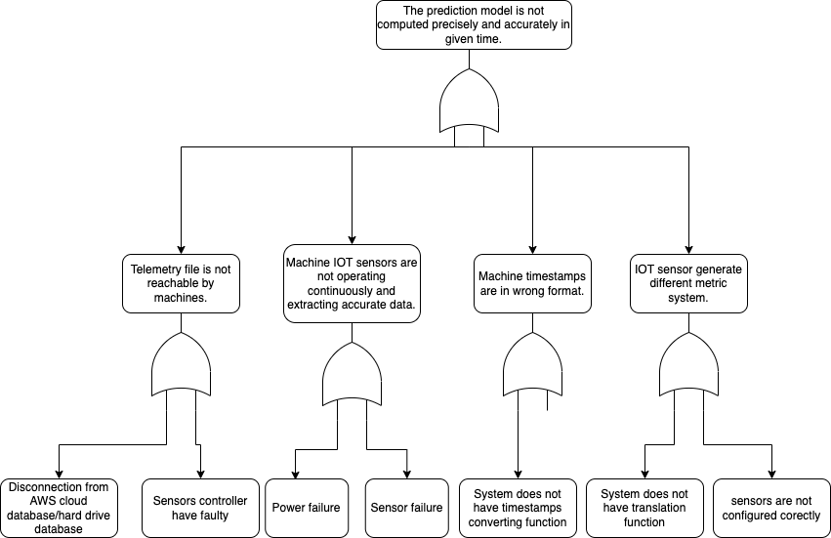

*Figure: Fault Tree Analysis*

1. **Hierarchical control structure**

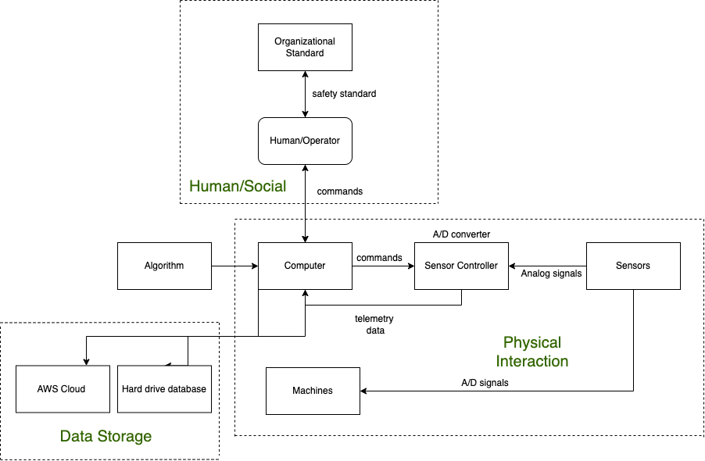

1. **Control structure under normal conditions**

For a normal conditions, the operators initiate the computer using the GUI. The computer then connects to data storage, the algorithm and the sensor measurement controllers. The sensor measurement controller will control sensors and send feedback to the computer about its current working status. The sensors are attached to machines and records telemetry data. Some of the loops work as independent, in series or parallel with others.

1. **Identify potential unsafe control actions**