Angular 2

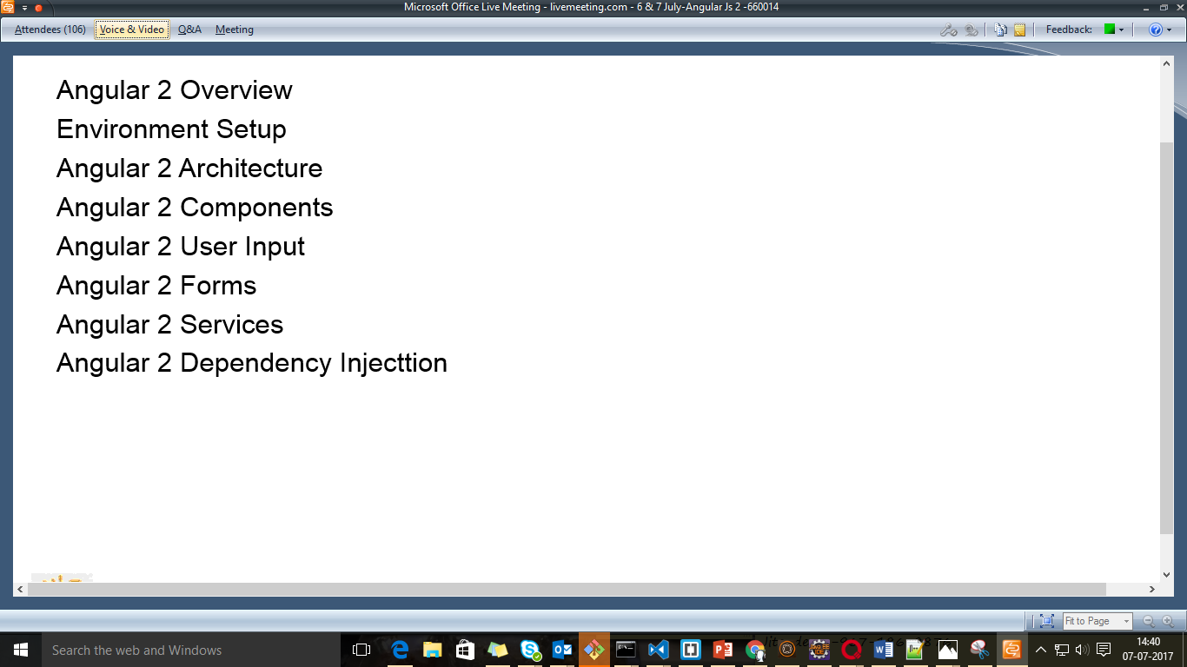

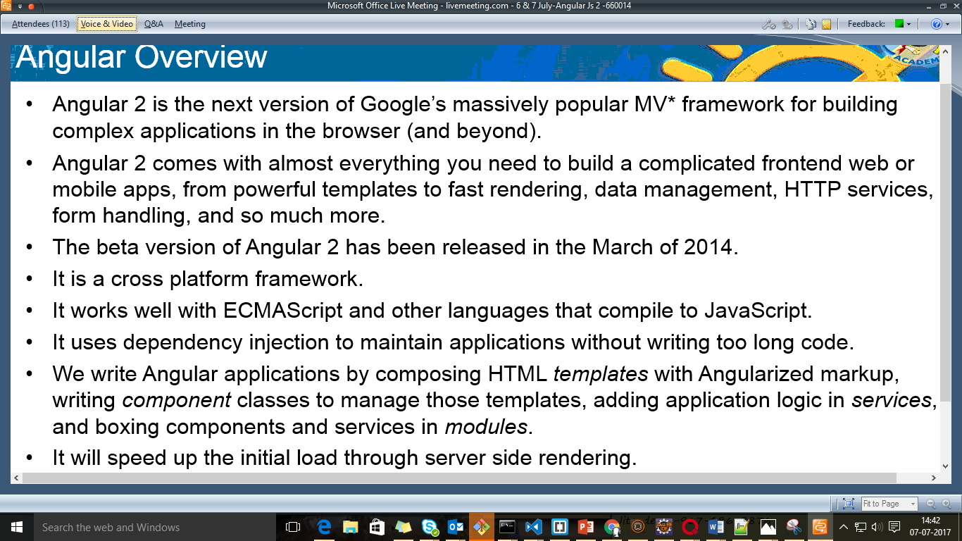

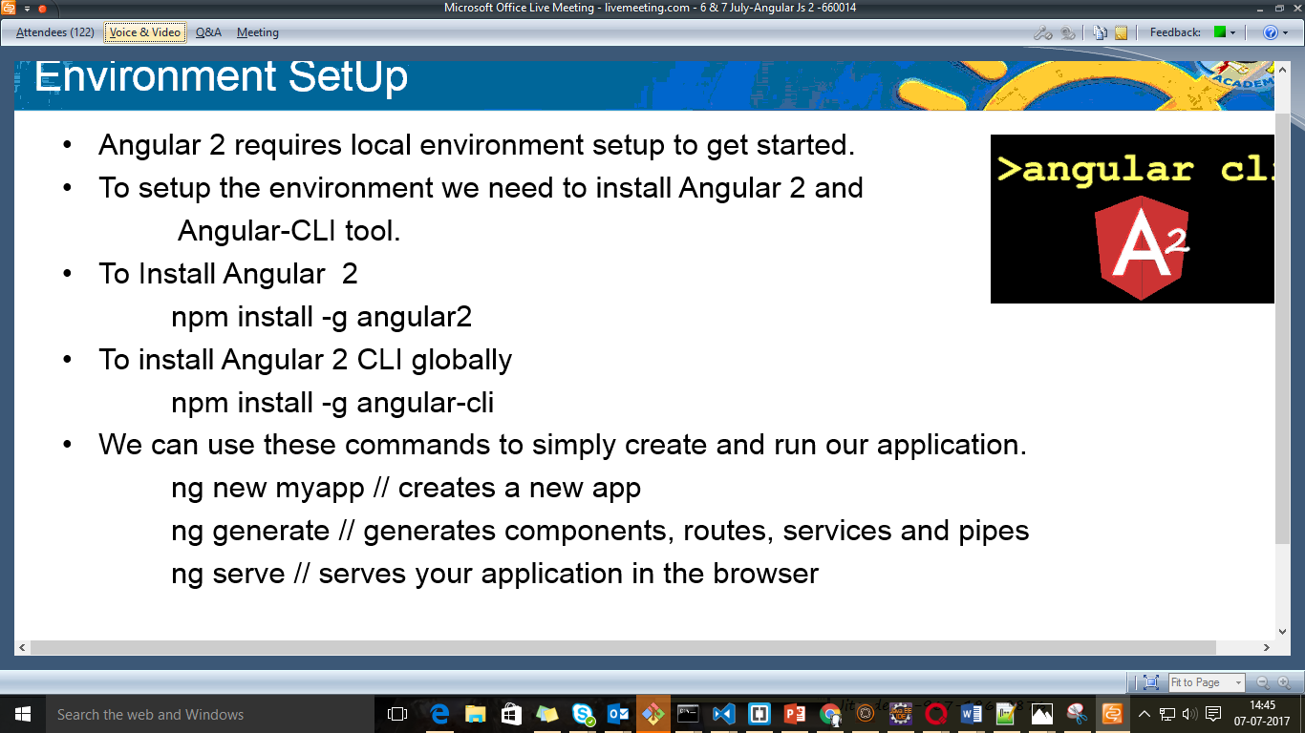



If you face proxy issue

You need to change .npmrc file

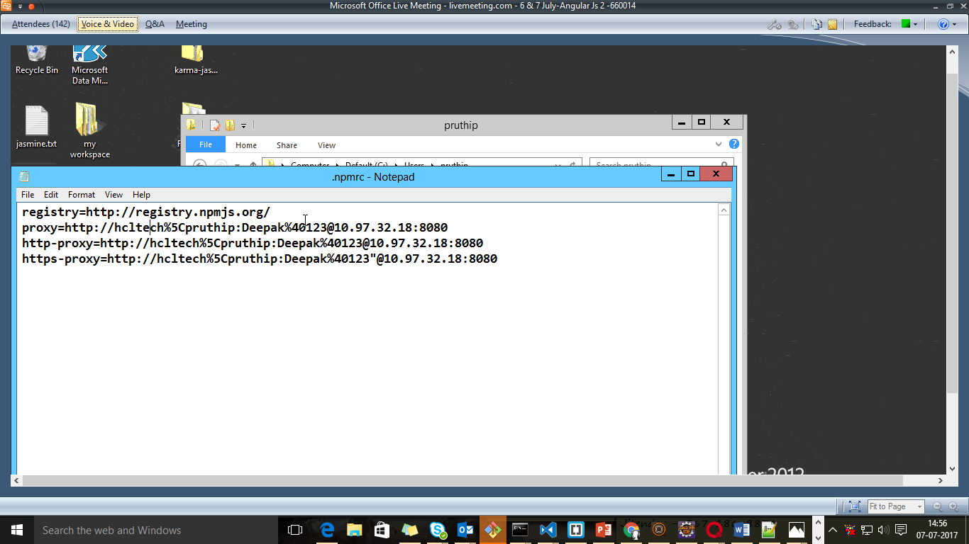

Ng represents the angular cli tool:

Package.json is a build tool

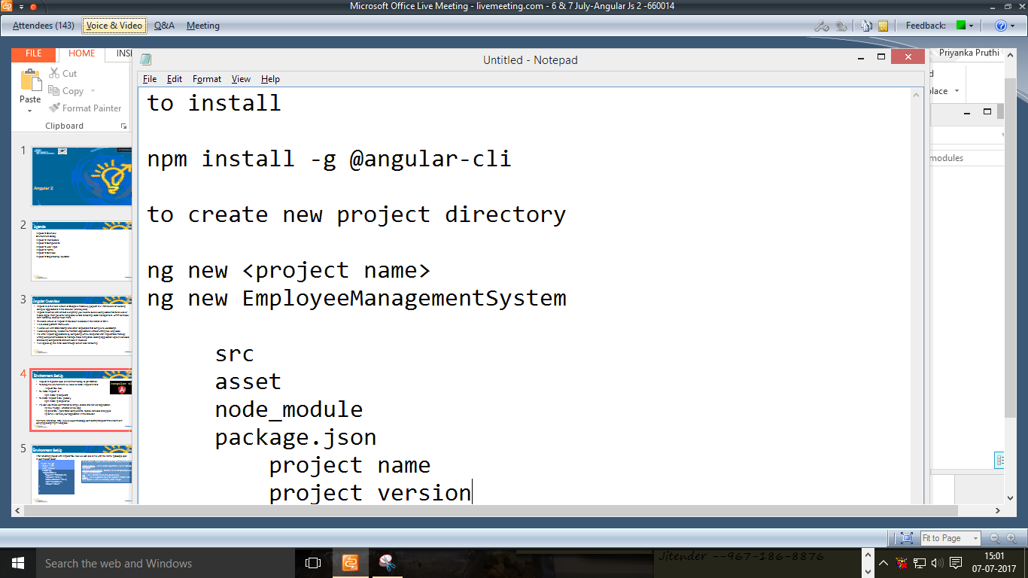

Package.json provides metadata of information

--licence mit licence

--dependencies ----if testing jasmine

Src—business logic

Assets—images, css, static content

Pollifil---to provide support to other browsers(old)

Config---typescript compiler ts to js file

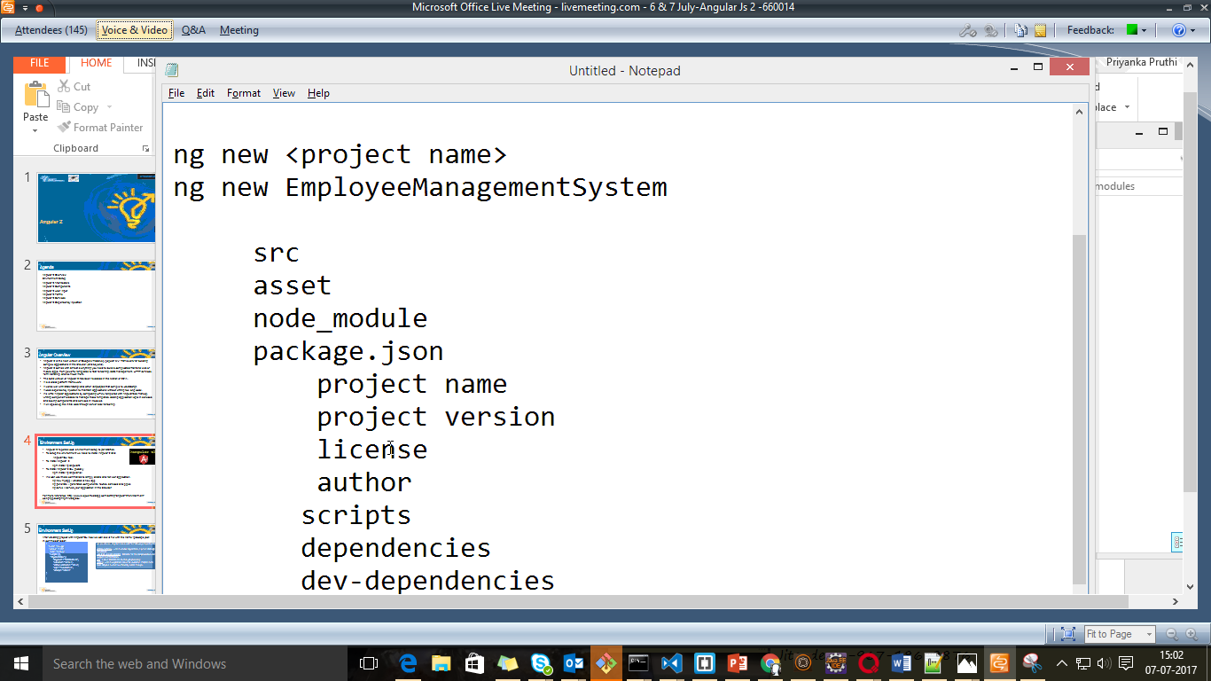

Ng serve – build and deploy on lite server by node.js

Part of angular Application

Component

Directory

Route

Pipe

Service

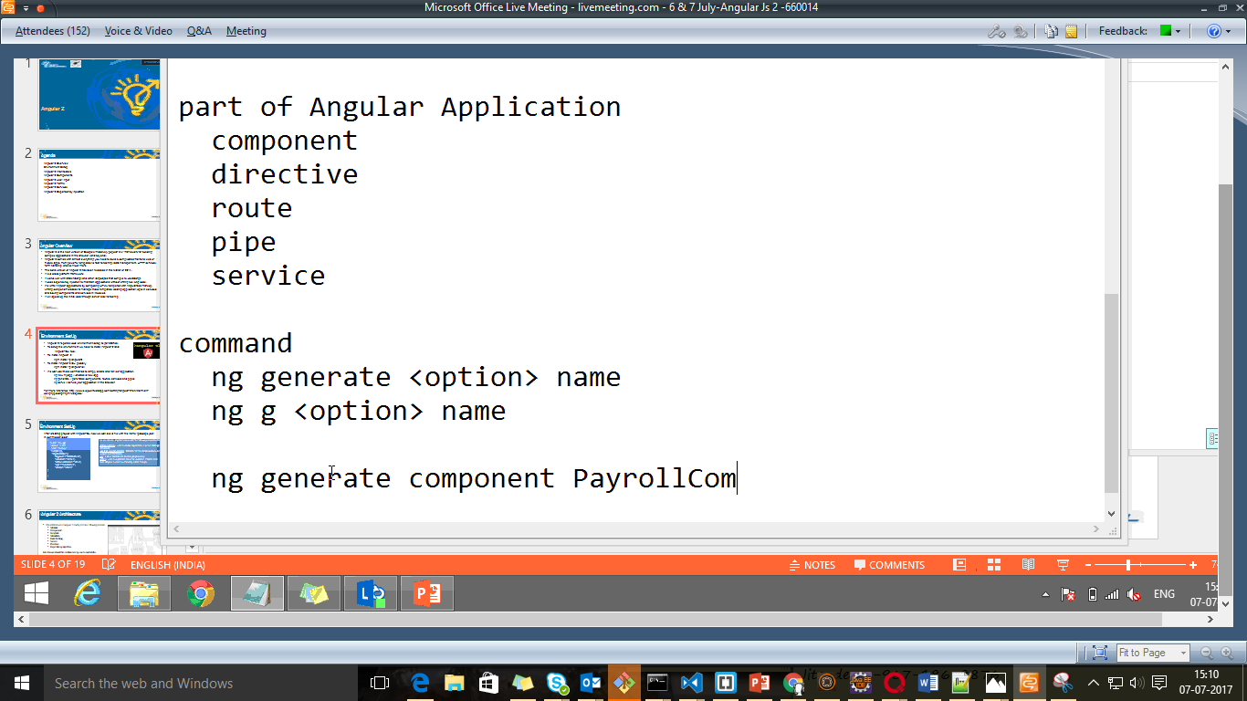

Component

Ng generate component payroll

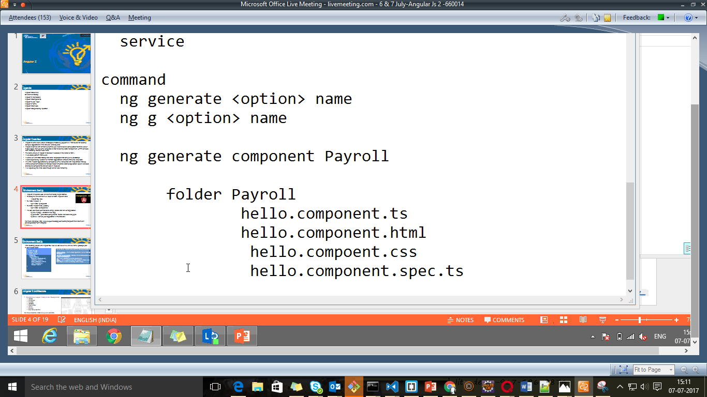

Uses of the files

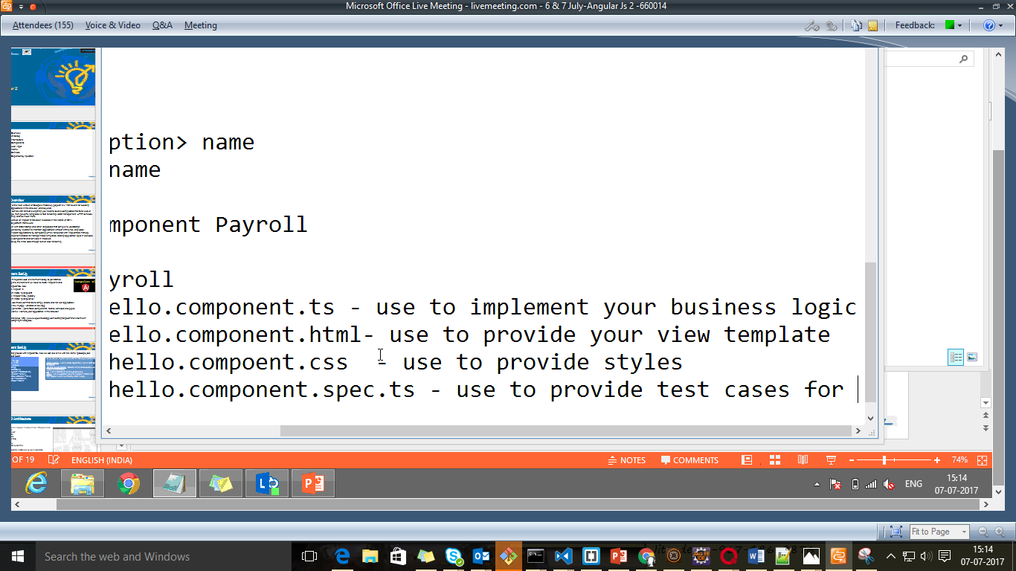

ng init- If you want to work on a particular folder

Architecture of Angular 2

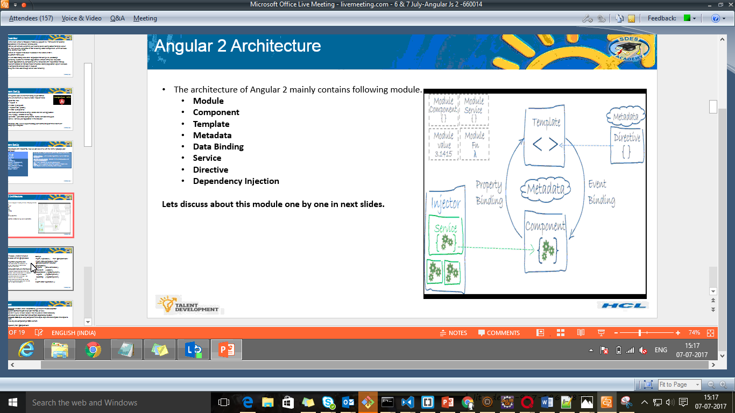

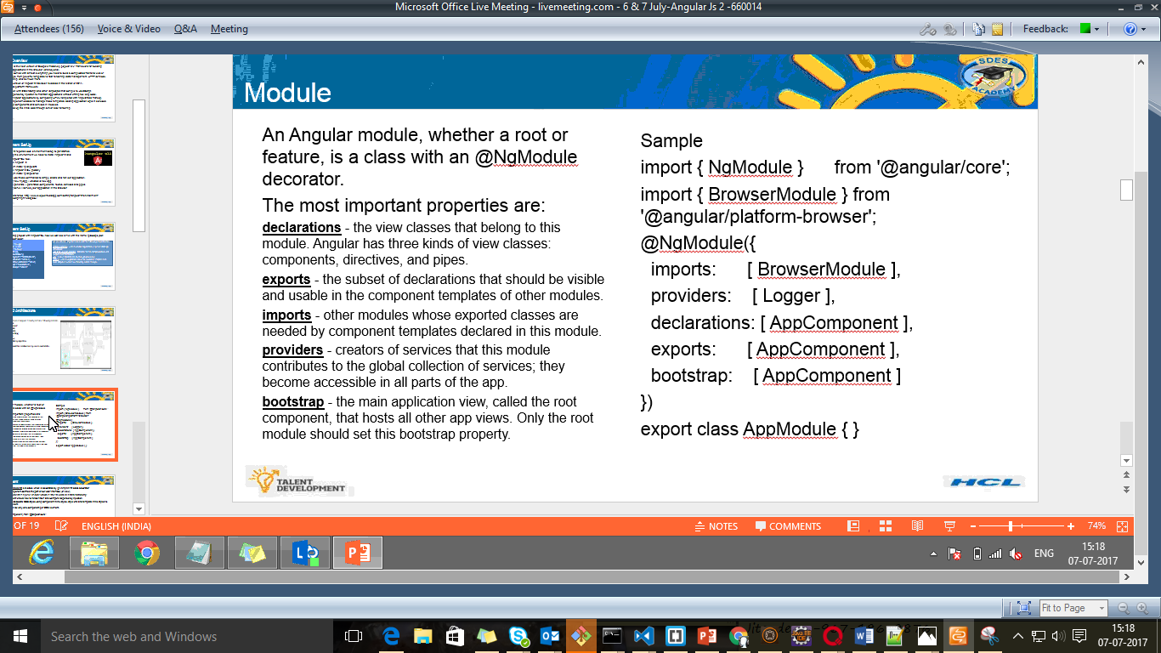

**Decorator or annotation**

@Ngmodule is a part of angular/core

Provider—provide services at

Application level---for ex

Component level----payroll service

Export:subset of declaration should be visible inside component or any other component

Bootstrap:part of application where application starts

2 Web workers

1)UI rendering

2) backend

JIT bootstrapping

AOT bootstrapping

Angular 2 is having own

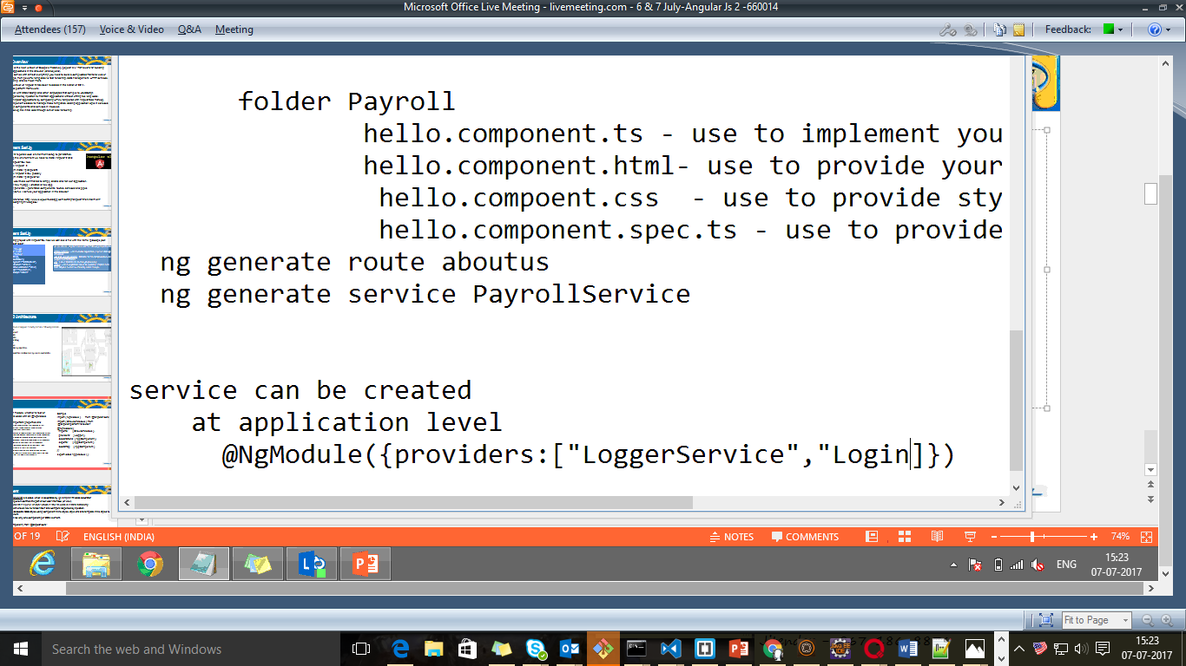

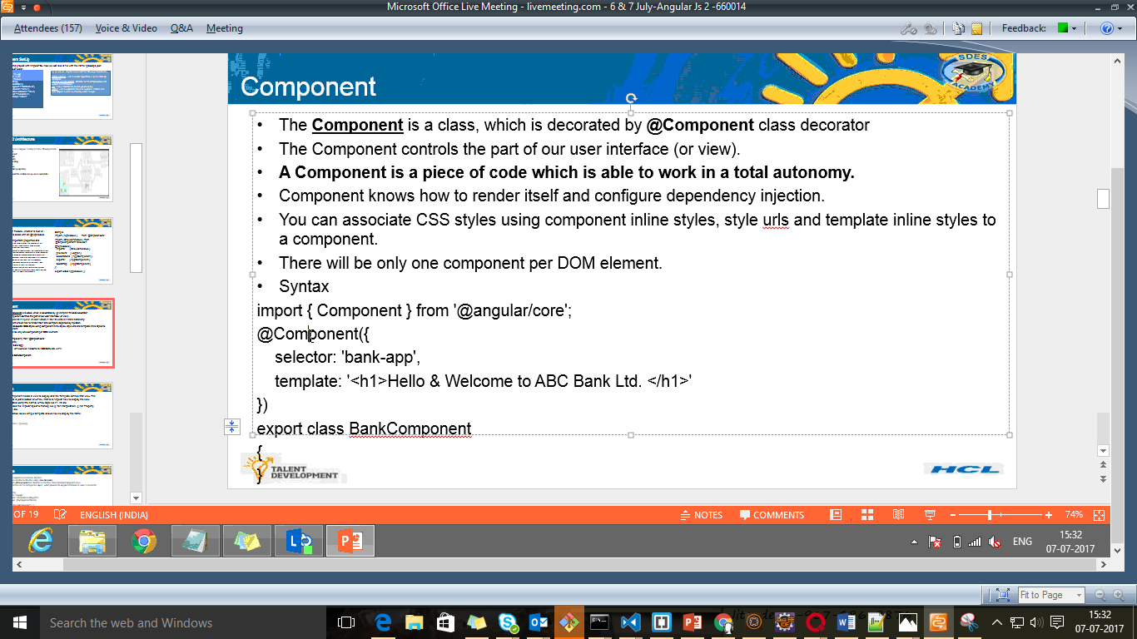

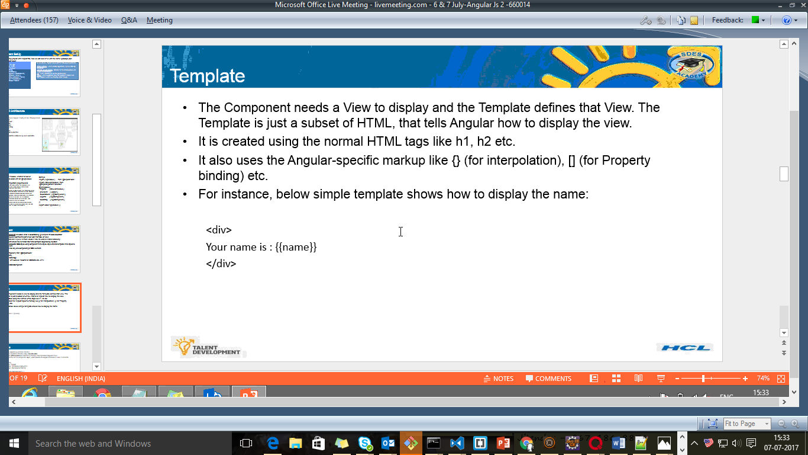

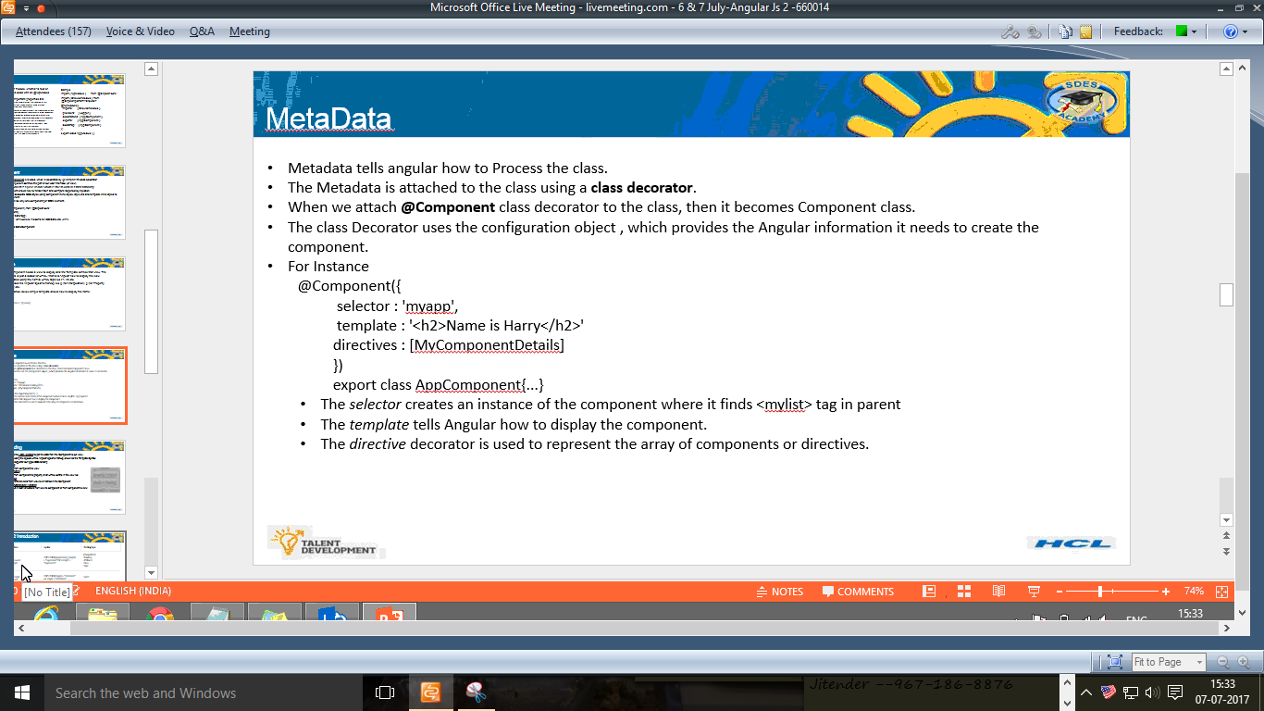

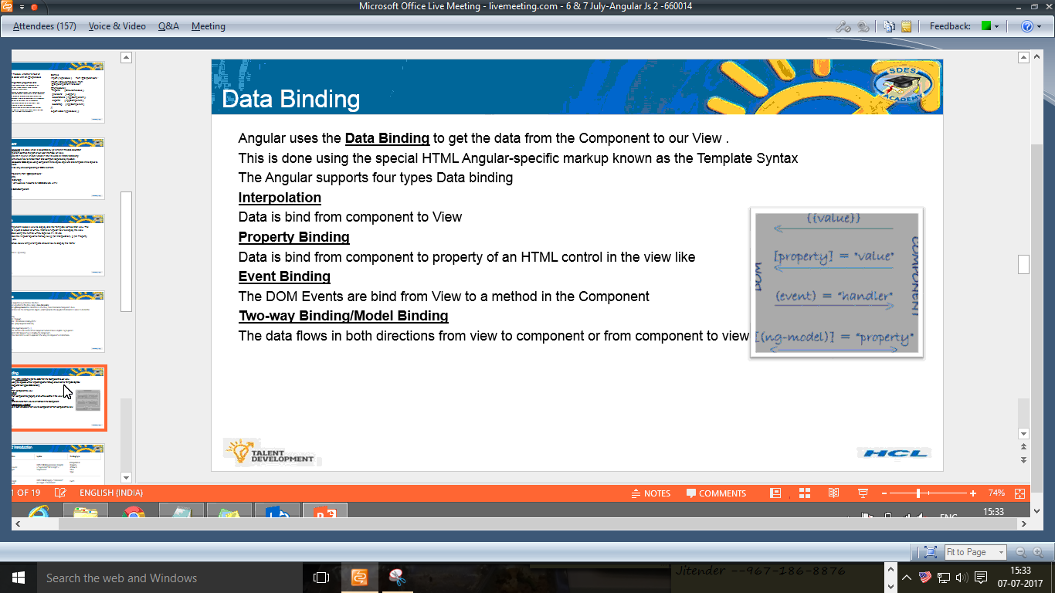

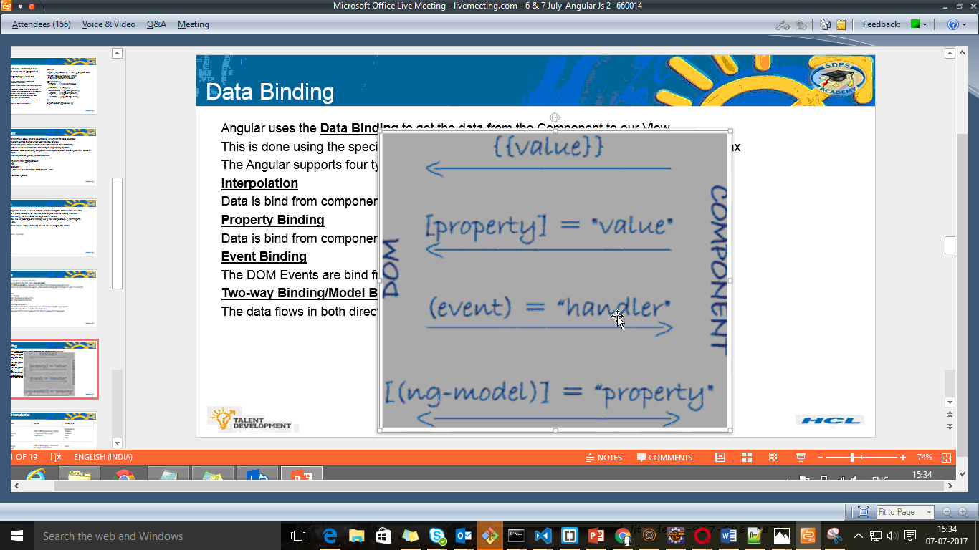

Example

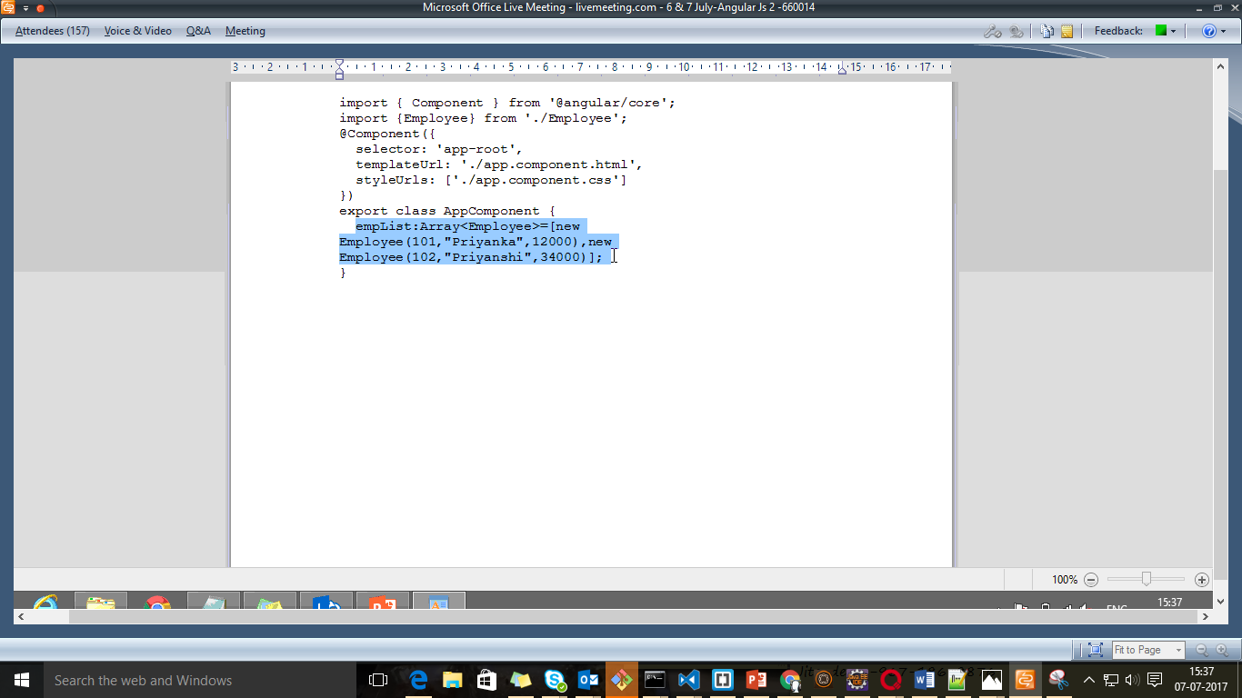

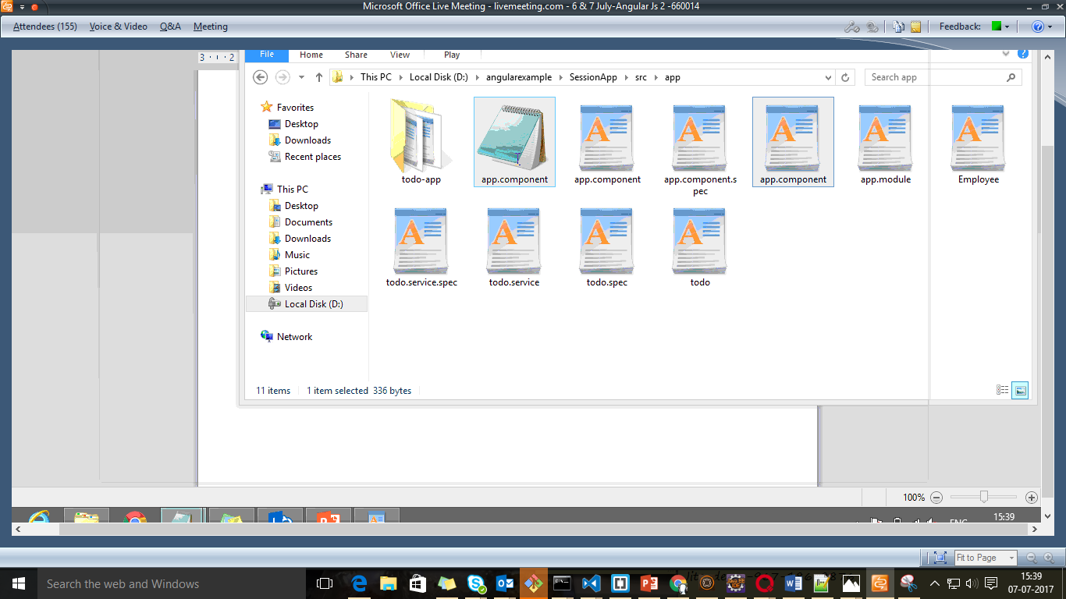

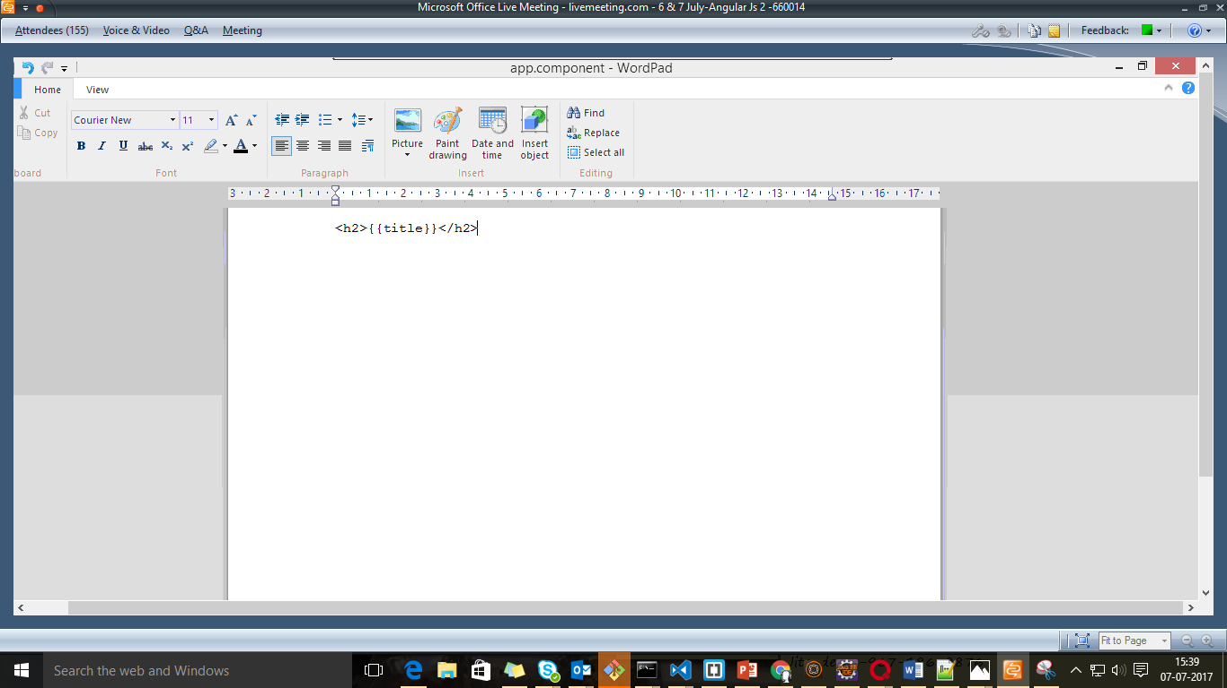

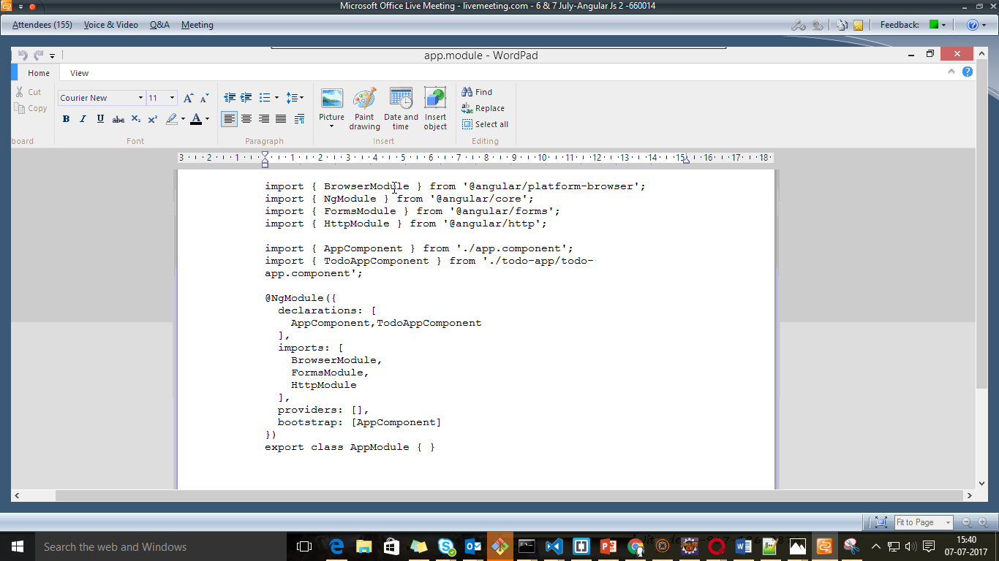

Index.html

