Incident Response & Forensics

Topic: M57 Patents Scenario

Table of Contents
1. Introduction 3
2. Incident Scenario 3
3. Incident Response Process 4
3.1 Preparation 4
3.2 Identification 4
3.3 Containment 4
3.4 Eradication 4
3.5 Recovery 5
3.6 Lessons Learned 5
4. Methodology 5
5. Forensic Analysis 6
5.1 Suspicious Items Analysis 6
5.2 User Content Analysis 7
5.3 Web Downloads Analysis 8
5.4 Web History Analysis 9
5.5 Email Analysis 10
5.6 Recent Documents Analysis 11
5.7 Installed Programs Analysis 12
5.8 Bad Items Analysis 13
5.9 Timeline Analysis 13
5.10 Keyword Search Analysis 14
6. Evidence & Findings 15
7. Conclusion 15
8. Recommendations 15
9. References 16

1. Introduction

Digital forensics plays a critical role in modern cybersecurity by enabling investigators to collect, analyze, and interpret digital evidence following a cyber incident. With the increasing dependence on digital systems, organizations face growing threats such as data breaches, insider attacks, and unauthorized system access. In such scenarios, digital forensic analysis helps in identifying the root cause of incidents and supports decision-making for remediation and prevention. This project focuses on conducting a forensic investigation of a simulated cybersecurity incident using the tool Autopsy. Autopsy is an open-source digital forensics platform widely used for analyzing disk images, recovering deleted files, examining user activity, and identifying suspicious artifacts.

The primary objective of this project is to analyze a disk image file (charlie-2009-12-11.E01) from the M57 Patents Scenario and identify any suspicious or unauthorized activities. The investigation involves examining various artifacts such as web history, downloads, email communications, system files, and user documents. Additionally, the project aims to reconstruct the sequence of events using timeline analysis and keyword-based searches. Through this investigation, the report demonstrates how forensic tools and techniques can be applied to detect potential insider threats, unauthorized data access, and suspicious system behavior. The findings are further used to provide recommendations for improving security measures and preventing similar incidents in the future.

2. Incident Scenario

The scenario considered in this project involves a suspected insider threat within an organization. The system under investigation belongs to a user named Charlie, whose activities have raised concerns regarding potential unauthorized access to sensitive company information. The suspicion arose due to unusual system behavior, including frequent file access, extensive web browsing, and possible interaction with external sources.

The organization deals with patent-related data, making it highly sensitive and valuable. Any unauthorized access, modification, or transfer of such data could result in significant financial and reputational damage. Therefore, a forensic investigation was initiated to examine Charlie’s system and identify any evidence of suspicious or malicious activity.

The investigation aims to determine whether the user accessed confidential files, downloaded unauthorized content, or communicated sensitive information through emails or other channels. The analysis focuses on identifying indicators of compromise such as suspicious files, unusual browsing activity, and unauthorized downloads.

By analyzing the disk image using forensic tools, the goal is to reconstruct the sequence of events and understand the nature of the suspected incident. This includes identifying what actions were performed, when they occurred, and whether they indicate malicious intent or policy violations.

3. Incident Response Process

The incident response process followed in this project is based on standard cybersecurity practices. It consists of several phases that ensure a structured approach to handling and analyzing the incident.

3.1 Preparation

The preparation phase involves setting up the necessary tools and environment for forensic analysis. In this project, the Autopsy tool was installed and configured. The disk image file was obtained and verified to ensure its integrity. Proper procedures were followed to avoid altering the original evidence.

3.2 Identification

During this phase, the incident is recognized and defined. The presence of suspicious activity on the system, such as unusual file access patterns and web activity, indicated a potential security issue. This triggered the need for further forensic investigation.

3.3 Containment

Although this is a simulated environment, in a real-world scenario, the affected system would be isolated from the network to prevent further damage. Containment ensures that the incident does not spread or cause additional harm.

3.4 Eradication

This phase involves identifying and removing the root cause of the incident. In the context of this project, the focus is on identifying suspicious artifacts rather than removing them.

3.5 Recovery

Recovery involves restoring systems to normal operation. In forensic investigations, this step ensures that evidence is preserved while systems are safely returned to use.

3.6 Lessons Learned

The final phase involves analyzing the incident and identifying areas for improvement. This includes understanding how the incident occurred and implementing measures to prevent similar issues in the future.

4. Methodology
The forensic investigation was conducted using a systematic approach to ensure accurate and reliable results. The process began with creating a new case in Autopsy and adding the disk image file (charlie-2009-12-11. E01) as the data source.
Various ingest modules were enabled, including recent activity, web artifacts, keyword search, and file type identification. These modules automatically analysed the data and generated relevant results for investigation.
The analysis was carried out in multiple stages. First, the system-generated results such as suspicious items and user content were examined. Next, web activity was analysed by reviewing browsing history and downloaded files. Email communications were also examined to identify any exchange of sensitive information.
Keyword searches were performed using terms such as “password,” “confidential,” and “patent” to locate relevant data. Timeline analysis was used to reconstruct the sequence of events and understand the flow of user activity.
Each finding was documented along with supporting evidence, including file paths, timestamps, and screenshots. This structured approach ensured that all relevant aspects of the investigation were covered.

5. Forensic Analysis
The forensic analysis was conducted using Autopsy to examine the disk image file charlie-2009-12-11. E01. The objective of this phase was to identify suspicious activities, recover relevant artifacts, and analyse user behaviour to determine whether any unauthorized or malicious actions had occurred. The analysis was divided into several key areas, including suspicious files, user-generated content, web activity, email communication, system artifacts, keyword search, and timeline reconstruction.

5.1 Suspicious Items Analysis
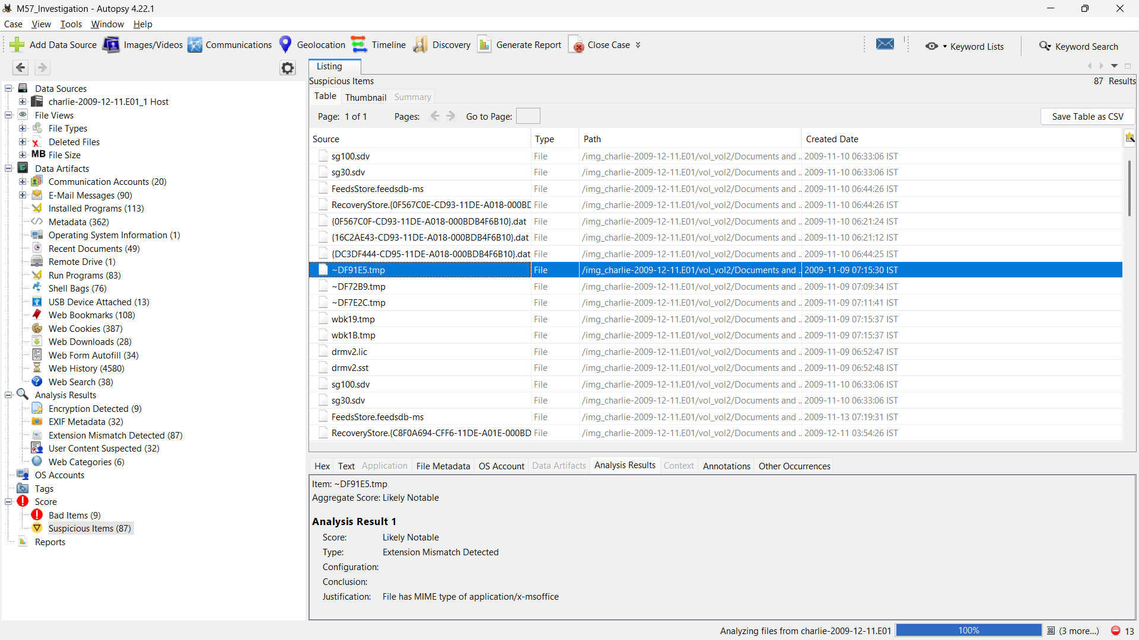Screenshot 5.1: Suspicious Items Analysis
The initial stage of the investigation focused on the “Suspicious Items” identified by Autopsy. These items are automatically flagged by the tool based on predefined rules and heuristics. The analysis revealed several files with extensions such as .tmp and .dat, which are commonly associated with temporary system storage and application data.
Temporary files (.tmp) are created by the operating system or applications during execution and are often deleted after use. However, their presence in the system may indicate recent activity or incomplete processes. In some cases, these files can contain remnants of user actions, including partially deleted data. Similarly, .dat files are used to store application-specific data and may contain valuable information related to system operations.
The presence of such files suggests that the system has undergone recent activity and may contain traces of user actions that were not completely removed. These artifacts are particularly important in forensic investigations, as they may provide insights into attempts to conceal or delete evidence. The identification of multiple suspicious files indicates the need for further analysis to determine their origin and relevance to the suspected incident.

5.2 User Content Analysis
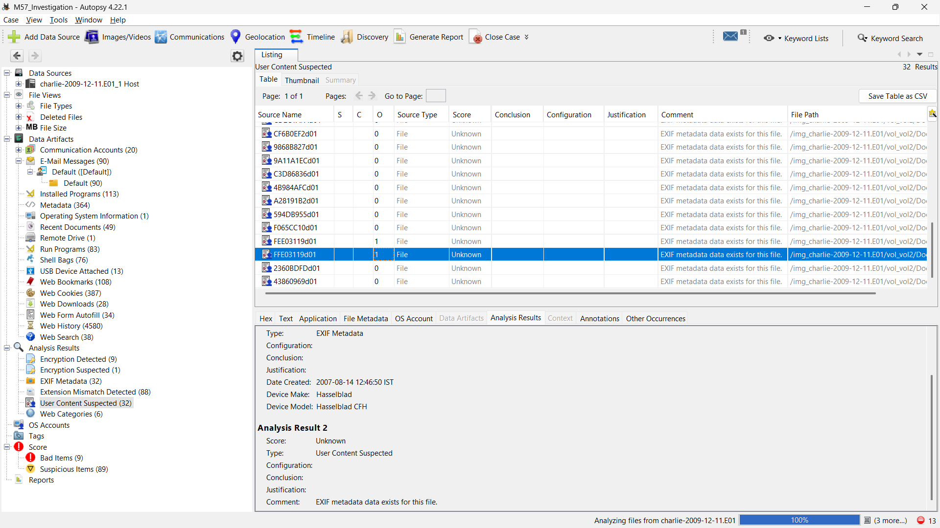Screenshot 5.2: User Content Analysis
The “User Content Suspected” section provided access to files that are likely to contain user-generated data. These files were examined to identify any sensitive or confidential information that may have been accessed or modified by the user.
The analysis included reviewing documents, text files, and other user-created content. Special attention was given to files with extensions such as .docx, .pdf, and .txt, as these are commonly used for storing important information. The presence of such files in the system indicates that the user had access to organizational data, which may include proprietary or confidential information.
By examining the contents of these files, it was possible to determine whether any sensitive data was accessed or manipulated. This step is crucial in identifying potential data leakage or unauthorized usage of information. The findings from this section contribute to understanding the nature of the user’s activities and their potential impact on the organization.

5.3 Web Downloads Analysis
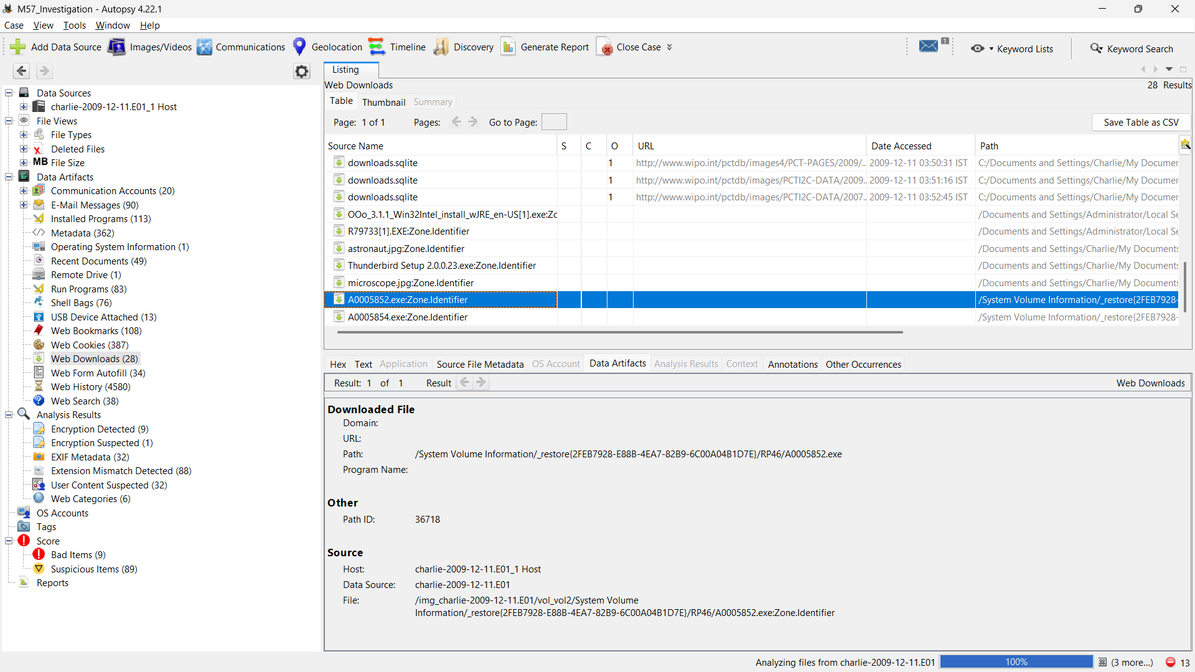Screenshot 5.3: Web downloads analysis
The web downloads section provided information about files downloaded from the internet. This analysis is critical in identifying whether the user interacted with external sources that may pose a security risk.
The investigation revealed multiple downloaded files, including documents and other file types. Each file was examined to determine its origin, type, and potential impact. The presence of downloaded files indicates that the user actively accessed external resources, which may include both legitimate and potentially harmful content.
Downloading files from untrusted sources can introduce malware or other security threats into the system. Therefore, it is important to analyse these files to determine whether they are safe or suspicious. The analysis of web downloads helps in identifying potential entry points for security breaches and understanding the user’s interaction with external environments.

5.4 Web History Analysis
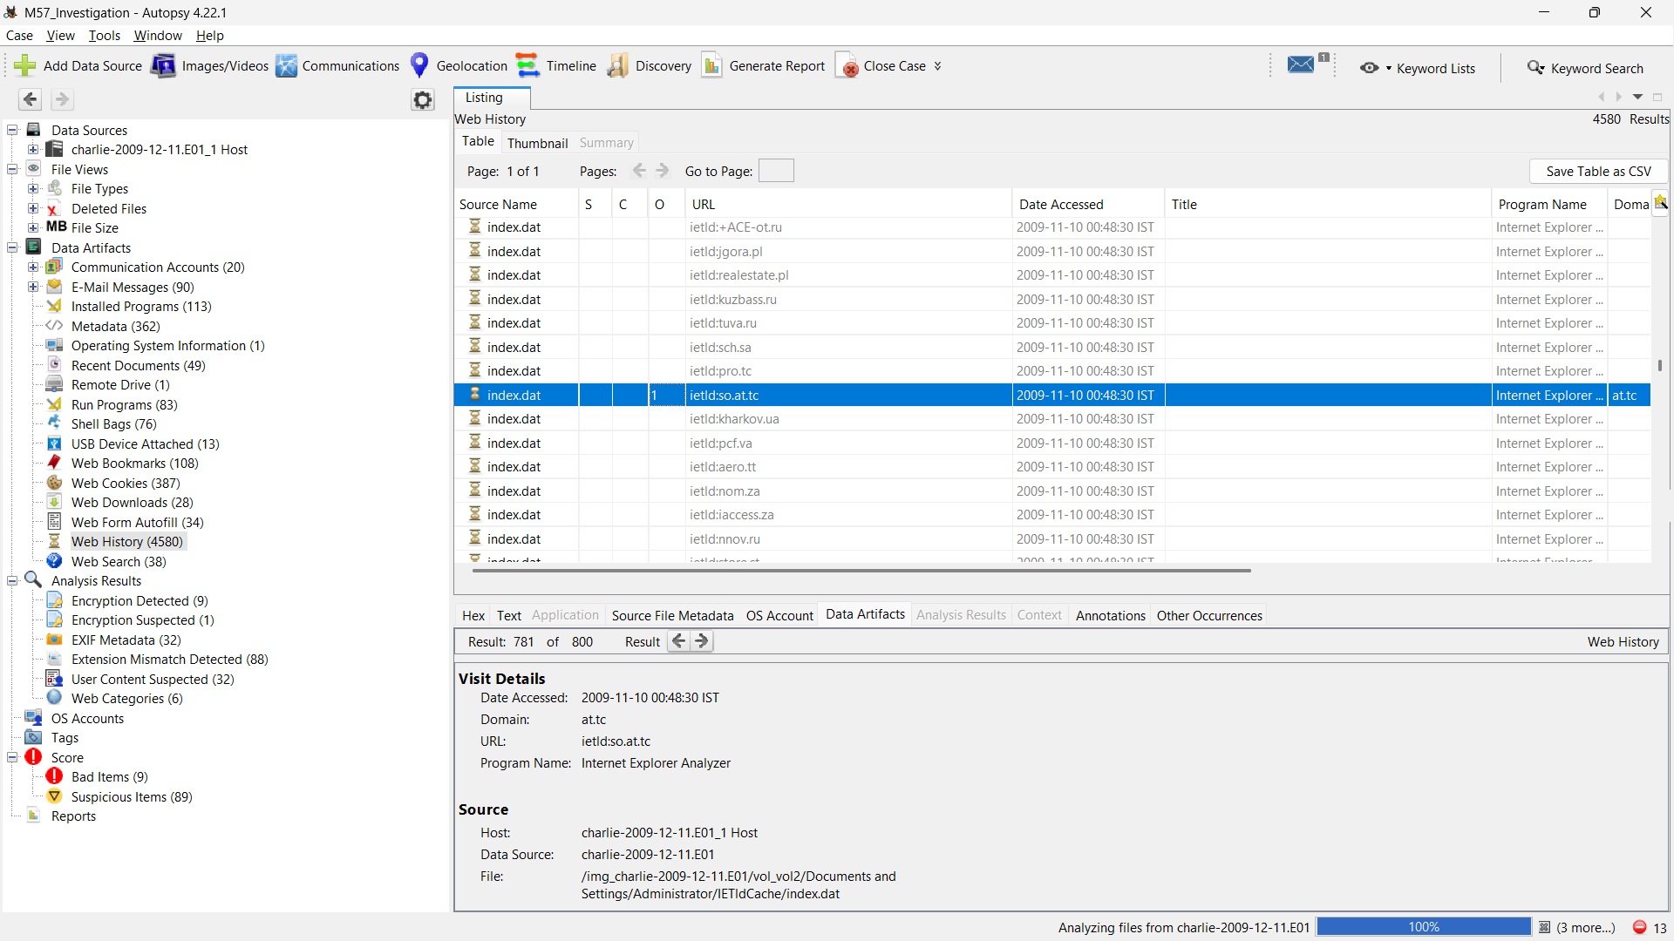Screenshot 5.4: Web history analysis
The web history analysis provided a comprehensive overview of the user’s browsing activity. The dataset contained a large number of entries, indicating extensive use of the internet.
By examining the browsing history, it was possible to identify the websites visited by the user, the frequency of visits, and the nature of the content accessed. This information is valuable in understanding the user’s behavior and intent. For example, visits to work-related websites may indicate normal activity, while access to unrelated or suspicious websites may raise concerns.
The analysis also helps in identifying patterns of behavior, such as repeated visits to certain websites or access to specific types of content. These patterns can provide insights into the user’s activities and help in determining whether any actions were intentional or accidental. The web history serves as a key source of evidence in reconstructing user actions and identifying potential security risks.

5.5 Email Analysis
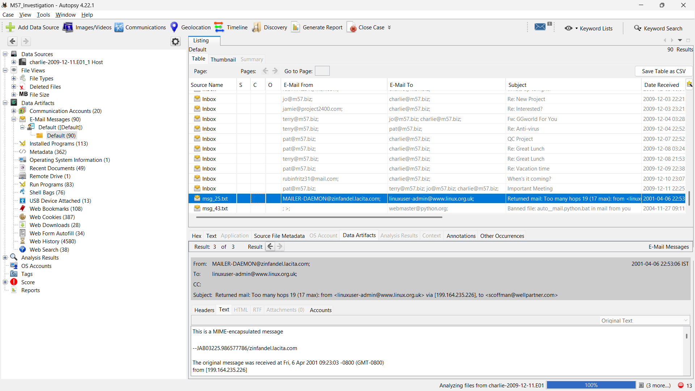
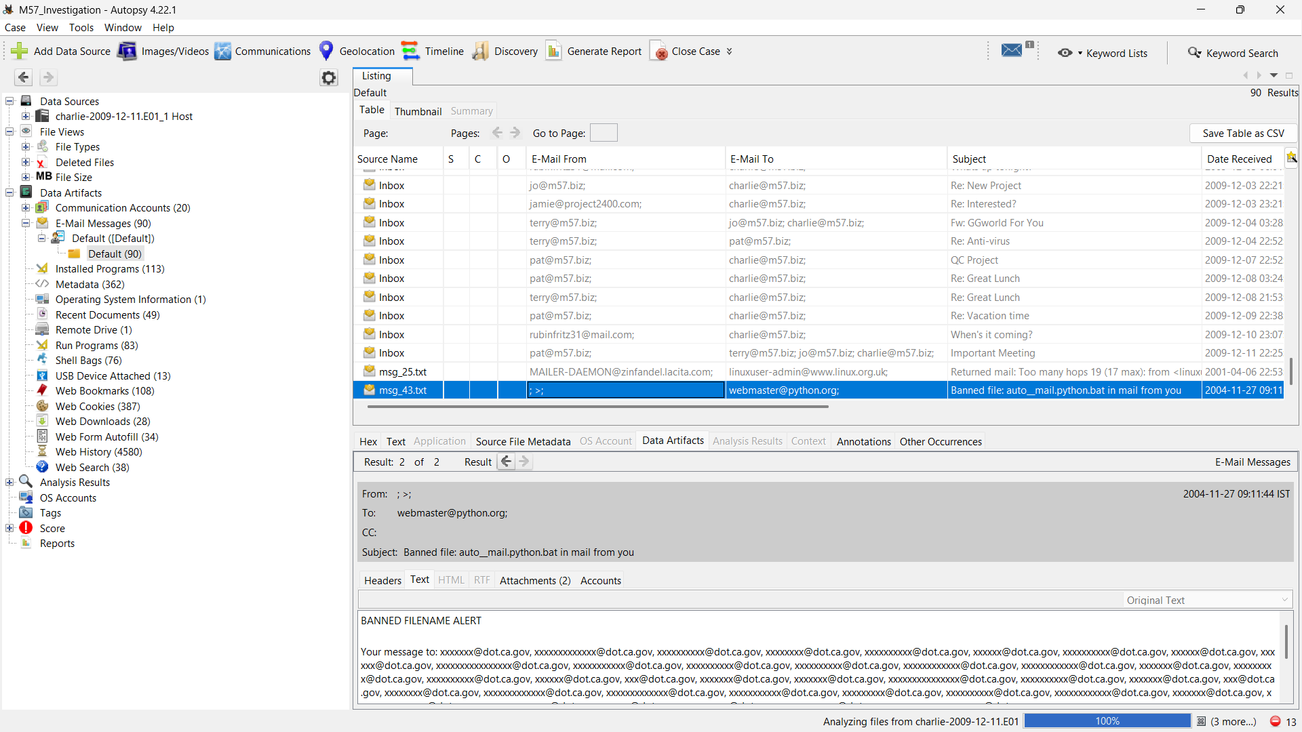Screenshot 5.5: Email analysis
Email communication is a critical component of forensic investigations, as it provides insights into user interactions and potential data exchange. The analysis of email messages revealed multiple communication records associated with the user.
Each email was examined to identify the sender, recipient, subject, and content. Special attention was given to emails containing attachments or references to sensitive information. The analysis aimed to determine whether any confidential data was shared with external parties or whether any suspicious communication took place.
Emails can serve as evidence of intent, especially in cases involving insider threats. For example, communication with external entities or the transfer of sensitive documents may indicate malicious activity. By analysing email records, it was possible to identify patterns of communication and assess their relevance to the suspected incident.

5.6 Recent Documents Analysis
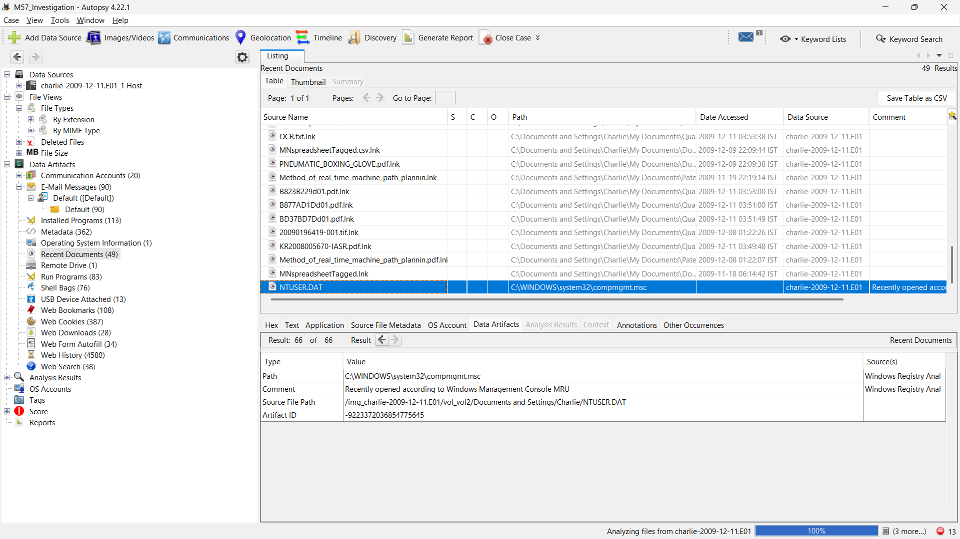Screenshot 5.6: Recent documents analysis
The recent documents section provided a list of files that were recently accessed by the user. This information is important in identifying the most recent activities performed on the system.
The analysis revealed several documents that were opened or modified, indicating active use of the system. These documents were examined to determine their content and significance. The presence of recently accessed files suggests that the user was actively working with these documents, which may include sensitive or important information.
By analysing recent documents, it is possible to identify the focus of the user’s activities and determine whether any unauthorized access occurred. This step is essential in understanding the context of the investigation and identifying potential areas of concern.

5.7 Installed Programs Analysis
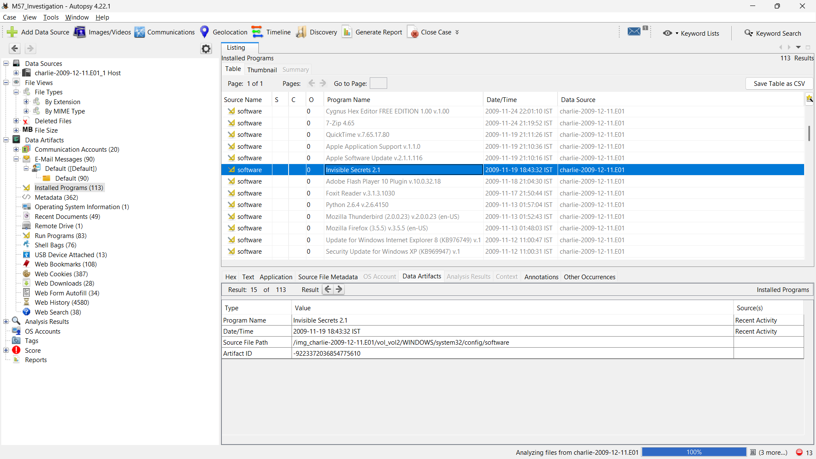Screenshot 5.7: Installed program analysis
The installed programs section provided a list of software applications present on the system. This analysis is important in identifying any unauthorized or suspicious software that may be linked to malicious activity.
The investigation involved reviewing the list of installed programs and identifying any unfamiliar or unexpected applications. Legitimate programs were distinguished from potentially suspicious ones based on their names, sources, and functionality.
The presence of unauthorized software may indicate that the system has been compromised or that the user installed tools for specific purposes. This analysis helps in identifying potential security vulnerabilities and understanding the overall system environment.

5.8 Bad Items Analysis
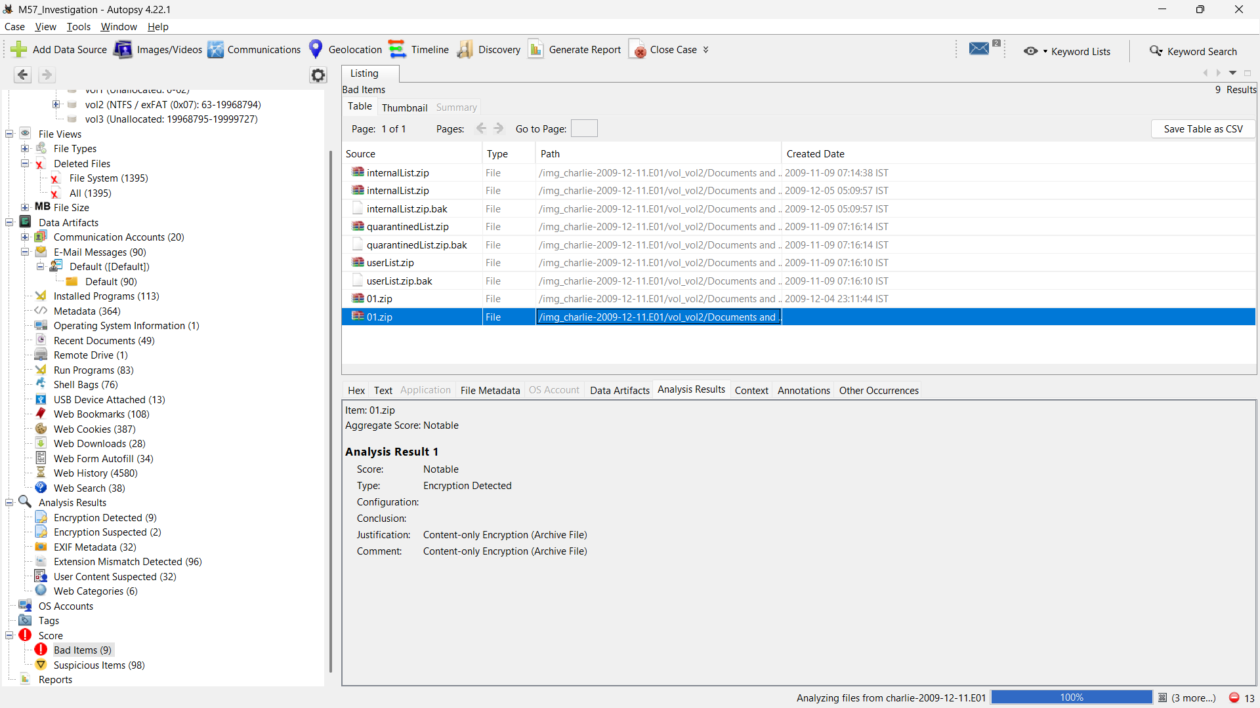Screenshot 5.8: Bad items analysis
The “Bad Items” analysis in Autopsy identifies files flagged as potentially malicious or suspicious based on predefined rules. In this case, compressed files such as .zip archives were detected with encryption, indicating possible attempts to hide data, suggesting potential security risks or unauthorized data handling activities.

5.9 Timeline Analysis
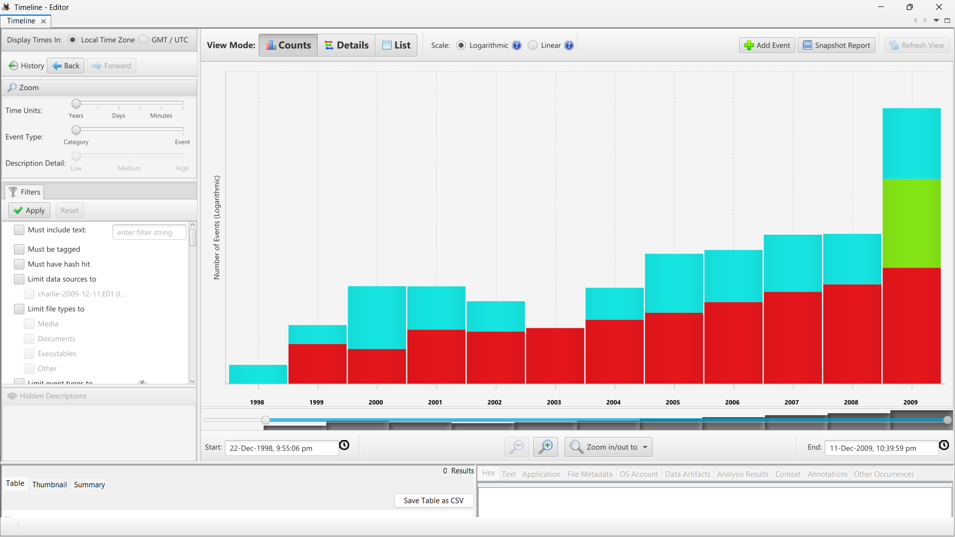Screenshot 5.9: Time-line analysis
Timeline analysis was used to reconstruct the sequence of events and understand the progression of user activity. By examining timestamps associated with files and system events, it was possible to create a chronological view of actions performed on the system.
The analysis revealed a sequence of events, including file access, web activity, and system changes. This information is crucial in understanding how the incident unfolded and identifying key points of interest.
Timeline analysis helps in establishing a clear connection between different activities and provides a comprehensive view of the incident. It allows investigators to identify patterns and correlations, which are essential for drawing accurate conclusions.

5.10 Keyword Search Analysis
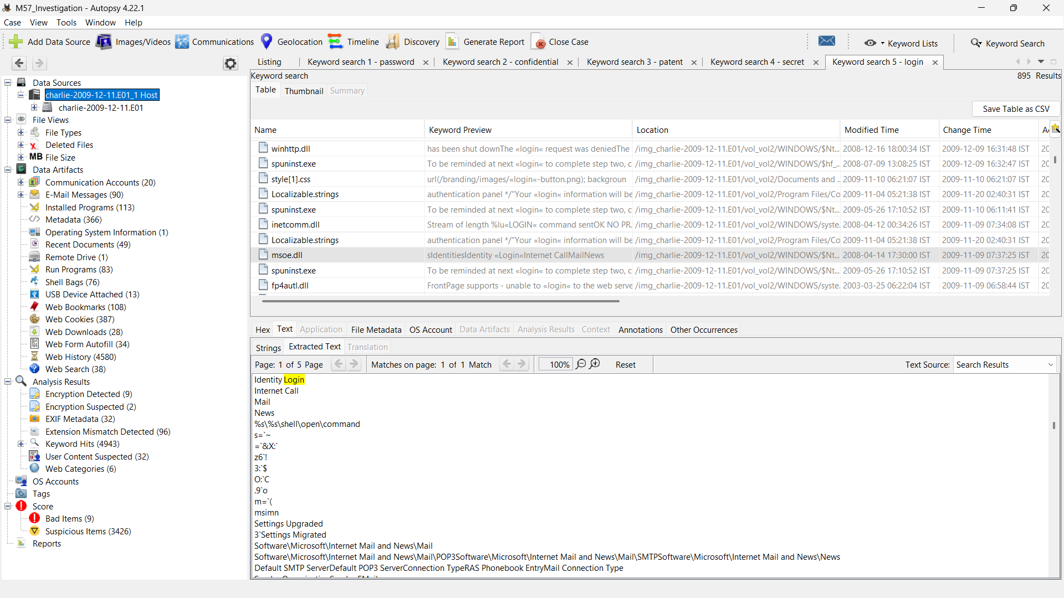Screenshot 5.10: Keyword search analysis
Keyword search is a powerful technique used to locate specific information within large datasets. In this investigation, keywords such as “password,” “confidential,” “patent,” and “login” were used to identify relevant data.
The search results revealed occurrences of these keywords in various files, indicating the presence of sensitive information. This analysis helps in quickly locating important data and identifying areas that require further examination.
Keyword search is particularly useful in identifying evidence of unauthorized access or data leakage. By focusing on specific terms, it is possible to narrow down the scope of the investigation and identify relevant artifacts more efficiently.

6. Evidence & Findings
The investigation revealed multiple indicators of suspicious activity. Temporary files suggested attempts to conceal actions, while web downloads indicated interaction with external sources. The browsing history showed extensive activity, including visits to various websites.
Email analysis provided insights into user communication patterns, which may involve handling sensitive information. Recent documents indicated access to important files, raising concerns about data exposure.
The keyword search results highlighted the presence of sensitive terms, further supporting the suspicion of unauthorized activity. Timeline analysis confirmed the sequence of events, providing a clear understanding of user actions.

7. Conclusion
The forensic investigation successfully identified multiple indicators of suspicious activity on the system. The use of Autopsy enabled efficient analysis of digital evidence, including files, web activity, and communication records.
The findings suggest potential unauthorized access to sensitive information, highlighting the importance of monitoring and securing user activities. The project demonstrates the effectiveness of digital forensic techniques in investigating cybersecurity incidents.

8. Recommendations
- Implement strict access control mechanisms to ensure that only authorized users can access sensitive data and systems.
- Continuously monitor user activity to detect unusual or suspicious behaviour at an early stage.
- Deploy and maintain updated antivirus software and intrusion detection systems (IDS) to protect against malware and cyber threats.
- Conduct regular security awareness training programs to educate employees about cybersecurity risks and safe practices.
- Perform periodic system audits and security assessments to identify vulnerabilities and ensure compliance with security policies.

9. References
1. Autopsy Official Documentation https://www.sleuthkit.org/autopsy/
2. Digital Corpora – M57 Patents Scenario
https://digitalcorpora.org/corpora/scenarios/m57-patents-scenario/
3. National Institute of Standards and Technology – Computer Forensics (CFReDS)
https://www.nist.gov/itl/ssd/software-quality-group/computer-forensics-tool-testing-program-cftt/cfreds
4. SANS Institute – Digital Forensics Resources
https://www.sans.org/cybersecurity-focus-areas/digital-forensics-incident-response
5. OWASP – Secure Coding & Security Practices https://owasp.org/
6. National Institute of Standards and Technology – Incident Response Guide (SP 800-61)
https://nvlpubs.nist.gov/nistpubs/SpecialPublications/NIST.SP.800-61r2.pdf
7. ISO – ISO/IEC 27001 Information Security Standard
https://www.iso.org/isoiec-27001-information-security.html
8. Guide to Computer Forensics and Investigations – Nelson, Phillips & Steuart
https://books.google.co.in/books/about/Guide_to_Computer_Forensics_and_Investig.html?id=ITYv0AEACAAJ&redir_esc=y
9. Cisco – Cybersecurity Fundamentals https://www.cisco.com/site/in/en/learn/topics/security/what-is-cybersecurity.html
10. Microsoft – Security Best Practices https://learn.microsoft.com/en-us/security/

