1. Create a Flask application with an /api route. When this route is accessed, it should return a JSON list. The data should be stored in a backend file, read from it, and sent as a response.

Answer: Explanation: created a folder, and inside folder have two files

[app.py](http://app.py) and backend.json

[app.py](http://app.py) has the code , shown in below image to perform the action

And backend.json file contains the json data

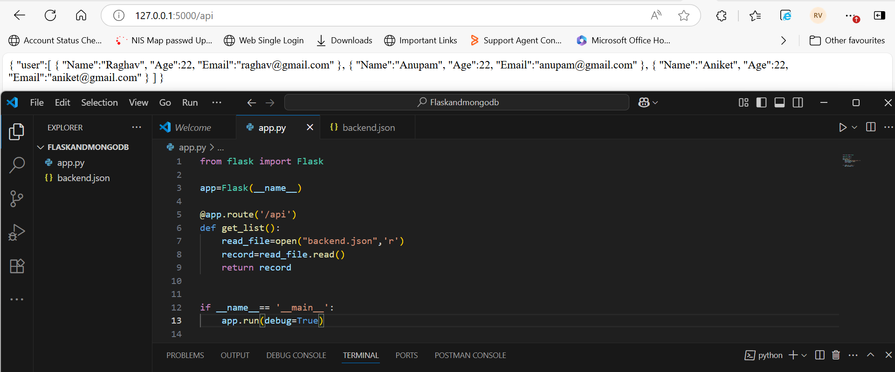

2. Create a form on the frontend that, when submitted, inserts data into MongoDB Atlas. Upon successful submission, the user should be redirected to another page displaying the message **"Data submitted successfully"**. If there's an error during submission, display the error on the same page without redirection.

Explanation: Created two HTML file: one for to enter the form data and one to show data entered successfully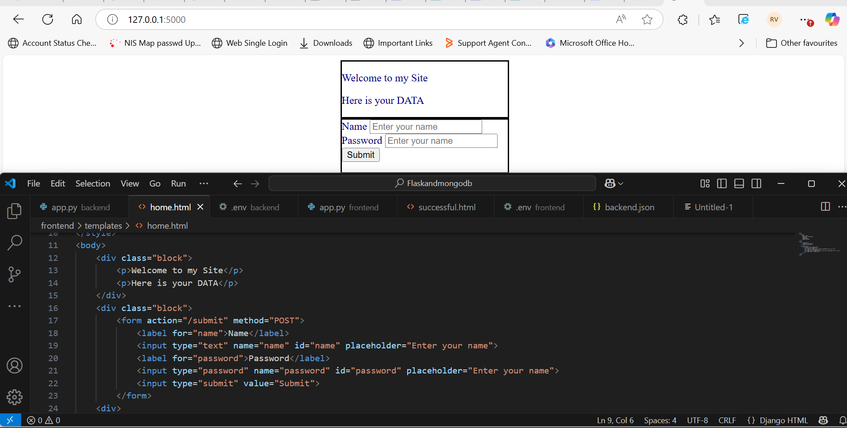

After clicking the submit button redirected to the another link url and show the Data successfully submitted message on HTML screen, 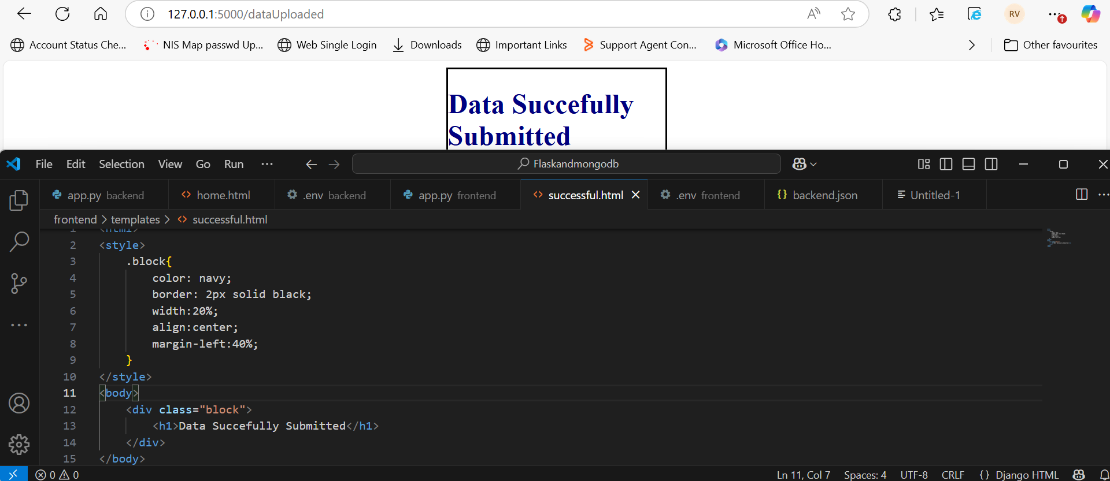

for redirection i have use for_url(‘functionname’) function with redirect() function, rather then using render_template(‘)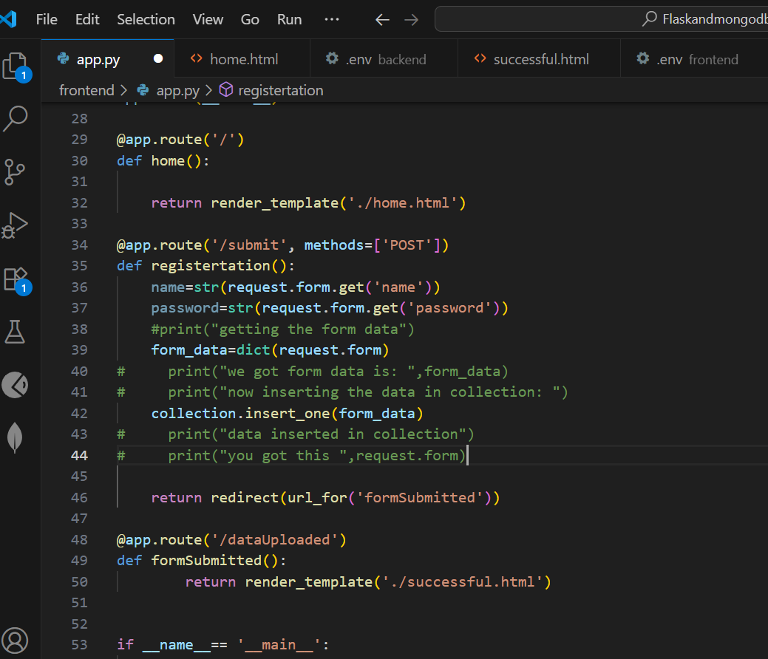

NOTES: for MONGODB offline usages

1. So i have installed the mongodb-win32 zip file in my device and then installed mongosh-2.5.3 zip file in my device
2. Unzipped both in same folder
3. Open the command prompt, go to the bin folder of mongodb

cd c:\Users\rvehgal\Documents\mongodb-windows-x86_64-8.0.11\mongodb-win32-x86_64-windows-8.0.11\bin

1. After then run the below command to execute the mongodb.exe and mongosh,lock file

mongod --dbpath C:\Users\rvehgal\Documents\mongodb-windows-x86_64-8.0.11\mongodb-win32-x86_64-windows-8.0.11\bin --logpath c:\Users\rvehgal\Documents\mongodb-windows-x86_64-8.0.11\data\db\mongod.lock

1. Open new command prompt and log to folder location bin of mongosh,where mongosh is stored

C:\Users\rvehgal\Documents\mongodb-windows-x86_64-8.0.11\mongosh-2.5.3-win32-x64\bin>m

1. Enter the command mongosh and hit enter to run mongosh

After then it starts and you will see the word test> after few minutes