# Linux Basics Assignment

## 1. Creating and Renaming Files/Directories

Commands:  
mkdir test_dir  
cd test_dir  
touch example.txt  
mv example.txt renamed_example.txt  
  
Explanation: mkdir creates directories, touch creates empty files, and mv renames or moves files.

SCREENSHOT1:-

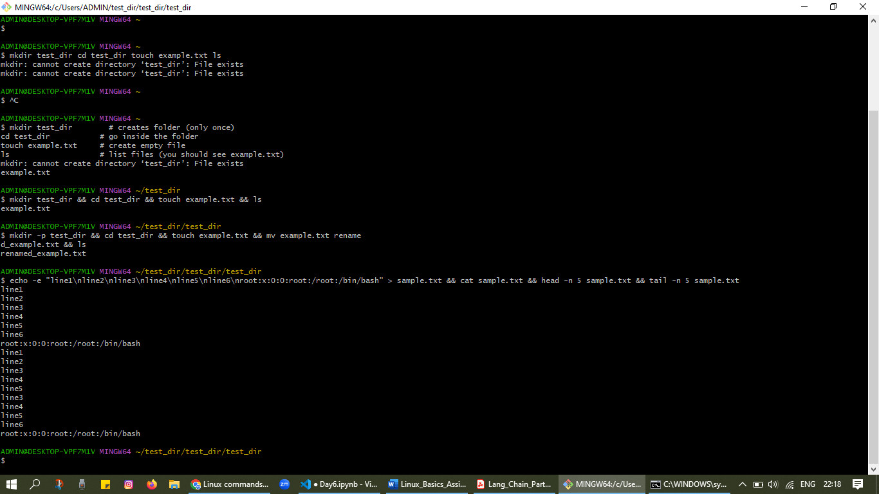

## 2. Viewing File Contents

Commands:  
cat /etc/passwd  
head -n 5 /etc/passwd  
tail -n 5 /etc/passwd  
  
Explanation: cat prints the full file, head shows first few lines, and tail shows last few lines.

SCREENSHOT:- INCLUDED IN ABOVE SCREENSHOT

## 3. Searching for Patterns

Command:  
grep "root" /etc/passwd  
  
Explanation: grep searches for the word 'root' in the file /etc/passwd.

## 4. Zipping and Unzipping

Commands:  
cd ..  
zip -r test_dir.zip test_dir  
unzip test_dir.zip -d unzipped_dir  
  
Explanation: zip -r compresses a directory recursively, unzip -d extracts into a new directory.

## 5. Downloading Files

Command:  
wget https://example.com/sample.txt  
  
Explanation: wget downloads files from the internet.

## 6. Changing Permissions

Commands:  
touch secure.txt  
chmod 444 secure.txt  
  
Explanation: chmod 444 sets read-only permissions for all users (r--r--r--).

## 7. Working with Environment Variables

Commands:  
export MY_VAR="Hello, Linux!"  
echo $MY_VAR  
  
Explanation: export sets an environment variable and echo prints its value.

SCREENSHOT2:-

