Class: Final Year (Computer Science and Engineering)
Year: 2025-26 Semester: 1
Course: High Performance Computing Lab

Practical No. 4
Exam Seat No: 22510015
Title of practical:
Study and Implementation of Synchronization

Problem Statement 1:

Analyze and implement a Parallel code for below programs using OpenMP considering synchronization requirements. (Demonstrate the use of different clauses and constructs wherever applicable)

Fibonacci Computation:

Code:
/* q1.c
Compile: gcc -fopenmp q1.c -o fib
Run: ./fib <n> <num_threads>
*/
#include <stdio.h>
#include <stdlib.h>
#include <omp.h>

long long *memo;
omp_lock_t *locks;

long long fib_task(int n) {
if (n <= 1) return n;

long long v = memo[n];
if (v != -1) return v;

omp_set_lock(&locks[n]);

if (memo[n] != -1) {
v = memo[n];
omp_unset_lock(&locks[n]);
return v;
}

long long x = 0, y = 0;

if (n > 20) {
#pragma omp task shared(x) firstprivate(n)
x = fib_task(n-1);
#pragma omp task shared(y) firstprivate(n)
y = fib_task(n-2);
#pragma omp taskwait
} else {
x = fib_task(n-1);
y = fib_task(n-2);
}

memo[n] = x + y;
v = memo[n];
omp_unset_lock(&locks[n]);
return v;
}

int main(int argc, char **argv) {
if (argc < 3) {
printf("Usage: %s <n> <num_threads>\n", argv[0]);
return 1;
}
int n = atoi(argv[1]);
int num_threads = atoi(argv[2]);

memo = malloc((n+1) * sizeof(long long));
locks = malloc((n+1) * sizeof(omp_lock_t));
for (int i=0;i<=n;i++) {
memo[i] = -1;
omp_init_lock(&locks[i]);
}
memo[0] = 0;
if (n>=1) memo[1] = 1;

omp_set_num_threads(num_threads);
double t0 = omp_get_wtime();
#pragma omp parallel
{
#pragma omp single
{
long long res = fib_task(n);
double t1 = omp_get_wtime();
printf("Fibonacci(%d) = %lld\n", n, res);
printf("Threads used: %d\n", num_threads);
printf("Time (s): %f\n", t1 - t0);
}
}

for (int i=0;i<=n;i++) omp_destroy_lock(&locks[i]);
free(memo);
free(locks);
return 0;
}

Screenshots:
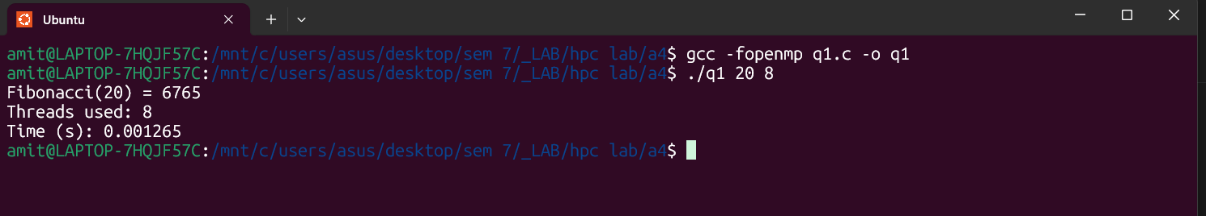

Information:

- #pragma omp parallel + #pragma omp single to start tasks once.
- #pragma omp task and #pragma omp taskwait show task creation and synchronization.
- omp_lock_t used to protect shared memo entries (demonstrates explicit lock API).

Problem Statement 2:

Analyze and implement a Parallel code for below programs using OpenMP considering synchronization requirements. (Demonstrate the use of different clauses and constructs wherever applicable)

Producer Consumer Problem

Code:
/* q2.c
Compile: gcc -fopenmp q2.c -o prodcons
Run: ./prodcons <buffer_size> <items_to_produce> <num_producers> <num_consumers>
*/
#include <stdio.h>
#include <stdlib.h>
#include <omp.h>

int main(int argc, char **argv) {
if (argc < 5) {
printf("Usage: %s <bufsize> <items> <producers> <consumers>\n", argv[0]);
return 1;
}

int bufsize = atoi(argv[1]);
int total_items = atoi(argv[2]);
int nprod = atoi(argv[3]);
int ncons = atoi(argv[4]);

int *buffer = malloc(bufsize * sizeof(int));
int in = 0, out = 0;
int count = 0;

omp_lock_t lock_in, lock_out;
omp_init_lock(&lock_in);
omp_init_lock(&lock_out);

static int global_produced = 0;
static int global_consumed = 0;

omp_set_num_threads(nprod + ncons);
double t0 = omp_get_wtime();

#pragma omp parallel
{
int tid = omp_get_thread_num();

if (tid < nprod) {
// Producer threads
while (1) {
int myglobal;
#pragma omp atomic read
myglobal = global_produced;

if (myglobal >= total_items)
break;

#pragma omp atomic update
global_produced++;

int item = myglobal + 1;

int placed = 0;
while (!placed) {
if (count < bufsize) {
omp_set_lock(&lock_in);
if (count < bufsize) {
buffer[in] = item;
in = (in + 1) % bufsize;
#pragma omp atomic update
count++;
placed = 1;
printf("[Producer %d] produced %d (count=%d)\n", tid, item, count);
}
omp_unset_lock(&lock_in);
}
}
}
} else {
// Consumer threads
while (1) {
int mycon;
#pragma omp atomic read
mycon = global_consumed;

if (mycon >= total_items)
break;

#pragma omp atomic update
global_consumed++;

int got = 0;
int item = -1;
while (!got) {
if (count > 0) {
omp_set_lock(&lock_out);
if (count > 0) {
item = buffer[out];
out = (out + 1) % bufsize;
#pragma omp atomic update
count--;
got = 1;
printf(" [Consumer %d] consumed %d (count=%d)\n", tid, item, count);
}
omp_unset_lock(&lock_out);
}
}
}
}
}

double t1 = omp_get_wtime();
printf("All done. Time: %f sec\n", t1 - t0);

omp_destroy_lock(&lock_in);
omp_destroy_lock(&lock_out);
free(buffer);
return 0;
}

Screenshots:
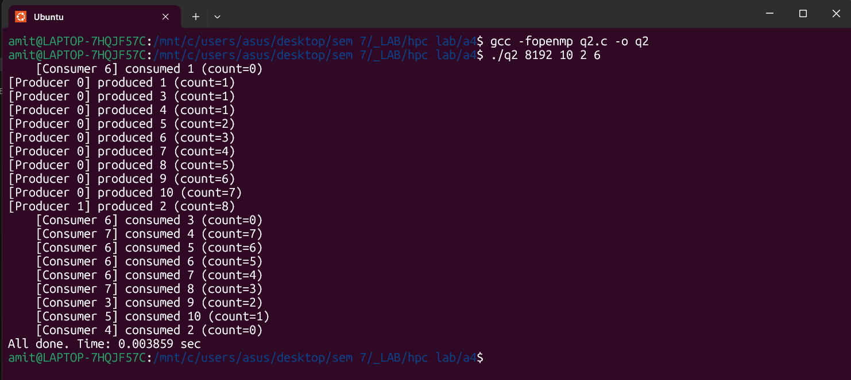

Information:
· We split roles by thread id to keep code simple for demonstration (you can implement sections or separate #pragma omp sections for clear producers vs consumers).
· omp_lock_t used to protect buffer indices (in and out).
· #pragma omp atomic used to update/inspect count and global counters safely and demonstrate atomic operations.

Github Link: https://github.com/amitwasnik1906/HPC_Lab/tree/main/a4

