Class: Final Year (Computer Science and Engineering)
Year: 2024-25 Semester: 1
Course: High Performance Computing Lab

Practical No. 5
Exam Seat No: 22510015

Title of practical: Implementation of OpenMP programs.
Implement following Programs using OpenMP with C:
- Implementation of Matrix-Matrix Multiplication.
- Implementation of Matrix-scalar Multiplication.
- Implementation of Matrix-Vector Multiplication.
- Implementation of Prefix sum.

Problem Statement 1:
Code:
// mm_mult.c
#include <stdio.h>
#include <stdlib.h>
#include <omp.h>

int main() {
int N = 1024; // adjust for testing
double *A = malloc(N * N * sizeof(double));
double *B = malloc(N * N * sizeof(double));
double *C = malloc(N * N * sizeof(double));

// init
for (int i=0;i<N*N;i++) { A[i]=1.0; B[i]=1.0; C[i]=0.0; }

double t0 = omp_get_wtime();

#pragma omp parallel for schedule(static)
for (int i = 0; i < N; ++i) {
for (int k = 0; k < N; ++k) {
double a = A[i*N + k];
for (int j = 0; j < N; ++j) {
C[i*N + j] += a * B[k*N + j];
}
}
}

double t1 = omp_get_wtime();
printf("Time: %f sec\n", t1 - t0);

// checksum
double sum = 0;
for (int i=0;i<N*N;i++) sum += C[i];
printf("Checksum: %f\n", sum);

free(A); free(B); free(C);
return 0;
}

Screenshots:
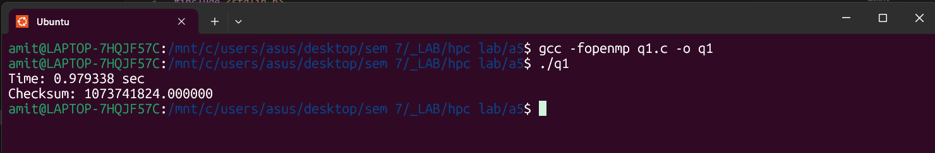
Information:
- Aim: Multiply two dense matrices A (m×k) and B (k×n) to produce C (m×n) using OpenMP to parallelize the computation.
- Input: Two matrices A and B (sizes m,k and k,n). Often use square matrices N×N for tests.
- Output: Result matrix C = A × B (m×n).

Analysis:
- Parallelize outer loops with #pragma omp parallel for.
- Good speedup for large matrices.
- Cache access patterns affect performance.

Problem Statement 2:
Code:
#include <stdio.h>
#include <stdlib.h>
#include <omp.h>

int main() {
int rows = 4000, cols = 4000;
double scalar = 2.5;
double *A = malloc(rows * cols * sizeof(double));
double *B = malloc(rows * cols * sizeof(double));

for (int i=0;i<rows*cols;i++) A[i] = i % 100;

double t0 = omp_get_wtime();

#pragma omp parallel for schedule(static)
for (int idx = 0; idx < rows * cols; ++idx) {
B[idx] = scalar * A[idx];
}

double t1 = omp_get_wtime();
printf("Time: %f sec\n", t1 - t0);
printf("Sample B[0]=%f B[last]=%f\n", B[0], B[rows*cols-1]);

free(A); free(B);
return 0;
}

Screenshots:
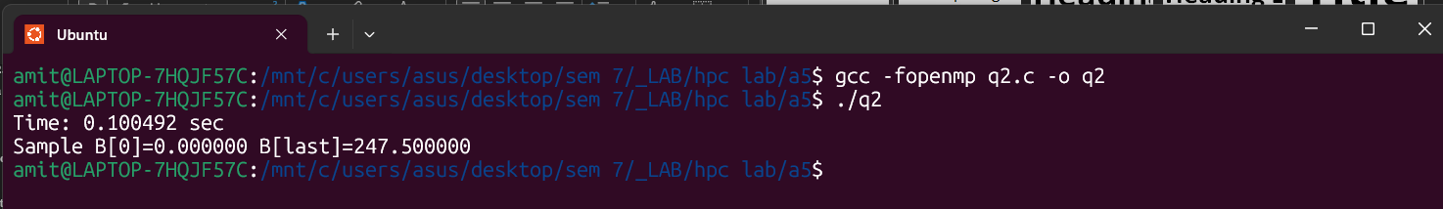

Information:
- Each element of a matrix is multiplied with a scalar using OpenMP.

Analysis:
- Embarrassingly parallel problem.
- High scalability for large sizes.
- Minimal overhead, near-linear speedup.

Problem Statement 3:
Code:
// mv_mult.c
#include <stdio.h>
#include <stdlib.h>
#include <omp.h>

int main() {
int m = 20000, n = 1000;
double *A = malloc((size_t)m * n * sizeof(double));
double *x = malloc(n * sizeof(double));
double *y = calloc(m, sizeof(double));

for (int i=0;i<n;i++) x[i] = 1.0;
for (size_t i=0;i<(size_t)m*n;i++) A[i] = 0.5;

double t0 = omp_get_wtime();

#pragma omp parallel for schedule(static)
for (int i = 0; i < m; ++i) {
double sum = 0.0;
size_t base = (size_t)i * n;
for (int j = 0; j < n; ++j) sum += A[base + j] * x[j];
y[i] = sum;
}

double t1 = omp_get_wtime();
printf("Time: %f sec\n", t1 - t0);
printf("y[0]=%f y[m-1]=%f\n", y[0], y[m-1]);

free(A); free(x); free(y);
return 0;
}

Screenshots:
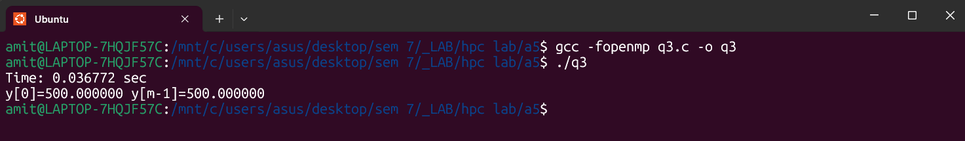
Information:
- Multiply a matrix with a vector to produce a resultant vector. Each row is processed in parallel.
Analysis:
- Parallelize row-wise computations.
- Efficient due to read-only vector reuse.
- Works best when matrix has many rows.

Problem Statement 4:
Code:
// prefix_sum.c
#include <stdio.h>
#include <stdlib.h>
#include <omp.h>

int main() {
int n = 20000000;
double *a = malloc(n * sizeof(double));
double *s = malloc(n * sizeof(double));
for (int i=0;i<n;i++) a[i] = 1.0; // or random

int T;
#pragma omp parallel
{ if (omp_get_thread_num() == 0) T = omp_get_num_threads(); }

double *block_sum = malloc(T * sizeof(double));

double t0 = omp_get_wtime();

// Phase 1: local scan and block sums
#pragma omp parallel
{
int tid = omp_get_thread_num();
int start = (long)tid * n / T;
int end = (long)(tid + 1) * n / T;
double local = 0.0;
for (int i = start; i < end; ++i) {
local += a[i];
s[i] = local; // local inclusive scan
}
block_sum[tid] = local;
}

// Phase 2: prefix of block sums (sequential, T small)
double acc = 0.0;
for (int t = 0; t < T; ++t) {
double tmp = block_sum[t];
block_sum[t] = acc; // block_sum[t] will hold offset for block t
acc += tmp;
}

// Phase 3: add offsets to each block (except first)
#pragma omp parallel
{
int tid = omp_get_thread_num();
int start = (long)tid * n / T;
int end = (long)(tid + 1) * n / T;
double offset = block_sum[tid];
if (offset != 0.0) {
for (int i = start; i < end; ++i) s[i] += offset;
}
}

double t1 = omp_get_wtime();
printf("Time: %f sec\n", t1 - t0);
printf("s[0]=%f s[n-1]=%f\n", s[0], s[n-1]);

free(a); free(s); free(block_sum);
return 0;
}

Screenshots:
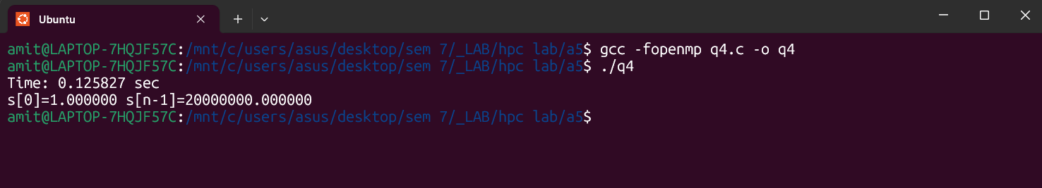

Information:
- Compute cumulative sum of array elements using a parallel scan approach.

Analysis:
- Done in two phases: local scan + offset addition.
- Achieves good performance on large arrays.
- Sequential dependencies are reduced via block method.

Github Link: https://github.com/amitwasnik1906/HPC_Lab

