## **Comprehensive Notes on US Medical Billing**

### **Interaction of Main Players in Medical Billing (FLOW)**

1. **Patient** gets prescription from **Physician**.
2. **Provider (DME Supplier)** delivers equipment & creates claim.
3. Claim goes via **Clearinghouse** → **Insurance Company (or Payer)**.
4. **Insurance** reviews → Pays provider (or denies).
5. **Billing/RCM Team** posts payment, reconciles accounts.
6. If denied, **Provider/RCM** appeals with more documents.
7. **Patient** may pay deductible/coinsurance.
8. **CMS/Govt** oversees compliance & rules.

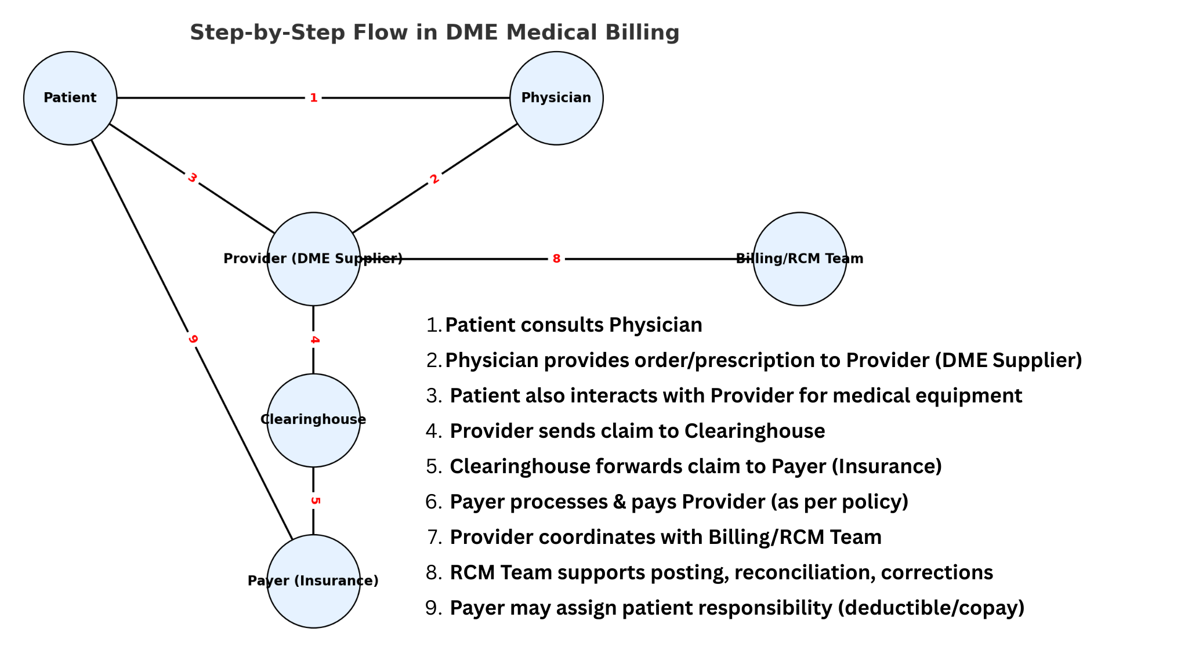

---------------------------------------------------------------------------------------------------------------------------

### **FOUNDATION OF MEDICAL BILLING**

### 

### **I. Introduction to Medical Billing**

* **Core Parties Involved:**
  + **Patient:** The individual receiving medical services.
  + **Provider:** The entity providing the service (e.g., hospital, physician).
  + **Payer:** The insurance company responsible for payment.
* **Three Main Types of Billing:**
  + Hospital Billing.
  + Physician Billing.
  + DME (Durable Medical Equipment) Billing.
* **Key Regulations and Concepts:**
  + **HIPAA (Health Insurance Portability and Accountability Act of 1996):** Federal law creating national standards to protect sensitive patient health information.
  + **PHI (Protected Health Information):** Any health information that can be tied to an individual.
  + **RCM (Revenue Cycle Management):** The financial process for managing claims, payment, and revenue. It begins with a patient's appointment and concludes with payment collection.

### **II. Government Insurance Programs**

#### **A. Medicare**

A federal government health insurance program.

* **Eligibility:**
  + Individuals aged 65 or older.
  + Must have paid federal taxes for 40 quarters (10 years).
  + Physically disabled individuals.
  + Individuals with End-Stage Renal Disease (ESRD).
* **The Four Parts of Medicare:**
  + **Part A (Hospital Insurance):** Covers inpatient services where a patient is admitted for more than 24 hours.
  + **Part B (Medical Insurance):** Covers outpatient services. Patients pay a monthly premium and a yearly deductible. It covers ambulance, MRI, CT scans, and DME.
  + **Part C (Medicare Advantage Plan):** An alternative plan combining Parts A and B. Often covers services not included in traditional Medicare, like dental, vision, and gym memberships.
  + **Part D (Prescription Drug Plan):** Covers prescription drugs.
* **MAPD (Medicare Advantage Prescription Drug Plan):** A plan that combines Medicare Parts C and D.

#### **B. Medicaid**

A health insurance program run by state governments.

* **Key Features:**
  + Often pays 100% of the cost with no patient responsibility.
  + Considered the "payer of last resort".
  + The single largest source of health coverage in the U.S..
* **Eligibility:**
  + Individuals with income below the Federal Poverty Line (FPL).
  + Permanently physically disabled individuals.
  + Pregnant women.

#### **C. SCHIP (State Children's Health Insurance Program)**

Provides coverage for orphans, homeless children, and dependents of families with income below the FPL.

#### **D. TRICARE (formerly CHAMPUS)**

A healthcare program for uniformed services, military personnel, and their families.

* **Beneficiaries:** Active duty, retired personnel, and their dependents.
* **Administration:** It's not an insurance program; private companies called fiscal intermediaries process claims.

#### **E. CHAMPVA (Civilian Health and Medical Program of the Department of Veterans Affairs)**

A healthcare program where the Department of Veteran Affairs covers health service costs for eligible veterans and their families.

### **III. Commercial (Private) Insurance Programs**

These are non-governmental plans, also known as commercial carriers.

* **Payment Structure:** Often pay a percentage (e.g., 80%) of the allowed amount, with the patient responsible for the rest.
* **Examples of Commercial Plans:** BCBS (Blue Cross Blue Shield), UHC (United HealthCare), Aetna, Cigna, Humana.
* **Special Types of Insurance:**
  + **No-fault and Liability Insurance:** Pays for healthcare services resulting from an injury where fault is not a factor, such as an auto accident.
  + **Worker's Compensation:** Provides coverage for employees injured on the job.

### **IV. Types of Managed Care Organizations (MCOs)**

* **HMO (Health Maintenance Organization):** The cheapest option; only covers **in-network providers**. Authorization and referrals are mandatory.
* **EPO (Exclusive Provider Organization):** A costlier plan that also only covers **in-network providers**. Authorization and referrals are not required.
* **POS (Point of Service):** Covers both **in-network and out-of-network providers**. Authorization and referrals are required only for out-of-network services.
* **PPO (Preferred Provider Organization):** The most expensive option. It covers both **in-network and out-of-network providers** and does not require authorization or referrals.
* **In-Network vs. Out-of-Network:**
  + **In-network** providers have a contract with the insurance company.
  + **Out-of-network** providers do not have a contract with the insurance company.

### **V. The Revenue Cycle Management (RCM) Process**

1. **Pre-Process & Registration:** The patient schedules an appointment and provides personal, clinical, and financial data. Eligibility is verified with the payer (e.g., Medicare, Commercial) to confirm coverage.
2. **Authorization:** The provider obtains prior authorization from the insurer if required.
3. **Service Delivery & Coding:** The patient receives the medical service. Services are translated into medical codes (CPT/HCPCS, ICD-10).
4. **Charge Entry & Claim Submission:** Charges are assigned, and the claim is sent to the insurance company, often via a **Clearing House** which checks for errors.
5. **Payment Posting:** Payments from insurance and patients are recorded. This can be a complex area involving portal-based entries, handling negative balances, and using specific MCR (Medicare) transaction numbers.
6. **A.R. & Denial Management:** The Accounts Receivable (A.R.) team follows up on unpaid claims. If a claim is denied, the team investigates and works to resolve the issue.

### **VI. Medical Coding, Forms, and Modifiers**

#### **A. Billing Forms**

* **CMS-1500:** Used by individual, non-institutional providers (e.g., physicians).
* **CMS-1450 (UB-04):** Used by facility providers (e.g., hospitals).

#### **B. Coding Systems**

* **CPT (Current Procedural Terminology):** Numeric codes for medical, surgical, and diagnostic procedures.
* **HCPCS (Healthcare Common Procedure Coding System):** Codes for medical products, supplies, and services. This includes specific codes for items like **oxygen concentrators** and **wheelchairs**.
* **ICD-10 (International Classification of Diseases, 10th Revision):** Alphanumeric codes describing a patient's diagnosis.

#### **C. Place of Service (POS) Codes**

These codes indicate where the service was rendered.

* **11:** Office
* **12:** Home
* **21:** Inpatient Hospital
* **22:** Outpatient Hospital
* **31:** Skilled Nursing Facility (SNF)
* **34:** Hospice

#### **D. Modifiers**

Modifiers provide additional information about a service or procedure.

* **RT/LT:** Right / Left
* **NU:** New Equipment Purchase
* **RR:** Rental Equipment
* **KX:** Medical Necessity documentation is on file
* **GY:** Item or service is statutorily excluded or does not meet the definition of a Medicare benefit.
* **KH, KI, KJ:** Modifiers for the 1st, 2nd-3rd, and 4th-13th months of DME rental, respectively.

### **VII. Key Terminology and Concepts**

* **Authorization:** Approval from an insurer before a service is rendered.
* **Referral:** A physician's recommendation for a patient to see a specialist.
* **Deductible:** The amount a patient must pay before their insurance starts to pay.
* **Co-payment (Co-pay):** A fixed amount a patient pays for a service.
* **Co-insurance:** The percentage of costs a patient pays after meeting their deductible.
* **AOB (Assignment of Benefits):** A form allowing the provider to be paid directly by the insurer.
* **ABN (Advanced Beneficiary Notice):** A form where a Medicare patient accepts financial responsibility if a service is denied.
* **COB (Coordination of Benefits):** The process of determining the order of payment when a patient has multiple insurance policies.
* **EOB/ERA (Explanation of Benefits / Electronic Remittance Advice):** A statement from the insurer detailing how a claim was processed.
* **Charge Amount:** The full price a provider bills for a service.
* **Allowed Amount:** The maximum amount an insurer will pay for a covered service.
* **DHHS (Department of Health and Human Services):** The U.S. government's principal agency for protecting the health of all Americans.
* **PRS (Patient Responsibility):** The total amount the patient owes, including deductible, co-pay, and co-insurance.

### **VIII. A.R. and Denial Management**

This involves investigating and resolving rejected or denied claims.

* **Common Reason for Denial:** The most common denial is for missing or invalid authorization.
* **Common Denial Codes:** Claims can be denied for numerous reasons, often indicated by specific codes on the EOB/ERA. Some common codes include:
  + **CO 16:** Claim/service lacks information which is needed for adjudication.
  + **CO 18:** Duplicate claim/service.
  + **CO 27:** Expenses were incurred after coverage terminated.
  + **CO 29:** The time limit for filing has expired.
  + **CO 97 (Auth):** The benefit for this service is included in the payment/allowance for another service that has been performed. Often relates to authorization issues.
  + **CO 118:** Escheatment.
  + **CO 197/198:** Precertification/authorization/notification absent or penalties applied.
  + **PR 1, 2, 3:** Codes indicating patient responsibility for Deductible, Co-insurance, and Co-payment.

--

### **PAYMENT POSTING**

### **What is Payment Posting?**

Payment Posting is the process of recording payments from insurance companies and patients into the medical billing system. It involves reading the **Explanation of Benefits (EOB)** or **Electronic Remittance Advice (ERA)** to update a patient's account with payments, adjustments, and denials.

### **Why It's Important**

* **Keeps Finances Accurate:** Ensures the provider's financial records are correct.
* **Catches Problems:** It's the first step to identifying claim denials or incorrect payments from insurance.
* **Enables Patient Billing:** You can't accurately bill a patient until you know what their insurance has paid.

### **The 5-Step Payment Posting Flow**

The process is a straightforward flow from receiving the payment information to finalizing the account.

1. **Receive Remittance 📬** Get the payment details from the insurance company, either as a paper **EOB** or an electronic **ERA** file.
2. **Post Payment 💵** Apply the insurance payment amount to the correct patient's claim in the billing software.
3. **Post Adjustments ✍️** Write off the **contractual adjustment**, which is the difference between the high amount you billed and the lower amount the insurance agreed to pay (the "allowed amount").
4. **Transfer Balance ➡️** Move the remaining balance (like a deductible or co-pay) to the patient's responsibility or to a secondary insurance company for billing.
5. **Handle Denials 🚫** If a claim is denied (paid $0), identify the denial reason code and send the claim to the Accounts Receivable (A/R) team to be investigated and fixed.

### **Overview of DME Payment Posting**

Payment posting for a DME provider is more complex than for a typical physician's office. It requires careful tracking of long-term rentals, purchase vs. rental status, and specific payer rules regarding equipment ownership. The poster isn't just closing a claim; they are managing an ongoing equipment lifecycle for each patient.

### **The Detailed DME Payment Posting Workflow**

This process details the journey from receiving the remittance to closing the line item, with special attention to the unique rules for different payers.

#### **Step 1: Receive and Reconcile Remittance**

The process begins when the provider receives payment information from the payer.

* **Action:** The poster receives an **Electronic Remittance Advice (ERA)** or a paper **Explanation of Benefits (EOB)**. They must first reconcile the total payment amount on the remittance with the actual bank deposit to ensure they match.
* **Payer Differences:** This step is a standard accounting control and is the same for all payers.

#### **Step 2: Identify Claim and Verify Details**

The poster locates the specific claim in the billing system that corresponds to the payment line item.

* **Action:** Match the patient's name, date of service (DOS), and the **HCPCS code** for the equipment (e.g., E0601 for a CPAP).
* **DME Specifics:** For DME, the poster must also verify the **modifier** used on the claim (e.g., **RR** for Rental, **NU** for New Purchase) and the rental month being paid. This is critical for the next steps.

#### **Step 3: Post Payment and Contractual Adjustment**

This is the core data entry part of the process where the payment and write-offs are recorded.

* **Action:** The poster enters the amount paid by the insurance and posts the **contractual adjustment**. This adjustment is the difference between the provider's full charge and the payer's allowed amount.
* **Payer Differences:**
  + 🦅 **Federal (Medicare):** The allowed amount is determined by the **Medicare Fee Schedule**. It is fixed and non-negotiable. The contractual adjustment is straightforward.
  + 🏢 **Commercial & Other:** The allowed amount is based on the provider's specific contract with that insurance company. The poster must verify this amount is correct, as it can vary greatly between plans.

#### **Step 4: Analyze Rental Cap Status**

This is the most critical and unique step in DME payment posting. The poster must determine what the payment means for the equipment's rental lifecycle.

* **Action:** Based on the payment, the poster updates the patient's equipment record in the system.
* **Payer Differences:**
  + 🦅 **Federal (Medicare):**
    - **Capped Rental Equipment (e.g., Wheelchairs, CPAPs):** Medicare pays for 13 months of continuous rental. After the **13th rental payment**, the equipment is considered owned by the patient. The poster must flag the account to **stop billing for rentals**.
    - **Oxygen Equipment:** Medicare pays for **36 months** of rental. After the 36th payment is posted, billing stops, but the provider is still responsible for servicing the equipment for a total of 5 years.
  + 🏢 **Commercial & Other:** These payers have highly variable rules. Some follow Medicare's 13-month cap, while others may have a 10-month "rent-to-own" policy or allow for indefinite rentals. The poster must read the EOB remarks carefully or refer to the specific payer policy to know when to stop billing.

#### **Step 5: Transfer Remaining Responsibility**

Once the insurance payment is posted, the poster moves the remaining balance to the next responsible party.

* **Action:** The poster transfers the balance for any **deductible, co-pay, or co-insurance** to either a secondary payer or directly to the patient.
* **Payer Differences:**
  + 🦅 **Federal (Medicare):** The patient is typically responsible for **20% co-insurance** of the Medicare-allowed amount. This is almost always billed to a secondary (Medigap) policy.
  + 🏢 **Commercial & Other:** The patient's responsibility is determined by their specific plan's benefits. This can be more complex to calculate if the patient has a high deductible that has not yet been met.

#### **Step 6: Handle Denials and Zero Pays**

When a claim line is paid $0, it requires special handling.

* **Action:** The poster identifies the denial reason code and routes the claim to the Accounts Receivable (A/R) team for investigation and appeal.
* **Common DME Denials:**
  + **Medical Necessity:** Often denied if the **KX modifier** (documentation on file) is missing. This is a common issue with both Medicare and Commercial payers.
  + **Same or Similar Equipment:** A frequent Medicare denial stating the patient already has the same equipment on file.
  + **Missing Prior Authorization:** A very common denial from Commercial payers who require pre-approval for most equipment.
  + **Rental Cap Met:** The payer denies the claim because their records show the rental period is complete. The poster must verify this against their own records.

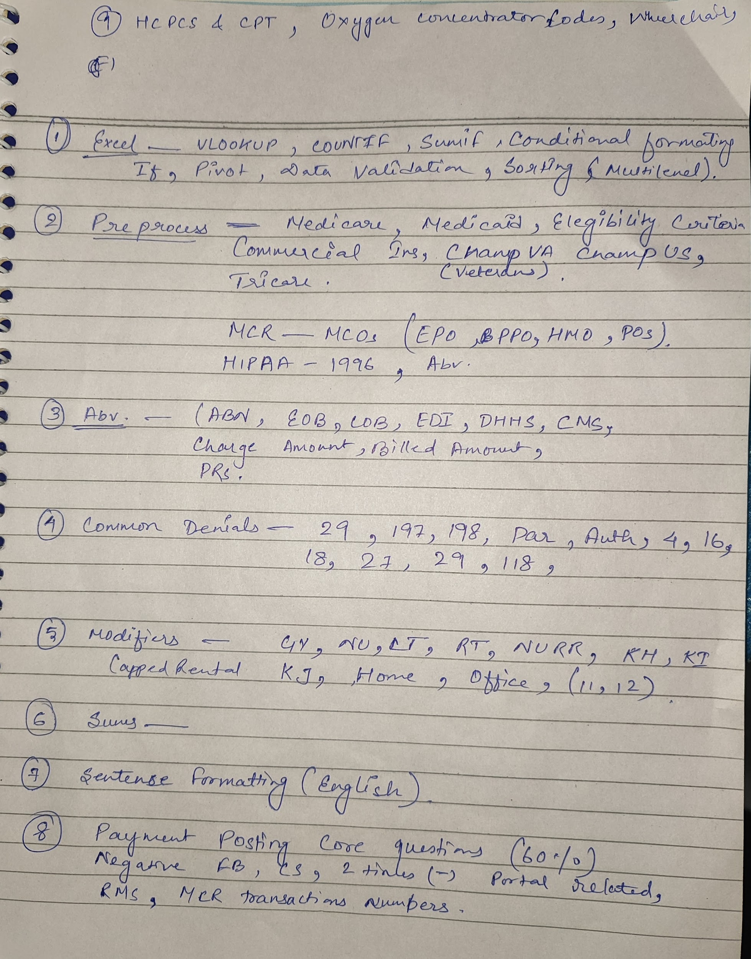

# **📘 Detailed Notes for Team Lead – Payment Posting (DME Medical Billing)**

## **1. Excel (For Payment Posting & DME Reporting)**

👉 **Why important for TL in DME**: Posting payments for multiple rentals, capped equipment, and insurance policies involves **huge data sets**. Excel helps track rentals, denials, and patient balances.

### **Key Functions:**

* **VLOOKUP** → Match HCPCS code with payment/allowed amount.  
  + Example: =VLOOKUP("E1390", A2:D200, 3, FALSE) → Find allowed for Oxygen concentrator (E1390).
* **COUNTIF** → Count denial codes.  
  + Example: How many denials with code “198” (missing auth).
* **SUMIF** → Sum payments per insurance (Medicare vs Commercial).
* **Conditional Formatting** → Highlight unpaid rentals after 13th month (capped rental).
* **Pivot Tables** →  
  + Denials by insurance.
  + Rental vs Purchase claims.
  + Monthly posting per team member.
* **Data Validation** → Prevent wrong HCPCS entry (only valid codes allowed).

✅ **TL Use Case in DME**:

* Track rental life cycle (KH → KI → KJ → capped).
* Report productivity per rep.
* Highlight accounts with recurring denials.

## **2. Pre-Process Knowledge (Insurance Types in DME)**

👉 In DME billing, insurance rules are very strict. **Eligibility checks** avoid denials.

* **Medicare**:  
  + Covers medically necessary DME.
  + Example: Oxygen concentrator (E1390) if O2 < 88%.
  + Rental-based: Capped after 13 months.
* **Medicaid**:  
  + State-specific. Covers wheelchairs, hospital beds, CPAPs.
* **Commercial Insurance**:  
  + BCBS, UHC, Aetna → Different fee schedules.
  + Prior authorization usually required for expensive items (wheelchairs, power scooters).
* **CHAMPVA / Tricare / VA**:  
  + Military patients (common in DME).

✅ **TL Role**: Ensure eligibility verified → correct insurance type → avoid “Not Covered / Terminated Coverage” denials.

## **3. Abbreviations (Used in DME Payment Posting)**

* **ABN** → Advance Beneficiary Notice → If Medicare won’t cover equipment.
* **EOB** → Explanation of Benefits (insurance response).
* **ERA** → Electronic Remittance Advice.
* **LOB** → Line of Business (Medicare, Medicaid, Commercial, VA).
* **EDI** → Electronic transmission of claims/payments.
* **DHHS** → Department of Health and Human Services.
* **CMS** → Centers for Medicare & Medicaid Services.
* **Charge Amount** → Provider submitted for DME (e.g., $150 for wheelchair).
* **Allowed Amount** → Insurance approved (e.g., $100).
* **Patient Responsibility** → Copay, Deductible, Coinsurance.

✅ **TL Role**: Ensure staff interpret **EOB/ERA correctly** → Apply write-offs, patient balance, and rental continuation correctly.

## **4. Common Denials (DME-Specific)**

Denials are frequent in DME because equipment requires strict documentation.

* **29** → Timely filing expired.
* **197** → Authorization required (wheelchair, hospital bed).
* **198** → Pre-authorization missing.
* **4** → Coverage terminated.
* **16** → Claim lacks information (e.g., missing doctor’s order).
* **18** → Duplicate claim.
* **27** → Expenses after coverage ended.
* **118** → Charges exceed fee schedule (common in rentals).

✅ **TL Role**:

* Create Denial Summary → Highlight top 3 denials for team.
* Ensure proper documentation (Doctor’s order, Certificate of Medical Necessity (CMN), Prior Authorization).

## **5. Modifiers (Most Important for DME)**

👉 DME depends heavily on **HCPCS codes with correct modifiers**.

* **GY** → Item/service not covered.
* **NU** → New equipment.
* **RR** → Rental.
* **LT / RT** → Left or Right side (e.g., prosthetics).
* **KH** → First rental month (Capped Rental).
* **KI** → 2nd–3rd month rental.
* **KJ** → 4th–13th month rental.
* **POS (Place of Service)**:  
  + **12 → Home** (most common for DME).
  + **11 → Office** (when dispensed in clinic).

✅ **TL Role**: Ensure billing team applies correct modifier.  
 Example: Wheelchair rental billed as RR + KH (month 1). If wrong → insurance denies.

## **6. Sums (DME Posting Calculations)**

In DME, most claims are **rental-based**, so amounts need careful calculation.

* **Billed Amount** → Charge entered by DME provider.
* **Allowed Amount** → As per Medicare/Insurance fee schedule.
* **Paid Amount** → Actual insurer payment.
* **Adjustment (Write-off)** → Difference between billed & allowed.
* **Patient Responsibility** → Deductible, Copay, Coinsurance.

**Formula:** Billed – Allowed – Paid = Patient Responsibility

✅ **Example**:  
 Oxygen concentrator billed: $150  
 Allowed: $100  
 Paid: $80  
 Adjustment: $50  
 Patient Responsibility: $20

✅ **TL Role**: Double-check adjustments → Prevent under/over-posting.

## **7. Sentence Formatting (Professional English – DME Context)**

👉 For **client communication, payer escalations, team handling**.

### **Examples:**

* “The claim for HCPCS E1390 was denied with code 197 due to missing authorization. Resubmission initiated with updated authorization.”
* “Patient responsibility applied correctly as per EOB, deductible amount shifted to patient ledger.”
* “Rental claim for wheelchair billed under KH modifier was incorrectly posted by the associate, correction applied.”

✅ **TL Role**: Mentor team to use **clear professional English** in emails and ticket updates.

## **8. Payment Posting – Core Questions (DME Focus)**

This is **60% of weightage** → TL must master this area.

* **Negative Balance** → Reasons:  
  + Overpayment from insurance.
  + Duplicate posting.
  + Claim reversal not posted.  
     ✅ Example: Medicare recoups money after rental ends → results in negative balance.
* **FB (Full Balance) vs Partial Posting**:  
  + **FB**: Payer pays entire allowed amount.
  + **Partial**: Patient portion (deductible, coinsurance) remains → must be transferred.
* **Portal Related Posting**:  
  + Sometimes ERA missing → TL/team checks Medicare, Medicaid, or Commercial portals to confirm payment.
* **RMS (Revenue Management System)**:  
  + DME billing software used for posting and reconciliation.
* **MCR Transaction Numbers**:  
  + Medicare assigns transaction control numbers → Required for reconciliation.

✅ **TL Role**:

* Ensure ERA/EOB, portal data, and RMS match.
* Investigate negative balances.
* Audit rental postings (KH → KI → KJ).

# **🧠 Mind Map (DME Version)**

DME Payment Posting

│

├── Excel

│ ├── VLOOKUP for HCPCS

│ ├── Pivot (Rental vs Purchase)

│ ├── Denial/Payment Reports

│

├── Pre-Process

│ ├── Medicare (13-month rentals)

│ ├── Medicaid

│ ├── Commercial

│ └── Tricare / VA

│

├── Abbreviations

│ ├── ABN / EOB / ERA

│ ├── CMS / DHHS

│ └── Allowed vs Billed

│

├── Denials

│ ├── 29, 197, 198

│ ├── 16, 18, 27, 118

│

├── Modifiers

│ ├── RR, NU, LT/RT

│ ├── KH / KI / KJ

│ └── POS 12 (Home), 11 (Office)

│

├── Sums

│ ├── Billed vs Allowed

│ ├── Adjustments

│ └── Patient Resp

│

├── Sentence Formatting

│ └── Client & Payer Emails

│

└── Core Questions

├── Negative Balances

├── FB vs Partial

├── Portal Posting

├── RMS

└── MCR Txn Numbers

⚡ Now you have **DME-focused detailed notes** that are tailored to your IJP.

Do you also want me to make a **one-page PowerPoint-style cheat sheet with diagrams & icons** for **last-day revision**?

………

### **EXCEL**

## **📒 Detailed Notes on Excel Topics**

### **1. VLOOKUP**

* **Definition:** Used to find a value in a column and return a corresponding value from another column.
* **Syntax:** =VLOOKUP(lookup_value, table_array, col_index_num, [range_lookup])
* **Example:** =VLOOKUP(5, A2:D21, 3, FALSE) → Finds ID = 5 and returns the Department.

### **2. COUNTIF**

* **Definition:** Counts the number of cells that meet a condition.
* **Syntax:** =COUNTIF(range, criteria)
* **Example:** =COUNTIF(C2:C21, "HR") → Counts how many employees are in HR.

### **3. SUMIF**

* **Definition:** Adds the values in a range that meet a condition.
* **Syntax:** =SUMIF(range, criteria, [sum_range])
* **Example:** =SUMIF(C2:C21, "Finance", D2:D21) → Adds all salaries of Finance employees.

### **4. Conditional Formatting**

* **Definition:** Highlights cells based on rules.
* **Examples:**
  + Highlight salaries greater than 70,000.
  + Color cells red if Score < 60.

### **5. IF Function**

* **Definition:** Returns one value if condition is TRUE, another if FALSE.
* **Syntax:** =IF(condition, value_if_true, value_if_false)
* **Example:** =IF(E2>5000, "High Bonus", "Low Bonus")

### **6. Pivot Table**

* **Definition:** Summarizes large data quickly (grouping, sums, averages).
* **Practice:**
  + Create a pivot table with Department as rows and average Salary as values.
  + Add Score as column field to compare department performance.

### **7. Data Validation**

* **Definition:** Restricts data entry in cells.
* **Examples:**
  + Allow only numbers between 1 and 100.
  + Create a dropdown for Department selection (HR, Finance, IT, Sales).

### **8. Sorting (Multi-level)**

* **Definition:** Arranges data in ascending/descending order with multiple levels.
* **Example:**
  + First sort by Department (A→Z), then by Salary (Largest → Smallest).

……………………………………………………………………………………………………