P.R.Pote Patil

College of Engineering Mangement , Amravati An Autonomous institute

CODING CLUB

THIS IS TO CERTIF**Y**

**{name}**

In appreciation of your valuable contribution as a **{event} And Technical team Co-Lead to the Coding Club during the academic year {date}.** Your dedication, enthusiasm, and consistent efforts played an important role in the success of our initiatives, events, and the overall journey of the team.

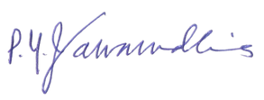

Prof.A.A Tayade Faculty Coordinator Coding Club PRPCEM



**_**

Prof.S.K.Nanda Dean of Student Welfare PRPCEM

Dr.P.M.Jawandhiya Principal PRPCEM