Running the WEB API to get the Currency Rate Via Fiddler/PostMan

In URL enter as ---- <http://amitapi.azurewebsites.net//api/v0/rate>

By default you will get the Currency Rate for USD by latest update currency date. Refer Screenshot1

**Screenshot1:**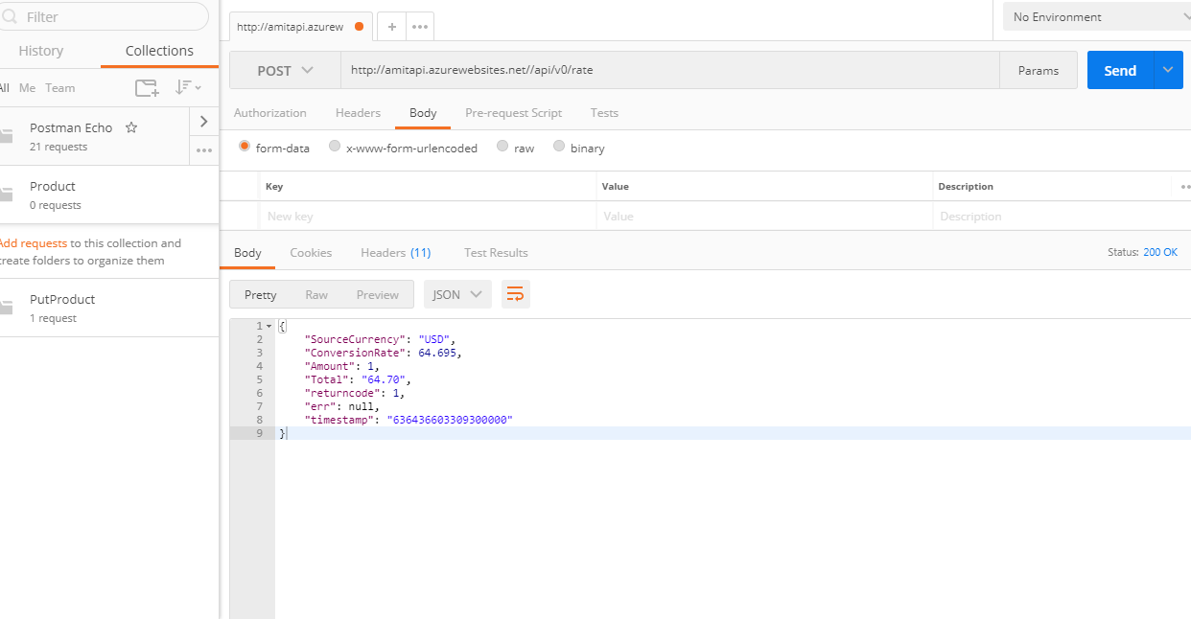

In URL enter as ---- http://amitapi.azurewebsites.net//api/v0/rate?CurrencyCode=EUR&amount=3

You will get the Currency Rate for EUR with calculated Total based on Amount entered. Refer Screenshot2

**Screenshot2**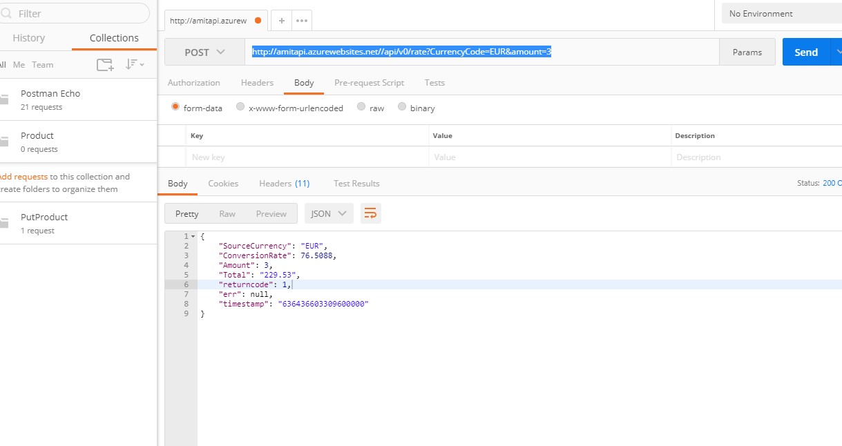

Manually you can Insert the rate via PostMan in SQL server database which is created in Azure(**Screenshot3**) and this same API will be called by Job scheduled in Azure Web Jobs for every 15 mins(**Screenshot4**).

URL :--- http://amitapi.azurewebsites.net/api/exchrate/create

In Request BODY

{

"SourceCurrency": "USD",

"ConversionRate": 46

}

**Screenshot3**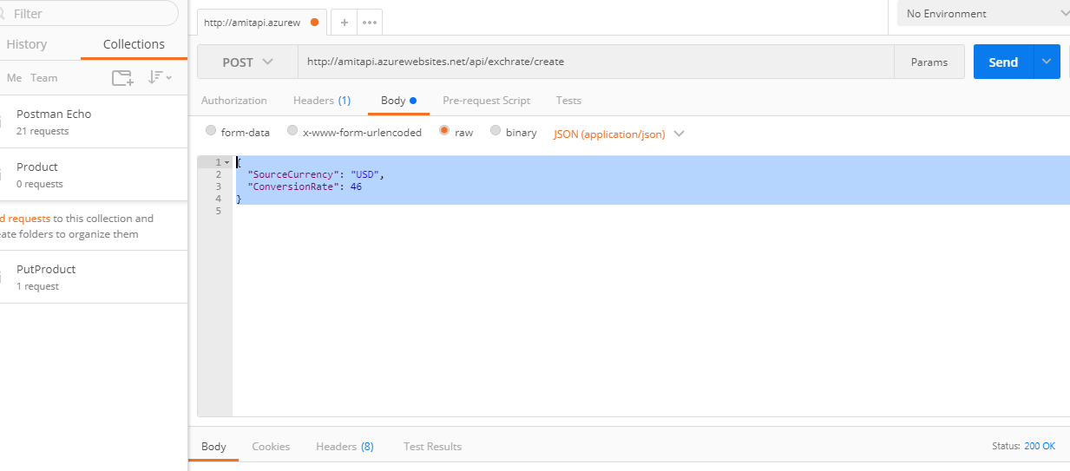

**Screenshot4 ---** job scheduled in Azure which runs every 15 mins and insert the new Rate for countries (USD, GBP, AUD, EUR, CAD and SGD)

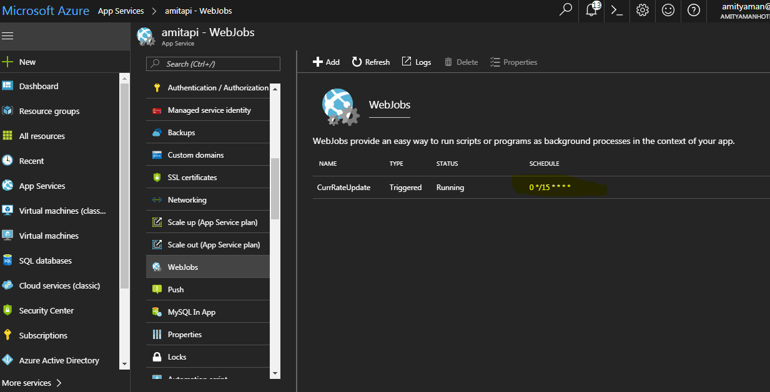

**Screenshot5---** Below screenshot indicates where I have deployed our Api site

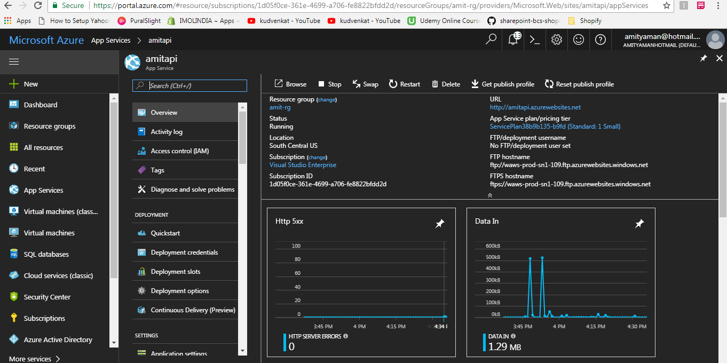

Here is the link I have followed to get this code exercise complete (This is not first time I am working before that also I have worked on below mentioned concept)

**Azure**

https://app.pluralsight.com/channels/details/0d31d4df-ca45-4df2-9905-6c40353d217c

[**https://app.pluralsight.com/player?course=introduction-azure-app-services&author=barry-luijbregts&name=introduction-azure-app-services-m0&clip=0**](https://app.pluralsight.com/player?course=introduction-azure-app-services&author=barry-luijbregts&name=introduction-azure-app-services-m0&clip=0)

**Ninject**

<https://blog.agilistic.nl/a-step-by-step-guide-to-using-ninject-for-dependancy-injection-in-c-sharp/>

<https://andreascode.wordpress.com/2010/11/22/webactivator-preapplicationstartmethod/>

<https://softwareengineering.stackexchange.com/questions/300376/does-having-di-happen-in-the-composition-root-go-against-the-whole-point-of-depe>

**CurrenyRate**

Here is the below link I have followed to get an Real-Time rate using Google’s API but none is giving the expected result

https://www.codeproject.com/Articles/421725/ASP-NET-Real-time-Currency-Converter-using-API-Goo

http://www.ashishblog.com/currency-exchange-rate-in-webpage-using-c-asp-net/

https://github.com/001saraju/Currency-Rate-api/blob/master/CurrencyRate/RateSchedular.cs

https://www.aspsnippets.com/Articles/Currency-Conversion-as-per-Exchange-Rates-using-Google-Finance-API-Web-Service-in-ASPNet.aspx

<http://www.aspdotnet-suresh.com/2013/01/aspnet-google-currency-converter-json.htm>

So finally I have used Currency Converter using Yahoo’s API to get an expected result

https://www.codeproject.com/Articles/421725/ASP-NET-Real-time-Currency-Converter-using-API-Goo

**Screenshot of Project Structure**

