Vacuole-Aware Myelin Quantification
in Electron Microscopy Images

Final report draft
A scale-aware computer-vision pipeline for detecting vacuolar disruption and estimating intact myelin area
Author | Noy Elyasi | ID: __________________
Author | Roni Hagai | ID: __________________
Author | Amit Yehezkel | ID: __________________
Principal investigator 1 | Name: __________________ | Email: __________________
Principal investigator 2 | Name: __________________ | Email: __________________
Course | ____________________________________________
Submission date | ____________________________________________
Status: course-project proof of concept; not a clinical or diagnostic system.

Abstract
Conventional electron-microscopy measurements of myelin thickness use the inner and outer fiber boundaries. When pathological vacuoles separate myelin lamellae, this gross envelope can make damaged myelin appear thicker rather than less intact. We developed a portable Python pipeline that detects bright vacuolar disruptions inside the gross myelin sheath and reports vacuole area, vacuole burden, intact-myelin area, the conventional area-based g-ratio, and an intact-equivalent g-ratio. The common detector is scale-aware and combines percentile normalization, contrast-limited adaptive histogram equalization, Gaussian smoothing, Otsu-adaptive hysteresis seeds, physical-unit morphology, seeded boundary refinement, and a shape- and location-filtered thin-cleft rescue branch. The software exposes three analysis modes: automatic whole-image processing, one supplied-mask crop, and batch processing of matched masked crops. Two additional resumable Napari entry points guide users from whole-image folders or existing crop folders through crop and mask preparation before invoking the same detector. On a 43-fiber student-annotated benchmark, with 20 development fibers and 21 quality-control-eligible test fibers, cropped-mode test medians were Dice 0.752, intersection-over-union 0.603, precision 0.930, recall 0.714, and absolute vacuole-area error 0.00628 µm². The controlled whole-image pathway underperformed because the automatic mask front end recovered only 25 of 43 target fibers and both masks met the predefined per-fiber criterion for 15 of 43. The results support a successful cropped-mask proof of concept and identify automatic fiber segmentation, expert annotation, and independent external validation as the main next steps.
Keywords: electron microscopy; myelin; vacuolization; g-ratio; image segmentation; AxonDeepSeg; computer vision

1. Introduction

1.1 Biological and measurement context
Myelin is a multilamellar membrane sheath that supports rapid and reliable axonal signal propagation. Changes in myelin structure are therefore relevant to neurodevelopment, disease, and experimental models of altered neural function. Electron microscopy (EM) exposes the ultrastructure needed to evaluate individual fibers, and the g-ratio is commonly used to summarize the relationship between axon size and the full myelinated-fiber size [1,2].
The conventional area-based g-ratio can be written as sqrt(Aaxon/Aouter), where Aouter is the area enclosed by the outside of the fiber. This representation works well when the sheath is compact. In pathological samples, however, myelin lamellae can separate and form pale clefts or vacuoles. The outer envelope expands while part of the enclosed region is no longer compact myelin. A boundary-only measurement can consequently describe vacuolated myelin as grossly thick even though its intact material is reduced.

1.2 Aim and contributions
The project aimed to add a vacuole-aware measurement layer to an axon/myelin segmentation workflow. Rather than treating every pixel between the axon and outer fiber boundaries as intact sheath, the system estimates the area occupied by vacuolar disruption and subtracts it from the gross sheath.
- A reproducible, scale-aware detector whose physical parameters are expressed in µm and µm².
- Three analysis modes plus two guided entry points: automatic whole-image analysis, one supplied-mask crop, a supplied-mask crop folder, guided preparation from whole images, and guided preparation from existing crops.
- A seeded detector that balances conservative high-confidence detection with connected boundary growth and selective thin-cleft rescue.
- Outputs focused on stable biological quantities: total vacuole area, vacuole burden, intact-myelin area, and intact-equivalent g-ratio.
- A development/test benchmark, preserved model history, visual overlays, quality-control flags, and a portable environment check.

2. Related Work
Manual g-ratio measurement is laborious and can limit sample size. MyelTracer addressed this problem with an OpenCV-based semi-automated workflow and reported a 40–60% reduction in total quantification time while maintaining consistency with manual analysis [2]. Its central task is tracing axon and outer myelin boundaries; it does not directly solve the project-specific problem of subtracting internal vacuolar disruption.
AxonDeepSeg introduced open-source convolutional neural networks for semantic segmentation of axon and myelin in SEM and TEM images [3]. It is suitable as a proposal-generating front end for whole laboratory images, but its published models were trained on specific modalities, resolutions, species, and acquisition conditions. Domain shift is therefore a realistic concern. In this project AxonDeepSeg is used only in whole-image mode; it is not the vacuole detector.
The vacuole detector follows an interpretable image-processing strategy. Otsu's method provides a per-fiber data-adaptive threshold [4], while contrast-limited adaptive histogram equalization (CLAHE) improves local contrast without unrestricted amplification [5]. The contribution is the way these standard operations are constrained to the gross sheath, calibrated in physical units, combined through hysteresis seeding, and followed by guarded refinement and thin-cleft rescue.

3. Materials and Methods

3.1 Images, annotations, and benchmark
The benchmark comprises 43 manually annotated fiber crops derived from EM data used during the course project. Each item contains a grayscale crop, scale in nm/pixel, a filled axon mask, a filled outer-fiber mask, and a reference vacuole mask. The split was assigned by source image to reduce leakage between closely related crops: 20 fibers were allocated to development and 23 to test. Two test rows were excluded from aggregate scoring by a pre-existing border-touching quality-control rule, leaving 21 eligible test fibers. The masks are student annotations and should not be interpreted as expert biological ground truth.

3.2 Analysis modes, guided entry points, and shared detector
Entry point | Boundary preparation | Analysis role
Automatic whole image | AxonDeepSeg, fiber extraction, and QC | Experimental proposal/review
Guided whole folder | User selects unlimited crops, then draws two masks | Resumable cropped analysis
Guided crop folder | User draws two masks for existing crops | Resumable cropped analysis
One masked crop | Validate supplied axon and outer masks | Single-fiber cropped core
Masked crop folder | Match and validate supplied masks | Batch cropped core
↓ All accepted fibers use the same frozen vacuole detector and measurement code ↓
Figure 1. Five user entry points differ in boundary preparation but converge on the same cropped-fiber detector.
Automatic whole-image mode resamples the input to the nearest validated AxonDeepSeg scale, masks the expected bottom-right scale-bar region, applies the bundled segmentation model, restores masks to native dimensions, separates connected fibers by axon-labeled watershed, fills fiber-envelope holes, and rejects or flags geometrically implausible candidates. Accepted fibers are cropped with a 0.25 µm margin. The supplied-mask crop modes bypass this front end. Two guided Napari entry points automate the surrounding preparation: one accepts a folder of whole images and supports any number of user-selected fiber crops per image, whereas the other begins with an existing crop folder. Both guide sequential axon and outer-fiber annotation, validate masks, save resumable state, and invoke the frozen detector after the final crop. These interfaces improve reproducibility and reduce file handling; they were not evaluated as a formal usability or annotation-accuracy intervention.
A terminal workflow wizard, launched with python -m mvp_pipeline, asks what inputs are available, validates paths, physical-scale information, and local environment readiness, displays the equivalent explicit command, and dispatches to the selected entry point. The wizard does not change detector logic or parameters; the explicit subcommands remain available for scripted and reproducible execution.

3.3 Mask definitions and cleanup
For each fiber, the axon mask describes the inner compartment and the outer-fiber mask describes the complete filled envelope. The gross sheath is defined as outer fiber AND NOT axon. If the supplied axon extends beyond the outer mask, the outer mask is expanded and a quality-control flag is recorded. Empty or inconsistent masks are rejected. Every prediction is clipped to the gross sheath, preventing a vacuole from appearing in the axon or outside the fiber.

3.4 Intensity response and hysteresis seeds
The detector searches for relatively bright disruption within generally darker myelin. Only sheath pixels determine intensity statistics. The 1st and 99th percentiles are mapped to 0 and 1; CLAHE with clip limit 0.01 and an approximately 0.25 µm kernel enhances local contrast; and a Gaussian filter with sigma 0.02 µm suppresses pixel noise. Otsu's threshold is then calculated from the processed sheath pixels. Pixels above Otsu + 0.20 form strong seeds. Pixels above Otsu + 0.10 are retained only when connected to those seeds. This hysteresis logic allows intensity variation inside a genuine vacuole without accepting all moderately bright sheath texture.

3.5 Morphology, boundary refinement, and thin-cleft rescue
The standard branch performs circular closing and opening with a 0.02 µm radius, then removes components below 0.01 µm². Because this can preserve the center of a vacuole while missing its pale border, each surviving component is refined independently. Connected growth is allowed within 0.05 µm through pixels reaching at least Otsu − 0.05. Growth is discarded if it exceeds 1.5 times the seed area, limiting leakage through weak edges.
Manual labels also contained thinner valid clefts. A second branch therefore revisits the raw hysteresis candidate using gentler 0.005 µm morphology and a minimum area of 0.0015 µm². A candidate is retained only when its maximum thickness is at least 0.045 µm, median radial position is no greater than 0.55, eccentricity is no greater than 0.95, and solidity is at least 0.85. These filters encode the observation that valid clefts tend to be coherent regions close to the axon-facing part of the sheath, whereas false positives often follow thin lamellar texture or the outer edge.
Parameter | Final value | Role
High / low Otsu offsets | +0.20 / +0.10 | Strong seeds and connected weak-pixel hysteresis
Gaussian sigma | 0.02 µm | Suppress pixel-scale noise
Main morphology radius | 0.02 µm | Close gaps, then remove thin noise
Main minimum area | 0.01 µm² | Reject small components in the standard branch
Refinement distance / floor | 0.05 µm / Otsu−0.05 | Expand an existing seed toward a plausible boundary
Refinement area guard | 1.5× seed | Prevent leakage through weak edges
Rescue minimum area | 0.0015 µm² | Retain thin annotated clefts
Rescue context filters | thickness, radial position, eccentricity, solidity | Reject compact-myelin texture that only looks bright
Table 1. Active vacuole-detector configuration selected on the development split.

3.6 Measurements
Pixel area is (nm_per_pixel/1000)² µm². The pipeline reports axon area, outer-fiber area, gross-sheath area, vacuole area, intact-myelin area, vacuole burden (Avacuole/Agross sheath), conventional g-ratio sqrt(Aaxon/Aouter), and intact-equivalent g-ratio sqrt[Aaxon/(Aouter − Avacuole)]. The intact-equivalent measure is an area-based project metric, not yet a biologically validated replacement for established g-ratio analysis. Vacuole count and mean component size were deliberately removed: a narrow boundary gap can split one biological cleft into several connected components, making those outputs unstable.

3.7 Evaluation
Parameters were chosen on the development split and then summarized on the test split. Pixel-level overlap and physical area error were evaluated against the reference vacuole masks. If prediction and truth were both empty, overlap metrics were defined as 1. Percentage area error was undefined for a compact reference with nonempty false prediction and was omitted from that median.
Metric | Definition | Interpretation
Dice | 2TP / (2TP + FP + FN) | Pixel overlap; 1 is perfect
IoU | TP / (TP + FP + FN) | Stricter pixel-overlap measure
Precision | TP / (TP + FP) | How much predicted vacuole is correct
Recall | TP / (TP + FN) | How much annotated vacuole is recovered
Absolute area error | |A_pred - A_ref| | Physical error in µm²
Percentage area error | |A_pred - A_ref| / A_ref | Relative error for non-compact references
Table 2. Evaluation metrics used in this project.

4. Results

4.1 Cropped-mask modes
The one-crop and folder modes use the same masks, detector, and measurements, so their expected segmentation accuracy is identical when supplied with the same inputs. Test precision (0.930) exceeded recall (0.714), indicating that the final configuration is comparatively conservative: most predicted pixels agree with annotations, but some true vacuole area remains unmarked. Dice and IoU remained similar between development and test medians, although the test area error was larger.
Metric | Development | Test | Meaning
Eligible fibers | 20 | 21 | Two test rows excluded by pre-existing QC
Median Dice | 0.764 | 0.752 | Good-but-incomplete overlap
Median IoU | 0.619 | 0.603 | Same overlap viewed more strictly
Median precision | 1.000 | 0.930 | Few predicted pixels outside annotations
Median recall | 0.842 | 0.714 | Under-segmentation remains the larger error
Median absolute area error | 0.00126 µm² | 0.00628 µm² | Physical vacuole-area error
Median percentage area error | 8.61% | 20.29% | Relative area error; excludes undefined compact cases
Table 3. Final cropped-mode performance. Values are medians over quality-control-eligible fibers.
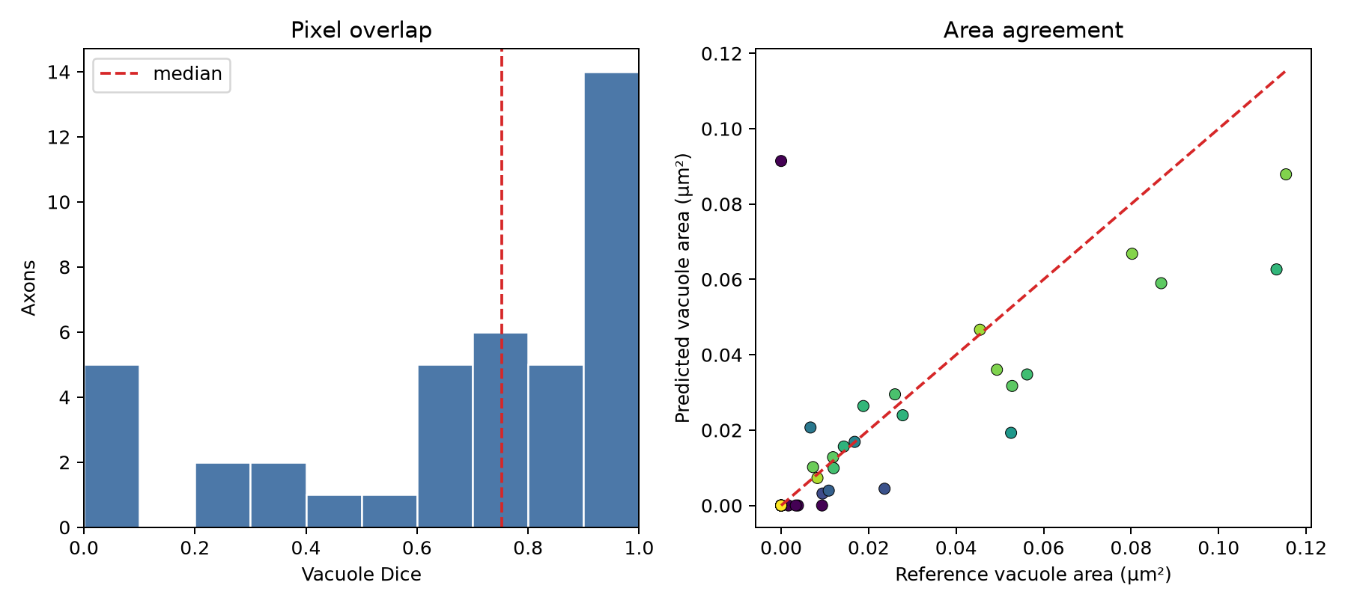
Figure 2. Final cropped-mode evaluation overview generated by the pipeline.

4.2 Qualitative performance
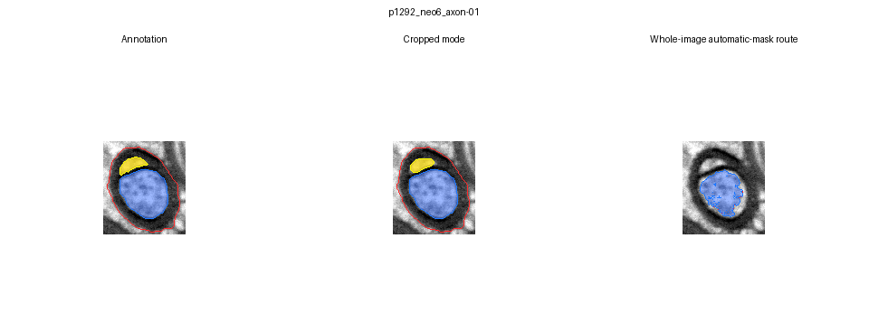
Figure 3. Example in which cropped-mask mode reproduces the annotated vacuole while the whole-image route misses it because it depends on automatic masks. Panels: annotation, cropped mode, whole-image mode.
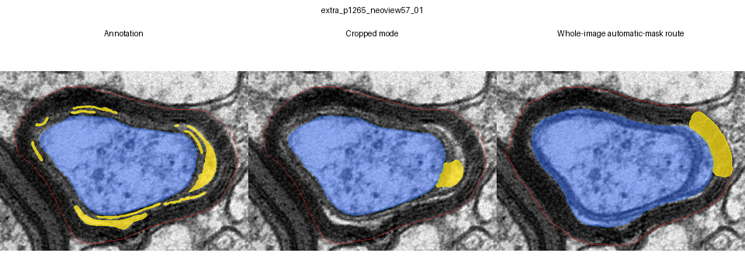
Figure 4. Challenging thin-cleft example. The selective rescue branch reduced complete misses, but difficult low-contrast or lamellar clefts can remain partial. Panels: annotation, cropped mode, whole-image mode.

4.3 Whole-image mode must be reported separately
The controlled end-to-end experiment applied AxonDeepSeg and the frozen vacuole detector to the same 43 benchmark fields. The automatic front end recovered 25 target fibers, both automatic masks met the predefined per-fiber quality criterion for 15/43 (34.9%), and 18 targets were complete misses. Median automatic-mask Dice was 0.028 for axon and 0.014 for outer fiber. End-to-end vacuole Dice was therefore 0.000 on both development and test. These values do not contradict the cropped-mode result: they test an additional, currently weak mask-generation stage. The whole-image mode is best described as a proposal/review workflow rather than an accepted fully automatic measurement mode.
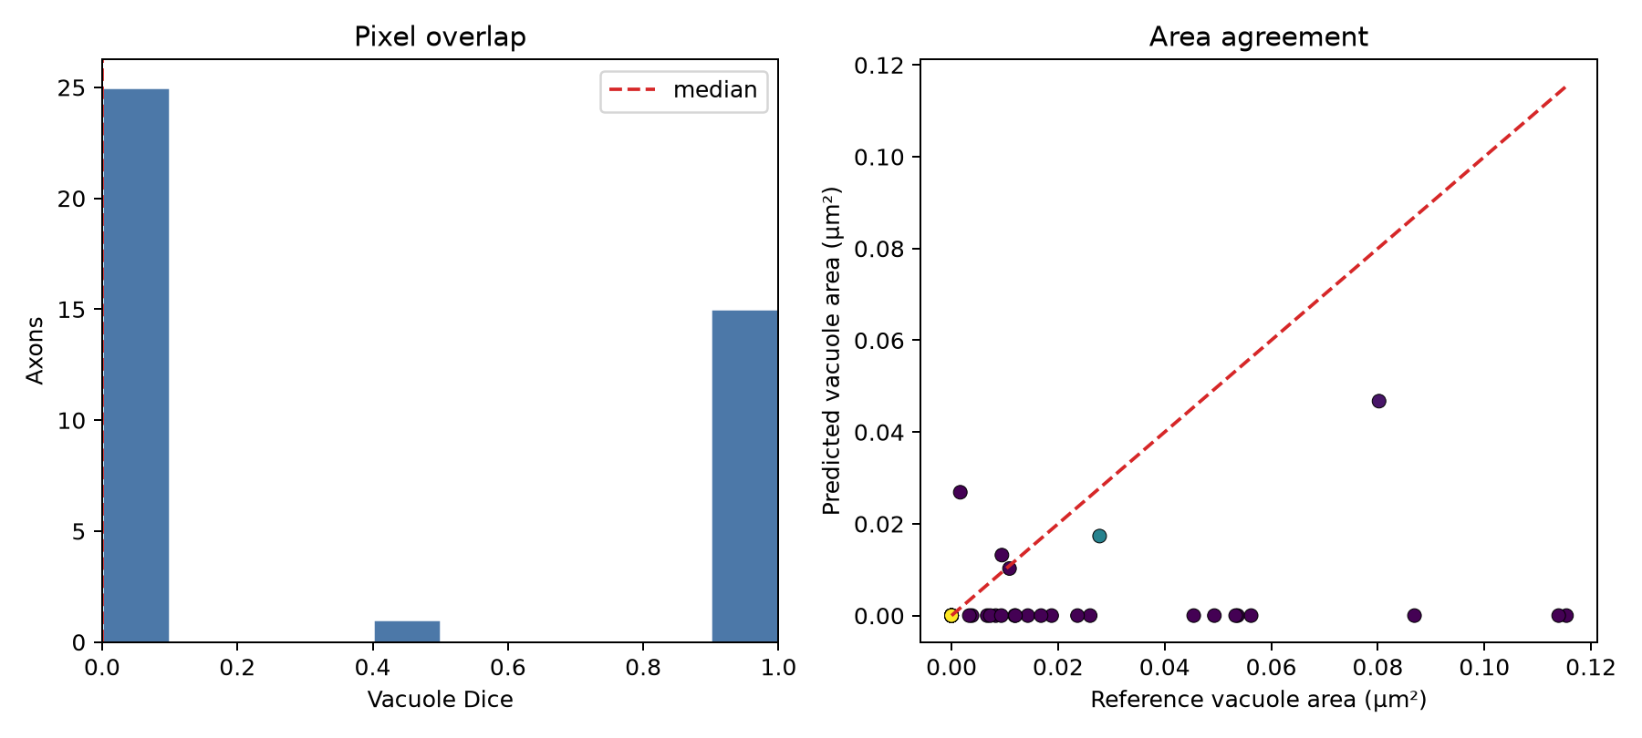
Figure 5. Controlled whole-image-mode evaluation. The dominant errors originate in target recovery and automatic axon/outer-fiber masks.

4.4 Effect of the final rescue logic
Earlier boundary refinement could enlarge an existing vacuole seed but could not create one after the main morphology/filtering stage removed it. The thin-seed rescue branch reduced complete positive-fiber misses from five to one while retaining the earlier compact-fiber false-positive count of 1/7. By contrast, lowering the global minimum area to 0.0015 µm² produced false positives in 5/7 compact fibers. This comparison motivated a selective feature-filtered rescue rather than a uniformly permissive threshold.

4.5 Guided workflow implementation
The implemented guided-whole-folder workflow opens each whole image in sequence for unrestricted rectangular crop selection, archives processed sources, and then advances directly to two-mask annotation. The guided-crop-folder workflow begins at the annotation stage. Both accept either a common nm/pixel value or a per-file scale CSV, preserve progress in a resumable state file, validate masks before completion, and write self-contained crops, masks, overlays, measurements, and provenance. Automated tests cover state recovery, scale handling, mask validation, and detector handoff. No formal usability study was performed, so these features are reported as an engineering and reproducibility contribution rather than evidence of improved human performance.
The terminal launcher was tested across its decision branches, including safe cancellation, explicit opt-in for the experimental automatic route, scale selection, and guided-session resume. All 35 automated project tests passed after integration. No formal user study was performed, so this establishes software behavior rather than improved usability or annotation accuracy.

5. Discussion

5.1 Interpretation
The cropped-mask result is strong enough to demonstrate technical feasibility for a course submission: the method achieves median Dice near 0.75 with high precision and physically small median area error. It should not be described as production-ready or biologically validated. There is no universal Dice threshold that defines adequacy, and performance depends on annotation quality, object size, class imbalance, and the intended error cost. Here, high precision with lower recall means the model is more likely to underestimate some vacuole extent than to label widespread compact myelin as damaged. That behavior is defensible for a conservative proof of concept, but it is not the final biological operating point.

5.2 Scientific and engineering contributions
- The pipeline exposes a measurement failure mode that is hidden when only inner and outer boundaries are considered.
- The detector is transparent: each prediction can be traced to local intensity, connectivity, morphology, distance, and shape rules.
- Physical-unit parameters allow the same logic to be applied across pixel scales.
- The interactive launcher makes the five entry paths discoverable while preserving their separation: a reliable cropped-mask measurement core, two reproducible guided-preparation paths, and a still-developing automatic segmentation front end.
- Preserved overlays, configurations, model-history folders, resumable guided state, environment definition, doctor check, and automated tests support reproducibility.

5.3 Challenges and limitations
- Vacuoles and compact-myelin texture can share brightness, especially after local contrast enhancement.
- A bright center with a weak border encourages under-segmentation; permissive growth can instead leak into intact sheath.
- Thin clefts can resemble ordinary lamellar spacing, creating a precision–recall trade-off.
- Only 43 fibers were labeled, annotations were made by students, and some test examples were visually inspected during iterative development.
- Whole-image target matching and outer-fiber reconstruction remain unreliable on the local image domain.
- The benchmark is two-dimensional and does not establish correspondence between a bright cleft and a fluid-filled biological vacuole across serial sections.

5.4 Recommended next work
- Obtain blinded annotations from at least two domain experts and quantify inter-rater agreement.
- Create a genuinely untouched external test set grouped by animal, preparation, and source image.
- Fine-tune or retrain the axon/outer-fiber segmentation front end on local images before claiming whole-image automation.
- Use uncertainty or review flags to route borderline fibers to a human instead of forcing an automatic result.
- Compare the rule-based detector with a small supervised segmentation network after substantially enlarging the annotated dataset.
- Test whether vacuole burden and intact-equivalent g-ratio correlate with expert pathology scores or independent functional measures.

6. Conclusion
This project produced a portable vacuole-aware myelin analysis pipeline that corrects a meaningful limitation of boundary-only EM measurements. With valid crop-level axon and outer-fiber masks, the final detector provides a reproducible and interpretable proof of concept, achieving median test Dice of 0.752 and precision of 0.930 while reporting stable area-based damage measures. The guided preparation paths and interactive launcher standardize execution of the cropped-mask workflow, but their usability has not been formally evaluated. The automatic whole-image pathway is not yet reliable because its mask front end does not transfer adequately to the local data. The clearest final claim is therefore two-part: cropped-mask vacuole quantification is promising and ready for further validation; fully automatic whole-image analysis remains an explicit future-development objective.

References
[1] I. Fischer et al., "Shank3 mutation impairs glutamate signaling and myelination in ASD mouse model and human iPSC-derived OPCs," Science Advances, vol. 10, eadl4573, 2024.
[2] T. Kaiser et al., "MyelTracer: A Semi-Automated Software for Myelin g-Ratio Quantification," eNeuro, vol. 8, no. 4, ENEURO.0558-20.2021, 2021. doi: 10.1523/ENEURO.0558-20.2021.
[3] A. Zaimi, M. Wabartha, V. Herman, P.-L. Antonsanti, C. S. Perone, and J. Cohen-Adad, "AxonDeepSeg: automatic axon and myelin segmentation from microscopy data using convolutional neural networks," Scientific Reports, vol. 8, 3816, 2018. doi: 10.1038/s41598-018-22181-4.
[4] N. Otsu, "A Threshold Selection Method from Gray-Level Histograms," IEEE Transactions on Systems, Man, and Cybernetics, vol. 9, no. 1, pp. 62–66, 1979. doi: 10.1109/TSMC.1979.4310076.
[5] K. Zuiderveld, "Contrast Limited Adaptive Histogram Equalization," in Graphics Gems IV, P. S. Heckbert, Ed. Academic Press, 1994, pp. 474–485.

Appendix A. Reproducibility Commands
From the project root, create/activate the environment, run the workspace doctor, and execute the test suite:
conda env create -f environment.yml
conda activate myelin-mvp
python -m mvp_pipeline doctor
$env:PYTEST_DISABLE_PLUGIN_AUTOLOAD='1'
python -m pytest -q

Appendix B. Fields to Complete Before Submission
- Insert each author's student ID.
- Insert the principal investigator name(s) and email address(es).
- Confirm the official course title and submission date.
- Obtain supervisor approval for the biological terminology and claims.
- Confirm whether the report must use a specific citation style, length, or Moodle filename.

