PROJECT STRUCTURE:
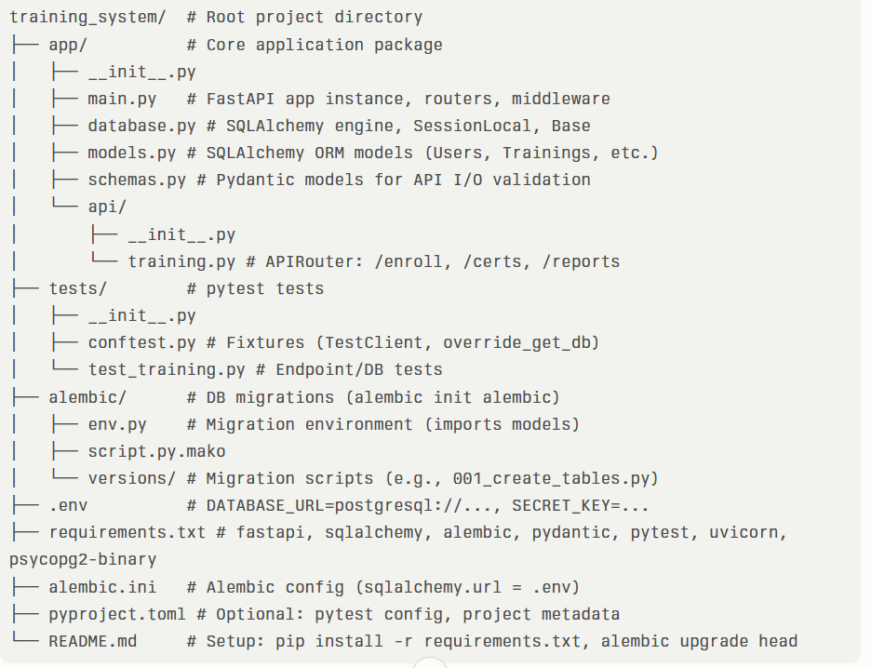

Objectives Mapping:

Objective | Implementation Location | Key Tech/Details
Manage learning/cert records | models.py (ORM), schemas.py (Pydantic) | Users, Trainings, Enrollments, Certs tables w/ expiry
Time-based validations | models.py queries, training.py deps | Filter certifications.expires_at < NOW() + 30 days
Generate compliance reports | api/training.py endpoints, pytest | GET /reports/expiring?days=30; test in test_training.py

Tables and Fields:

Table | Fields (Type; Required unless opt)
departments | id (Serial PK), name (Varchar(100) unique), description (Text opt), created_at (Timestamp), updated_at (Timestamp)
users | id (Serial PK), email (Varchar(255) unique), name (Varchar(255)), password_hash (Varchar(255)), department_id (Int FK opt), role (Varchar(50) opt='employee'), created_at (Timestamp), updated_at (Timestamp)
trainings | id (Serial PK), name (Varchar(200)), description (Text opt), status (Enum: 'scheduled','active','completed'), start_date (Timestamp opt), end_date (Timestamp opt), instructor_id (Int FK users), created_at (Timestamp), updated_at (Timestamp)
enrollments | id (Serial PK), user_id (Int FK users), training_id (Int FK trainings), enrollment_date (Timestamp), status (Enum: 'enrolled','completed'), completion_date (Timestamp opt), created_at (Timestamp)
certifications | id (Serial PK), enrollment_id (Int FK enrollments unique), cert_number (Varchar(100) unique), issued_date (Timestamp), expires_at (Timestamp), status (Enum: 'active','expired'), file_url (Varchar(500) opt), created_at (Timestamp)

Table Connections:

From Table | To Table | Type | FK Field | Cardinality / Purpose
users | departments | Many-to-One | department_id | Users belong to one dept
trainings | users | Many-to-One | instructor_id | Trainings led by instructors
enrollments | users | Many-to-One | user_id | Users enroll in many trainings
enrollments | trainings | Many-to-One | training_id | Trainings have many enrollments​
certifications | enrollments | One-to-One | enrollment_id (unique) | One cert per completed enrollment

Development Workflow:
- Define models.py (tables/relationships), alembic revision --autogenerate.​
- Schemas.py for validation (CertCreate: expires_at=Datetime).​
- training.py: routers w/ Depends(get_db), security (JWT).​
- test_training.py: TestClient for endpoints, fixtures for DB.​
- Deploy: uvicorn; CI w/ pytest coverage

