**School: Engineering And Technology.**

**Dept: Computer Science & Engineering.**

**Subject: SOFTWARE ENGINEERING LAB….**

**((( Assignment )))**

**Subject code: ECS43204**

**Name: Abir Paul**

**Course: B.Tech**

**Roll No: UG/02/BTCSE/2018/061**

**Enrolment No: AU/2018/02/0002552**

**Sec: B**

**Year: 3rd**

**Semester: 6th**

**Software Engineering Lab**

**Assignment 3**

**Date: 22.02.2021**

1. **Using Open Office Draw prepare a E-R Diagram for Library Management System.**

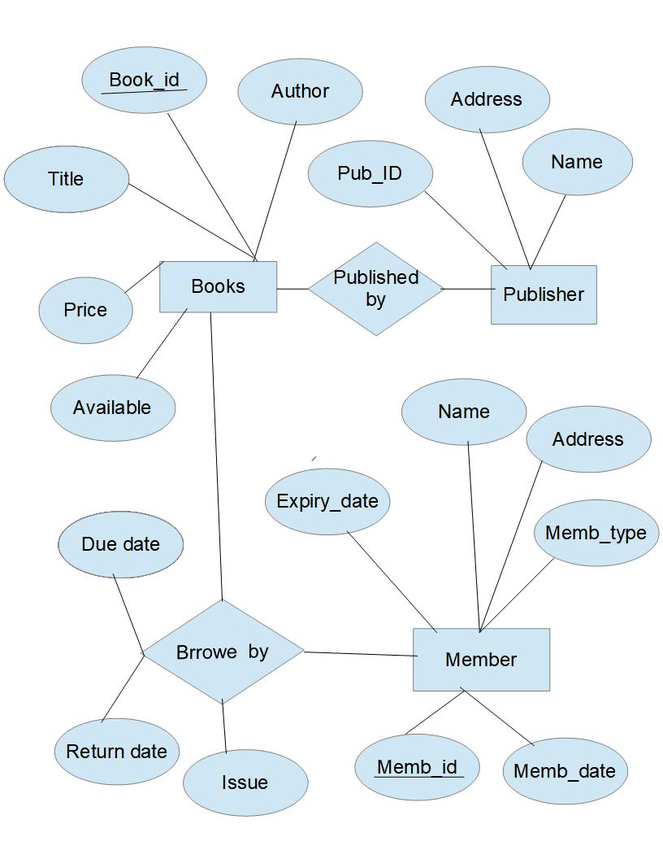

**Software Engineering Lab**

**Assignment 8**

**Date: 30.04.2021**

**Library Management System.**

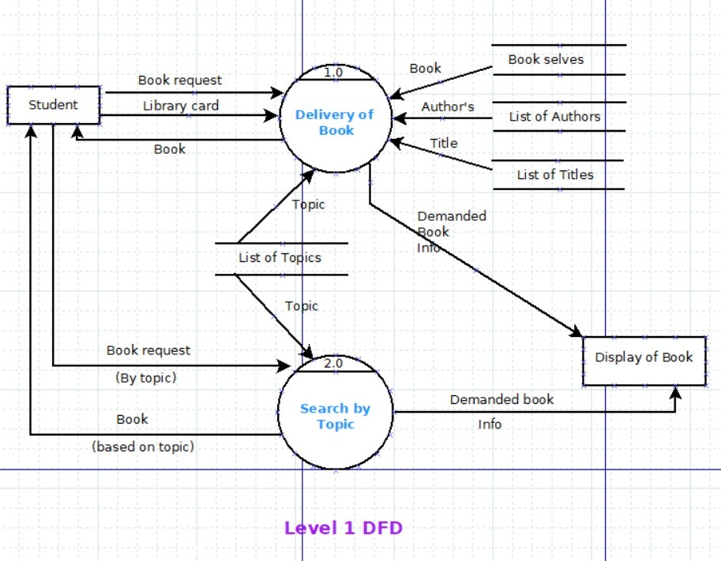

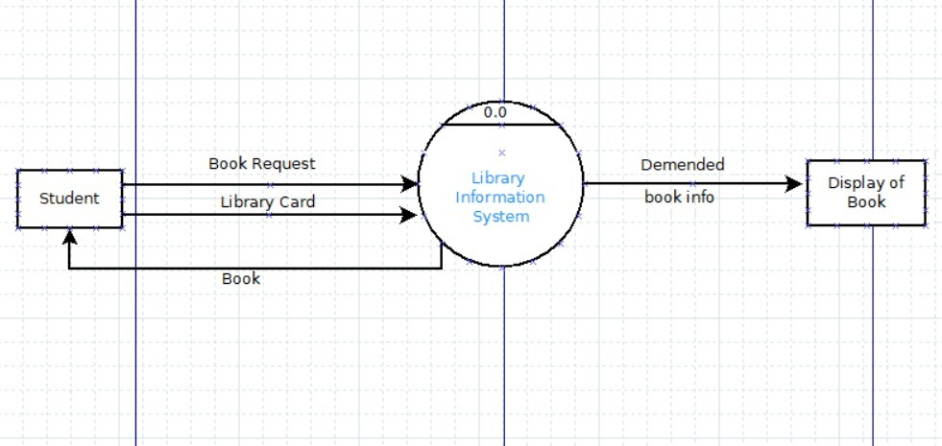

**Assignment**

**Software Engineering Lab**

**Assignment 8**

**Using Open Office Draw prepare an E-R Diagram for Online Railway Reservation System.**

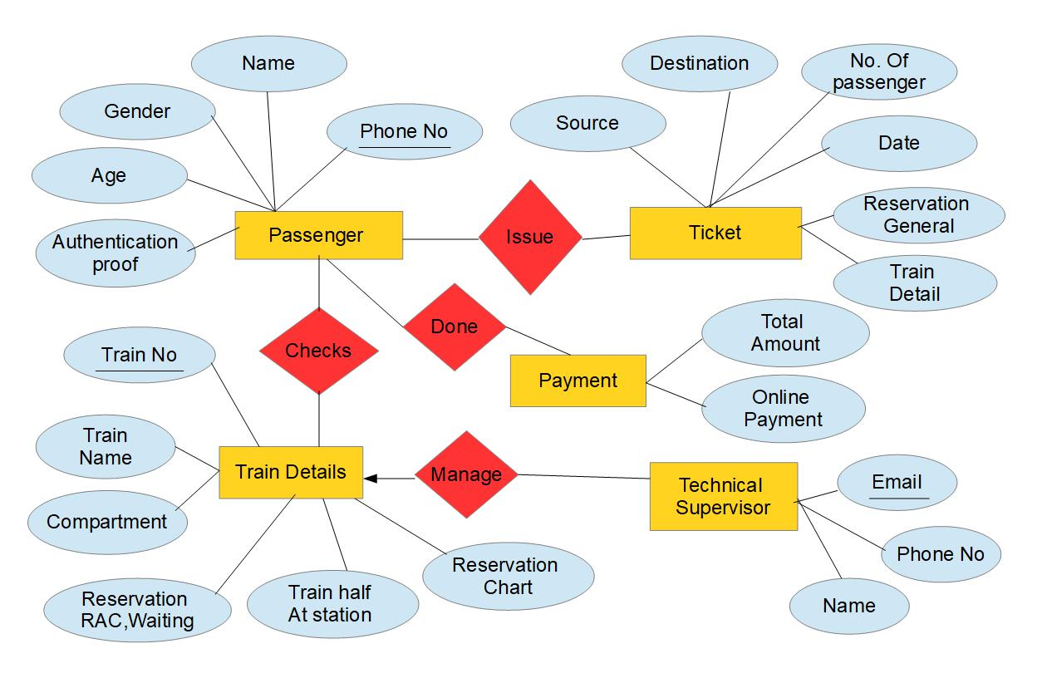

**E-R Diagram for Online Railway Reservation System**

**Software Engineering Lab**

**Assignment 7**

**Date: 09.04.2021**

**1.Using Open Office Draw prepare an E-R Diagram for Banking System.**

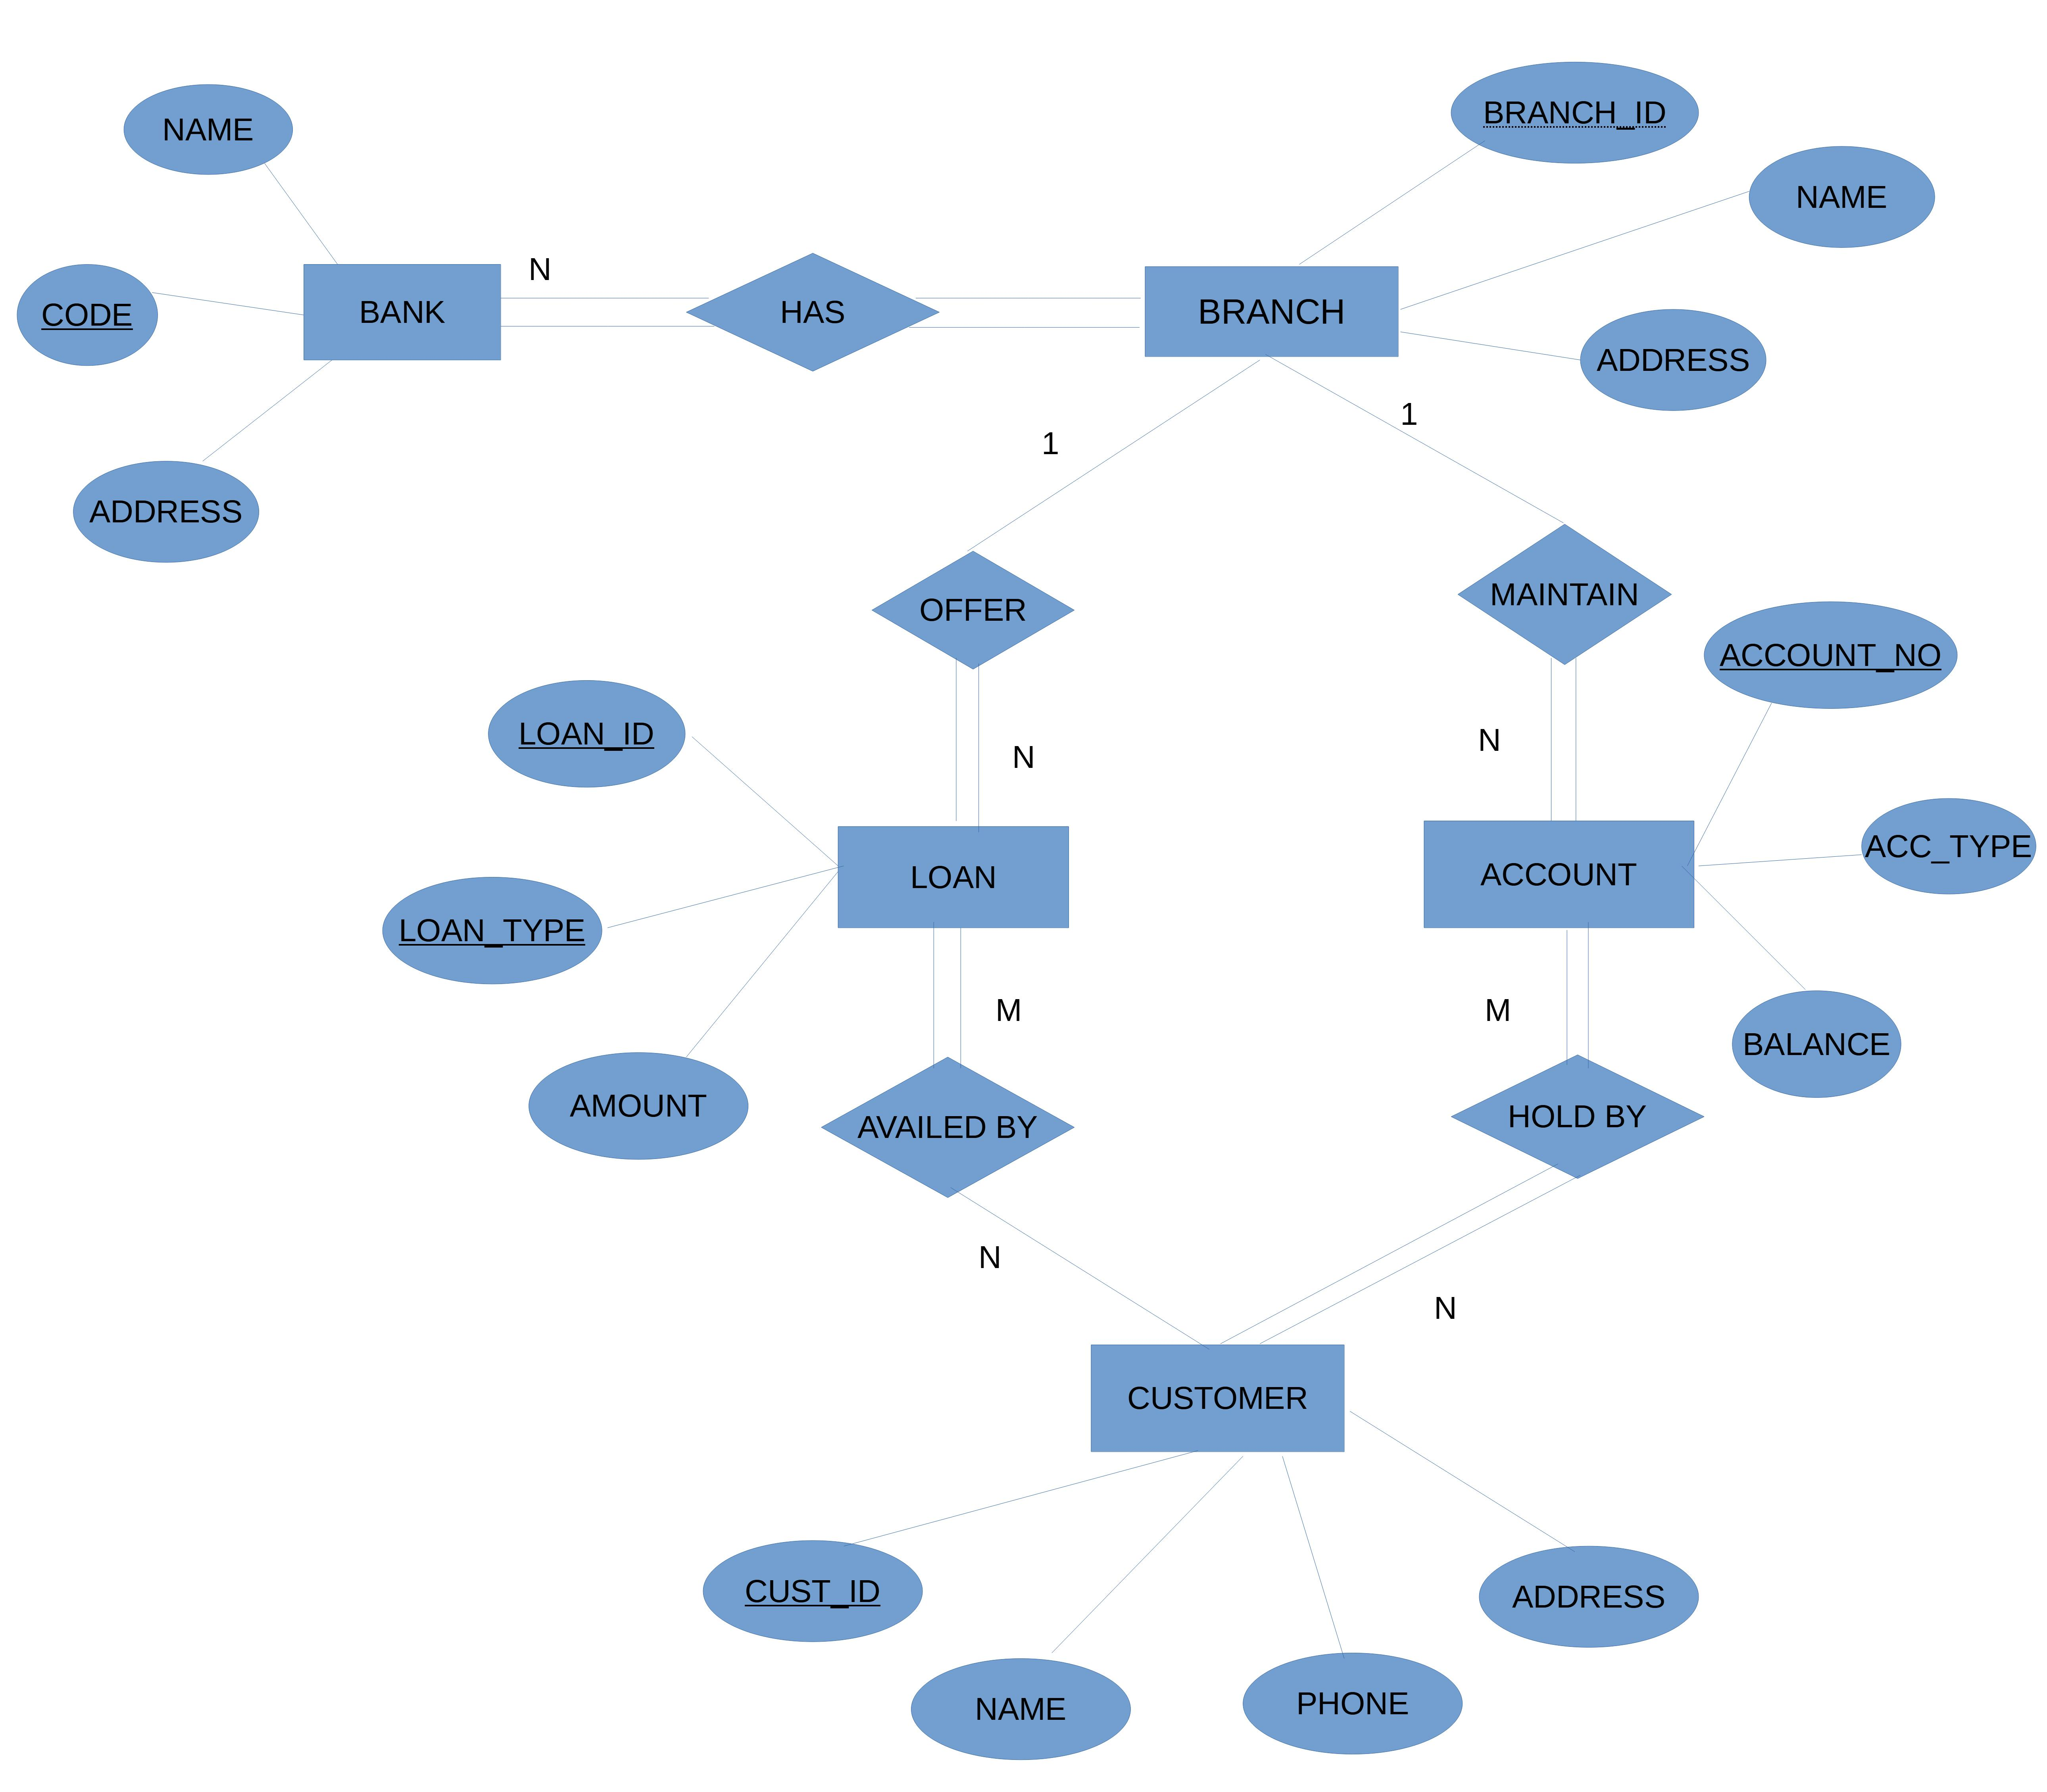

**E-R Diagram for Banking System**

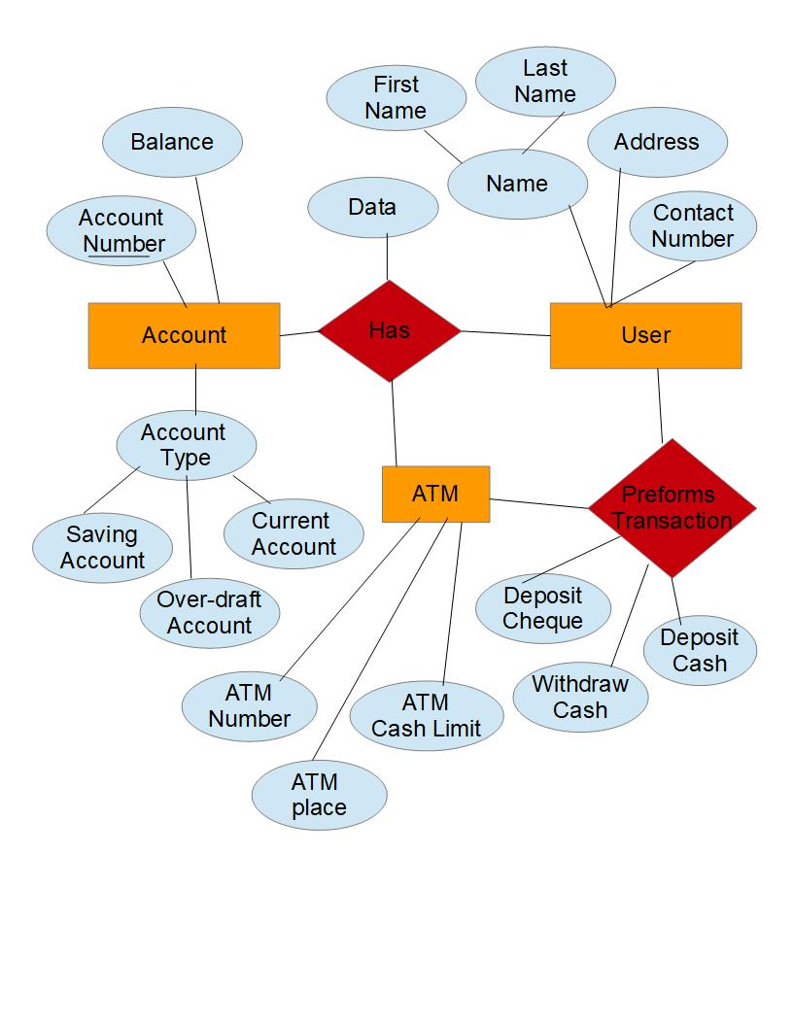

**E-R Diagram for Banking System**

**Software Engineering Lab**

**Assignment 4**

**Date: 12.03.2021**

1. **Using Open Office Draw prepare a E-R Diagram for Hospital Management System.**

