**School: Engineering And Technology.**

**Dept: Computer Science & Engineering.**

**Subject: DATABASE MANAGEMENT SYSTEM LAB**

**File**

**Subject code: ECS43204**

**Name: Abir Paul**

**Course: B.Tech**

**Roll No: UG/02/BTCSE/2018/061**

**Enrolment No: AU/2018/02/0002552**

**Sec: B.**

**Year: 3 Semester: 6th**

**Assignment SQL – II(22.02.2021)**

(Table Creation ,Constraint Add & Data Insertion)

1. Create the following Tables –

a).CUSTOMERS **(**CUST_ID(primary key), NAME, AGE, ADDRESS, SALARY**)**

b).SHIPEMENT(SHIPMENT_NO(primary key), CUST_ID, WEIGHT)

c) Add the following constraints

* SHIPMENT (CUST_ID) references CUSTOMERS(CUST_ID)
* Declare NOT NULL : name

d). Add new column START_CITY in SHIPMENT table.

2) a) Insert the following data into CUSTOMERS table.

**CUSTOMERS**

|  |  |  |  |  |
| --- | --- | --- | --- | --- |
| **CUST_ID** | **| NAME** | **AGE** | **| ADDRESS** | **SALARY** |
| C001 | Ramesh | 32 | Ahmedabad | 12000.00 |
| C002 | Khilan | 25 | Delhi | 14500.00 |
| C003 | Kaushik | 23 | Kota | 18000.00 |
| C004 | Muffy | 25 | Mumbai | 15000.00 |

b) Insert the following data into SHIPMENT table.

**SHIPMENT**

|  |  |  |  |
| --- | --- | --- | --- |
| **SHIPMENT_NO** | **CUST_ID** | **WEIGHT** | **START_CITY** |
| S201 | C001 | 120 | Indore |
| S202 | C002 | 210 | Kolkata |
| S203 | C003 | 320 | Mumbai |

**Write SQL statements to retrieve these query :**

1. Describe customer and shipment table .

2. Show the entire customer and shipment table.

3. Find out the start_city of shipment table.

4. Change age of Kaushik to 35.

5. Change salary of Ramesh to 15500.00.

6. Delete data of S202 in Shipment table.

**1.Create the following Tables –**

**Describe customer and shipment table**

**a). CUSTOMERS (CUST_ID(primary key), NAME, AGE, ADDRESS, SALARY)**

**PROGRAM CODE:**

**create table CUSTOMERS**

**( CUST_ID varchar(5) primary key,**

**NAME varchar(8),**

**AGE int(3),**

**ADDRESS varchar(10),**

**- SALARY float(8,2) );**

**OUTPUT:**

**Query OK**

**b). SHIPEMENT(SHIPMENT_NO(primary key), CUST_ID, WEIGHT)**

**PROGRAM CODE:**

**create table SHIPMENT**

**( SHIPMENT_NO varchar(6) primary key,**

**CUST_ID varchar(5),**

**WEIGHT int(5) );**

**OUTPUT:**

**Query OK**

**c) Add the following constraints**

* **SHIPMENT (CUST_ID) references CUSTOMERS (CUST_ID)**
* **Declare NOT NULL : name**

**PROGRAM CODE:**

**alter table SHIPMENT add foreign key(CUST_ID)**

**references CUSTOMERS (CUST_ID);**

**OUTPUT:**

**Query OK**

**PROGRAM CODE:**

**alter table CUSTOMERS**

**modify NAME varchar(8) not null;**

**OUTPUT:**

**Query OK**

**d). Add new column START_CITY in SHIPMENT table.**

**PROGRAM CODE:**

**alter table SHIPMENT**

**add START_CITY varchar(7);**

**OUTPUT:**

**Query OK**

**2. Show the entire customer and shipment table.**

**PROGRAM CODE:**

**insert into CUSTOMERS values('C001','Ramesh',32,'Ahmedabad',12000.00);**

**insert into CUSTOMERS values('C002','Khilan',25,'Delhi',14500.00);**

**insert into CUSTOMERS values('C003','Kaushik',23,'Kota',18000.00);**

**insert into CUSTOMERS values('C004','Muffy',25,'Mumbai',150.00);**

**insert into SHIPMENT values('S201','C001',120,'Indore');**

**insert into SHIPMENT values('S202','C002',210,'Kolkata');**

**insert into SHIPMENT values('S203','C003',320,'Mumbai');**

**OUTPUT:**

**Query OK**

**PROGRAM CODE:**

**desc CUSTOMERS;**

**OUTPUT:**

+---------+-------------+------+-----+---------+-------+

| Field | Type | Null | Key | Default | Extra |

+---------+-------------+------+-----+---------+-------+

| CUST_ID | varchar(5) | NO | PRI | NULL | |

| NAME | varchar(8) | NO | | NULL | |

| AGE | int | YES | | NULL | |

| ADDRESS | varchar(10) | YES | | NULL | |

| SALARY | float(8,2) | YES | | NULL | |

+---------+-------------+------+-----+---------+-------+

**PROGRAM CODE:**

**desc SHIPMENT;**

**OUTPUT:**

+-------------+------------+------+-----+---------+-------+

| Field | Type | Null | Key | Default | Extra |

+-------------+------------+------+-----+---------+-------+

| SHIPMENT_NO | varchar(6) | NO | PRI | NULL | |

| CUST_ID | varchar(5) | YES | MUL | NULL | |

| WEIGHT | int | YES | | NULL | |

| START_CITY | varchar(7) | YES | | NULL | |

+-------------+------------+------+-----+---------+-------+

**PROGRAM CODE:**

**Select * from CUSTOMERS;**

**OUTPUT:**

+---------+---------+------+-----------+----------+

| CUST_ID | NAME | AGE | ADDRESS | SALARY |

+---------+---------+------+-----------+----------+

| C001 | Ramesh | 32 | Ahmedabad | 12000.00 |

| C002 | Khilan | 25 | Delhi | 14500.00 |

| C003 | Kaushik | 23 | Kota | 18000.00 |

| C004 | Muffy | 25 | Mumbai | 150.00 |

+---------+---------+------+-----------+----------+

**PROGRAM CODE:**

**Select * from SHIPMENT;**

**OUTPUT:**

+-------------+---------+--------+------------+

| SHIPMENT_NO | CUST_ID | WEIGHT | START_CITY |

+-------------+---------+--------+------------+

| S201 | C001 | 120 | Indore |

| S202 | C002 | 210 | Kolkata |

| S203 | C003 | 320 | Mumbai |

+-------------+---------+--------+------------+

**3. Find out the start_city of shipment table.**

**PROGRAM CODE:**

**Select START_CITY from SHIPMENT;**

**OUTPUT:**

+------------+

| START_CITY |

+------------+

| Indore |

| Kolkata |

| Mumbai |

+------------+

**4. Change age of Kaushik to 35.**

**PROGRAM CODE:**

**UPDATE CUSTOMERS SET AGE=35 WHERE NAME='Kaushik'**;

**OUTPUT:**

**Query OK**

**PROGRAM CODE**

**SELECT *FROM CUSTOMERS;**

**OUTPUT:**

+---------+---------+------+-----------+----------+

| CUST_ID | NAME | AGE | ADDRESS | SALARY |

+---------+---------+------+-----------+----------+

| C001 | Ramesh | 32 | Ahmedabad | 12000.00 |

| C002 | Khilan | 25 | Delhi | 14500.00 |

| C003 | Kaushik | 35 | Kota | 18000.00 |

| C004 | Muffy | 25 | Mumbai | 150.00 |

+---------+---------+------+-----------+----------+

**5. Change salary of Ramesh to 15500.00.**

**PROGRAM CODE:**

**UPDATE CUSTOMERS SET SALARY='155500.00' WHERE NAME='Ramesh';**

**OUTPUT:**

**Query OK**

**PROGRAM CODE:**

**SELECT * FROM CUSTOMERS;**

**OUTPUT:**

+---------+---------+------+-----------+-----------+

| CUST_ID | NAME | AGE | ADDRESS | SALARY |

+---------+---------+------+-----------+-----------+

| C001 | Ramesh | 32 | Ahmedabad | 155500.00 |

| C002 | Khilan | 25 | Delhi | 14500.00 |

| C003 | Kaushik | 35 | Kota | 18000.00 |

| C004 | Muffy | 25 | Mumbai | 150.00 |

+---------+---------+------+-----------+-----------+

**PROGRAM CODE:**

**OUTPUT:**

**6. Delete data of S202 in Shipment table.**

**PROGRAM CODE:**

**DELETE FROM SHIPMENT WHERE SHIPMENT_NO='5202';**

**OUTPUT:**

**Query OK**

**PROGRAM CODE:**

**SELECT *FROM SHIPMENT;**

**OUTPUT:**

+-------------+---------+--------+------------+

| SHIPMENT_NO | CUST_ID | WEIGHT | START_CITY |

+-------------+---------+--------+------------+

| S201 | C001 | 120 | Indore |

| S202 | C002 | 210 | Kolkata |

| S203 | C003 | 320 | Mumbai |

+-------------+---------+--------+------------+

**SCREENSHOT OF OUTPUTS:**

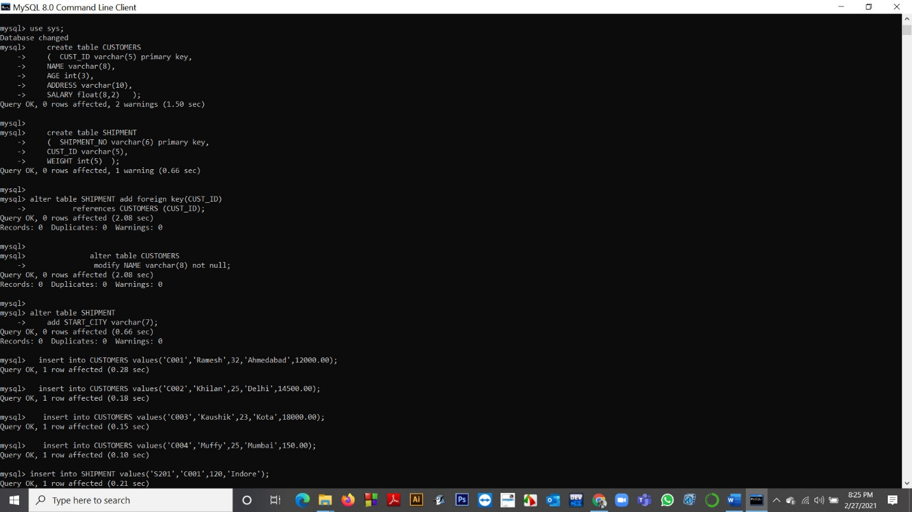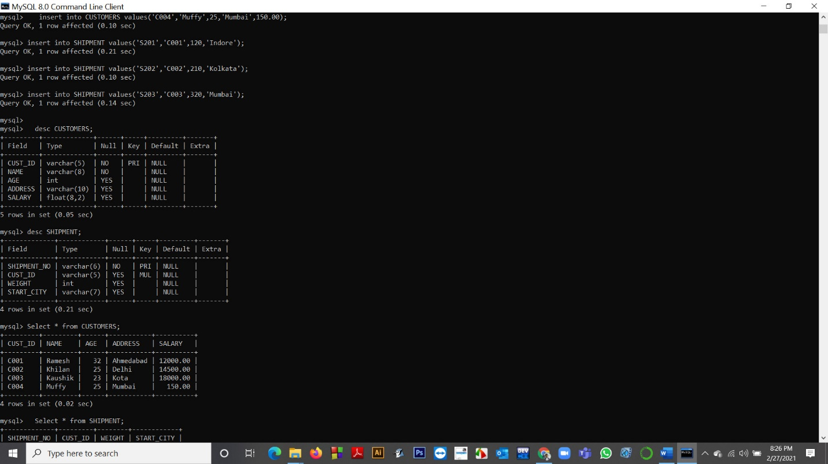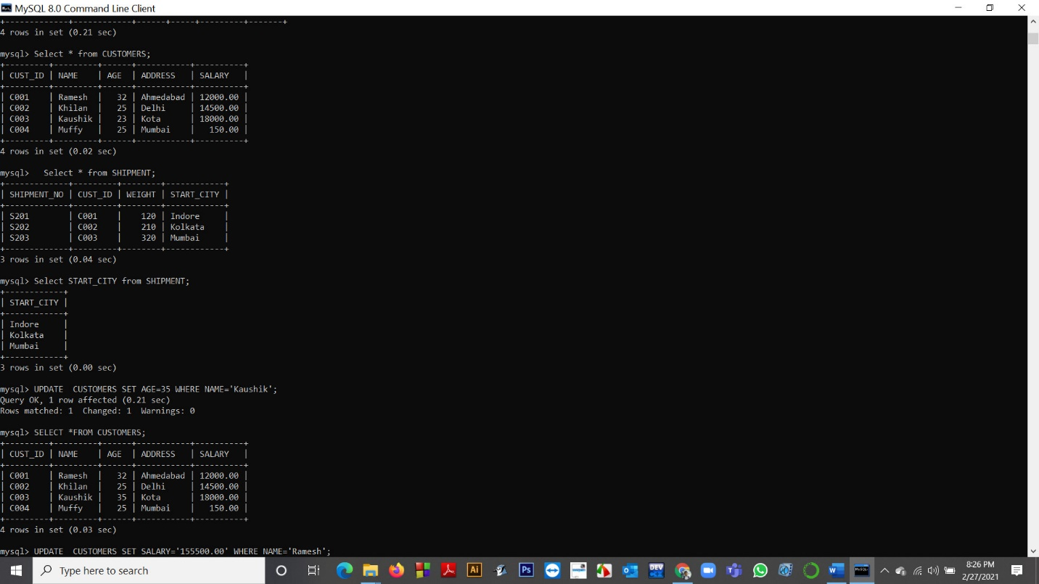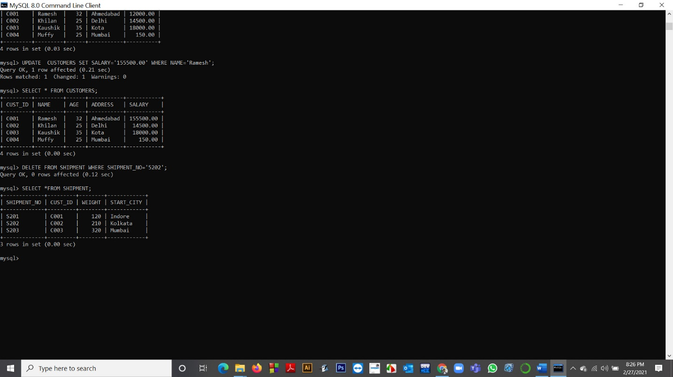

**Assignment SQL – IV(B)**

**11.Change the area of cust _ id 'A05' to 'vs'.**

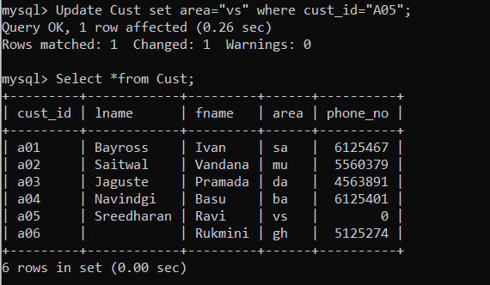

**12.Change the return date of invoice number 'I08' to 16-08-93.**

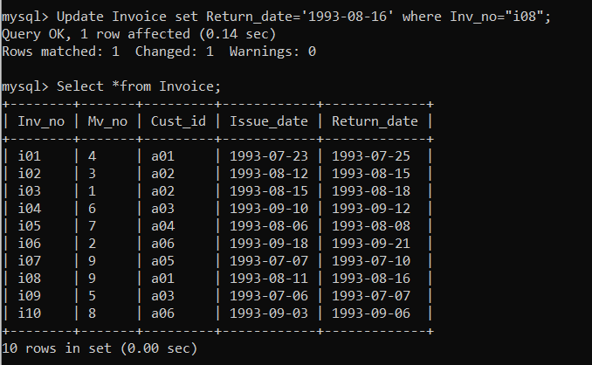

**13.Find the names of all customers having 'a' as the second letter in their fnames.**

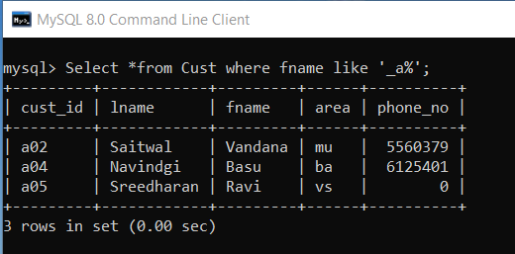

**14.Find the lnames of all customers that begin with 's ' or 'j' .**

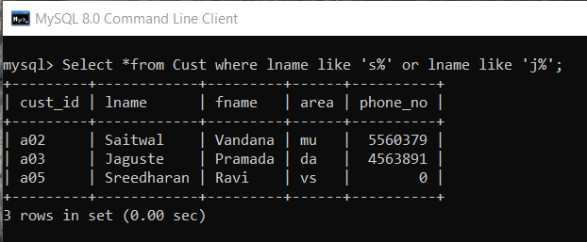

**15.Find out the customers who stay in an area whose second letter is 'a'.**

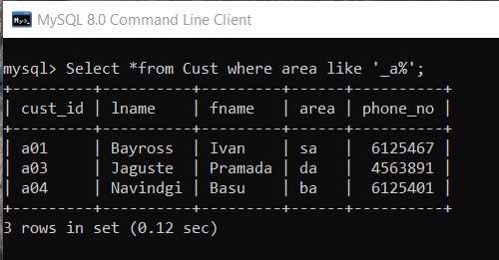

**16.Find the list of all customers who stay in area 'da' or area 'mu' or area 'gh'.**

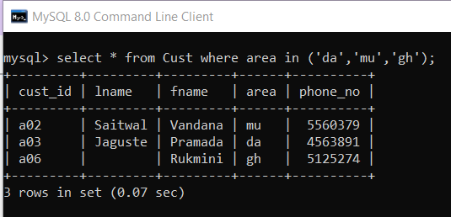

**17.Print the list of employees whose phone numbers are greater than the value 5550000.**

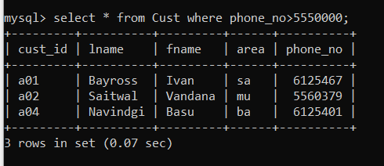

**18.Print the information from invoice table of customers who have been issued movies in the month of september**.

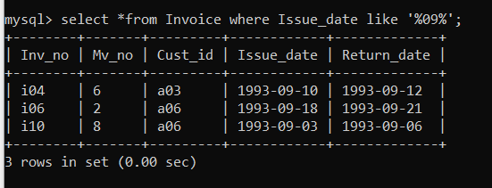

**19.Display the invoice table information for cust _id 'a01' and 'a02'.**

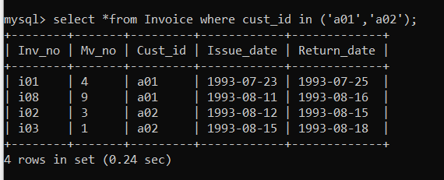

**20.Find the movies of type 'action' and 'comedy' .**

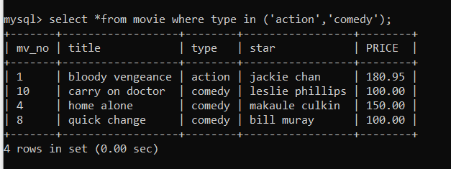

**ASSIGNMENT IVC**

**21.Find the movies whose price is greater than 150 and less than or equal to 200.**

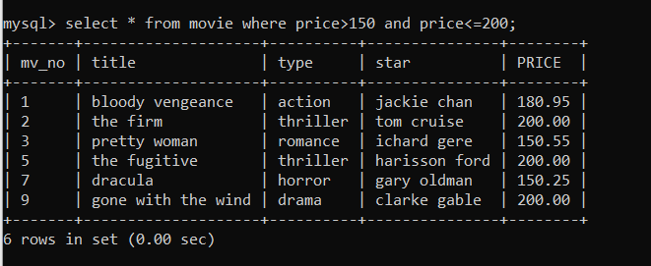

**22.Find the movies that cost more than 150 and also find the new cost as original cost * 15.**

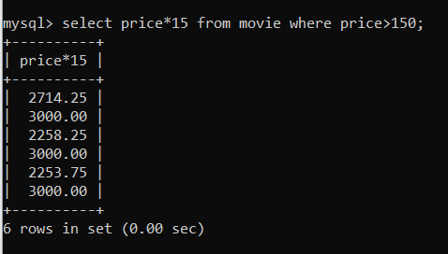

**23.Rename the new column in the above query as new-price.**

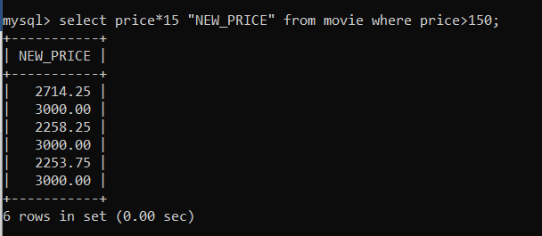

24.**List the movies in sorted order of their titles.**

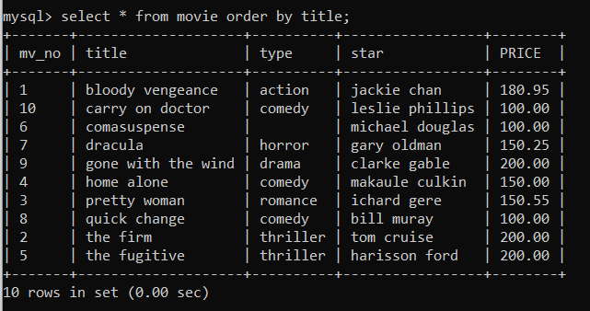

25.**Print the names and types of all the movie except horror movies.**

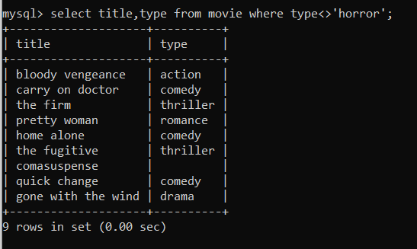

26.**Divide the cost of movie 'home alone' by difference between its price and 100.**

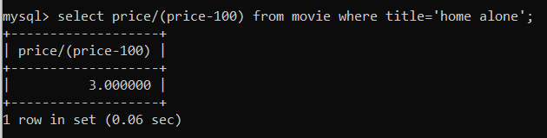

27.**List the names, areas and cust _ id of customers without phone numbers.**

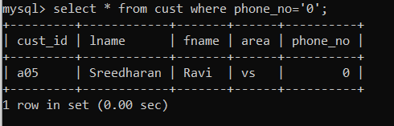

**28. List the names of customers without lname.**

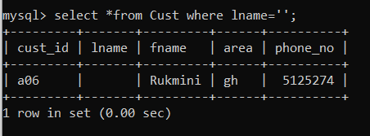

**29.List the mv - no, title, type of movies whose stars begin with letter 'm'.**

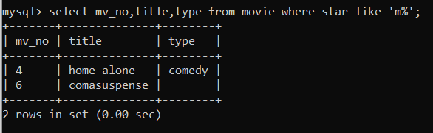

30.**List the mv-no and inv-no of customers having inv-no less than 'i05'from the Invoice Transaction Table.**

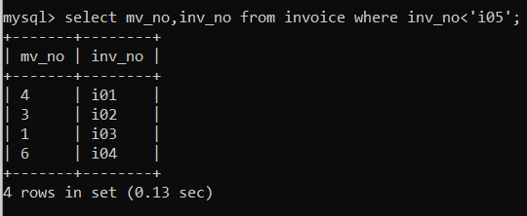

**Assignment SQL – I (22.02.2021)**

(Table Creation & Data Insertion)

**TEST**

|  |  |  |
| --- | --- | --- |
| **E_ID** | **Name** | **City** |
| C101 | Deepak | Mumbai |
| C102 | Aman | Bangalore |
| C103 | Rajkumar | Kolkata |
| C104 | Aman | Delhi |
| C105 | Kunal | Mumbai |

1. Create the test table.
2. Insert data in test table.

3. Describe test table.

4. Show the entire test table.

5. Find out all names of test table.

1. **Create the test table.**

**PROGRAM CODE:**

**create table TEST(E_ID varchar(5),Name char(25),City char(20));**

**OUTPUT:**

**Query OK**

1. **Insert data in test table.**

**PROGRAM CODE:**

**insert into TEST values('C101','Deepak','Mumbai');**

**insert into TEST values('C102','Aman','Bangalore');**

**insert into TEST values('C103','Rajkumar','Kolkata');**

**insert into TEST values('C104','Aman','Delhi');**

**insert into TEST values('C105','Kunal','Mumbai');**

**OUTPUT:**

**Query OK**

1. **Describe test table.**

**PROGRAM CODE:**

**desc TEST;**

**OUTPUT:**

+-------+------------+------+-----+---------+-------+

| Field | Type | Null | Key | Default | Extra |

+-------+------------+------+-----+---------+-------+

| E_ID | varchar(5) | YES | | NULL | |

| Name | char(25) | YES | | NULL | |

| City | char(20) | YES | | NULL | |

+-------+------------+------+-----+---------+-------+

1. **Show the entire test table.**

**PROGRAM CODE:**

**select *from TEST;**

**OUTPUT:**

+------+----------+-----------+

| E_ID | Name | City |

+------+----------+-----------+

| C101 | Deepak | Mumbai |

| C102 | Aman | Bangalore |

| C103 | Rajkumar | Kolkata |

| C104 | Aman | Delhi |

| C105 | Kunal | Mumbai |

+------+----------+-----------+

1. **Find out all names of test table.**

**PROGRAM CODE:**

**select Name from TEST;**

**OUTPUT:**

+----------+

| Name |

+----------+

| Deepak |

| Aman |

| Rajkumar |

| Aman |

| Kunal |

+----------+

**SCREENSHOT OF OUTPUTS:**

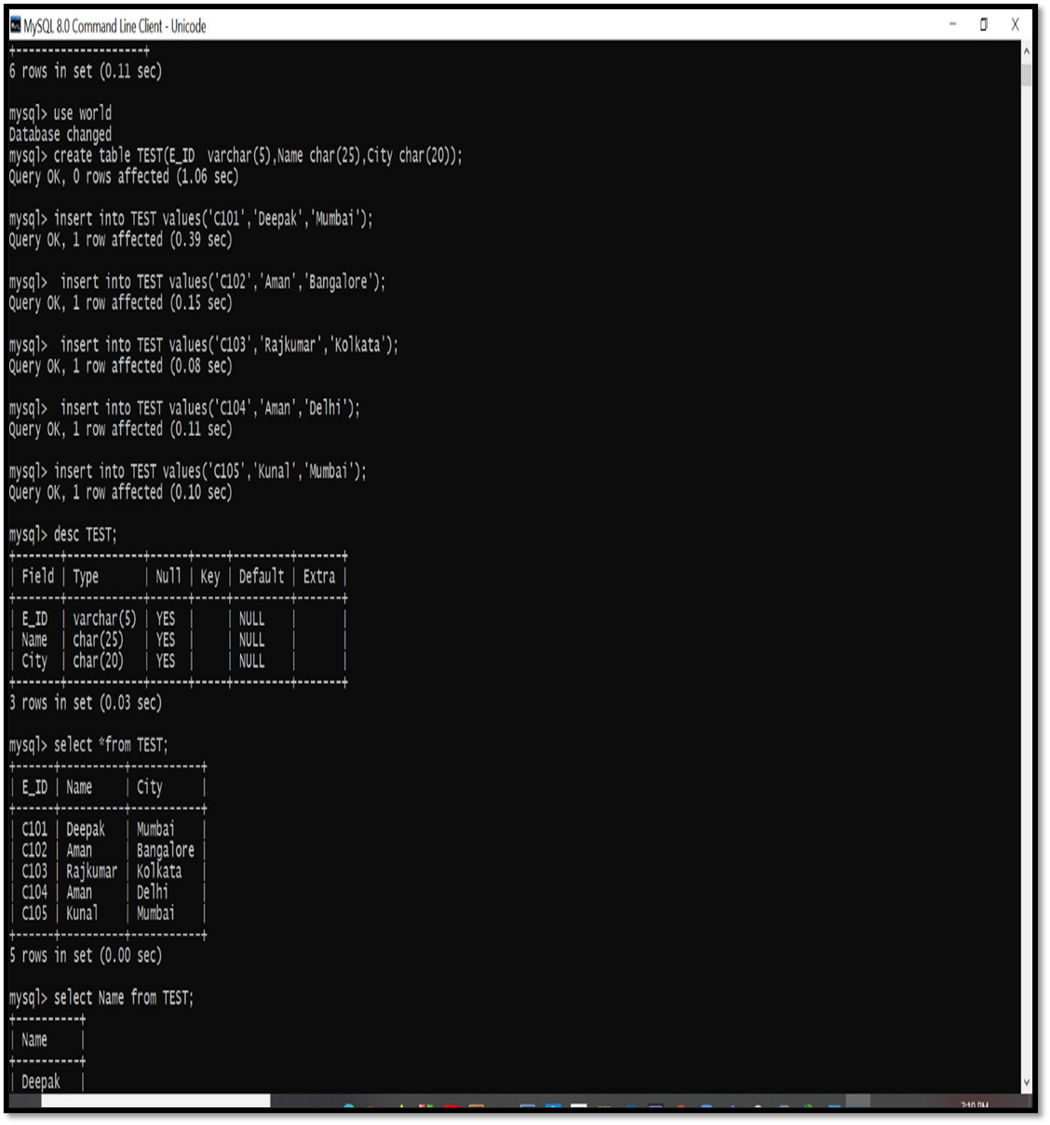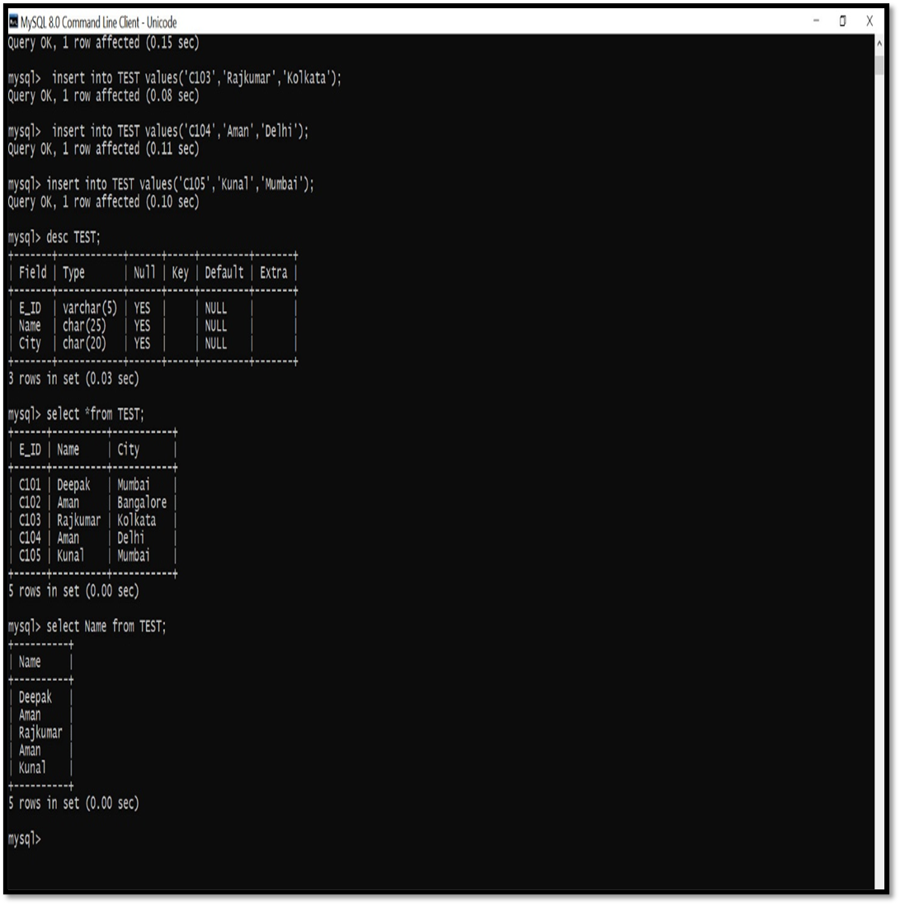

**Assignment SQL – III(01.03.2021)**

**(Table Creation ,Constraint Add & Data Insertion)**

**1)** **Create the following Tables -**

1. Customer master table: **Cust**

**Column Name Format Remarks**

cust_id varchar2(3) Primary key

lname varchar2(15)

fname varchar2(15)

area varchar2(2)

phone_no number(8)

2. Movies master table : **Movie**

**Column Name Format Remarks**

mv_no varchar2(2) Primary key

title varchar2(25)

type varchar2(10)

star varchar2(25)

3. Invoice transaction table : **Invoice**

**Column Name Format Remarks**

Inv_no varchar2(3) primary key

Mv_no varchar2(2)

Cust_id varchar2(3)

Issue_date date

Return_date date

4. Add the following constraints

1. INVOICE(Cust_id) references CUST(Cust_id)
2. INVOICE(Mv_no) references MOVIE(Mv_no)
3. Declare NOT NULL : fname, title, type

5. Add a new column PRICE in Movie table with data type number(8,2)

6. Insert the following data into the respective tables :

6.1. **Data for Cust table**

**Cust_id Lname fname Area Phone_no**

a01 Bayross Ivan sa 6125467

a02 Saitwal Vandana mu 5560379

a03 Jaguste Pramada da 4563891

a04 Navindgi Basu ba 6125401

a05 Sreedharan Ravi va

a06 Rukmini gh 5125274

6.2. **Data for Movie table**

**mv_no title type star price**

1 bloody vengeance action jackie chan 180.95

2 the firm thriller tom cruise 200.00

3 pretty woman romance richard gere 150.55

4 home alone comedy macaulay culkin 150.00

5 the fugitive thriller harisson ford 200.00

6 coma suspense michael douglas 100.00

7 dracula horror gary oldman 150.25

8 quick change comedy bill muray 100.00

9 gone with the wind drama clarke gable 200.00

10 carry on doctor comedy leslie phillips 100.00

6.3. **Data for Invoice table**

**inv_no mv_no cust_id issue_date return_date**

i01 4 a01 23-july-93 25-jul-93

i02 3 a02 12-aug-93 15-aug-93

i03 1 a02 15-aug-93 18-aug-93

i04 6 a03 10-sep-93 12-sep-93

i05 7 a04 05-aug-93 08-aug-93

i06 2 a06 18-sep-93 21-sep-93

i07 9 a05 07-jul-93 10-jul-93

i08 9 a01 11-aug-93 14-aug-93

i09 5 a03 06-jul-93 07-jul-93

i10 8 a06 03-sep-93 06-sep-93

**1) Create the following Tables -**

1**. Customer master table: Cust**

**PROGRAM CODE:**

**create table Cust**

**(**

**cust_id varchar(3) primary key,**

**lname varchar(15),**

**fname varchar(15),**

**area varchar(2),**

**phone_no int(8) );**

**OUTPUT:**

**Query OK**

**PROGRAM CODE:**

**desc Cust;**

**OUTPUT:**

+----------+-------------+------+-----+---------+-------+

| Field | Type | Null | Key | Default | Extra |

+----------+-------------+------+-----+---------+-------+

| cust_id | varchar(3) | NO | PRI | NULL | |

| lname | varchar(15) | YES | | NULL | |

| fname | varchar(15) | YES | | NULL | |

| area | varchar(2) | YES | | NULL | |

| phone_no | int | YES | | NULL | |

+----------+-------------+------+-----+---------+-------+

**2. Movies master table : Movie**

**PROGRAM CODE:**

**create table Movie**

**(**

**mv_no varchar(2) primary key ,**

**title varchar(25),**

**type varchar(10),**

**star varchar(25)**

**);**

**OUTPUT:**

**Query OK**

**PROGRAM CODE:**

**desc Movie;**

**OUTPUT:**

+-------+-------------+------+-----+---------+-------+

| Field | Type | Null | Key | Default | Extra |

+-------+-------------+------+-----+---------+-------+

| mv_no | varchar(2) | NO | PRI | NULL | |

| title | varchar(25) | YES | | NULL | |

| type | varchar(10) | YES | | NULL | |

| star | varchar(25) | YES | | NULL | |

+-------+-------------+------+-----+---------+-------+

**3. Invoice transaction table : Invoice**

**PROGRAM CODE:**

**create table Invoice**

**(**

**Inv_no varchar(3) primary key ,**

**Mv_no varchar(2),**

**Cust_id varchar(3),**

**Issue_date date,**

**Return_date date**

**);**

**OUTPUT:**

**Query OK**

**PROGRAM CODE:**

**desc Invoice;**

**OUTPUT:**

+-------------+------------+------+-----+---------+-------+

| Field | Type | Null | Key | Default | Extra |

+-------------+------------+------+-----+---------+-------+

| Inv_no | varchar(3) | NO | PRI | NULL | |

| Mv_no | varchar(2) | YES | | NULL | |

| Cust_id | varchar(3) | YES | | NULL | |

| Issue_date | date | YES | | NULL | |

| Return_date | date | YES | | NULL | |

+-------------+------------+------+-----+---------+-------+

**4. Add the following constraints**

1. **INVOICE(Cust_id) references CUST(Cust_id)**
2. **INVOICE(Mv_no) references MOVIE(Mv_no)**
3. **Declare NOT NULL : fname, title, type**

**PROGRAM CODE:**

**alter table Invoice add foreign key(Cust_id)**

**references Cust (Cust_id);**

**OUTPUT:**

**Query OK**

**PROGRAM CODE:**

**alter table Invoice add foreign key(Mv_no)**

**references Movie(Mv_no);**

**OUTPUT:**

**Query OK**

**PROGRAM CODE:**

**alter table Cust**

**modify fname varchar(15) not null;**

**OUTPUT:**

**Query OK**

**PROGRAM CODE:**

**alter table Movie**

**modify title varchar(25) not null;**

**OUTPUT:**

**Query OK**

**PROGRAM CODE:**

**alter table Movie**

**modify type varchar(10) not null;**

**OUTPUT:**

**Query OK,**

**5. Add a new column PRICE in Movie table with data type number(8,2)**

**PROGRAM CODE:**

**alter table Movie**

**add PRICE float(8,2);**

**Query OK**

**OUTPUT:**

**Query OK**

**6. Insert the following data into the respective tables** :

**6.1. Data for Cust table**

**Cust_id Lname fname Area Phone_no**

a01 Bayross Ivan sa 6125467

a02 Saitwal Vandana mu 5560379

a03 Jaguste Pramada da 4563891

a04 Navindgi Basu ba 6125401

a05 Sreedharan Ravi va

a06 Rukmini gh 5125274

**PROGRAM CODE:**

**insert into Cust values('a01','Bayross','Ivan','sa','6125467');**

**insert into Cust values('a02','Saitwal','Vandana','mu','5560379');**

**insert into Cust values('a03','Jaguste','Pramada','da','4563891');**

**insert into Cust values('a04','Navindgi','Basu','ba','6125401');**

**insert into Cust values('a05','Sreedharan','Ravi','va','0');**

**insert into Cust values('a06','','Rukmini','gh','5125274');**

**OUTPUT:**

**Query OK**

**PROGRAM CODE:**

**select * from Cust;**

**OUTPUT:**

+---------+------------+---------+------+----------+

| cust_id | lname | fname | area | phone_no |

+---------+------------+---------+------+----------+

| a01 | Bayross | Ivan | sa | 6125467 |

| a02 | Saitwal | Vandana | mu | 5560379 |

| a03 | Jaguste | Pramada | da | 4563891 |

| a04 | Navindgi | Basu | ba | 6125401 |

| a05 | Sreedharan | Ravi | va | 0 |

| a06 | | Rukmini | gh | 5125274 |

+---------+------------+---------+------+----------+

**6.2. Data for Movie table**

**mv_no title type star price**

1 bloody vengeance action jackie chan 180.95

2 the firm thriller tom cruise 200.00

3 pretty woman romance richard gere 150.55

4 home alone comedy macaulay culkin 150.00

5 the fugitive thriller harisson ford 200.00

6 coma suspense michael douglas 100.00

7 dracula horror gary oldman 150.25

8 quick change comedy bill muray 100.00

**PROGRAM CODE:**

**insert into Movie values('1','bloody vengeance','action','jackie chan','180.95');**

**insert into Movie values('2','the firm','thriller','tom cruise','200.00');**

**insert into Movie values('3','pretty woman','romance','ichard gere','150.55');**

**insert into Movie values('4','home alone','comedy','makaule culkin','150');**

**insert into Movie values('5','the fugitive','thriller','harisson ford','200.00');**

**insert into Movie values('6','comasuspense','','michael douglas','100.00');**

**insert into Movie values('7','dracula','horror','gary oldman','150.25');**

**insert into Movie values('8','quick change','comedy','bill muray','100.00');**

**insert into Movie values('9','gone with the wind','drama','clarke gable','200.00');**

**insert into Movie values('10','carry on doctor','comedy','leslie phillips','100.00');**

**OUTPUT:**

**Query OK**

**PROGRAM CODE:**

**select * from Movie;**

**OUTPUT:**

+-------+--------------------+----------+-----------------+--------+

| mv_no | title | type | star | PRICE |

+-------+--------------------+----------+-----------------+--------+

| 1 | bloody vengeance | action | jackie chan | 180.95 |

| 10 | carry on doctor | comedy | leslie phillips | 100.00 |

| 2 | the firm | thriller | tom cruise | 200.00 |

| 3 | pretty woman | romance | ichard gere | 150.55 |

| 4 | home alone | comedy | makaule culkin | 150.00 |

| 5 | the fugitive | thriller | harisson ford | 200.00 |

| 6 | comasuspense | | michael douglas | 100.00 |

| 7 | dracula | horror | gary oldman | 150.25 |

| 8 | quick change | comedy | bill muray | 100.00 |

| 9 | gone with the wind | drama | clarke gable | 200.00 |

+-------+--------------------+----------+-----------------+--------+

6.3. **Data for Invoice table**

**inv_no mv_no cust_id issue_date return_date**

i01 4 a01 23-july-93 25-jul-93

i02 3 a02 12-aug-93 15-aug-93

i03 1 a02 15-aug-93 18-aug-93

i04 6 a03 10-sep-93 12-sep-93

i05 7 a04 05-aug-93 08-aug-93

i06 2 a06 18-sep-93 21-sep-93

i07 9 a05 07-jul-93 10-jul-93

i08 9 a01 11-aug-93 14-aug-93

i09 5 a03 06-jul-93 07-jul-93

i10 8 a06 03-sep-93 06-sep-93

**PROGRAM CODE:**

**insert into Invoice values('i01','4','a01','1993-07-23','1993-07-25');**

**insert into Invoice values('i02','3','a02','1993-08-12','1993-08-15');**

**insert into Invoice values('i03','1','a02','1993-08-15','1993-08-18');**

**insert into Invoice values('i04','6','a03','1993-09-10','1993-09-12');**

**insert into Invoice values('i05','7','a04','1993-08-06','1993-08-08');**

**insert into Invoice values('i06','2','a06','1993-09-18','1993-09-21');**

**insert into Invoice values('i07','9','a05','1993-07-07','1993-07-10');**

**insert into Invoice values('i08','9','a01','1993-08-11','1993-08-14');**

**insert into Invoice values('i09','5','a03','1993-07-06','1993-07-07');**

**insert into Invoice values('i10','8','a06','1993-09-03','1993-09-06');**

**OUTPUT:**

**Query OK**

**PROGRAM CODE:**

**select * from Invoice;**

**OUTPUT:**

+--------+-------+---------+------------+-------------+

| Inv_no | Mv_no | Cust_id | Issue_date | Return_date |

+--------+-------+---------+------------+-------------+

| i01 | 4 | a01 | 1993-07-23 | 1993-07-25 |

| i02 | 3 | a02 | 1993-08-12 | 1993-08-15 |

| i03 | 1 | a02 | 1993-08-15 | 1993-08-18 |

| i04 | 6 | a03 | 1993-09-10 | 1993-09-12 |

| i05 | 7 | a04 | 1993-08-06 | 1993-08-08 |

| i06 | 2 | a06 | 1993-09-18 | 1993-09-21 |

| i07 | 9 | a05 | 1993-07-07 | 1993-07-10 |

| i08 | 9 | a01 | 1993-08-11 | 1993-08-14 |

| i09 | 5 | a03 | 1993-07-06 | 1993-07-07 |

| i10 | 8 | a06 | 1993-09-03 | 1993-09-06 |

+--------+-------+---------+------------+-------------+

**SCREENSHOT OF OUTPUTS:**

