

**MEMORANDUM OF UNDERSTANDING**

**ON A STRATEGIC PARTNERSHIP ON SUSTAINABLE RAW MATERIALS VALUE CHAINS**

**BETWEEN THE EUROPEAN UNION AND THE ARGENTINE REPUBLIC**

# Introduction

* 1. *Objectives*

The European Union - EU- and the Argentine Republic (hereinafter "the Participants") wish to establish a strategic partnership on sustainable raw materials value chains (hereinafter "the Partnership") through signing this Memorandum of Understanding (the Memorandum). In the framework of the Partnership, the Participants intend to deepen cooperation in the field of sustainable raw materials value chains that support the clean energy and digital transition.

The Participants are both committed to improve the sustainability of raw materials supply chains and recognise that securing a sustainable supply of strategic and critical raw materials listed in the Annex, is an essential prerequisite for delivering on clean energy and digital objectives.

Concretely, the Partnership, based on mutual benefits, aims to support:

* + - identifying and jointly developing innovative and sustainable and responsible raw materials value chain projects by facilitating business opportunities, deploying financial support, investment de-risking instruments;
    - closer economic and industrial integration of the Participants in sustainable value chain of raw

materials;

* + - cooperation to increase resilience of raw materials value chains;
    - developing the Argentine Republic's sustainable raw materials value chains in its environmental, social and economic dimensions as a lever for a sustainable and inclusive economic growth, the creation of local added value, quality employment, the development of local industrialization and domestic revenue mobilisation; thereby increasing the competitiveness ofthe Argentine economy;
    - the development of open, resilient and competitive markets for raw, processed and recycled

materials, allowing the EU to diversify its suppliers for materials necessary in particular to achieve the clean and digital transition and its open strategic autonomy;

* + - promoting the alignment of sustainable raw materials value chains developed between the EU

and the Argentine Republic with internationally agreed principles and guidelines for environmental, social and governance (ESG) standards;

* + - cooperation on skills, capacity building and competences necessary for the development of sustainable raw materials value chains, including the promotion of the most sustainable extraction and transformation practices, and circular economy;



* + - to facilitate closer cooperation on research and innovation along the raw materials value chain, including advanced exploration, earth observation, innovative extractive, processing, refining and recycling technologies;
  1. *Policy context*

Currently the EU and the Argentine Republic relations are governed by the Framework Agreement for Trade and Economic Cooperation between the European Community and the Argentine Republic signed in 1990, which establishes the basis for bilateral cooperation in foreign trade, economy, agriculture and industry. The Participants also signed a specific agreement, the Agreement for Scientific and Technological Cooperation between the European Community and the Argentine Republic, in 1999. Moreover, the EU and the Argentine Republic, as part of Mercosur, have politically concluded the negotiations for an Association Agreement. During the XII EU - Argentina Joint Cooperation Commission (June 2022) both parties agreed to launch the negotiations for new bilateral institutional framework to strengthening our Partnership and fostering bi-regional dialogue on cooperation**1.**

# Scope of the Partnership

The Partnership covers strategic and critical raw materials listed in the Annex that are necessary for the clean energy and digital transition, covering the entire value chain - exploration, extraction, refining, processing, and recycling - including extractive waste and the value adding downstream industries.

This Memorandum envisages to set the framework for shared commitment to enhance cooperation in the field of raw materials value chains for the clean energy transition in following five (5) areas of collaboration:

integration of sustainable raw materials value chains, including networking, joint development of projects (e.g. via joint ventures), creation of new business models and promotion and facilitation of trade and investment linkages, ensuring the well-functioning, sustainability and resilience of these raw materials value chains;

cooperation on research and innovation along the raw materials value chains, including on minerals knowledge, the minimisation of environmental and climate footprint, and circular ewnomy;

cooperation to leverage Environmental, Social, and Governance (ESG) Criteria and align with international standards;

deployment of hard and soft infrastructure for projects development, minimising their environmental and climate impact, in accordance with international ESG standards; strengthen capacities, training and skills development along sustainable raw materials value chains in accordance with international labour standards.

1 Press(22.06.2022). Comunicado Conjunto



A roadmap is envisaged to complement this Memorandum, including specific actions to start cooperating in each area ofcollaboration. It should engage stakeholders from both Participants and identify the leading organisations to implement each action.

# Principles of the Partnership

The Partnership envisages to be conducted fully in concordance with the Framework Agreement for Trade and Economic Cooperation between the European Community and the Argentine Republic, which establishes the rules and the procedures governing political and economic relations between the Participants.

The Participants reaffirm their willingness to reinforce dialogue and cooperation on issues of mutual interest, to contribute to the implementation of the Agenda 2030 for Sustainable Development, the Paris Agreement concluded on December 12, 2015, and the Kunming-Montreal Global Biodiversity Framework.

The Participants recognise the importance of the EU Global Gateway Strategy to promote high quality investments and its links to the objectives, collaboration areas and principles of this Strategic Partnership.

The Partnership envisages to promote trade and responsible and sustainable investment by ensuring a level playing field and expanding and diversifying the EU-Argentine Republic trade relations and contributing to long-term, sustainable, inclusive mutual economic growth, strengthened competitiveness and resilience ofrelated value chains.

The Participants intend to promote the active participation and cooperation ofrelevant stakeholders along the raw materials value chains.

The Participants envisages to ensure that the assessment ofthe environmental and social impact of future joint projects is carried out in line with the relevant provisions ofthe laws and regulations of the respective Participants, ensuring public participation in line with international standards and conventions.

The Partnership should be open and inclusive, ensure a strong multi-level public-private involvement ofindustry, business, labour, social, and other relevant partners from both Participants.

# Implementation and monitoring of the Partnership

Within 6 months from the signature of the Memorandum, the Participants intend to develop a Strategic Partnership Roadmap (Roadmap). The Roadmap should identify concrete actions for cooperation agreed by the Participants, along the five (5) areas of cooperation identified above as well as the corresponding working arrangements.

The Participants intend to monitor the implementation ofthe Roadmap through a dedicated working group consisting ofsenior officials. Upon agreement the Part{cipants may update the list ofstrategic and critical raw materials included in the Annex.

The Participants intend to organise a regular annual meeting to take stock of the Partnership progress, discuss possible new strategic collaboration directions and endorse the Roadmap for the

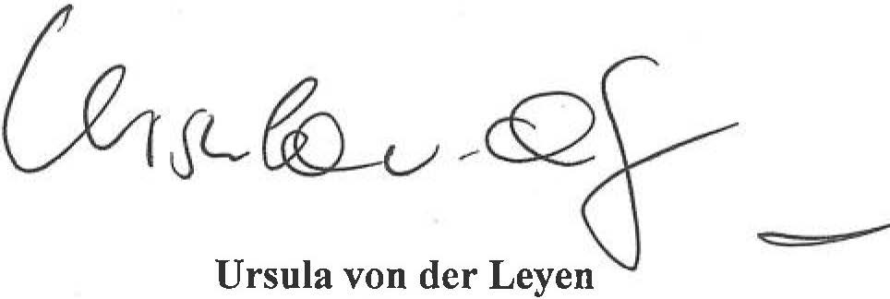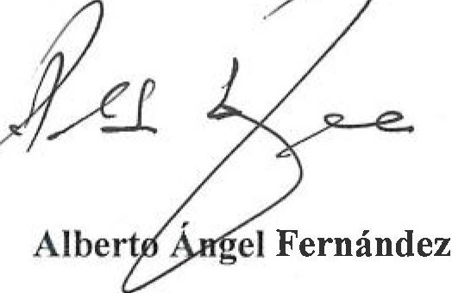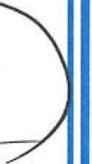

upcoming period. The Participants, may, by mutual agreement, propose a Ministerial level meeting for strategic matters.

# Legal Format

The Partnership does not give rise to any rights or obligations under international or domestic law. In particular, nothing in this Memorandum represents a commitment of financing on the part of either Participant.

Furthermore, this Memorandum does not represent any commitment from either Participant to give preferential treatment to the other Participant in any matter contemplated herein or otherwise.

The implementation of this Memorandum and any other activity hereunder is to be in accordance with each Participant's domestic laws, regulations, policies and procedures, as well as each Participant's international obligations.

The activities described in this Memorandum are to commence on the day after it has been signed by both Participants.

Signed in Buenos Aires on the 13 June 2023 in two originals, each in the Spanish and English languages, being both equally authentic.

# For the European Union For the Argentine Republic

')

**President of the European Commission President of the Argentine Republic**



**ANNEX**

List of Strategic Raw Materials

* 1. Bismuth
  2. Boron - metallurgy grade
  3. Cobalt
  4. Copper
  5. Gallium
  6. Germanium
  7. Lithium - battery grade
  8. Magnesium metal
  9. Manganese - battery grade
  10. Natural Graphite - battery grade
  11. Nickel - battery grade
  12. Platinum Group Metals
  13. Rare Earth Elements for magnets (Nd, Pr, Tb, Dy, Gd, Sm, and Ce)
  14. Silicon metal
  15. Titanium metal
  16. Tungsten

List of Critical Raw Materials

1. Antimony
2. Arsenic
3. Bauxite
4. Baryte
5. Beryllium
6. Bismuth
7. Boron
8. Cobalt
9. Coking Coal
10. Copper
11. Feldspar
12. Fluorspar
13. Gallium
14. Germanium
15. Hafnium
16. Helium
17. Heavy Rare Earth Elements
18. Light Rare Earth Elements
19. Lithium
20. Magnesium
21. Manganese
22. Natural Graphite
23. Nickel - battery grade



1. Niobium
2. Phosphate rock
3. Phosphorus
4. Platinum Group Metals
5. Scandium
6. Silicon metal
7. Strontium
8. Tantalum
9. Titanium metal
10. Tungsten
11. Vanadium